WEB-DBMS CIA 2

First Member Name       Jason Gonsalves

First Member Roll No.    31

First Member UidNo.     195229

Second Member Name      Calist Dsouza

Second Member Roll No.   17

Second Member UidNo.     195222

We made a gym management website. this will help the gym owners to maintain records of the gym and their members. This will be very useful and convenient for the owners to maintain all the records.

In the website ,after opening first you will see the login-page. From there the admin can login ,admin has to enter his username and password . it also have a sign-in page from where you can sign-in. after login-in there is a page to register a new member , in this admin has to enter first name, last name, email, member id, trainer and then register a member .

Website contains member details page from where you can see all the details of the members you also can search members by member-id’s. there is a payments page for payments.

There is a package details page, where one can see all the packages and price of packages.

There is a trainers details page from one can see all the available trainers .this have all the details of the trainer like contact no and trainer id. Website also have a add trainer page from where admin can add new trainers and in putting all the details. After you can log-out using logout button.

For frontend, website is using HTML, CSS, Bootstrap, Jquery, JavaScript.

For Backend, website is using PHP and for database MySql

Screenshots of Website :

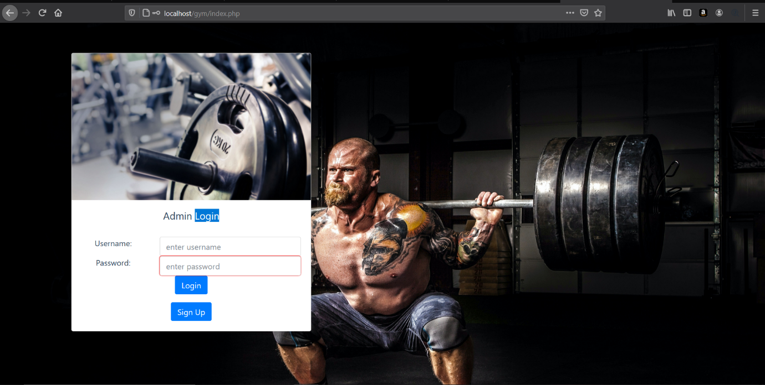

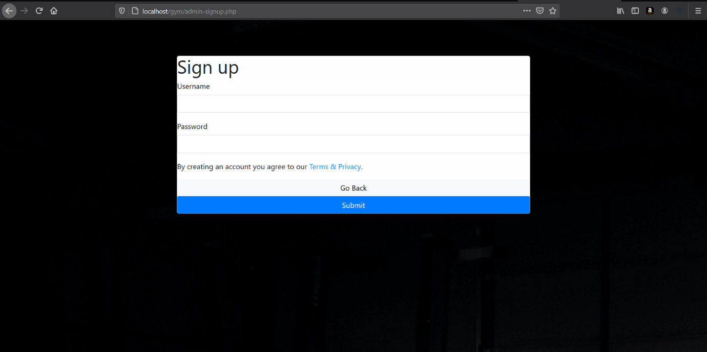

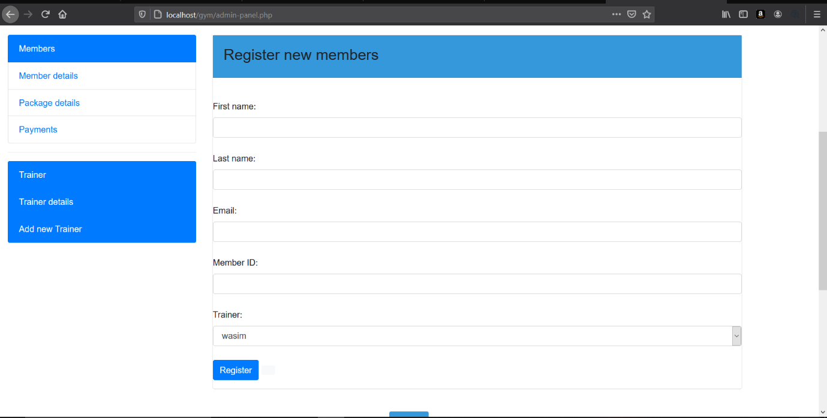

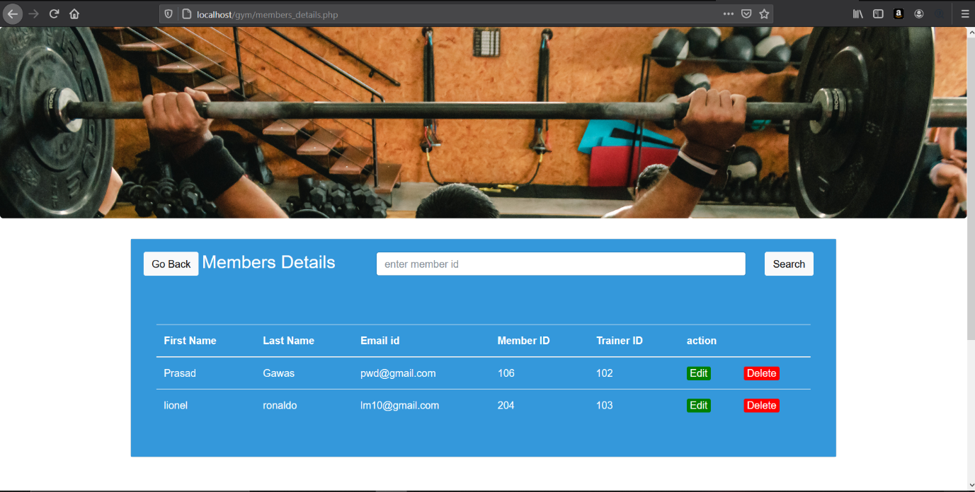

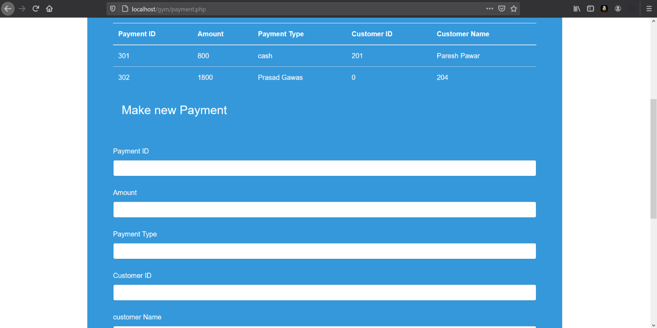

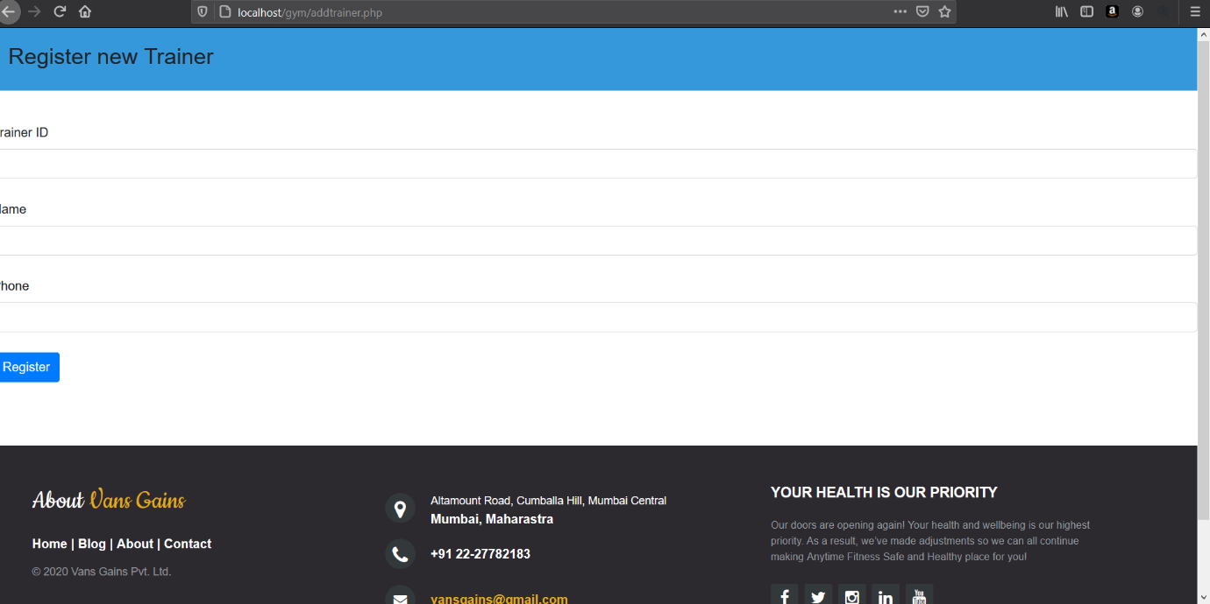

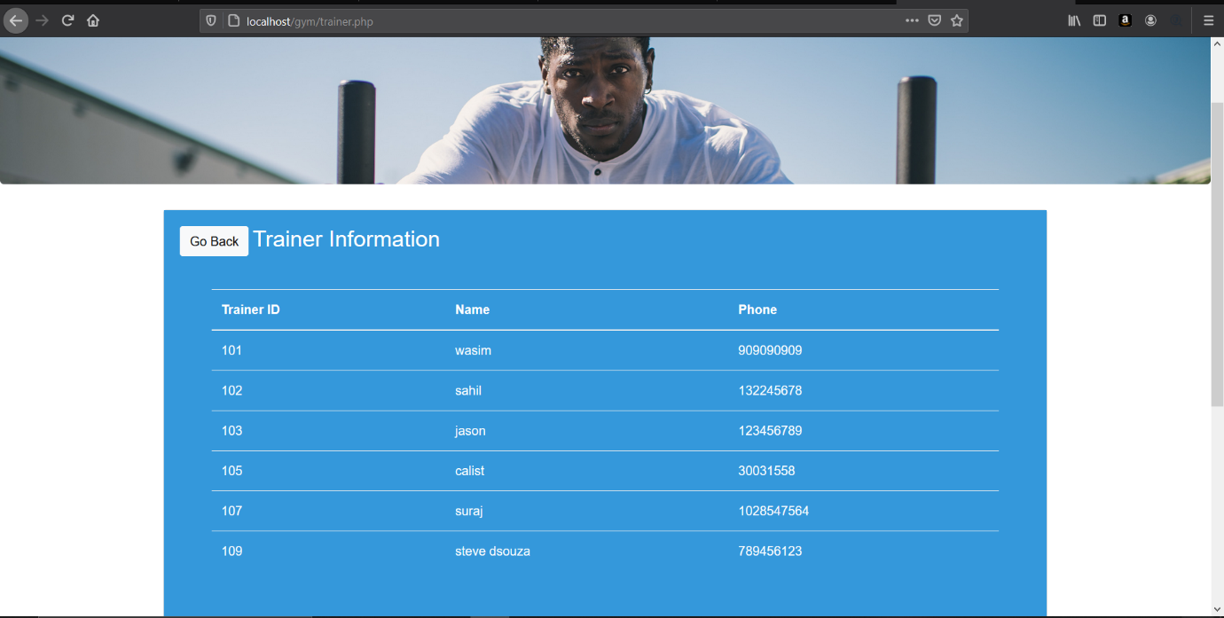

Site map:

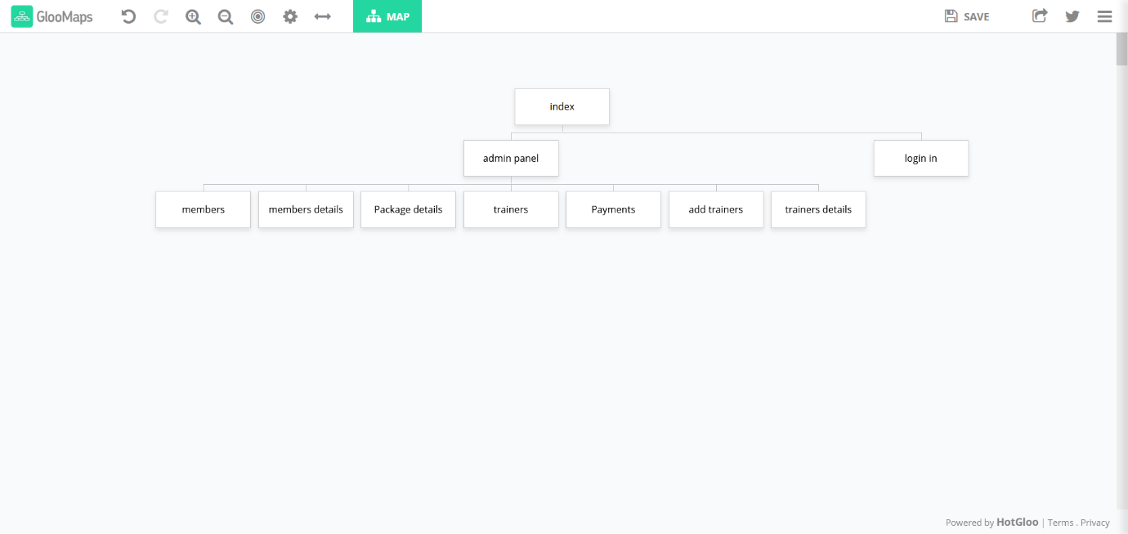

Reference:

* Youtube videos
* W3schools.com