PENTECOST UNIVERSITY
PUIT/24210003_ CALIXTO BOLEKIA SULU



Report: A Secure Login Authentication System

The task was a simple login system that identifies users, authenticates them with two factors, applies access rules, stores passwords with a salt and a pepper, and keeps a sensible balance between security and access. I built it twice. The first version was in Python with Flask. The second, which is the final one, is in plain HTML, CSS and JavaScript, and it adds encrypted automatic backups and cryptographic protection for confidentiality and integrity. This report mostly describes the second version and mentions the first where it helps.

Identification and password storage
Every user registers with a unique username (3 to 30 letters, digits or underscores) and a password of at least ten characters with upper case, lower case, a number and a symbol. The first account created becomes the administrator. Every account after that is a normal user, so nobody can choose their own role.
The password itself is never saved. Each user gets a random 16-byte salt, so two people with the same password end up with different hashes. The password is then mixed with a pepper using HMAC-SHA256 and run through PBKDF2 with 210,000 rounds, which makes guessing slow. The pepper is a long secret kept in the code, away from the stored data, so someone who copies only the data is missing one ingredient.
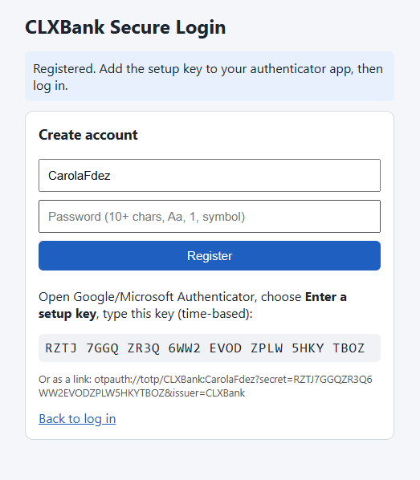

Two-factor authentication
Login has two steps. First the password is checked. If it is correct the user is not let in yet; the system only remembers for two minutes that step one passed. Then the user types the six-digit code from an authenticator app such as Google Authenticator. I wrote the TOTP calculation myself with the Web Crypto API (HMAC-SHA1, 30-second steps) and allowed one step of clock drift. Only after both checks does a session start, and it expires after 15 minutes. A wrong password and an unknown username give the same message, "Invalid credentials", so nobody can find out which usernames exist.

Rules and access control
Access depends on the role. A user can see only their own balance, a manager can also see every balance, and an admin can in addition change roles and manage backups. All actions go through the same permission check, which first asks whether there is a valid session and then whether the role allows that action. A refused action is written to the audit log. After five wrong passwords the account is locked for five minutes. I made the lock temporary on purpose, because a permanent one would let anyone lock a real user out just by typing wrong passwords.

Confidentiality and integrity
Balances and the 2FA secret are encrypted with AES-256-GCM before they are saved. The keys come from PBKDF2 and HKDF, with one key for encryption and a different one for integrity. AES-GCM also adds an authentication tag, so if someone edits the saved data the record simply refuses to decrypt. Each record is also tied to its owner's username, which stops one user's record from being swapped into another account.
I used HMAC-SHA256 for integrity in two more places. The audit log is chained: each entry's code includes the code of the entry before it, so changing or deleting an old line breaks every line after it, and the admin can press a button to check the whole chain. The backups are signed as well, as described next.

Automatic backups
A backup of the whole data store is made every 30 seconds and again two seconds after any change, and the last five are kept. Each backup is encrypted with AES-GCM and signed with an HMAC. Before a restore the signature is checked, and if it does not match nothing is restored. I added a "tamper test" button that corrupts the latest backup on purpose, so the restore can be shown failing with an integrity error. The admin can also download a backup as a file and restore from it later.

Testing
I ran the final version in the browser on Windows. I registered an account, added the setup key to my authenticator app, logged in with the password and then the code, and the balance of 1000appeared. 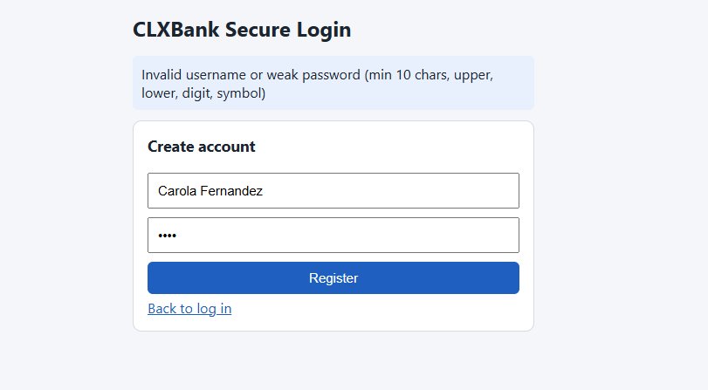weak password rejected, lockout after five attempts, wrong code, "forbidden" for a normal user, and the tamper test.

Limitations
This is a learning demo. Everything runs in the browser, so the pepper in the code and the data in local storage are within reach of anyone with full access to that browser. The keys are also derived from the pepper, which is the weakest point. A real system would do all of this on a server, use HTTPS and keep secrets in a secrets manager. Other improvements would be recovery codes in case the phone is lost, limits on login attempts per address, and a QR code instead of typing the setup key.

Conclusion
The system covers identification, two-factor login, role-based rules, salted and peppered password hashing, encryption, integrity checks and automatic backups. What I took from it is that each protection covers a different weakness, and that where the secrets are kept matters as much as which algorithm is used.

