
PENTECOST UNIVERSITY
LEVEL 200 – INFORMATION TECHNOLOGY
CALIXTO BOLEKIA SULU- PUIT/24210003
DATA COMMUNICATION ASSIGNMENT

ARCHITECTURAL AND FUNCTIONAL COMPLEXITIES OF SATELLITE DATA COMMUNICATION

1.INTRODUCTION
To begin, we need to talk about what a satellite is, the history of satellites, types of satellites,
technological advances, current infrastructure, modern role, interesting facts about satellites, their usefulness, importance and the purpose of my work.
In astronomy, a satellite is defined as an object that orbits a planet, that means it revolves around. There are hundreds of natural satellites, or moons, in our solar system, but since 1957, thousands of artificial (man-made) satellites have also been launched into space. These have very diverse uses, such as capturing images of the sun, Earth, and other planets, or exploring space to study black holes, and communications satellites, weather satellites, and international space station.
The first artificial satellite, Sputnik 1, was launched in 1957, It was very simple: An aluminium sphere the size of a beach ball equipped with four long antennas and powered by batteries. Inside were radio transmitters that sent out distinctive, intermittent beep that could be detected worldwide. The launch of this small, simple satellite marked the beginning of the space age.
The ITU (International Telecommunication Union) highlights that the idea of satellites emerged during the cold war (1950s) as part of the technological competition between the US and the USSR to demonstrate scientific and military superiority. The key milestone was the launch of Sputnik-1 by the Soviet Union on October 5, 1957.
The main technical and scientific objectives of the URSS were:
- Testing orbital deployment: Demonstrating that it was possible to launch and maintain an artificial object in orbit around the Earth.
- Radio signal transmission: Emitting radio pulses at frequencies of 20.005 and 40.002 MHz to be received worldwide, allowing its trajectory to be tracked and the operation of the on-board equipment to be verified.
- Atmospheric study: Collecting data on the density of the upper atmosphere and the propagation of radio waves through the ionosphere.

- Technological demonstration: Testing the design of pressurized aluminium sphere (58 cm in diameter) with four antennas, designed to be simple yet reliable, powered by internal batteries.

Types of satellites: ACCORDING TO ITS FUNCTION.
Earth observation satellites: They collect data about the Earth’s surface for mapping, natural resources management, environmental monitoring, and agriculture.
Examples:
Landsat (NASA/USGS): Monitoring land use and climate change.
Sentinel (ESA): Part of the Copernicus program, for environment monitoring.
Navigation Satellites: They emit very precise time and position signals, allowing receivers on Earth (GPS) to determinate their exact location.
Examples:
GPS (USA): The best-know system.
Galileo (Europe): Europe’s own navigation system.
Meteorological satellites: They monitor the atmosphere, clouds, winds, and temperatures for weather forecasting and tracking extreme weather events.
Examples:
GOES (USA): NOAA’s geostationary satellites.
Meteosat (Europe): Operated by EUMETSAT (European Space Agency).

Military satellites (Reconnaissance/Spy): Designed for defence purposes, including surveillance, espionage, military communications, and early warning of missile launches.
Scientific and astronomical satellites: Orbiting observatories that study outer space without interference from Earth’s atmosphere, or investigate Earth’s magnetic fields and gravity.

Examples:
Hubble Space Telescope: Observation of the universe in visible light.
James Webb Space Telescope: Infrared observation.
Space Station: Complex structures designed for humans to live and work in space for extended periods to conduct experiments.
Examples:
International Space Station(ISS): Located in low Earth orbit(LEO).

I consider it an important part of the introduction on satellites to discuss how they have been chronologically modified and improved, while also highlighting what event led to the next step for an advancement compared to the previous.
As mentioned 1957 was the begging the era, with Sputnik 1, launched by the Soviet Union, in 1958 the US response in its satellite, Explorer 1, which discovered the Van Allen radiation belts, those are two doughnut shaped zones of highly energetic charged particles that surround Earth, trapped by its magnetic field. This was a demonstration of the capacity of satellites for scientific research. In the early 60’s during the beginning of communication, the Telstar 1 was launched, what led to the first live television broadcast across the Atlantic.
In 1963 the Syncom 3 was launched, allowing the satellites to remain fixed over a point on Earth, facilitating continuous communication. 9 years after that the US Landsat program begins, initiating the continuous recording of satellites images to assess changes on Earth, and in 1976 the MARISAT satellite was launched, dedicated to maritime civil communication.
In 1980, 3 axis stabilized satellites, such as INTELSAT V, are launched to offer greater transmission capacity. 1990 came with massive use of the GPS (Global Positioning System) constellation during the Gulf War (The war to kick Iraq out of Kuwait), demonstrating its value for precise navigation and defence, the 2000’s started with the launch of e-Bird by Eutelsat (European company), focused on providing broadband satellite internet. Especially in remote areas.

2010’s presented Miniaturization and mega constellation, transition from large satellite to small. Standardization satellites such as CubeSat, the rise of Starlink and other project aims to create networks with thousands of satellites in low Earth orbit (LEO) for high speed, low latency global internet.

It is important to keep in mind that many of the activities we perform on a daily basis are thanks to communication satellites. The impact has been transformative, making a turning point in human history by eliminating geographical barriers to information and connectivity. From the first TV broadcast in the 1960s to today’s broadband internet, these technologies have redefined immediacy, security, and the global economy. It eliminated distances, allowing the transmission of live news and events to the entire world. Also the new satellites constellations allow access to high-speed internet, a clear example is ELON MUSK’s STARLINK, in places where fiber optics don’t reach, such as ships, airplanes, rural or desert areas, Lately it has become very common to see people who document the lives of different tribes in the vastness of the jungles, places where it’s hard to imagine there could be an internet connection, we also rely on medium Earth orbit (MEO) satellites for real-time navigation, shipment tracking, and precise synchronization in banking transactions and power grids. Weather forecasting, essential for agriculture and security, depends on satellites that monitor clouds and storms, saving lives.
As of April 2026, the latest news about satellites covers the launching of 29 Amazon Leo satellites by ULA, on Atlas 5 rocket from Cape Canaveral (Florida, USA), with the objective of expand their low Earth orbit broadband internet network, another important news is about SpaceX scrubs Falcon Heavy launch of final Viasat-3 satellite due to poor weather but it was finally launched from launch Complex 39A at NASA’s Kennedy Space Center.

The objective of this work is to provide an understanding of one of the most consequential technologies ever created by human, Satellites are woven into virtually every aspect of modern life. Also to take the reader from the very beginning from the moment of humanity first object into orbit. From a historical standpoint, the work traces the origins of satellites technology through the cold war (USA-URSS). To summarize, the work looks forward the convergence of satellite networks with 6G telecommunications standards, the deployment of artificial intelligence for autonomous satellite management, the development of direct-to-device connectivity that bypasses traditional ground infrastructure entirely, and the push toward more sustainable and responsible space operations. All of these represent a transformation of satellite technology that is already underway. The decisions being made today about constellation design, spectrum allocation. Debris migration, and cybersecurity norms will determine what kind of satellite dependent world the next generation will inherits.

2. TECHNICAL PRINCIPLES
At this point we are going to talk about Orbital mechanics (GEO, MEO, LEO, Orbital inclination, eccentricity, and period, and sun synchronous orbits), that are the rules that govern how satellites, planets, and spacecraft move through space, it’s basically how to fall forever without ever hitting the ground.
We are also going to talk about frequency spectrums management (C-band, KU-band, KA-band, ITU frequency coordination, and Spectrum scarcity). And the Signal modulation QPSK (Quadrature Phase Shift Keying).
Orbital Mechanics:
Orbital mechanics govern the movement of everything from the planets to our ever-growing fleet of satellites. Understanding these dynamics is crucial for space agencies, telecommunication companies, weather satellite enthusiasts, and anyone interested in the choreography of objects orbiting Earth.
Is the study of how objects move under the influence of gravity, a fundamental concept in physics and engineering, and is used to design the trajectories of spacecraft, satellites, and even interplanetary probes.
The foundation of orbital mechanics is Isaac Newton’s law of universe gravitation, which states that every particle in the universe attracts every other particle with a force that is directly proportional to the product of their square of the distance between their centers.
Orbital mechanics has some basic principles, such as the Newton’s Law of motion: They describe the relationship between an object’s motion and the faces acting on it. The Law of universal Gravitation: This law describes the force of gravity between two objects.
Orbital Path: Objects in orbit follow a specific path, which is usually an ellipse, but can also be a circle, parabola, or hyperbola.
Orbital velocity: The speed at which an object travels in its orbit depends on its distance from the central body and the mass of the central body, and the Escape velocity: That refers to the minimum speed required for an object to escape the gravitational pull of a body and travel into outer space.

GEO, MEO and LEO are the 3 layers’ humanity uses to fill the space near Earth. They work as a team: each one covers what the others lack. And there is a rule that ties them together, Lower means faster, cheaper, and more satellites needed while Higher means slower, more expensive, and fewer satellites needed.

LEO (Low Earth Orbit): Is an orbit that is relatively close to the Earth’s surface. It is normally at an altitude of less than 1000 km but could be as low as 160 km above Earth, which is low compared to other orbits, but still very far above Earth’s surface. By comparison, most commercial aero planes do not fly at altitudes much greater than 14 km, so, even the lowest LEO is more than ten times higher than that. Unlike satellites in GEO that must always orbit along Earth’s equator, LEO satellites do not always have to follow a particular oath around Earth in the same way, their plane can be tilted, what means there are more available routes for satellites in LEO, which is one of the reasons why LEO is a very commonly used orbits. LEO’s close proximity to Earth makes it useful for several reasons. It is the orbit most commonly used for satellite imaging, as being near the surface allows it to take images of higher resolution. It is also the orbit used for the International Space Station as it is easier for astronauts to travel to and from it at a shorter distance. Satellites in this orbit travel at a speed of around 7.8 km per second; at this speed, a satellite takes approximately 90 minutes to circle the Earth, meaning the ISS travels Earth about 16 times a day, However, individual LEO satellites are less useful for tasks such as telecommunication, because they move so fast across the sky and therefore require a lot of effort to track from ground stations.
Instead, communications satellites in LEO often work as part of a large combination or constellation, of multiple satellites to give constant coverage. In order to increase coverage, sometimes constellations like this, consisting of several of the same or similar satellites, are launched together to create a ‘net’ around Earth. This lets them cover large areas of Earth simultaneously by working together.
As April 27, 2026, the number of active satellites in LEO is in the thousands, and it keeps rising fast, for example, Amazon LEO had 270 satellites already in orbit by April 2026. On April 27 they launched 29 more confirmed by space.com.

There is no public exacts day to day count, but between Starlink and Amazon alone there were already over 10.000 active satellites in LEO by 2026.
Below are some examples of satellites currently in LEO:

SPUTNIK 1: Out of so many, I consider this satellite one of the most important, if not the most important. Because, as I mentioned earlier, it was the first one ever launched by humanity, and it’s located in LEO.

STARLINK (SPACE X): A massive commercial broadband constellation designed to provide global internet access. The first set of operational satellites was launched in 2019, with more than 7,500 active satellites in 2026 and globally known for being the most powerful network today according to public opinion, Elon Musk’s company has reached Ghana and the most remote areas of several countries. In places hard to imagine with high speed internet, Starlink has to be named among my favorite satellites no matter what.

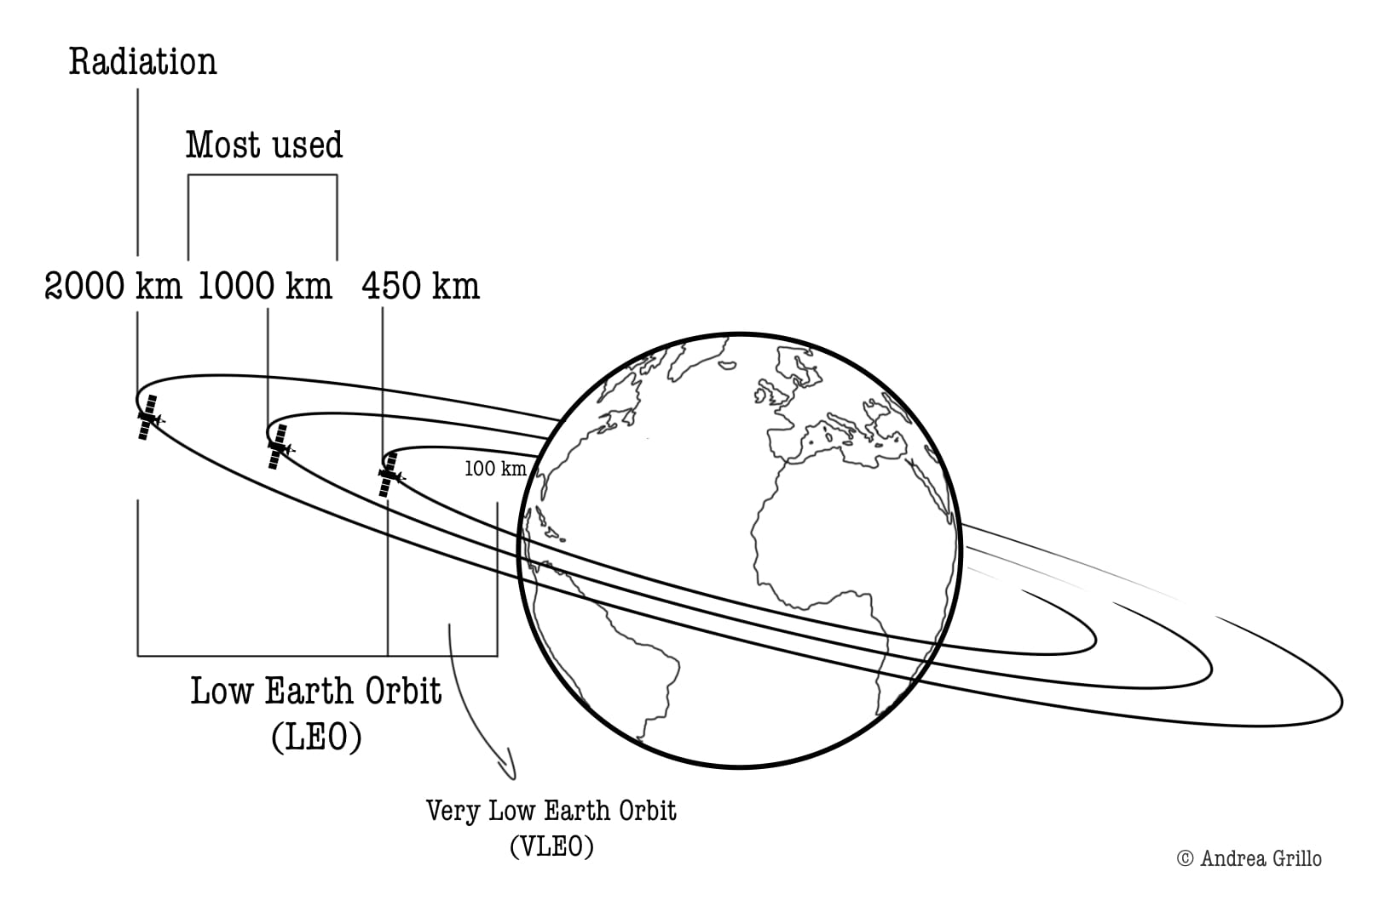

MEO (medium Earth Orbit): Is The orbital regime where every GPS, GLONASS, Galileo, and BeiDou satellite quietly does the work of telling the world where it is and where it is going.
When you opened a maps app this morning, the position your phone reported was triangulated from satellites flying through one of the harshest neighbourhoods’ in space a band of trapped radiation that sits between the low orbits everyone talks about and the geostationary belt everyone takes for granted. The satellites in that band do not get much press. They also happen to run the global economy.

Medium Earth Orbit, or MEO, is the orbital regime between roughly 2,000 kilometres and 35,786 kilometres altitude. The lower bound is wherever you decide LEO ends; the upper bound is the geostationary altitude where a satellite’s orbital period matches Earth’s rotation. Everything in between navigation constellations, a handful of broadband relays, some scientific missions lives in MEO. It is the smallest of the three major orbital regimes by population, but per satellite, it is arguably the most strategically important volume of space humans use.
MEO covers a huge altitude range, but most operational satellites cluster in two specific bands. The first is the GNSS band around 19,100 and 23,200 km, where every major global navigation system flies. The second is around 5,400 km, occupied almost entirely by SES’s O3b broadband constellation.
GPS sits at roughly 20,200 km in a 12-hour orbit. That period is not arbitrary. A 12-hour orbit completes exactly two revolutions per sidereal day, which means each satellite repeats its ground track over the same longitudes every day a property called semi synchronous. With six orbital planes inclined at 55 degrees and four to six satellites per plane, the constellation guarantees that at least four satellites are visible from any point on Earth at any time. Twenty-four operational satellites are the magic number for global four satellite coverage; the full constellation usually flies 31 to maintain redundancy.

The other GNSS systems made similar choices with deliberate variations. GLONASS uses 19,100 km at 64.8 degrees inclination higher than GPS specifically to provide better coverage at high latitudes, which matters when half your country is above 60 degrees north. Galileo flies at 23,222 km and 56 degrees. BeiDou’S MEO segment sits at 21,500 km and 55 degrees. Japan’s QZSS is the odd one out, using inclined geosynchronous and HEO orbits to provide regional augmentation rather than global coverage.
O3b is a different animal entirely. SES’s broadband constellation flies at about 5,400 km in an equatorial orbit, completing a revolution every four hours or so. The lower altitude means much lower latency than GEO, and the equatorial inclination means the satellites permanently sweep over the regions O3b was designed to serve – the equatorial belt where geostationary look angles are highest and terrestrial fiber is thinnest. The “other 3 billion” in the name is not a marketing flourish; it was the original target market.
The defining environmental hazard of MEO is the Van Allen radiation belts. The inner belt extends from roughly 1,000 to 10,000 km and is dominated by high energy protons. The outer belt runs from about 13,000 to 60,000 km and is dominated by relativistic electrons. GPS at 20,200 km sits squarely in the outer belt; O3b at 5,400 km lives just above the inner belt, in a relatively benign slot. Either way, MEO satellites cannot avoid the belts the way LEO satellites do, and they cannot fly above them the way GEO satellites do. They sit in the radiation, year after year. Every component has to be radiation hardened, every solar panel oversized, every piece of memory error corrected. This is not a place to fly commodity electronics.
The thing MEO does better than any other orbital regime is balance coverage with latency. A GEO satellite can see a third of the planet but its signal takes about 500 milliseconds to make a round trip from the ground. A LEO satellite has latency under 50 milliseconds but covers a tiny patch of Earth and is gone in minutes. MEO splits the difference from 70 to 130 milliseconds round trip, with a single satellite footprint that can cover a continent and a constellation small enough to be financially viable.
MEO is pretty empty compared to LEO. You are looking at around 120 to 140 active satellites total, nothing like the 11.000+ we saw in LEO.

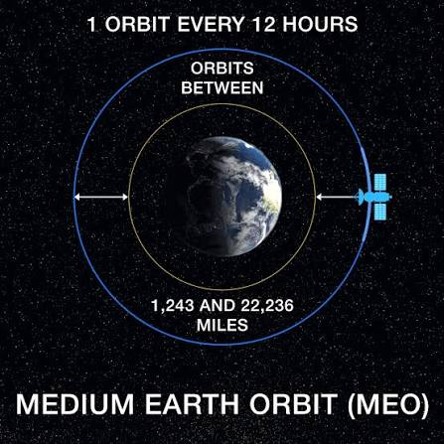

GEO (Geostationary Earth Orbits): Geostationary orbits of 36,000km from the Earth’s equator are best known for the many satellites used for various forms of telecommunication, including television. Signals from these satellites can be sent all the way round the world. Telecommunication needs to see their satellite all time and hence it must remain stationary in the same positions relative to the Earth’s surface. A stationary satellite provides the advantage for remote sensing that it always views the Earth from the same perspective, which means that it can record the same image at brief intervals. This arrangement is particularly useful for observations of weather conditions. One disadvantage of geostationary orbits is the great distance to the Earth, which reduces the achievable spatial resolution.
A geostationary orbit is a specific type of circular orbit around Earth, positioned approximately 35,786 kilometers (22,236 miles) above the equator. In this orbit, a satellite travels at the same rotational speed as the Earth, allowing it to appear stationary from the perspective of an observer on the ground. This synchronized motion is essential for various applications, particularly in communication technology, where satellites relay television, radio broadcasts, and data across the globe.

The concept of geostationary orbit emerged in the early 20th century, with theorists like Konstantin Tsiolkovsky and Arthur C. Clarke laying the groundwork for artificial satellites. Clarke’s innovative ideas in 1945 highlighted the feasibility of using multiple satellites positioned to cover the Earth, which ultimately led to the successful launches of geostationary satellites by NASA in the 1960s. Achieving this orbit requires meticulous calculations and precision in launching, as satellites must maintain their position over the equator and make adjustments, known as station keeping, to stay on course.
Today, geostationary satellites play a crucial role in global communications, enabling fast data transfer and connectivity, significantly impacting how people interact and share information worldwide.
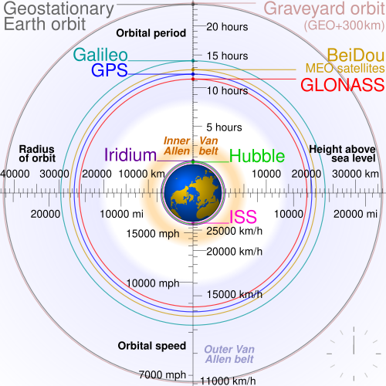

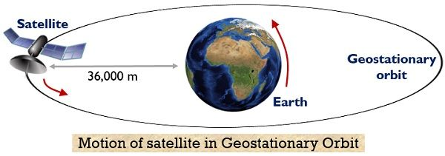

Orbital Inclination, eccentricity and period: Orbital inclination and eccentricity are two of the properties of orbits collectively known as orbital elements, Eccentricity describes the shape of an orbit. All orbits are ellipses, and a circle is a special case. Eccentricity is zero for a
circle and increases as the orbit becomes more elongated.
Inclination describes the vertical tilt of the elliptical orbit with the respect to reference plane.
The international Space Station has an inclination of 51.6 grades. That means it never goes further north than southern Canada or further south than the Falkland Islands. As a real life example we can think of it like a car driving around Earth, but the road is tilted. If we stood in Accra, Ghana, the ISS passes almost overhead sometimes. But if we lived in Iceland, we’d Never see it. It stuck between 51.6 North and 51.6 South because of that tilt.
Sun synchronous orbits: Is a particular kind of polar orbit which satellites are in sync with the sun. Matching Earth’s rotation around the sun, they always appear in the same position relative to our star. This means they pass over the same spot on Earth at the same local time every day. This consistency allows for accurate monitoring of changes over days, weeks, months or years, as images are more comparable in terms of light and shadows. Scientist use SSO and this ability to compare like for like images over time to investigate how weather patterns emerge, help predict extreme weather events, monitor emergencies like forest fires or flooding and to accumulate data on long term problems like deforestation or rising sea levels.
Often, satellites in SSO are synchronised so that they are in constant dawn or dusk, constantly riding a sunset or sunrise and ensuring as consistent as possible illumination or shadows. A satellite in a Sun Synchronous Orbit usually flies at an altitude of between 600 to 800 km. agt 800 km, it will travel at a speed of approximately 7.5 km per second.

Frequency Spectrum Management:
Spectrum refers to the range of invisible radio waves that are around us which is used for communication purposes. This includes the FM (Frequency modulation) or AM (Amplitude modulation) radio broadcasts that we listen to and even other wireless forms of communication like Bluetooth and WIFI. The smartphone we have also uses these same radio waves to transmit data, and the difference really lies in the specific frequencies in use, and also the technology used to convert those waves into something useful. This could be the voice on the radio, the SMS we read, or the webpage we load.
Like other natural resources, spectrum could be auctioned by the government (National communication Authority of Ghana for example) to companies which can be used to offer a number of services and recoup their investments as well as revenue for the nation. Something like that happened when the NCA auctioned 800MHz spectrum in 2015, and MTN Ghana won it.
The NCA like other communication regulators regulates the procedures and principles of allocation and assignment of radio frequency for effective spectrum management, this also includes regulating radio communication sector and controlling procedures within the scope of natural laws, International Telecommunication Union (ITU) agreements and obligations to promote efficient use and gain a net social benefit.
The C-Band is a designation by the Institute of Electrical and Electronic Engineers(IEEE) for a portion of electromagnetic spectrum in the microwave range of frequencies ranging from 4.0 to 8.0 gigahertz. However, the U.S. Federal Communications Commission C band proceeding and auction, designated from 3.7 to 4.2 gigahertz as Band. The band is used for many satellite communications transmission, some cordless telephones, as well as some radar and weather radar systems. C band has a number of benefits when it comes to 5G networks, as it can support the high speeds and low latency of 5G. Additionally, C band has greater capacity than other frequencies on the radio spectrum, meaning that more data can be transmitted over C band. This makes C band an ideal solution for 5G networks.

The Ku band is a frequency band in satellite communication that spans from approximately 12 to 18 gigahertz (GHz) in the electromagnetic spectrum. The “Ku” in Ku-band stands for “K-under,” indicating that it is situated below the K-band frequencies.
Satellites equipped with Ku-band communication systems offer a versatile solution for various applications, including direct-to-home (DTH) television broadcasting, video distribution, broadband internet services, and corporate network communications. The Ku-band’s characteristics, including its relatively high frequency and narrower bandwidth compared to KA band, make it well-suited for delivering high-quality video content and broadband data.
One of the key advantages of Ku band is its ability to provide excellent performance in regions with less rainfall and atmospheric interference. Its resistance to rain attenuation makes it a popular choice for delivering reliable and consistent satellite services, especially for broadcasting live events and ensuring seamless connectivity in diverse geographical areas.
The Ka band refers to a portion of the electromagnetic spectrum with frequencies ranging from approximately 26.5 to 40 gigahertz (GHz). Named after the “K above” band, it represents higher frequencies than traditional microwave bands, such as C-band and Ku-band.
Satellites equipped with Ka band communication systems harness the advantages of these higher frequencies, which offer significant benefits in terms of data transmission capacity, speed, and efficiency. Ka band’s wider bandwidth enables the transmission of larger amounts of data, making it ideal for high-definition video streaming, internet services, and other data-intensive applications.
The increased capacity and data rates provided by Ka band have transformed satellite communications, enabling satellite operators to meet the ever-growing demands for broadband connectivity and data services across the globe. These satellites have found extensive use in various sectors, including telecommunications, broadcasting, internet services, and even military applications.

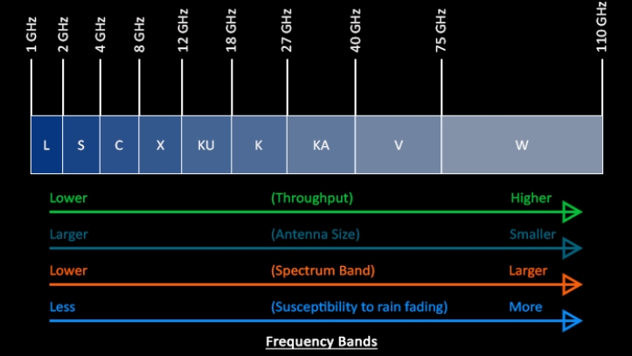

ITU Frequency coordination: Coordination is bilateral/multilateral process, aimed at interference-free operation of existing and planned systems of administrations. From a regulatory point of view there are two types of coordination between administrations: mandatory and voluntary. Mandatory coordination covers: (a) coordination of terrestrial services in the frequency bands shared with the space services above 100 MHz under provisions RR9.16, RR9.18 and RR9.19; (b) Obtaining agreement for terrestrial services in the bands which are indicated in the Article 5 footnotes making reference to provision RR9.21; (c) Coordination of stations of non-planned terrestrial services operating in the bands and geographical areas covered by different Regional Agreements (e.g. GE85-EMA) vis-à-vis planned services; and (d) coordination required by some WRC Resolutions (e.g. Resolution 612 (WRC-12)). Voluntary coordination: direct coordination between administrations concerned without involvement of the Radio Communication Bureau, e.g. coordination of cellular networks in border areas.
Coordination of terrestrial stations vis-à-vis receiving earth stations in the bands above 100 MHz shared with equal rights between terrestrial and space service and allocated to space services in space to Earth direction of transmission if the terrestrial station is located in the coordination area of an earth station (RR9.16 or RR9.18).
Coordination of transmitting terrestrial station vis-à-vis typical earth station included in the service area of a space station in the broadcasting-satellite service in the bands shared with equal rights between terrestrial and broadcasting-satellite service (RR9.19).

Spectrum scarcity: Is the concept that the radio frequency spectrum is a finite resource, limiting how many wireless signals can operate simultaneously without interfering. The spectrum is scarce because one user’s transmission on a specific frequency, time, and location prevents any other user from using that channel. If signals operate on the same frequency in the same area, they produce interference, preventing the desired signal from being understood.
The physics of radio waves dictate a trade-off between range and capacity that contributes to this scarcity. Lower frequency bands (below 1 gigahertz or GHz) travel vast distances and penetrate obstacles, making them suitable for wide-area coverage, but they have limited capacity for high data rates. Higher frequency bands, such as millimetre-wave (mm Wave) spectrum above 24 GHz, offer ultra-fast speeds and massive capacity due to greater available bandwidth. Conversely, these high-frequency signals have a much shorter range and are easily blocked, requiring a denser network of transmission points.

Signal Modulation QPSK (Quadrature Phase Shift Keying):
This technical brief covers the basic characteristics of a digital modulation scheme known as quadrature phase shift keying.
In the world of wired electronics, analog signals exhibit continuous variations whereas digital signals assume (ideally) one of two discrete states. This distinction can be extended to systems that transmit data via electromagnetic radiation instead of electric current traveling through wires. When used for analog signals, frequency modulation and amplitude modulation lead to continuous variations in the frequency or amplitude of a carrier wave. When modulation techniques are used for digital communication, the variations applied to the carrier are restricted according to the discrete information being transmitted.

Examples of common digital modulation types are OOK (on/off keying), ASK (amplitude shift keying), and FSK (frequency shift keying). These schemes cause the carrier to assume one of two possible states depending on whether the system must transmit a binary 1 or a binary 0; each discrete carrier state is referred to as a symbol.
Quadrature phase shift keying (QPSK) is another modulation technique, and it’s a particularly interesting one because it actually transmits two bits per symbol. In other words, a QPSK symbol doesn’t represent 0 or 1, it represents 00, 01, 10, or 11.
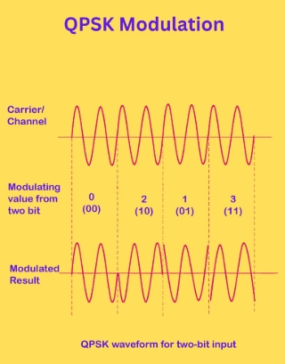

8PSK, 16APSK and 32APSK are high order modulation schemes used in digital satellite broadcasting to increase spectral efficiency, 8PSK or 8 Phase Shift Keying uses 8 distinct phase points on a single circle. Commonly used for TV broadcasting, providing higher spectral efficiency than QPSK but requiring better link conditions. 16APSK or 16 Amplitude Phase Shift Keying arranges 16 points in two concentric rings. It is designed for higher capacity than 8PSK and offers better performance in non-lineal transponders, compared to 16QAM (16 Quadrature Amplitude Modulation). 32APSK or 32 Amplitude Phase Shift Keying uses 32 points arranged in three concentric rings, this is used for maximum throughput, but requires high signal quality.
FEC (Forward error correction): Is a method for obtaining error control in data transmission in which the source (transmitter) sends redundant data and the destination (receiver) recognizes only the portion of the data that contains no apparent errors. When FEC is used in data transmissions, the receiver can detect and correct a limited number of errors. If there are too many errors, the sender must retransmit the packets that contain the errors.

FEC does not require handshaking between the source and the destination, which means that the two systems do not need to establish a connection before data can be transmitted. This makes it possible to broadcast data to multiple destinations simultaneously from a single source. In addition, FEC's ability to correct errors means that less data needs to be retransmitted, reducing bandwidth and power consumption. Because of its error-correcting capabilities, FEC is commonly implemented when transmitting data over noisy or unreliable communication channels, making it suitable for both wired and wireless communications. For example, FEC provides an efficient solution for streaming video content or supporting cellular networks. It can also be used by modems and routers, support cable and optic communications, and facilitate one-way data transmissions.
DVB-S2X standard defines the second generation modulation and channel coding system for satellite TV to make use of the improvements that have emerged since the publication of the DVB-S Standard Is a very flexible standard covering a variety of applications by satellite.
TDMA and FDMA are channels access methods used to allow multiple users to share a limited communication medium. FSMA divides the bandwidth into distinct frequency channels assigned to users for duration of the call. TDMA divides a single frequency channel into multiple time slots, with users alternating transmissions in their assigned slot.
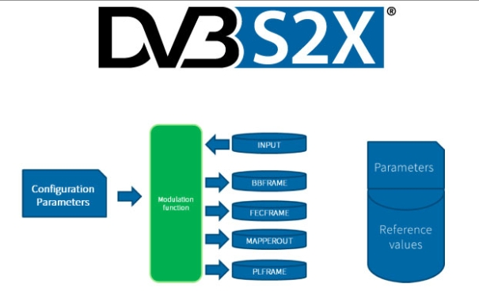

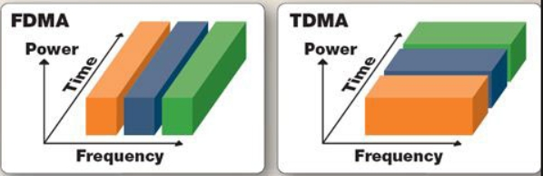

3. SATELLITE ZOOMING AND PRECISION
In this part we will zoom in on how satellites get fast and accurate. Old satellites worked like a floodlight, covering huge areas with one beam, Beam is the area on Earth that a satellite’s signal actually covers.
HTS (High-throughput satellites, frequency reuse, and spot beams) satellites use spot beams, like pointing dozens of flashlights instead of one big lamp. Each beam covers a small town, so users get more speed. Zooming and precision really means three things: HTS for power, spot beams for targeting, and frequency reuse for efficiency. That is how modern satellites deliver real broadband from space.
HTS refer to a new generation of communication satellites that leverage advanced technologies to deliver significantly higher data transfer rates compared to their predecessors. Traditional satellites typically operate with a fixed beam, covering a specific geographic area. In contrast, HTS utilizes multiple spot beams, allowing for a more targeted and efficient distribution of bandwidth. The architecture of High Throughput Satellites revolves around the use of spot beams, the beams can be steered to specific regions on the Earth's surface, providing a more concentrated and powerful signal. This beamforming technology enhances the overall throughput and efficiency of data transmission. The key differentiator in the architecture of an HTS system, setting it apart from its predecessors, is the utilization of multiple spot beams to cover specific service areas rather than employing wide beams that are focused and narrow radio frequency signals. This architectural choice brings about a triple advantage:
Frequency Re-use: HTS systems leverage the high directivity of spacecraft antennas to position the spot beam footprint strategically. In contrast to the wide beams used by FSS, HTS employs multiple spot beams with smaller footprints. This allows multiple beams to reuse the same frequency. The frequency reuse factor, theoretically equal to the number of beams if they are sufficiently separated, is a crucial aspect. However, achieving continuous coverage necessitates overlapping beams, leading to the use of different frequencies and polarizations in adjacent beams to prevent interference. This focused approach minimizes interference and facilitates the reuse of the same frequency band across different geographic regions. This frequency reuse, coupled with spot beam technology, maximizes the overall capacity of the satellite system for the allocated frequency band.
Spot Beam Technology: HTS achieves its remarkable throughput by employing advanced technologies such as spot beam technology and high-frequency reuse. Unlike traditional satellites that use broad single beams, HTS utilizes multiple narrow spot beams, each covering a smaller region. This approach allows for the efficient reuse of the same frequency band, enhancing spectral efficiency and supporting higher data transfer speeds. HTS operates across various frequency bands, including Ku-band, Ka-band, and C-band. The choice of frequency bands depends on factors such as the desired coverage area, data transfer rates, and atmospheric conditions. Ka-band is gaining popularity for its ability to support high data rates, making it suitable for broadband internet services. Contrary to a common misconception, HTS is not restricted to the Ka-band. While many high-throughput satellites operate in the Ka-band, they can be deployed across various spectrum bands. The Ku-band (lower) and Ka-band (higher) are commonly used, demonstrating the flexibility of HTS in adapting to different frequency ranges.
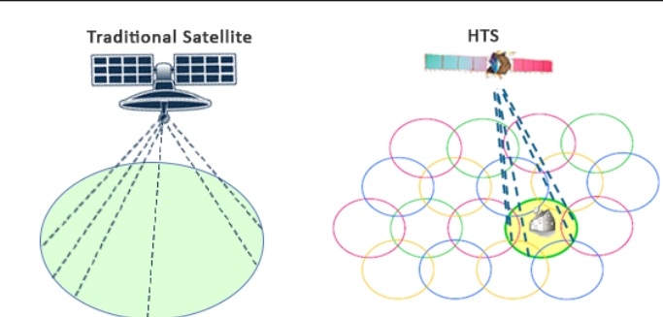

- COMPARATIVE ANALYSIS
Satellites vs terrestrial data communication
Both satellite and terrestrial systems consist of transmit and receive components. The transmit system converts the baseband signal to a microwave signal, while the receive system performs the reverse process. The baseband signal is a multiplexed signal carrying multiple individual low-bandwidth signals, such as voice, data, and video, using either Time Division Multiplexing or Frequency Division Multiplexing.

Terrestrial Communication Systems:
Terrestrial systems facilitate the transmission of voice, data, and video signals over land-based physical infrastructure. These systems employ various communication technologies and mediums operating on the Earth’s surface, including cables, fiber optics, Ethernet, and microwave wireless transmission systems. Unlike satellite communication, which relies on space-based satellites, terrestrial communication depends on fixed and mobile networks located on the ground. It is widely used for applications such as internet connectivity, television broadcasting, telephone services, and data transmission, forming the backbone of modern communication infrastructure for seamless connectivity in residential and commercial settings. A terrestrial system comprises a transmitter, a transmission medium, and a receiver. The transmission medium can be wired or wireless. Wired communication utilizes copper cables, fiber optic cables, Ethernet, and the like. Wireless communication employs radio frequency waves or microwave signals to transmit data without physical cables.

Satellite Communication Systems:
Satellite-based networks operate in two primary modes: mesh and star. In this system, baseband information is transmitted at a microwave carrier frequency from a ground station (VSAT) to the satellite using a directional antenna.

The satellite receives the signal using an on-board antenna, shifts the received frequency to another band, and amplifies the translated signal before relaying it over a large area of the earth. For example, a 6 GHz uplink frequency and a 4 GHz downlink frequency are common, with a 2 GHz difference achieved using a Local Oscillator (LO) frequency of 2225 MHz Here, 6 GHz refers to the frequency range from 5.925 to 6.425 GHz, and 4 GHz refers to the range from 3.7 to 4.2 GHz. Satellite frequencies are chosen to mitigate the effects of the ionosphere and absorption by gases and water vapor. Geostationary satellites are positioned at an altitude of 35,800 km and travel at approximately 11,000 km/hour. This allows for fixed antenna placement at the ground station because satellite tracking is not required.
What satellites do better | What terrestrial wins
Coverage in remote places. You can get internet in a village without waiting for MTN to build a tower. | Latency is rough for gaming, even Starlink LEO is around 40-60 Ms. Fiber in Accra is around 5ms. If I play GTA online I feel it.
Fast to deploy after disasters, when floods cut fiber cables, a satellite terminal works the same day. NGOs used this a lot during the 2023 floods. | Rain kills the signal. If there is a heavy rain at Lapaz, my 16 QAM drops to QPSK and speeds tank. Fiber does not care if it is raining.
One satellites cover whole countries. SES O3b covers all of Ghana with 8 birds. | Terminal are expensive upfront. When a Starlink gear is around 6500ghc, a 4G router is 277ghc.
No need to dig trenches or get permits from every district. Big deal in rural areas where land disputes slow fiber projects. | Data caps and throttling. Most satellite plans still cap you at 1TB.
Works on ships, Planes, mining sites. You cannot run fiber to a ship in the gulf of Guinea. | Congestion is real.
 | Power issues A phone tower has batteries but if there is light off in our village we cannot user our satellite dish router.

- CHALLENGES
Satellite communications play a vital role in modern telecommunications, providing global coverage and connectivity. But the signals travelling between satellites and Earth stations face real obstacles, and understanding those obstacles is just as important as understanding how the technology works when everything goes right. One of the main issues is atmospheric attenuation, which simply means the signal loses strength as it passes through the atmosphere. In this section I want to go through what causes that signal loss, what it actually does to communication quality, and how engineers deal with it. It is a practical problem that affects everything from your DSTV signal cutting out during a rainstorm to GPS accuracy dropping in certain weather conditions.
Atmospheric attenuation is caused by various factors, including rain and precipitation, atmospheric gases and fog, and ionospheric and tropospheric effects. Atmospheric attenuation can have significant effects on satellite communications, including signal degradation and loss, reduced signal-to-noise ratio, and increased bit error rate.
Signal Degradation and Loss
When a signal is attenuated, its strength is reduced, leading to a degradation in signal quality. If the attenuation is severe, the signal can be lost entirely, resulting in a loss of communication.
Reduced Signal-to-Noise Ratio
Atmospheric attenuation can also reduce the signal-to-noise ratio (SNR) of a signal. The SNR is a measure of the ratio of the signal power to the noise power. When the signal is attenuated, the SNR is reduced, making it more difficult to detect the signal.
Increased Bit Error Rate
The bit error rate (BER) is a measure of the number of errors that occur in a digital signal. When the SNR is reduced due to atmospheric attenuation, the BER can increase, leading to a degradation in communication performance.
Latency is another serious challenge with satellite internet, and it is one I personally notice when using it. The problem is straightforward: data has to travel a very long distance to reach a geostationary satellite sitting about 36,000 km above Earth, and then travel back down again. That round trip adds up to roughly 500 to 700 milliseconds of delay for GEO satellites. To put that in perspective, a good fiber connection in Accra might have a latency of around 5 to 10ms. For things like loading a webpage or sending an email, you might not notice that much. But for video calls, online gaming, or any application that needs fast back-and-forth communication, that delay becomes a real problem.

LEO satellites like Starlink have improved this significantly, bringing latency down to around 40 to 60 milliseconds, which is much more usable. But even that is still higher than what you get from a fiber cable. The practical impact is that applications which require constant quick exchanges between your device and a server, things like multiplayer games, voice over IP calls, or live trading platforms, will always perform better on a wired terrestrial connection. Satellite internet excels at coverage and deployment speed, but latency will remain one of its trade-offs for some time.
Space cybersecurity is becoming an increasingly important topic as the world looks to expand its presence in space. With the growing number of satellites and space missions, the need to protect critical space assets has never been more urgent. Space cybersecurity is about safeguarding sensitive data, infrastructure, and communication systems that are vital to modern operations in space.
Growing Threats to Space Systems
The first major challenge in space cybersecurity is the increasing threats from cybercriminals and state-sponsored actors. Satellites, space stations, and other assets in space are vulnerable to various cyber-attacks such as data breaches, hacking, and denial of service (DoS) attacks. These attacks can disrupt communication systems, steal sensitive information, or even damage critical infrastructure.
Vulnerabilities in Satellite Communication Systems
Satellite communication systems are crucial for global communications, GPS, and military operations. However, these systems are inherently vulnerable to cyber-attacks due to their reliance on radio waves and space-based infrastructure. Satellite signals can be intercepted, jammed, or spoofed, allowing attackers to manipulate the data.
Supply Chain Risks in Space Mission Security
The space industry involves numerous contractors, suppliers, and manufacturers working on various components of space missions. The security of the supply chain is often overlooked, but it is essential for maintaining the integrity of space operations. Attackers can target vulnerabilities in the supply chain to introduce malicious software or tamper with hardware before it is launched into space.

Cybersecurity for Space-Based Technologies
As space missions become more complex and rely on AI and autonomous technologies, ensuring the security of space-based technologies is paramount. These systems can be vulnerable to software bugs, human errors, and cyber-attacks that could compromise the safety of the mission.
International Cooperation for Space Cybersecurity
As space missions often involve cooperation between multiple nations and organizations, international collaboration on space cybersecurity is crucial. Cyber threats to space systems often transcend borders, making it necessary for countries to work together to create global security standards and protocols.

- FUTURE TREND
The number of people connecting to wireless networks keeps growing fast, and the types of applications people use keep getting more demanding. Since 5G started rolling out globally in 2019, things have clearly improved compared to 4G: faster speeds, better coverage in cities, lower costs for operators, and generally more stable connections. But 5G was never going to be the final answer. As I read more into this topic, it became clear that 5G still struggles when you need to connect enormous numbers of devices at once, when you need almost zero delay for things like remote surgery or self-driving cars, or when you need truly global coverage including in places satellites currently handle. That is exactly where 6G enters the picture, and satellite communication is expected to be a big part of making 6G work everywhere.
To be more specific about where 5G falls short: connecting billions of IoT sensors simultaneously is still a challenge, extended reality apps like AR and VR need lower delay than 5G can reliably give, and health tech applications that depend on instant response simply cannot afford dropped packets or high latency. On top of that, 5G has very limited reach over oceans, in the sky, or in remote regions without ground infrastructure. These are not minor complaints, they are the exact reasons researchers and companies have already started laying the groundwork for 6G. The goals being discussed for 6G include handling far higher connection density, managing much larger volumes of data, and providing genuinely seamless global coverage including through satellite integration.
Artificial intelligence is probably the most talked about ingredient in 6G planning right now. The idea is that AI will not just run on top of the network, it will be built into how the network is designed, how resources get allocated, and how problems get fixed in real time. From what I have read, the vision is that 6G networks will essentially manage themselves, using machine learning to detect congestion before it happens, reroute traffic automatically, and adjust satellite beam coverage based on demand. AI would be present across every layer of the network, from core infrastructure down to individual user devices.
What makes this interesting to think about from a satellite perspective is that satellites in 6G would not just be passive relay stations. AI could allow a satellite to decide on its own which beam to point where, how much power to allocate to a specific region, and when to hand off a connection to another satellite or a ground tower. That kind of autonomous decision-making is very different from how satellites work today. Currently, a lot of those decisions are made from the ground. In a 6G world with thousands of LEO satellites like Starlink or Amazon’s network, having a human or even a simple software script manage each one individually would be impossible. AI-driven management is not just a nice feature, it becomes a necessity at that scale.
Looking at what has been written so far about AI in wireless networks, most of the focus has been on applying machine learning to specific problems within 5G, things like optimizing a single channel or offloading computation to edge servers. What is less explored is how AI works across all layers of a 6G network together, and specifically how satellite communication fits into that picture. That gap is part of what makes this topic worth paying attention to as a student going into IT. The decisions being made right now about how to integrate satellites into 6G will shape what kind of connected world we all live and work in.
One thing I find worth pointing out is that most of the conversation about 6G and AI still focuses heavily on what happens in cities and developed regions. But from where I sit as a student in Ghana, the most exciting part of this technology is what it could mean for places that terrestrial networks have never properly reached. In rural northern Ghana, in parts of the Congo Basin, in remote Pacific islands, the combination of LEO satellite coverage and AI-managed networks could deliver real connectivity without waiting decades for fiber rollouts. That is not a distant dream. It is already beginning to happen with Starlink, and 6G will push it further. The technology is moving fast, and the question is whether the policies and pricing will move fast enough to make it genuinely accessible.
Another future direction worth mentioning is direct-to-device satellite connectivity. Right now, to use a satellite like Starlink, you need a terminal dish, the white circular receiver most people have seen on rooftops. But companies are already working on technology where a satellite signal connects directly to your smartphone without any extra hardware. If that becomes mainstream, it changes everything about how we think about coverage gaps. A person in the middle of the Amazon or in a small village in northern Ghana would have the same connectivity options as someone in Accra or London, just from their phone. We are not fully there yet, but the direction is clear.
Sustainability is also becoming a bigger conversation in the satellite industry. With tens of thousands of satellites being launched, the question of what happens when they stop working is serious. Space debris is already a monitored problem, and as LEO gets more crowded, the risk of collisions increases. Some companies are working on satellites that can deorbit themselves at end of life, and regulators are starting to enforce stricter deorbiting timelines. Cybersecurity, as I covered in the challenges section, is another area that will only get more critical as satellites become more central to things like banking, military operations, and emergency response. The future of satellite communication is exciting, but it also comes with responsibility.
To summarize this section: 6G is not just a faster version of 5G. It represents a shift in how networks are designed, where satellites are partners in the system rather than a backup option for when terrestrial networks run out. AI is the technology that makes managing that kind of hybrid, large-scale, global network actually feasible. As someone studying information technology in Ghana, where terrestrial infrastructure still has significant gaps, I find it genuinely motivating that the future of connectivity is one where satellites play a central role. The tools being built now, from LEO constellations to AI network management, could have a real impact on places like ours.

Conclusion:
After several days digging into satellites, data communication, how they work, and how far we have come with all this, I have no doubt that humanity is aiming for much more. I am sure that in some time the technology will be more advanced, communication systems will be on another level, and I hope that also happens thanks to some Africans, since we don’t show up much in these topics.
Satellites wet from huge relays parked in geostationary orbit to LEO constellations that target with precision using spot beams and reuse frequencies to multiply capacity. That leap wasn’t magic. It was engineering applied to a real problem.
Hopefully the next time we talk about Zooming and precision in satellites, we will be citing engineers from Ghana, Nigeria, Equatorial Guinea, Congo…Someone Who designed the antenna, the algorithm, or the policy that made it possible. Because space does not have an owner, and neither should connectivity.

References:
All About Circuits. (n.d.). Quadrature phase shift keying (QPSK) modulation. https://www.allaboutcircuits.com/technical-articles/quadrature-phase-shift-keying-qpsk-modulation/
AST Networks. (n.d.). Future trends of satellite communication. https://ast-networks.com/insights/blog/future-trends-of-satellite-communication/
AST Networks. (n.d.). LEO and GEO satellites: A comparison. https://ast-networks.com/insights/blog/leo-and-geo-satellites/
Chen, N., Song, Y., Cao, Y., Sun, Z., Zhao, B., Wang, M., He, D., & Peng, G. (2024). Network-layer perspectives on satellite–terrestrial integrated networks in 6G: A comprehensive review [Press release]. EurekAlert. https://www.eurekalert.org/news-releases/1103265
CIPR Armenia. (n.d.). AI and the future of satellites. https://cipr.am/blog/ai-and-the-future-of-satellites/
Clark, S. (2026, April 27). Live coverage: ULA launches 29 Amazon Leo satellites on Atlas V rocket from Cape Canaveral. Spaceflight Now. https://www.space.com/space-exploration/launches-spacecraft/atlas-v-rocket-launch-amazon-la-06-satellite-mission
DVB. (n.d.). Second generation framing structure, channel coding and modulation systems for broadcasting, interactive services, news gathering and other broadband satellite applications – Part 2: DVB-S2 extensions. https://dvb.org/?standard=second-generation-framing-structure-channel-coding-and-modulation-systems-for-broadcasting-interactive-services-news-gathering-and-other-broadband-satellite-applications-part-2-dvb-s2-extensions
EBSCO Information Services. (n.d.). Geostationary orbit. Research Starters: Engineering. https://www.ebsco.com/research-starters/engineering/geostationary-orbit
Eureka. (n.d.). What are BPSK, QPSK and 256-QAM modulation techniques? Patsnap Eureka. https://eureka.patsnap.com/article/what-are-bpsk-qpsk-and-256-qam-modulation-techniques
European Space Agency. (2020, March). Low Earth orbit [Image]. ESA Multimedia. https://www.esa.int/ESA_Multimedia/Images/2020/03/Low_Earth_orbit
European Space Agency. (n.d.). Benefits of satellite navigation in low Earth orbit. https://www.esa.int/Applications/Satellite_navigation/Celeste/Benefits_of_satellite_navigation_in_low_Earth_orbit
European Space Agency. (n.d.). Los satélites [Satellites]. ESA Kids. https://www.esa.int/kids/es/Aprende/Tecnologia/El_espacio_util/Los_satelites
European Space Agency. (n.d.). Zooming in on our planet. https://www.esa.int/Applications/Observing_the_Earth/SEOSAT-Ingenio/Zooming_in_on_our_planet
Georgia Institute of Technology. (2010). Satellite communication link budget [Course project materials, ECE 6390]. Propagation Research Group. https://propagation.ece.gatech.edu/ECE6390/project/Fall2010/Projects/group6/ExoBuzz/page1/page8/page8.html
Hensoldt. (n.d.). Spectrum management and monitoring. https://www.hensoldt.net/domains/land/protection/spectrum-management-and-monitoring
iDirect. (n.d.). High throughput satellites: The bigger picture. https://www.idirect.net/blog/high-throughput-satellites-the-bigger-picture/
IEEE Communications Society. (n.d.). Advanced wireless communication technologies for satellite. IEEE Open Journal of the Communications Society. https://www.comsoc.org/publications/journals/ieee-ojcoms/cfp/advanced-wireless-communication-technologies-satellite
Inseego. (n.d.). What is C-band? 5G glossary. https://inseego.com/resources/5g-glossary/what-is-c-band/
International Telecommunication Union. (2007). The C-band. ITU News, (8). https://www.itu.int/itunews/manager/display.asp?lang=en&year=2007&issue=08&ipage=C-band
International Telecommunication Union. (2021). Report ITU-R SM.2405-1: Spectrum monitoring evolution. ITU. https://www.itu.int/hub/ru/publication/r-rep-sm-2405-1-2021/
International Telecommunication Union. (2024, June). ITU journal explores fast-approaching future of satellite communications. https://www.itu.int/hub/2024/06/itu-journal-explores-fast-approaching-future-of-satellite-communications/
International Telecommunication Union. (n.d.). Frequency coordination. ITU-R. https://www.itu.int/en/ITU-R/terrestrial/fmd/Pages/coordination.aspx
IPLook Technologies. (n.d.). What are high throughput satellites (HTS)? https://www.iplook.com/info/what-are-high-throughput-satellites-hts-i00331i1.html
ITU Academy. (n.d.). Global satellite regulation essentials: Key principles, institutional landscape and role of the ITU. https://academy.itu.int/training-courses/full-catalogue/global-satellite-regulation-essentials-key-principles-institutional-landscape-and-role-itu
Kaila. (n.d.). Satellite data and innovation: Trends shaping the future. https://kaila.eu/blog/satellite-data-and-innovation-trends-shaping-the-future/
KeepTrack.space. (n.d.). Medium Earth orbit. https://keeptrack.space/space-terms/medium-earth-orbit
L3Harris Technologies. (n.d.). What you should know about QPSK modulation: Basics and advantages. https://resources.l-p.com/knowledge-center/what-you-should-know-about-qpsk-modulation-basics-advantages
Legacy IAS. (n.d.). Satellites used for telecommunication relay are kept in a geostationary orbit. https://www.legacyias.com/satellites-used-for-telecommunication-relay-are-kept-in-a-geostationary-orbit/
London School of Economics and Political Science. (n.d.). Cyberattacks on satellites. LSE IDEAS. https://www.lse.ac.uk/ideas/projects/space-policy/publications/cyberattacks-on-satellites
MathWorks. (n.d.). What is satellite communications? https://www.mathworks.com/help/satcom/gs/what-is-satellite-communications.html
NASA Scientific Visualization Studio. (n.d.). [Satellite visualization 4385]. https://svs.gsfc.nasa.gov/4385
NASA. (n.d.). Basics of space flight: Orbital mechanics. https://science.nasa.gov/learn/basics-of-space-flight/chapter3-4/
National Radio Astronomy Observatory. (n.d.). Spectrum management. https://public.nrao.edu/spectrum-management/
National Telecommunications and Information Administration. (n.d.). Regulating the use of spectrum. https://www.ntia.gov/book-page/regulating-use-spectrum
Navarro, T., & Da Costa Dinis, D. (2024). Future trends in AI for satellite communications. In Proceedings of the 2024 9th International Conference on Machine Learning Technologies (ICMLT 2024) (pp. 64–73). ACM. https://doi.org/10.1145/3674029.3674040
New America. (n.d.). An overview of low Earth orbiting (LEO) satellites: An emerging technology for connectivity and innovation. https://www.newamerica.org/insights/an-overview-of-low-earth-orbiting-leo-satellites-an-emerging-technology-for-connectivity-and-innovation/
Ocean County NJ Daily Voice. (2025, June 10). Cybersecurity in satellite communications: Challenges and best practices. https://ocnjdaily.com/news/2025/jun/10/cybersecurity-in-satellite-communications-challenges-and-best-practices/
Ookla. (n.d.). Ookla – The global leader in broadband testing and network intelligence. https://www.ookla.com/
RF Wireless World. (n.d.). Satellite vs. terrestrial communication: A comprehensive comparison. https://www.rfwireless-world.com/terminology/satellite-vs-terrestrial-communication
Rocket Me Up Cybersecurity. (n.d.). Cybersecurity risks in satellite-based internet services: Protecting global connectivity. Medium. https://medium.com/@RocketMeUpCybersecurity/cybersecurity-risks-in-satellite-based-internet-services-protecting-global-connectivity-32bbf71cf2ce
Rocket Me Up Networking. (n.d.). Low Earth orbit (LEO) satellites vs. geostationary satellites: A technical comparison. Medium. https://medium.com/@RocketMeUpNetworking/low-earth-orbit-leo-satellites-vs-geostationary-satellites-a-technical-comparison-2a4f15aaedc9
Satellite Today. (2025, October/November). Satellites & AI future: The big debate. Via Satellite. https://interactive.satellitetoday.com/via/october-november-2025/satellites-ai-future-the-big-debate
SatNow. (2025, February 12). What are high throughput satellites (HTS)? https://www.satnow.com/community/what-are-high-throughput-satellites-hts
SatNow. (n.d.). What are terrestrial satellite networks? https://www.satnow.com/community/what-are-terrestrial-satellite-networks
Spaceflight Now. (2026, April 27). Live coverage: SpaceX to launch final ViaSat-3 satellite on Falcon Heavy rocket. https://spaceflightnow.com/2026/04/27/live-coverage-spacex-to-launch-final-viasat-3-satellite-on-falcon-heavy-rocket/
Spire Global. (n.d.). Ka-band. Spirepedia. https://spire.com/spirepedia/ka-band/
Spire Global. (n.d.). Ku-band. Spirepedia. https://spire.com/spirepedia/ku-band/
Starlink. (n.d.). Starlink Ghana. https://starlink.com/gh
Tait Radio Academy. (n.d.). The difference between FDMA and TDMA. https://www.taitradioacademy.com/topic/the-difference-between-fdma-and-tdma-1/
TechTarget. (n.d.). What is forward error correction (FEC)? TechTarget. https://www.techtarget.com/searchmobilecomputing/definition/forward-error-correction
US Radio Guy. (n.d.). Orbital dynamics 101. https://usradioguy.com/orbital-dynamics-101/

