An Automated Approach to Artist Classification Using DL With the Help of Classical Principles. AKA Tim.

Alireza Alizadeh

Selected path
Computer Vision (Image classification).

Problem statement and objective
We are aiming to train 1 or more models to predict the artist form a given piece of art with following metrics: Recall≥0.70, Accuracy≥0.70. In addition, all other standard metrics such as F1-Score and Precision will be reported as well.
A secondary objective of this project is to reach the goals mentioned above using consumer grade mid to low tier GPUs (6 GB VRAM or less).

Dataset
For this task there are 2 famous datasets. The WikiArt dataset and the Best Artworks of All Time dataset.
Since we aim to train and use our model locally we choose the 2.4 GB Best Artworks of All Time dataset since the alternative WikiArt dataset is a heavy 33.8 GB dataset.

Dataset information and introduction
The Best Artworks of All Time dataset is a collection of artworks from the 50 most influential artists of all time. The dataset features roughly 8,000 Images both in original resolution and resized to half of the original resolution.
This dataset contains three files/directories:
- artists.csv: dataset of information for each artist
- images: collection of images (full size), divided in folders and sequentially numbered
- resized: same collection but images have been resized and extracted from folder structure
The data was scraped from artchallenge.ru during the end of February 2019.

EDA
Before beginning our work in EDA, we used the ‘ls’ command in our raw and resized directories which uncovered an encoding issue which had led to Albrecht Dürer works being duplicated and represented with “Albrecht_DuΓòá├¬rer” and “Albrecht_Du╠êrer”. This led to us doing a small preprocessing step before exploration which we will explain in detail in the Preprocessing section.
Even though the dataset advertises having 50 artists a quick dive into our data shows that not all artists have the same amount artwork which will to imbalance in training. This characteristic is visible in the following charts. For the purpose of our task, we will only be working with artists that have 99 or more artworks present in the database. 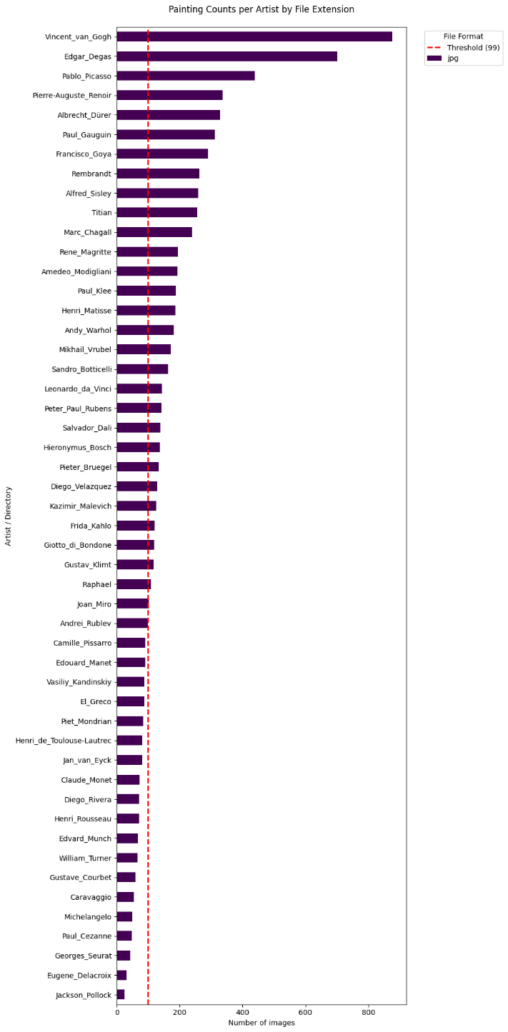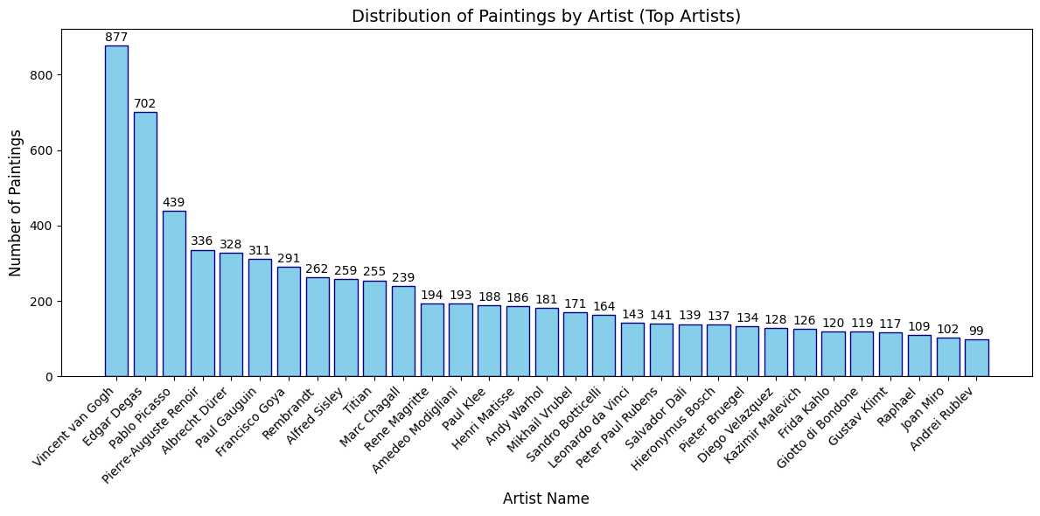
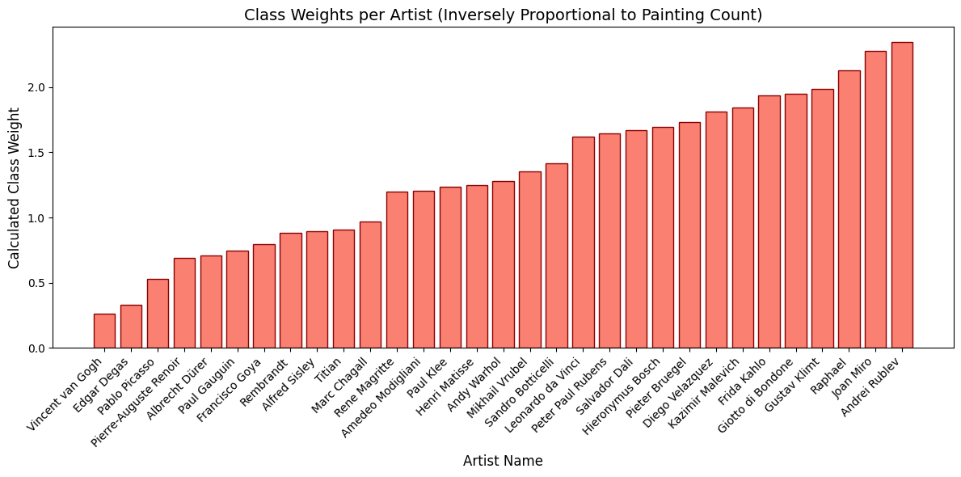
The following pie chart shows the artists representation in dataset.
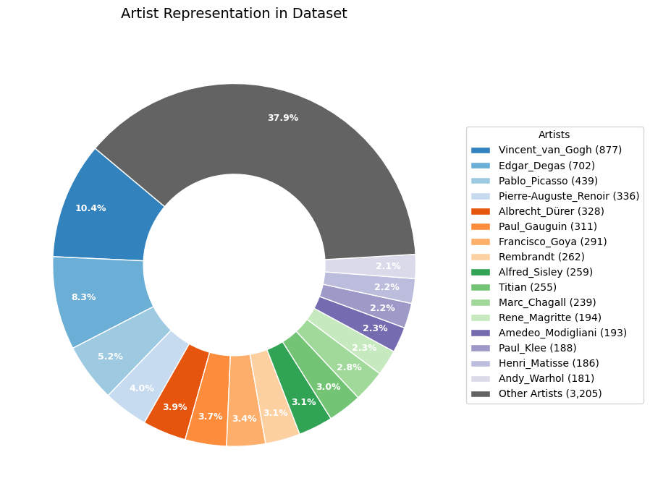

A quick look at file types shows that thankfully all images are uniformly in jpg format.
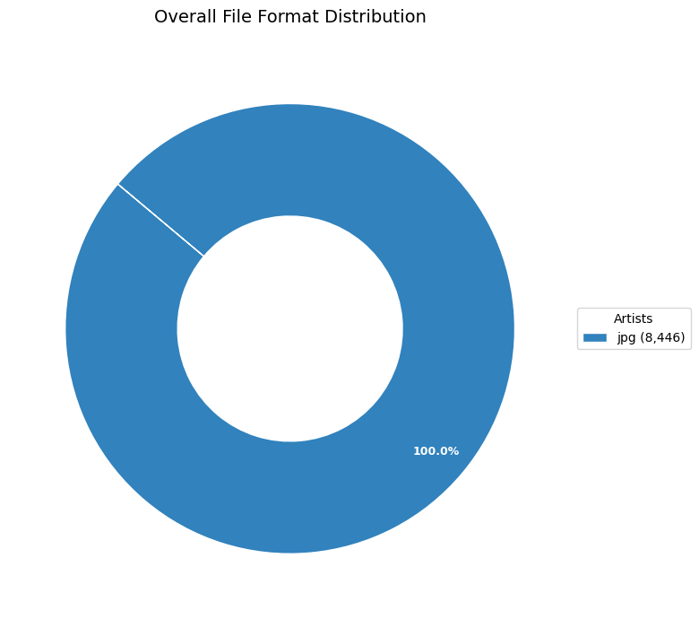

We can also analyze the nationality and genre distributions in our dataset. These two somewhat correlate with our artist representation charts.
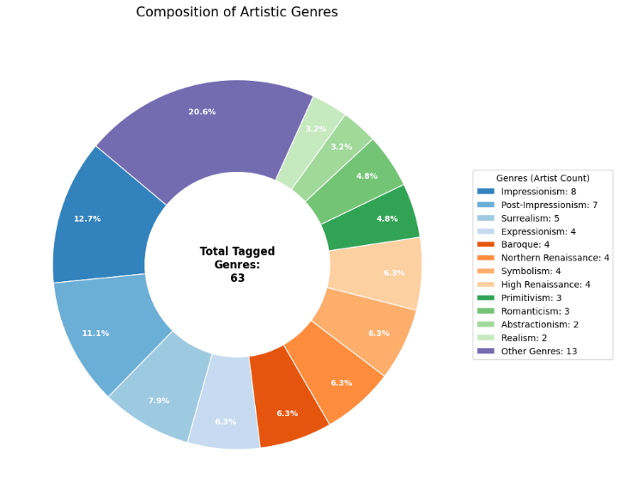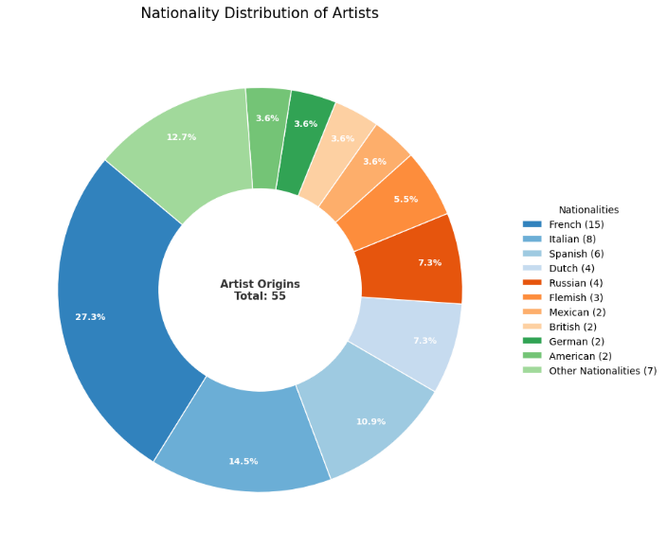

Preprocessing
In this section we discuss the preprocessing tasks done so far. These tasks are only done on artists with 99 or more artworks present in our dataset.

Extraction (prep.py)
First, we extract the zip archive and clean up our data directory to get rid of unnecessarily nested folders.

Name correction and removing duplicate (name_correction.py)
As mentioned in the EDA section Albrecht Dürer had duplicate artwork and an encoding error regarding file names. Here we recursively remove duplicates and rename the artworks to the appropriate name.

Resizing
Here we aim to somewhat standardize and normalize our data by resizing to a model friendly 224×224 size.

Scaling method (resize.py)
Here we create a copy of the eligible data by going through the artists with 99 or more sample and scaling all of them to our desired 224×224 size. This method does not retain aspect ratio nor does it retain relativity of the painting’s concepts. But it’s beneficial to smaller models since all the data is useful data.

Padding method (resize_padding.py)
Here we create a copy of the eligible data by going through the artists with 99 or more sample and scaling all of them to our desired 224×224 size by applying padding to fill the empty space and retain aspect ratio and relativity of concepts. This could be problematic for smaller models since padding data is useless and model has to learn to not work the black bars around the image. However, it could improve accuracy in bigger models that have the capacity to learn and workaround paddings because of the retained proportions.

Base-model
We will use the ResNet-50 for this purpose for its relatively small size and acceptable performance. This will provide us with a good benchmark for our other models.

Experiments
We plan to experiment with at least two parameters that can be applied to every model, resolution and batch size.
Additionally, we will experiment using augmentation to see how that will affect our models.
If any other interesting experiments come up in development they will be added to this section retroactively.

References
https://docs.pytorch.org/vision/main/models/generated/torchvision.models.resnet50.html#torchvision.models.resnet50
https://stackoverflow.com/a/49882055/24042168
https://www.ultralytics.com/blog/what-is-resnet-50-and-what-is-its-relevance-in-computer-vision
https://www.datacamp.com/tutorial/complete-guide-data-augmentation
https://www.kaggle.com/datasets/ikarus777/best-artworks-of-all-time
https://www.kaggle.com/datasets/steubk/wikiart

