**Q1 (3 points)**

You are asked to write a console application named Q1 which allows user to create a new account and test it.

Create an Account class contains:

* 1. Two attributes: accNo (int) and amount (double).
  2. Two methods: Deposit(double amount) and Withdraw(double money).
  3. Necessary constructors.
  4. Throw necessary exception.
  5. Override method ToString() as below:

public override string ToString()=> => $"Account: {AccNo}, Current balance: {Amount}";

The Main function of your application as below:

static void Main(string[] args)

{

double money;

Console.WriteLine("OUTPUT:");

Account account = new Account() { AccNo = 100, Amount = 2000 };

Console.WriteLine(account);

Console.Write("Deposit:");

money = double.Parse(Console.ReadLine());

account.Deposit(money);

Console.WriteLine(account);

Console.Write("Withdraw:");

money = double.Parse(Console.ReadLine());

try

{

account.Withdraw(money);

}

catch(Exception ex)

{

Console.WriteLine(ex.Message);

}

Console.WriteLine(account);

Console.Write("Withdraw:");

money = double.Parse(Console.ReadLine());

try

{

account.Withdraw(money);

}

catch (Exception ex)

{

Console.WriteLine(ex.Message);

}

Console.WriteLine(account);

Console.Read();

}

Your program output as below:

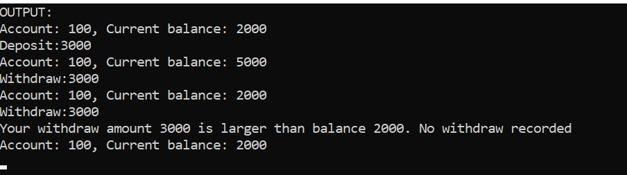

**Q2 (3 points)**

You are asked to write a console application named Q2 which allow user to enter the list of examinees and display message if he/she is failed (marks < 20).

Create an Examinee class contains:

1. Two attributes: name (string) and marks (double)
2. Necessary delegate and even.

The Main function of your application should look like following

private static void Examinee_LowMarks(string name, double marks)

=> Console.WriteLine("Marks of examinee {0} = {1} - Failed.", name, marks);

static void Main(string[] args)

{

List<Examinee> examinees = new List<Examinee>();

int no;

Console.Write("Enter the number of students:");

no = int.Parse(Console.ReadLine());

string name;

double marks;

Console.WriteLine("OUTPUT:");

for (int i = 0; i < no; i++)

{

Examinee examinee = new Examinee();

examinee.LowMarks += Examinee_LowMarks;

Console.Write($"Enter name of student # {i+1}:");

name = Console.ReadLine();

Console.Write($"Enter marks of student # {i+1}:");

marks = double.Parse(Console.ReadLine());

examinee.Name = name;

examinee.Marks = marks;

}

Console.Read();

}

Your application should display like following:

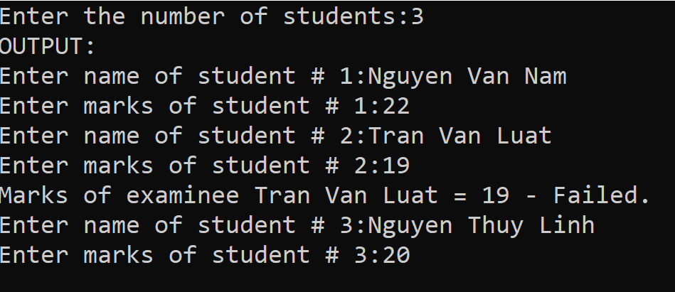

**Q3 (4 points)**

You are asked to write a console application named Q3 that reads the list of students stored in file C:\CSharp\ListStudents.txt, then group by class ID, and display as below

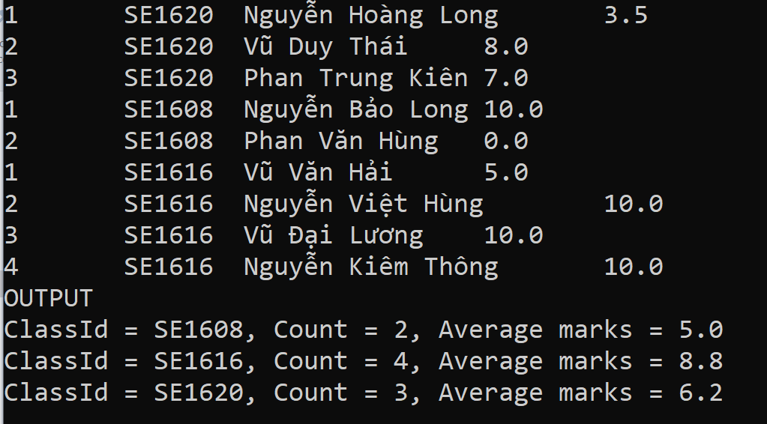

Note: Each line of file ListStudents.txt contains information of each student, including Student number, Class ID, Student name, and Marks. Each field is separated by the tab (‘\t).

B

A

Your task is to create class Student and fill into blank and

of the following Main function:

static void Main(string[] args)

{

List<Student> list = new List<Student>();

StreamReader sr = new StreamReader("C:\\CSharp\\ListStudents.txt");

string line;

Console.OutputEncoding = System.Text.Encoding.UTF8;

while((line = sr.ReadLine()) != null)

{

Console.WriteLine(line);

string[] tokens = line.Split('\t');

list.Add(new Student

{

A

});

}

Console.WriteLine("OUTPUT");

var ls =

B

foreach (var group in ls)

foreach (var group in ls)

Console.WriteLine($"ClassId = {group.Key}, Count = {group.Count}, Average marks = {group.Average:N1}");

Console.ReadLine();

}