SECTION A: GRAMMAR & VOCABULARY
I. Choose the best option A, B, C, or D to complete each sentence.
1. She is looking forward to ___________ her old friends at the annual reunion.
A. see B. seeing C. saw D. seen
2. If it ___________ heavily tomorrow, the outdoor festival will be postponed.
A. rain B. rains C. rained D. raining
3. Choose the word whose underlined part is pronounced differently:
A. cat B. city C. car D. cup
4. My elder brother has been working as a software developer ___________ 2018.
A. for B. since C. in D. at
5. Choose the word that has a different primary stress pattern:
A. teacher B. doctor C. student D. agree
**Word Bank:** photosynthesis chlorophyll ecosystem
6. Green plants produce oxygen and glucose during the process of ___________.
A. photosynthesis B. chlorophyll
C. ecosystem D. respiration
Last summer, Minh visited his grandparents in the countryside. The peaceful atmosphere and fresh air helped him relax after a stressful school year. Every morning, he woke up early to ride his bicycle around the village lake.
7. Why did Minh enjoy his summer stay in the countryside?
A. Because he liked riding cars
B. Because of the peaceful environment and fresh air
C. Because he wanted to work on a farm
D. Because his school was located there
8. What does this traffic sign indicate?
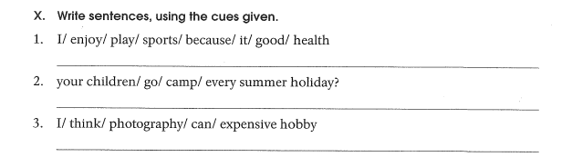
Maximum speed allowed is 40 km/h.
You must drive faster than 40 km/h.
Vehicles over 40 tons are forbidden.
Parking is allowed for 40 minutes only.
II. ERROR CORRECTION
Identify the error in the sentence and write the correct word in the answer column.
9. Nam is my classmates. He watches TV every night.
III. SENTENCE TRANSFORMATION
Complete the second sentence so that it has the same meaning as the first.
10. What is your favourite hobby?
→ What hobby

