**开发代号：Logistics**

**用户系统**

**接口文档**

# 历史记录：

|  |  |  |  |  |
| --- | --- | --- | --- | --- |
| **作者** | **日期** | **变动** | **接口名** | **版本** |
| 王津 | 2016-09-02 | 完成初始 |  | 1.00 |
| 吴迪 | 2016-10-10 | 资讯 |  |  |
| 李昂 | 2016-10-13 | 二次改派接口 | reSendOrder() | 1.00 |
| 康兵兵 | 2016-10-14 | 订单任务 |  | 1.00 |
| 赵乔乔 | 2016-10-14 | 完成初始 |  | 1.00 |
| 刘旭阳 | 2016-10-14 | 可提现金额 |  | 1.00 |

目录：

1、司机端首页 8

2.更多资讯 10

3.资讯详情 12

4、驾驶员信息上传 14

5、车辆信息上传 16

6、头像上传 17

7、认证状态与司机信息 18

8、邀请好友 20

9、取货异常 21

10.二次改派 22

11. 获取验证码 25

12. 添加银行卡(银行卡类型，电话) 26

13. 添加银行卡(持卡人姓名，卡号) 27

14. 选择银行卡 28

15、获取手机验证码 29

16、用户注册 30

17、修改绑定手机号，共分为三步 31

18、扫码上车 35

19、下车 36

20、订单详情 38

21、确认取货 40

22、确认送达 42

23、订单任务 44

24、信息反馈 47

25、用户退出登陆 48

26、消息中心 50

27、历史订单列表 51

28.登陆接口 53

29.忘记密码获取验证码 54

30.验证短信验证码是否通过 55

31.设置新密码 56

32.个人中心首页 57

33.订单列表 58

34.消息已读未读接口 60

61

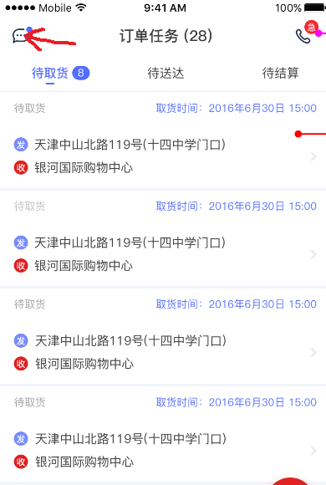

35.异常原因列表 62

62

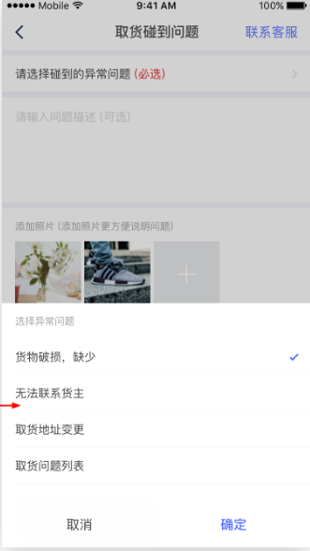

36、获取用户信息 63

64

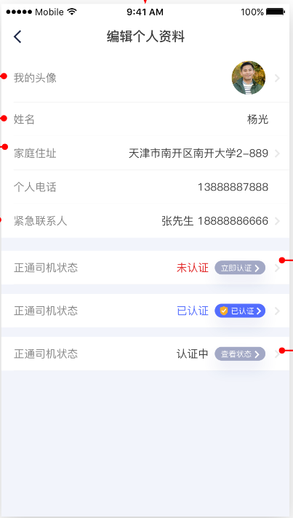

37、个人中心修改资料 66

66

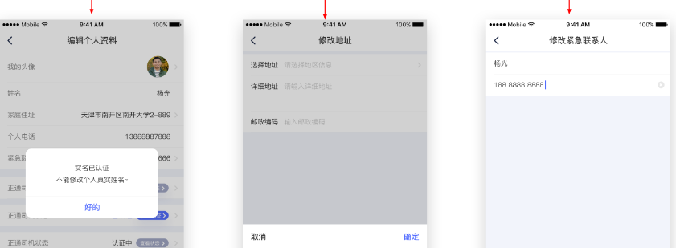

1、司机端首页

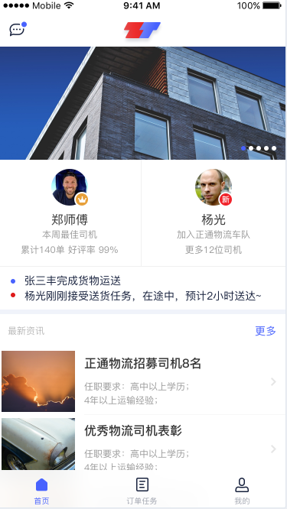

|  |  |  |  |
| --- | --- | --- | --- |
| 接口名称： | | | |
| homePage | | | |
| 示例： | | | |
| {"command":"homePage","page":"1","limit":"10","sid":"daefhgherr45456"} | | | |
| 返回： | | | |
| {  "code": "1",  "data": {  "command": "homePage",  "banner": [  {  "id": "9",  "bigImg": "./pic/banner/9.jpg"  },  {  "id": "18",  "bigImg": "./pic/banner/18.jpg"  }  ],  "driverThisWeek": [],  "driverLastWeek": [],  "latestInfo": [  {  "id": "8",  "smallImg": "./pic/thumbnail/8.png",  "title": "高校迎物流高峰 国庆节后高校开学首日迎来",  "content": "10月8日国庆节结束后，高校迎物流高峰。据悉，在山西财经大学校园外一处空地上摆满各个物流公司发来的快"  },  ]  },  "msg": "操作正常"  } | | | |
| 传入数据： | | | |
| Key | Value | | 说明 |
| command | 字符串常量：homePage | | 命令 |
| page | 字符串变量 | | 分页 |
| limit | 字符串变量 | | 条数 |
| 传出数据 | | | |
| command | 字符串 | | 当前命令 |
| banner | Json对象 | | 首页轮播信息 |
| Key | Value | 说明 |
|  | id | 整数 | 资讯ID |
|  | bigImg | 字符串 | 轮播图像 |
| driverThisWeek | Json对象 | | 本周最佳司机 |
| key | Value | 说明 |
|  | id | 字符串 | 司机ID |
|  | face | 字符串 | 司机头像 |
|  | dName | 字符串 | 司机姓名 |
|  | orderNum | 整数 | 司机完成订单数 |
|  | positiveRatio | 浮点数 | 好评率 |
| driverLastWeek | Json对象 | | 上周最佳司机 |
| Key | Value | 说明 |
|  | id | 字符串 | 司机ID |
|  | face | 字符串 | 司机头像 |
|  | dName | 字符串 | 司机姓名 |
|  | orderNum | 整数 | 司机完成订单数 |
|  | positiveRatio | 浮点数 | 好评率 |
| latestInfo | Json对象 | | 最新资讯 |
| Key | Value | 说明 |
|  | id | 字符串 | 资讯ID |
|  | smallImg | 字符串 | 缩略图 |
|  | title | 字符串 | 标题 |
|  | content | 字符串 | 缩略内容 |

2.更多资讯

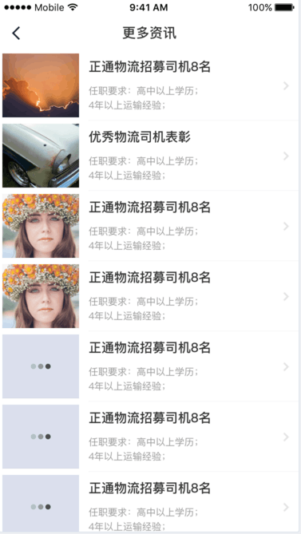

|  |  |  |  |
| --- | --- | --- | --- |
| 接口名称： | | | |
| getInformation | | | |
| 示例： | | | |
| {"command":"getInformation","page":"1","limit":"10"} | | | |
| 返回： | | | |
| {  "code": "1",  "data": {  "command": "getInformation",  "latestInfo": [  {  "id": "8",  "smallImg": "./pic/thumbnail/8.png",  "title": "高校迎物流高峰 国庆节后高校开学首日迎来",  "content": "10月8日国庆节结束后，高校迎物流高峰。据悉，在山西财经大学校园外一处空地上摆满各个物流公司发来的快"  },  {  "id": "1",  "smallImg": "./pic/thumbnail/1.png",  "title": "测试",  "content": "测试"  }  ]  },  "msg": "操作正常"  } | | | |
| 传入数据： | | | |
| Key | Value | | 说明 |
| command | 字符串常量：getInformation | | 命令 |
| page | 字符串变量 | | 分页 |
| limit | 字符串变量 | | 条数 |
| 传出数据 | | | |
| command | 字符串 | | 当前命令 |
| latestInfo | Json对象 | | 最新资讯 |
| Key | Value | 说明 |
|  | id | 字符串 | 资讯ID |
|  | smallImg | 字符串 | 缩略图 |
|  | title | 字符串 | 标题 |
|  | content | 字符串 | 缩略内容 |

3.资讯详情

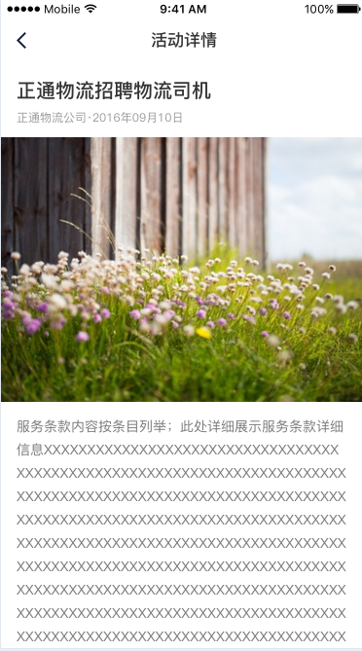

|  |  |  |  |
| --- | --- | --- | --- |
| 接口名称： | | | |
| infoDetails | | | |
| 示例： | | | |
| {"command":"infoDetails","id":"8"} | | | |
| 返回： | | | |
| {  "code": "1",  "data": {  "command": "infoDetails",  "InfoArray": [  {  "id": "8",  "title": "高校迎物流高峰 国庆节后高校开学首日迎来",  "content": "<p>10月8日国庆节结束后......积压一周的学生网购物品集中分发，现场一片忙碌。</p>",  "createTime": "2016-10-08 16:43:25",  "smallImg": "./pic/thumbnail/8.png",  "bigImg": ""  }  ]  },  "msg": "操作正常"  } | | | |
| 传入数据： | | | |
| Key | Value | | 说明 |
| command | 字符串常量：infoDetails | | 命令 |
| id | 字符串变量 | | 资讯Id |
| 传出数据 | | | |
| command | 字符串 | | 当前命令 |
| InfoArray | Json对象 | | 资讯 |
| Key | Value | 说明 |
|  | id | 字符串 | 资讯ID |
|  | smallImg | 字符串 | 缩略图 |
|  | title | 字符串 | 标题 |
|  | content | 字符串 | 内容 |
|  | createTime | 字符串 | 创建时间 |
|  | bigImg | 字符串 | 轮播图 |

4、驾驶员信息上传

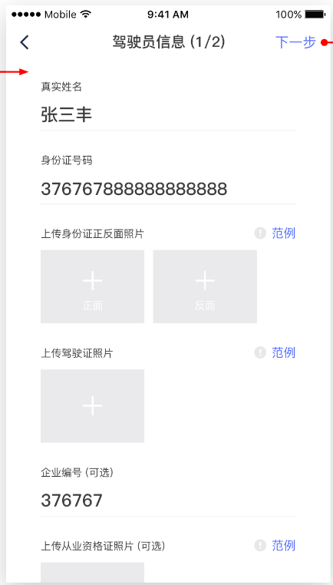

|  |  |  |  |
| --- | --- | --- | --- |
| 接口名称： | | | |
| driverMessage | | | |
| 示例： | | | |
| {"command":"driverMessage",  "dName":"张三丰",  "idCardNum":"130925199999999999",  "cooperationId":"QY020161010100005",  "sid":"daefhgherr45456"} | | | |
| 返回： | | | |
| {  "code": "1",  "data": {  "command": "driverMessage"  },  "msg": "操作正常"  } | | | |
| 传入数据： | | | |
| Key | | Value | 说明 |
| command | | 字符串常量：driverMessage | 命令 |
| sid | | 字符串变量 | $sid |
| dName | | 字符串变量 | 驾驶员姓名 |
| idCardNum | | 字符串变量 | 身份证号 |
| cooperationId | | 字符串变量 | 企业编号 |
| idCardFrontImg | | 文件 $_FILES | 身份证正面照片 |
| idCardBackImg | | 文件 $_FILES | 身份证反面照片 |
| DLImg | | 文件 $_FILES | 驾驶证图片 |
| DLImg2 | | 文件 $_FILES | 驾驶证图片副本 |
| professionImg | | 文件 $_FILES | 从业资格证照片 |
|  | |  |  |
|  | |  |  |
| 传出数据 | | | |
| command | 字符串 | | 当前命令 |

5、车辆信息上传

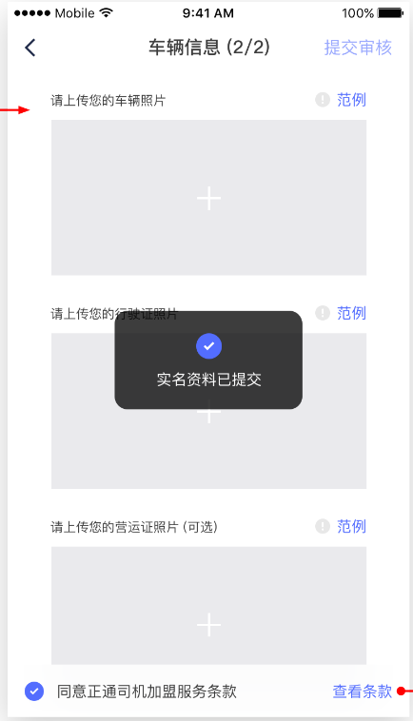

|  |  |  |  |
| --- | --- | --- | --- |
| 接口名称： | | | |
| driverMessage | | | |
| 示例： | | | |
| {"command":"driverMessage",  "dName":"张三丰",  "idCardNum":"130925199999999999",  "sid":"daefhgherr45456"} | | | |
| 返回： | | | |
| {  "code": "1",  "data": {  "command": "driverMessage"  },  "msg": "操作正常"  } | | | |
| 传入数据： | | | |
| Key | | Value | 说明 |
| command | | 字符串常量：driverMessage | 命令 |
| sid | | 字符串变量 | $sid |
| dName | | 字符串变量 | 驾驶员姓名 |
| idCardNum | | 字符串变量 | 身份证号 |
| idCardFrontImg | | 文件 $_FILES | 身份证正面照片 |
| idCardBackImg | | 文件 $_FILES | 身份证反面照片 |
| DLImg | | 文件 $_FILES | 驾驶证图片 |
| DLImg2 | | 文件 $_FILES | 驾驶证图片副本（可选） |
| professionImg | | 文件 $_FILES | 从业资格证照片（可选） |
| vehicleImg | | 文件 $_FILES | 车辆照片 |
| vehicleLicenseImg | | 文件 $_FILES | 行驶证照片 |
| vehicleLicenseImg2 | | 文件 $_FILES | 行驶证照片副本 |
| operationLicenseImg | | 文件 $_FILES | 营运证照片 |
|  | |  |  |
| 传出数据 | | | |
| command | 字符串 | | 当前命令 |

6、头像上传



|  |  |  |  |
| --- | --- | --- | --- |
| 接口名称： | | | |
| upServerHeadPic | | | |
| 示例： | | | |
| {"command":"upServerHeadPic","sid":"daefhgherr45456"} | | | |
| 返回： | | | |
| {  "code": "1",  "data": {  "command": "upServerHeadPic"  },  "msg": "操作正常"  } | | | |
| 传入数据： | | | |
| Key | | Value | 说明 |
| command | | 字符串常量：driverMessage | 命令 |
| sid | | 字符串变量 | $sid |
| face | | 文件 $_FILES | 头像 |
|  | |  |  |
| 传出数据 | | | |
| command | 字符串 | | 当前命令 |

7、认证状态与司机信息

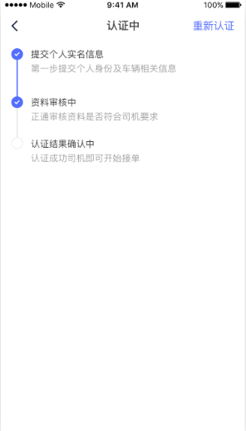

|  |  |  |  |  |  |
| --- | --- | --- | --- | --- | --- |
| 接口名称： | | | | | |
| certificationState | | | | | |
| 示例： | | | | | |
| {"command":"certificationState","sid":"daefhgherr45456"} | | | | | |
| 返回： | | | | | |
| {  "code": "303",  "data": {  "command": "certificationState"  },  "msg": "已提交信息，资料审核中"  } | | | | | |
| 传入数据： | | | | | |
| Key | | Value | | 说明 | |
| command | | 字符串常量：certificationState | | 命令 | |
| sid | | 字符串变量 | | $sid | |
| dName | | 字符串变量 | | 姓名 | |
|  | |  | |  | |
| 传出数据 | | | | | |
| command | 字符串 | | | 当前命令 | |
| userInfo | Json对象 | | | | |
| Key | | Value | | 说明 |
|  | id | | 字符串 | | 司机编号 |
|  | tel | | 字符串 | | 电话 |
|  | face | |  | | 头像路径 |
|  | driverType | |  | | 司机类型 |
|  | EcontactTel | |  | | 紧急联系电话 |
|  | Econtact | |  | | 紧急联系人 |
|  | addr | |  | | 现地址 |
|  | cooperationId | |  | | 企业ID |
|  |  | |  | |  |

8、邀请好友

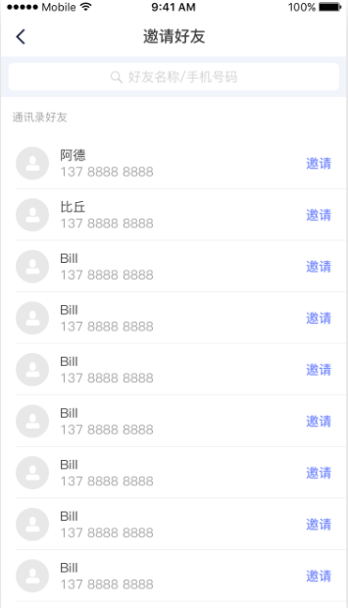

|  |  |  |  |
| --- | --- | --- | --- |
| 接口名称： | | | |
| invite | | | |
| 示例： | | | |
| {"command":"invite","sid":"daefhgherr45456","tel":"15620830714"} | | | |
| 返回： | | | |
| {  "code": "304",  "data": {  "command": "invite"  },  "msg": "邀请成功"  } | | | |
| 传入数据： | | | |
| Key | | Value | 说明 |
| command | | 字符串常量：invite | 命令 |
| sid | | 字符串变量 | $sid |
| tel | | 字符串变量 | 电话 |
|  | |  |  |
| 传出数据 | | | |
| command | 字符串 | | 当前命令 |

9、取货异常

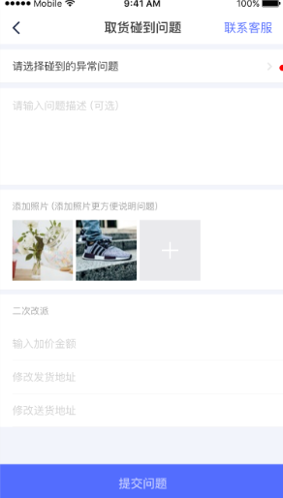

|  |  |  |  |
| --- | --- | --- | --- |
| 接口名称： | | | |
| pickupProblem | | | |
| 示例： | | | |
| {"command":"pickupProblem","sid":"daefhgherr45456","type":"3","describe":"12sadad12","orderId":"12sadad12"} | | | |
| 返回： | | | |
| {  "code": "1",  "data": {  "command": "pickupProblem"  },  "msg": "操作正常"  } | | | |
| 传入数据： | | | |
| Key | | Value | 说明 |
| command | | 字符串常量：invite | 命令 |
| sid | | 字符串变量 | $sid |
| orderId | | 字符串变量 | 订单编号 |
| type | | 字符串变量 | 异常类型 |
| describe | | 字符串变量 | 异常描述 |
| exceptionImg1 | | 文件 $_FILES | 异常图片 |
| exceptionImg2 | | 文件 $_FILES |  |
| exceptionImg3 | | 文件 $_FILES |  |
| 传出数据 | | | |
| command | 字符串 | | 当前命令 |

10.二次改派

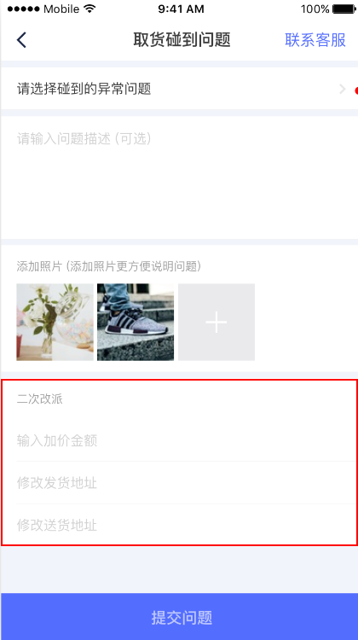

|  |  |  |  |
| --- | --- | --- | --- |
| 接口名称： | | | |
| reSendOrder() | | | |
| 示例： | | | |
| {"command":"reSendOrder","sid":"uajndv9kead8lf0u45e2pbnrg7","orderID":"1","newPrice":"120","newDeliverAddr":"aaaaaa","newReceiptAddr":"bbbbbb","exceptionReasonId":"1","describe":"1111"} | | | |
| 返回： | | | |
| {  "code": "1",  "data": {  "command": "reSendOrder"  },  "msg": "操作正常"  } | | | |
| 传入数据： | | | |
| Key | | Value | 说明 |
| command | | 字符串常量：invite | 命令 |
| sid | | 字符串变量 | $sid |
| orderID | | 字符串变量 | 订单编号 |
| newPrice | | 字符串变量 | 更改的价格 |
| newDeliverAddr | | 字符串变量 | 更改的取货地址 |
| newReceiptAddr | | 字符串变量 | 更改的收货地址 |
| exceptionReasonId | | 字符串变量 | 异常原因ID |
| describe | | 字符串变量 | 具体异常原因 |
| 传出数据 | | | |
| command | 字符串 | | 当前命令 |

11. 获取验证码

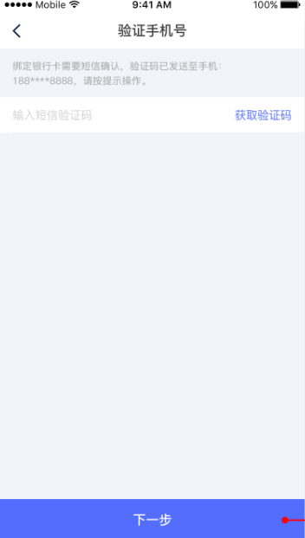

|  |  |  |  |
| --- | --- | --- | --- |
| 接口名称： | | | |
| getCode | | | |
| 示例： | | | |
| {"command":"getCode","sid":"daefhgherr45456","tel":"15620830714"} | | | |
| 返回： | | | |
| {  "code": "305",  "data": {  "command": "getCode"  },  "msg": "验证码发送成功"  } | | | |
| 传入数据： | | | |
| Key | | Value | 说明 |
| command | | 字符串常量：getCode | 命令 |
| sid | | 字符串变量 | $sid |
| tel | | 字符串变量 | 电话 |
| 传出数据 | | | |
| command | 字符串 | | 当前命令 |

12. 添加银行卡(银行卡类型，电话)

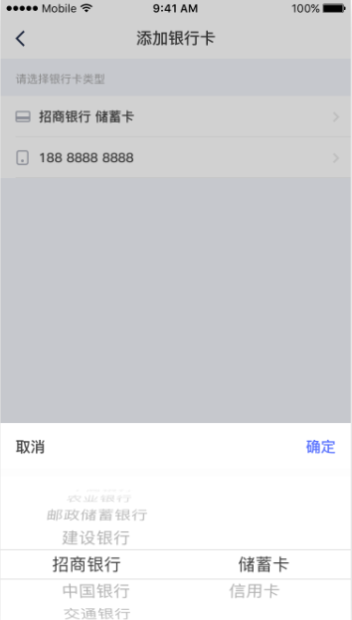

|  |  |  |  |
| --- | --- | --- | --- |
| 接口名称： | | | |
| addBankCard | | | |
| 示例： | | | |
| {"command":"addBankCard","sid":"daefhgherr45456","bank":"民生银行","tel":"15620830714"} | | | |
| 返回： | | | |
| {  "code": "306",  "data": {  "command": "addBankCard"  },  "msg": "添加成功"  } | | | |
| 传入数据： | | | |
| Key | | Value | 说明 |
| command | | 字符串常量：addBankCard | 命令 |
| sid | | 字符串变量 | $sid |
| bank | | 字符串变量 | 银行卡 |
| tel | | 字符串变量 | 电话 |
| 传出数据 | | | |
| command | 字符串 | | 当前命令 |

13. 添加银行卡(持卡人姓名，卡号)

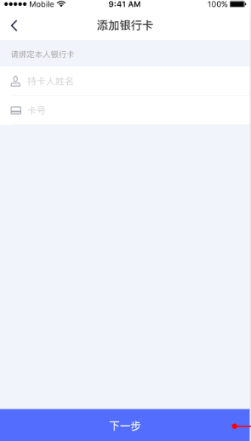

|  |  |  |  |
| --- | --- | --- | --- |
| 接口名称： | | | |
| addBankCardName | | | |
| 示例： | | | |
| {"command":"addBankCardName","sid":"daefhgherr45456","cName":"哈哈","cardNumber":"1234557624156"} | | | |
| 返回： | | | |
| {  "code": "306",  "data": {  "command": "addBankCardName"  },  "msg": "添加成功"  } | | | |
| 传入数据： | | | |
| Key | | Value | 说明 |
| command | | 字符串常量：addBankCardName | 命令 |
| sid | | 字符串变量 | $sid |
| cName | | 字符串变量 | 持卡人姓名 |
| cardNumber | | 字符串变量 | 卡号 |
| 传出数据 | | | |
| command | 字符串 | | 当前命令 |

14. 选择银行卡

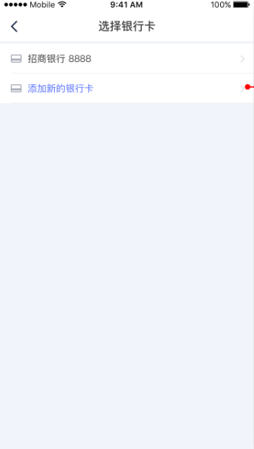

|  |  |  |  |
| --- | --- | --- | --- |
| 接口名称： | | | |
| selectBankCard | | | |
| 示例： | | | |
| {"command":"selectBankCard","sid":"daefhgherr45456","id":"1"} | | | |
| 返回： | | | |
| {  "code": "307",  "data": {  "command": "selectBankCard"  },  "msg": "查询成功！"  } | | | |
| 传入数据： | | | |
| Key | | Value | 说明 |
| command | | 字符串常量：addBankCardName | 命令 |
| sid | | 字符串变量 | $sid |
| id | | 字符串变量 | id |
| 传出数据 | | | |
| command | 字符串 | | 当前命令 |

15、获取手机验证码

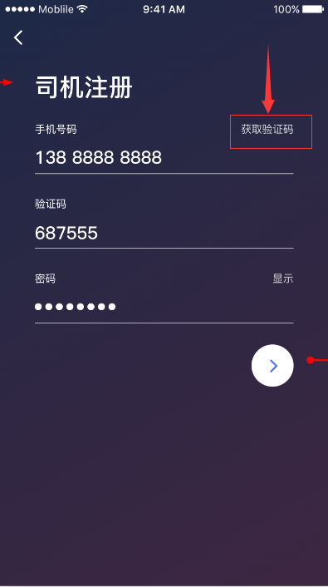

文档中的描述为：

|  |  |  |
| --- | --- | --- |
| 接口名称： | | |
| sendMessage | | |
| 示例： | | |
| {"command":" sendMessage ","tel":"18222933753"} | | |
| 返回： | | |
| {  "code": "-5",  "data": {  "command": "sendMessage"  },  "msg": "该号码已注册"  } | | |
| 传入数据： | | |
| Key | Value | 说明 |
| command | 字符串常量：sendMessage | 命令 |
| tel | 字符串 | 用户电话号码 |
| 传出数据 | | |
| command | 字符串常量 | 当前命令 |
| msg | 字符串常量 | 根据输入手机号返回的结果 |

16、用户注册

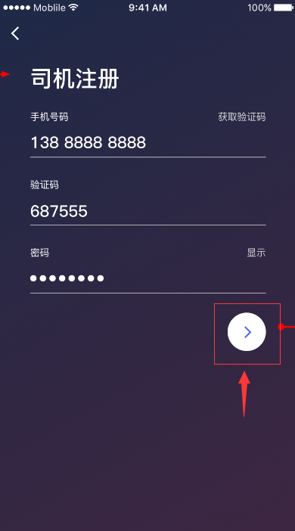

文档中的描述为：

|  |  |  |
| --- | --- | --- |
| 接口名称： | | |
| register | | |
| 示例： | | |
| {"command":"register","tel":"18222933753","password":"223","verCode":"321546"} | | |
| 返回： | | |
| {  "code": "-1",  "data": {  "command": "register",  "msg1": "验证码错误"  },  "msg": "提交数据有误"  } | | |
| 传入数据： | | |
| Key | Value | 说明 |
| command | 字符串常量：register | 命令 |
| tel | 字符串 | 用户电话号码 |
| password | 字符串 | 用户密码 |
| verCode | 字符串 | 输入的验证码 |
| 传出数据 | | |
| command | 字符串常量 | 当前命令 |
| msg1 | 字符串 | 根据输入验证码返回的结果 |

17、修改绑定手机号，共分为三步

1. 向旧手机发送验证码

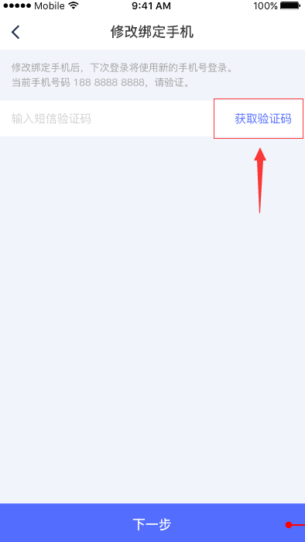

文档中的描述为：

|  |  |  |
| --- | --- | --- |
| 接口名称： | | |
| sendVerifyCode | | |
| 示例： | | |
| {"command":"sendVerifyCode","sid":"1"} | | |
| 返回： | | |
| {  "code": "-1",  "data": {  "command": "sendVerifyCode",  "msg1": "发送失败"  },  "msg": "提交数据有误"  } | | |
| 传入数据： | | |
| Key | Value | 说明 |
| command | 字符串常量：register | 命令 |
| sid | 整形变量 | session_id，根据sid查找手机号 |
| 传出数据 | | |
| command | 字符串常量 | 当前命令 |
| msg1 | 字符串 | 根据传来的sid返回的结果 |

1. 当用户修改手机号的时候，判断验证码是否正确

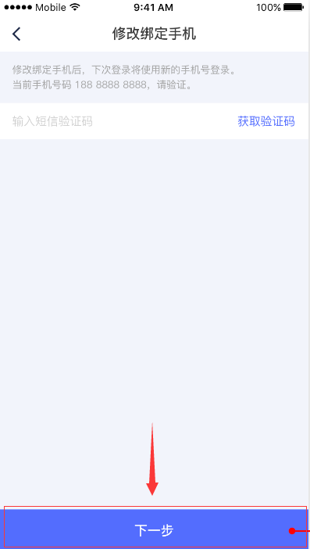

文档中的描述为：

|  |  |  |
| --- | --- | --- |
| 接口名称： | | |
| checkVerifyCode | | |
| 示例： | | |
| {"command":"checkVerifyCode","verCode":"132456","sid":"1"} | | |
| 返回： | | |
| {  "code": "-1",  "data": {  "command": "checkVerifyCode",  },  "msg": "提交数据有误"  } | | |
| 传入数据： | | |
| Key | Value | 说明 |
| command | 字符串常量：register | 命令 |
| verCode | 字符串 | 输入的验证码 |
| sid | 整形变量 | session_id，根据sid查找手机号 |
| 传出数据 | | |
| command | 字符串常量 | 当前命令 |
| msg1 | 字符串 | 根据输入的验证码返回的结果 |

1. 修改新的手机号

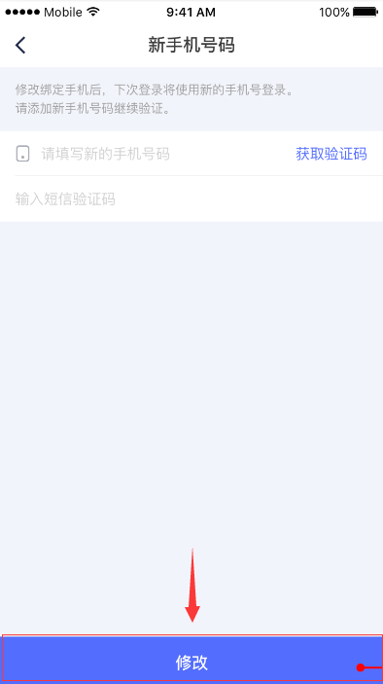

文档中的描述为：

|  |  |  |
| --- | --- | --- |
| 接口名称： | | |
| modifyMobile | | |
| 示例： | | |
| {"command":"modifyMobile","tel":"18222933753","verCode":"123456","sid":"1"} | | |
| 返回： | | |
| {  "code": "-1",  "data": {  "command": "modifyMobile",  "msg1": "验证码错误"  },  "msg": "提交数据有误"  } | | |
| 传入数据： | | |
| Key | Value | 说明 |
| command | 字符串常量：register | 命令 |
| tel | 字符串 | 用户电话号码 |
| verCode | 字符串 | 输入的验证码 |
| sid | 整形变量 | session_id，根据sid查找需要修改号码的用户 |
| 传出数据 | | |
| command | 字符串常量 | 当前命令 |
| msg1 | 字符串 | 根据输入的验证码返回的结果 |

18、扫码上车

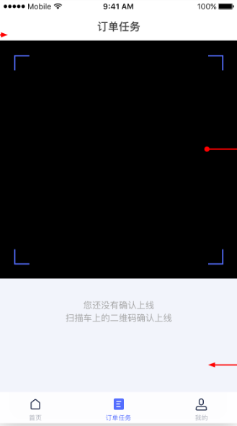

文档中的描述为：

|  |  |  |
| --- | --- | --- |
| 接口名称： | | |
| changeQRCode | | |
| 示例： | | |
| {"command":"changeQRCode","vehicleId":"3","sid":"oabpuph1sob7jbepafktn23q53","page":"1","limit":"3"} | | |
| 返回： | | |
| {  "code": "1",  "data": {  "command": "changeQRCode"  },  "msg": "操作正常"  } | | |
| 传入数据： | | |
| Key | Value | 说明 |
| command | 字符串常量：changeQRCode | 命令 |
| vehicleId | 字符串 | 车辆Id |
| sid | 字符串 | Session_id |
| page | 字符串 | 订单起始页码 |
| limit | 字符串 | 每页订单个数 |
| 传出数据 | | |
| command | 字符串常量 | 当前命令 |
| msg | 字符串常量 | 根据输入信息返回的结果 |

19、下车

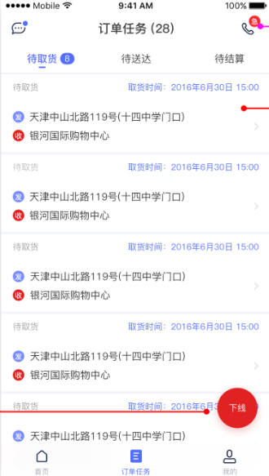

文档中的描述为：

|  |  |  |
| --- | --- | --- |
| 接口名称： | | |
| getOff | | |
| 示例： | | |
| {"command":"getOff","sid":"kjgb5uelqnl0lccq18q5qatsq3"} | | |
| 返回： | | |
| {  "code": "1",  "data": {  "command": "changeQRCode"  },  "msg": "操作正常"  } | | |
| 传入数据： | | |
| Key | Value | 说明 |
| command | 字符串常量：getOff | 命令 |
| sid | 字符串 | Session_id |
| 传出数据 | | |
| command | 字符串常量 | 当前命令 |
| msg | 字符串常量 | 根据输入信息返回的结果 |

20、订单详情

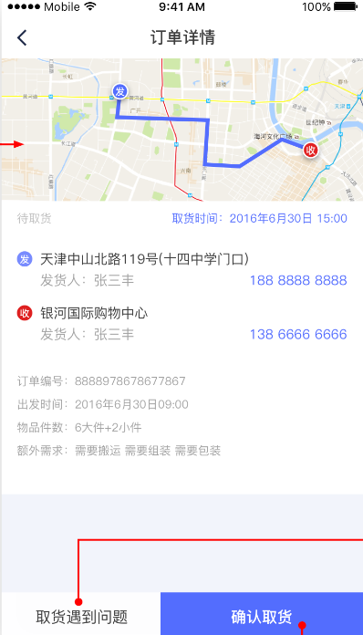

文档中的描述为：

|  |  |  |
| --- | --- | --- |
| 接口名称： | | |
| orderDetail | | |
| 示例： | | |
| {"command":"orderDetail","sid":"tofv4terv8ksi12u5poo312hn2","status":"0","orderId":"1"} | | |
| 返回： | | |
| {  "code": "1",  "data": {  "command": "affirmDelivery"  },  "msg": "操作正常"  } | | |
| 传入数据： | | |
| Key | Value | 说明 |
| command | 字符串常量：register | 命令 |
| sid | 字符串 | Session_id |
| status | 字符串 | 状态 |
| orderId | 字符串 | 订单Id |
| 传出数据 | | |
| command | 字符串常量 | 当前命令 |
| msg | 字符串 | 根据输入数据返回的结果 |

21、确认取货

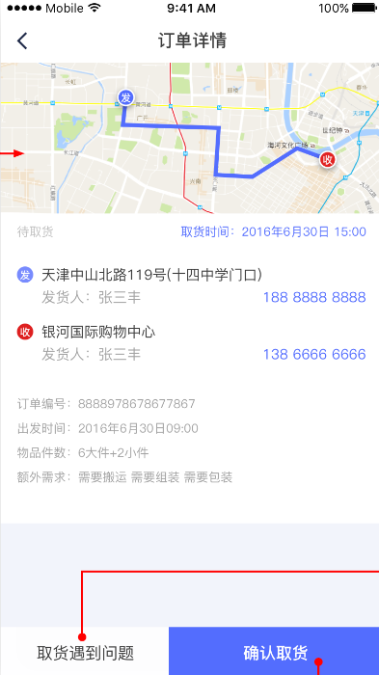

文档中的描述为：

|  |  |  |
| --- | --- | --- |
| 接口名称： | | |
| affirmPickGoods | | |
| 示例： | | |
| {"command":"affirmPickGoods","sid":"tofv4terv8ksi12u5poo312hn2","orderId":"1"} | | |
| 返回： | | |
| {  "code": "1",  "data": {  "command": "affirmDelivery"  },  "msg": "操作正常"  } | | |
| 传入数据： | | |
| Key | Value | 说明 |
| command | 字符串常量：register | 命令 |
| sid | 字符串 | Session_id |
| orderId | 字符串 | 订单Id |
| 传出数据 | | |
| command | 字符串常量 | 当前命令 |
| msg | 字符串 | 根据输入数据返回的结果 |

22、确认送达

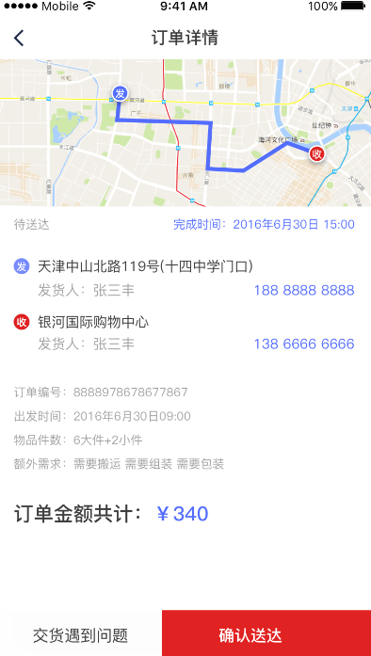

文档中的描述为：

|  |  |  |
| --- | --- | --- |
| 接口名称： | | |
| affirmDelivery | | |
| 示例： | | |
| {"command":"affirmDelivery","sid":"tofv4terv8ksi12u5poo312hn2","orderId":"4"} | | |
| 返回： | | |
| {  "code": "1",  "data": {  "command": "affirmDelivery"  },  "msg": "操作正常"  } | | |
| 传入数据： | | |
| Key | Value | 说明 |
| command | 字符串常量：register | 命令 |
| sid | 字符串 | Session_id |
| orderId | 字符串 | 订单Id |
| 传出数据 | | |
| command | 字符串常量 | 当前命令 |
| msg | 字符串 | 根据输入数据返回的结果 |

23、订单任务



文档中的描述为：

|  |  |  |
| --- | --- | --- |
| 接口名称： | | |
| orderTask | | |
| 示例： | | |
| {"command":"orderTask","sid":"irtmitofa8471bft2gucnv7gb4","page":"0","limit":"1"} | | |
| 返回： | | |
| {  "code": "1",  "data": {  "command": "orderTask",  "order": [  {  "id": "2",  "orderNum": "2",  "orderStatus": "3",  "driverId": "1",  "vehicleId": "1",  "customerId": "",  "deliver": "",  "deliverTel": "",  "sCompany": "",  "sProvance": "",  "deliverAddr": "",  "receipt": "",  "receiptTel": "",  "rCompany": "",  "rProvance": "",  "receiptAddr": "",  "rounteId": "",  "volume": "0.0",  "weight": "0.0",  "long": "0",  "wide": "0",  "tall": "0",  "goodsNum": "",  "description": "",  "payMethod": "1",  "createTime": "0000-00-00 00:00:00",  "takersTime": "",  "callTime": "",  "leadTime": "",  "exceptionReasonId": "",  "addRequir": "",  "callImg": "",  "leadImg": "",  "exceptionImg": ""  }  ]  },  "msg": "操作正常"  } | | |
| 传入数据： | | |
| Key | Value | 说明 |
| command | 字符串常量：register | 命令 |
| sid | 字符串 | Session_id |
| page | 整型变量 | 起始记录 |
| limit | 整型变量 | 每次传入的记录个数 |
| 传出数据 | | |
| command | 字符串常量 | 当前命令 |
| order | 数组 | 所需要的每个订单详情 |
| msg | 字符串 | 根据输入数据返回的结果 |

24、信息反馈

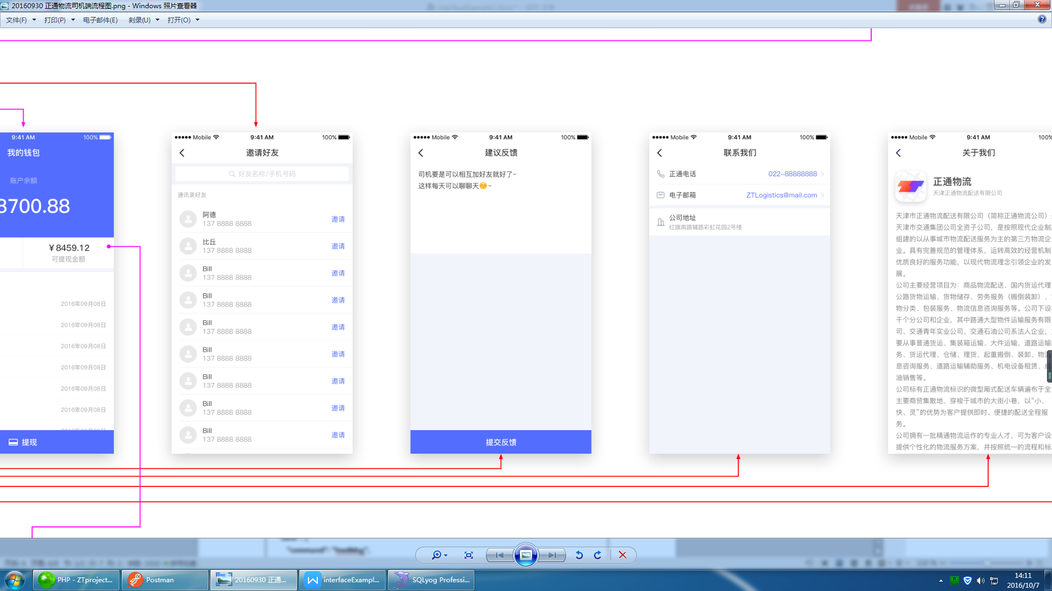

|  |  |  |
| --- | --- | --- |
| 接口名称： | | |
| feedMsg | | |
| 示例： | | |
| {"command":"feedMsg","sid":"22","message":"发货速度太慢","userType":"1","userId":"34"} | | |
| 返回： | | |
| {  "code": "1",  "data": {  "command": "feedMsg",  "msg": "反馈成功"  },  "msg": "操作正常"  } | | |
| 传入数据： | | |
| Key | Value | 说明 |
| command | 字符串常量：feedMsg | 命令 |
| sid | 字符串 | Session_id |
| message | 字符串 | 用户反馈信息 |
| userType | 整形 | 用户类别：1--司机；2--客户 |
| userId | 字符 | 用户Id |
| 传出数据 | | |
| key | Value | 说明 |
| command | 字符串常量 | 字符串常量 |
| msg | 字符串 | 反映反馈信息是否插入正确 |

25、用户退出登陆

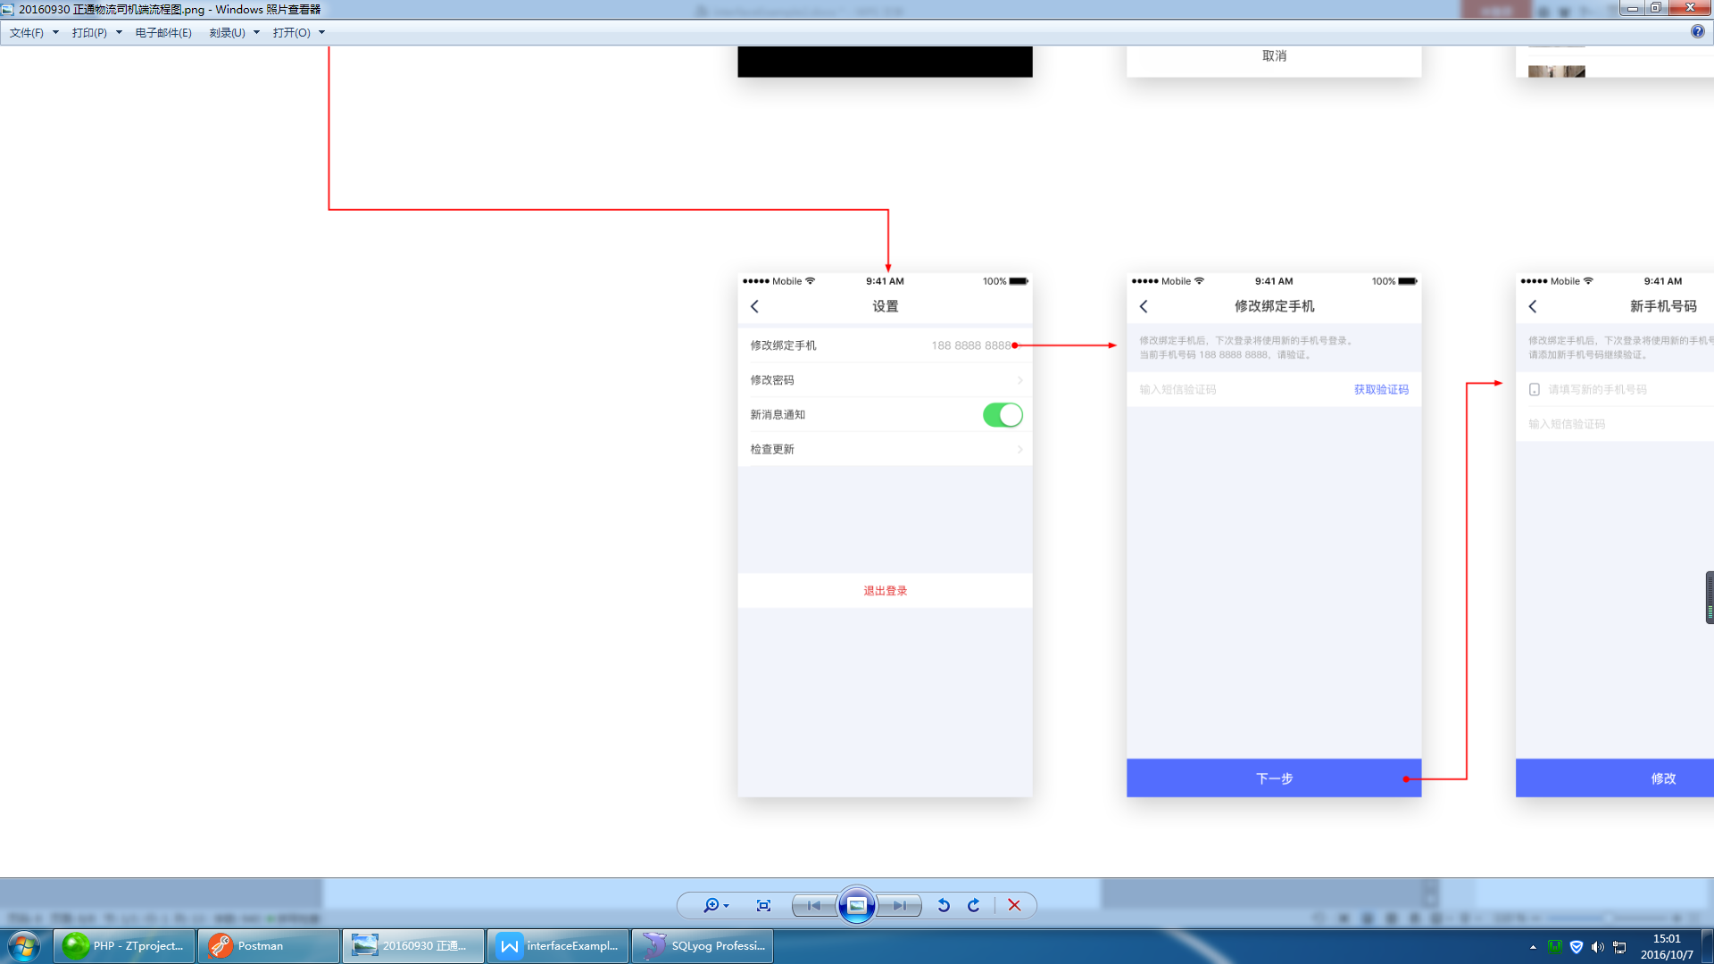

|  |  |  |  |
| --- | --- | --- | --- |
| 接口名称： | | | |
| logout | | | |
| 示例： | | | |
| {"command":"logout","sid":"22"} | | | |
| 返回： | | | |
| {  "code": "1",  "data": {  "command": "logout"  },  "msg": "操作正常"  } | | | |
| 传入数据： | | | |
| Key | Value | | 说明 |
| command | 字符串常量：logout | | 命令 |
| sid | 字符串变量 | | Session_id |
| 传出数据 | | | |
| command | 字符串 | | 当前命令 |
| ajaxReturn | Json对象 | | 提示信息 |
| AppendLog | Json对象 | | 用户日志信息 |
| Key | Value | 说明 |
|  | addMsg | 字符串 | 用户退出登陆是否成功 |

26、消息中心

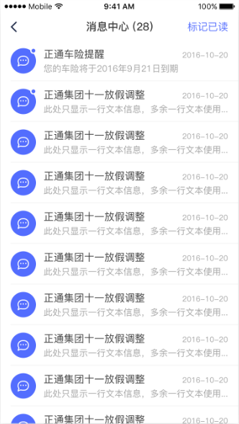

|  |  |  |
| --- | --- | --- |
| 接口名称： | | |
| centerOfMessage | | |
| 示例： | | |
| {"command":"centerOfMessage","sid":"7it7f8k994scn6n8p1ffkvi3j4"} | | |
| 返回： | | |
| {  "code": "1",  "data": {  "command": "feedMsg",  "msg": "反馈成功"  },  "msg": "操作正常"  } | | |
| 传入数据： | | |
| Key | Value | 说明 |
| command | 字符串常量：centerOfMessage | 命令 |
| sid | 字符串 | Session_id |
| 传出数据 | | |
| key | Value | 说明 |
| command | 字符串常量 | 字符串常量 |
| msg | 字符串 | 反映反馈信息是否插入正确 |
| id | 整形 | 用户id |
| title | 字符 | 消息标题 |
| content | 字符 | 消息文本 |
| isRead | 整形 | 标识是否已读 |
| issueTime | 时间字符 | 标识发布时间 |

27、历史订单列表

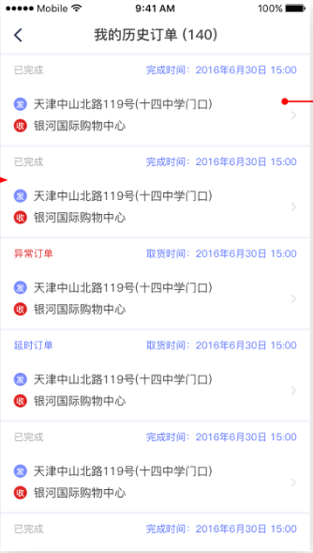

|  |  |  |
| --- | --- | --- |
| 接口名称： | | |
| historyOfOrder | | |
| 示例： | | |
| {"command":"historyOfOrder","sid":"akmtk2of89rmmm3vnrijfeqp40","page":"1","perPage":"10"} | | |
| 返回： | | |
| {  "code": "1",  "data": {  "command": "historyOfOrder",  "orderList": [  {  "id": "1",  "orderNum": "001",  "orderStatus": "1",  "driverId": "DR20161019100003",  "vehicleId": "1",  "customerId": "12",  "deliver": "李强",  "deliverTel": "15623468791",  "sCompany": "天津腾信公司",  "sProvance": "天津",  "deliverAddr": "天津市和平区鞍山西道地铁站",  "receiptTel": "15627438194",  "receipt": "李恒",  "rCompany": "河北信达公司",  "rProvance": "河北",  "receiptAddr": "河北省承德市京承铁路",  "rounteId": "0",  "volume": "1000.0",  "weight": "3000.0",  "long": "4000",  "wide": "3000",  "tall": "2000",  "goodsNum": "10000",  "description": "梳子",  "payMethod": "1",  "createTime": "2016-10-18 18:24:42",  "takersTime": "2016-10-19 18:25:03",  "callTime": "2016-10-20 18:25:16",  "leadTime": "2016-10-21 18:25:28",  "exceptionReasonId": "",  "exceptionReason": "",  "addRequir": "",  "callImg": "D:\\PHP\\wamp\\www\\pictures\\get.jpg",  "leadImg": "D:\\PHP\\wamp\\www\\pictures\\post.jpg",  "exceptionImg": ""  },  {  "id": "2",  "orderNum": "002",  "orderStatus": "1",  "driverId": "DR20161019100003",  "vehicleId": "",  "customerId": "",  "deliver": "李强",  "deliverTel": "15623468791",  "sCompany": "天津腾信公司",  "sProvance": "天津",  "deliverAddr": "天津市和平区鞍山西道地铁站",  "receiptTel": "15627438194",  "receipt": "李恒",  "rCompany": "河北信达公司",  "rProvance": "河北",  "receiptAddr": "河北省承德市京承铁路",  "rounteId": "",  "volume": "1000.0",  "weight": "3000.0",  "long": "4000",  "wide": "3000",  "tall": "2000",  "goodsNum": "10000",  "description": "梳子",  "payMethod": "1",  "createTime": "2016-10-18 18:24:42",  "takersTime": "2016-10-19 18:25:03",  "callTime": "2016-10-20 18:25:16",  "leadTime": "2016-10-21 18:25:28",  "exceptionReasonId": "",  "exceptionReason": "",  "addRequir": "",  "callImg": "D:\\PHP\\wamp\\www\\pictures\\get.jpg",  "leadImg": "D:\\PHP\\wamp\\www\\pictures\\post.jpg",  "exceptionImg": ""  }  ]  },  "msg": "操作正常"  } | | |
| 传入数据： | | |
| Key | Value | 说明 |
| command | 字符串常量：historyOfOrder | 命令 |
| page | 整形变量 | 起始页码 |
| perPage | 整形变量 | 每页显示的个数 |
| sid | 字符串变量 | Session_id |
| 传出数据 | | |
| command | 字符串 | 当前命令 |
| orderList | 数组 | 订单信息 |

28.登陆接口

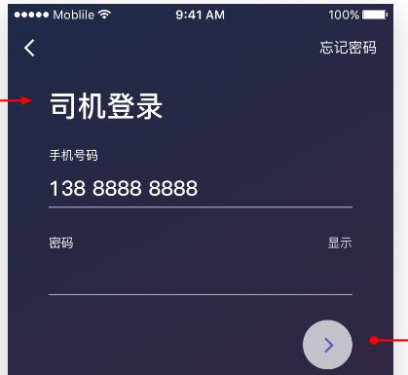

|  |  |  |
| --- | --- | --- |
| 接口名称： | | |
| Login | | |
| 示例： | | |
| {"command":"login","tel":"18330219027","password":"admin"} | | |
| 返回： | | |
| {  "code": "101",  "data": {  "command": "historyOfOrder"，  “sid”:’dggr4fhsdsgvfghh’  },  "msg": "登陆成功"  } | | |
| 传入数据： | | |
| Key | Value | 说明 |
| command | 字符串常量：login | 命令 |
| tel | 字符串 | 手机号 |
| password | 字符串变量 | 密码 |
| 传出数据 | | |
| command | 字符串 | 当前命令 |
| Sid | 字符串 | Sid |

29.忘记密码获取验证码

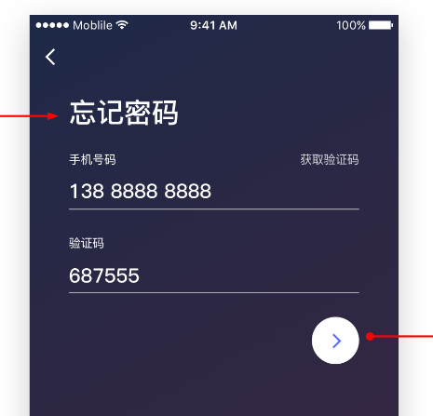

|  |  |  |
| --- | --- | --- |
| 接口名称： | | |
| Login | | |
| 示例： | | |
| {"command":"sendMessageForResetPWD","tel":"18330219027"} | | |
| 返回： | | |
| {  "code": "104",  "data": {  "command": " sendMessageForResetPWD "，  },  "msg": "验证码发送成功"  } | | |
| 传入数据： | | |
| Key | Value | 说明 |
| command | 字符串常量：login | 命令 |
| tel | 字符串 | 手机号 |
| 传出数据 | | |
| command | 字符串 | 当前命令 |

30.验证短信验证码是否通过



|  |  |  |
| --- | --- | --- |
| 接口名称： | | |
| Login | | |
| 示例： | | |
| {"command":"checkVerifyCodeNoSs","tel":"18330219027","verCode":"183302"} | | |
| 返回： | | |
| {  "code": "105",  "data": {  "command": " checkVerifyCodeNoSs "，  },  "msg": "验证码发送成功"  } | | |
| 传入数据： | | |
| Key | Value | 说明 |
| command | 字符串常量：checkVerifyCodeNoSs | 命令 |
| tel | 字符串 | 手机号 |
| verCode | 字符串 | 验证码 |
| 传出数据 | | |
| command | 字符串 | 当前命令 |

31.设置新密码

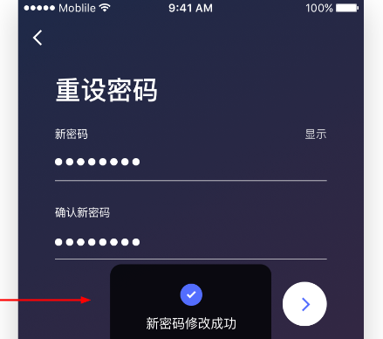

|  |  |  |
| --- | --- | --- |
| 接口名称： | | |
| Login | | |
| 示例： | | |
| {"command":"Resetpassword","tel":"18330219027","password":"183302","confirmpassword":"183302"} | | |
| 返回： | | |
| {  "code": "103",  "data": {  "command": " Resetpassword "，  },  "msg": "验证码发送成功"  } | | |
| 传入数据： | | |
| Key | Value | 说明 |
| command | 字符串常量：Resetpassword | 命令 |
| tel | 字符串 | 手机号 |
| password | 字符串 | 密码 |
| confirmpassword | 字符串 | 重复密码 |
| 传出数据 | | |
| command | 字符串 | 当前命令 |

32.个人中心首页

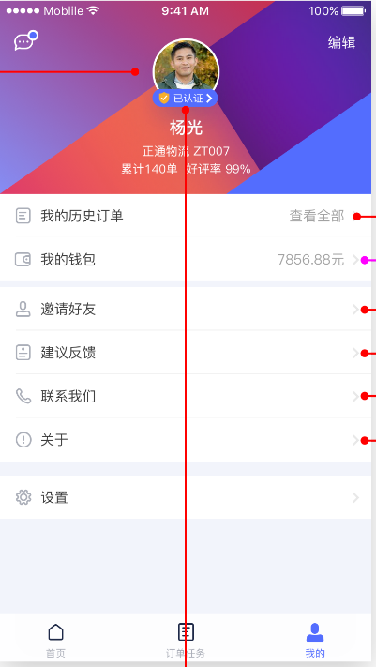

|  |  |  |
| --- | --- | --- |
| 接口名称： | | |
| driverPersonCenter | | |
| 示例： | | |
| {"command":"driverPersonCenter","sid":"5lcnbap5mda6uqhlalnhokkcf7"} | | |
| 返回： | | |
| {  "code": "106",  "data": {  "command": " driverPersonCenter ",  "reviewStatus": "2",  "hasNewMsg": "1",  "dName": "张三",  "driverId": "1",  "orderCount": "0",  "favorableRate": "100%"  },  "msg": "个人中心数据返回成功"  } | | |
| 传入数据： | | |
| Key | Value | 说明 |
| command | 字符串常量：Resetpassword | 命令 |
| sid | 字符串 | sid |
| 传出数据 | | |
| command | 字符串 | 当前命令 |
| reviewStatus | 字符串 | 审核状态 -1：认证失败 0：未认证 1认证中 2认证成功 |
| hasNewMsg | 字符串 | 是否有新消息 1：有 0无 |
| dName | 字符串 | 司机姓名 |
| driverId | 字符串 | 司机编号 |
| orderCount | 字符串 | 累计单数 |
| favorableRate | 字符串 | 好评度 ，暂时固定为100% |

33.订单列表

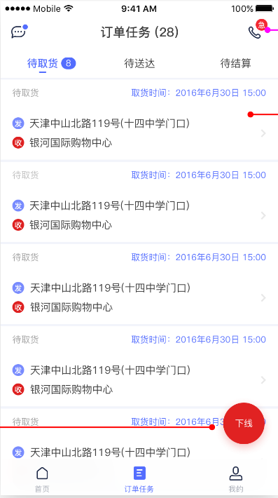

|  |  |  |  |  |
| --- | --- | --- | --- | --- |
| 接口名称： | | | | |
| orderList | | | | |
| 示例： | | | | |
| {"command":"orderList","sid":"sbk9gnh6na1eqdr26fu5aa9ne6","orderStatus":"3","limit":"2","page":"1"} | | | | |
| 返回： | | | | |
| {  "code": "1",  "data":  "command": "orderList",  "orderList": [  {  "id": "3",  "orderNum": "2",  "deliverAddr": "河西区",  "receiptAddr": "那开区",  "callTime": ""  },  {  "id": "4",  "orderNum": "2",  "deliverAddr": "河北区",  "receiptAddr": "和平区",  "callTime": ""  }  ]  "isRead": "1",  },  "msg": "操作正常"  } | | | | |
| 传入数据： | | | | |
| Key | Value | | 说明 | |
| command | 字符串常量：orderList | | 命令 | |
| sid | 字符串 | | sid | |
| orderStatus | 字符串常量  待配送5  待取货3  待送达 4 | | orderStatus | |
| page | 页码 | |  | |
| limit | 一页显示条数 | |  | |
| 传出数据 | | | | |
| command | 字符串 | | 当前命令 | |
| orderList | Json对象 | | | |
| Key | Value | | 说明 |
| Id | 字符串 | | 订单ID | |
| orderNum | 字符串 | | 订单编号 | |
| deliverAddr | 字符串 | | 发货地址 | |
| receiptAddr | 字符串 | | 目的地 | |
| callTime | 字符串 | | 取货时间 | |
| leadTime | 字符串 | | 交货时间 | |

34.消息已读未读接口



|  |  |  |  |  |
| --- | --- | --- | --- | --- |
| 接口名称： | | | | |
| orderList | | | | |
| 示例： | | | | |
| {"command":"isRead","sid":"09mv02pbcj5iss621mqn18c4n2"} | | | | |
| 返回： | | | | |
| {  "code": "1",  "data": {  "command": "isRead",  "isRead": "1"  },  "msg": "操作正常"  } | | | | |
| 传入数据： | | | | |
| Key | Value | | 说明 | |
| command | 字符串常量：isRead | | 命令 | |
| sid | 字符串 | | sid | |
| 传出数据 | | | | |
| command | 字符串 | | 当前命令 | |
| isRead | Json对象 | | | |
| Key | Value | | 1:有未读消息0无 |

35.异常原因列表



|  |  |  |  |  |
| --- | --- | --- | --- | --- |
| 接口名称： | | | | |
| exceptionReason | | | | |
| 示例： | | | | |
| {"command":"exceptionReason","sid":"uajndv9kead8lf0u45e2pbnrg7","type":"1"} | | | | |
| 返回： | | | | |
| {  "code": "1",  "data": {  "command": "exceptionReason",  "reason": [  {  "reasonId": "1",  "type": "1",  "title": "货物异常"  },  {  "reasonId": "2",  "type": "1",  "title": "取货地址变更"  }  ]  },  "msg": "操作正常"  } | | | | |
| 传入数据： | | | | |
| Key | Value | | 说明 | |
| command | 字符串常量：exceptionReason | | 命令 | |
| sid | 字符串 | | sid | |
| type | 类型 | | 1:取货问题2：送货问题 | |
| 传出数据 | | | | |
| command | 字符串 | | 当前命令 | |
| reason | Json对象 | | | |
| Key | Value | | 说明 |
| reasonId | 字符串 | | 异常ID | |
| type | 字符串 | | 异常类型 | |
| title | 字符串 | | 异常原因 | |

36、获取用户信息



|  |  |  |  |  |
| --- | --- | --- | --- | --- |
| 接口名称： | | | | |
| exceptionReason | | | | |
| 示例： | | | | |
| {"command":"getUserInfo","sid":"6v4nkpju9adbcqqi38kf1h1802"} | | | | |
| 返回： | | | | |
| {  "code": "113",  "data": {  "command": "getUserInfo",  "userInfo": {  "id": "48",  "dName": "张三丰",  "tel": "18330219027",  "face": "Driver/header/2016-10-18/5805c6c70765e.jpg",  "driverType": "0",  "cooperationId": "QY020161013100009",  "idCardNum": "123456789098765432",  "idCardFrontImg": "Driver/idCardFrontImg/2016-10-13/57ff6ea991281.jpg",  "idCardBackImg": "Driver/idCardBackImg/2016-10-13/57ff6ea99247b.jpg",  "idCardValidDate": "",  "addr": "",  "class": "",  "DLNum": "",  "DLImg": "Driver/DLImg/2016-10-13/57ff6ea993627.jpg",  "DLImg2": "Driver/DLImg2/2016-10-13/57ff6ea99470d.jpg",  "DLValidDate": "",  "CCBPNum": "",  "CCBPImg": "",  "CCBPValidDate": "",  "professionNum": "",  "professionImg": "Driver/professionImg/2016-10-13/57ff6ea9957d6.jpg",  "professionValidDate": "",  "reviewTime": "",  "reviewStatus": "",  "reviewNote": "",  "available": "0",  "cooprationAvailable": "1",  "Econtact": "",  "EcontactTel": ""  }  },  "msg": "获取用户信息成功"  } | | | | |
| 传入数据： | | | | |
| Key | Value | | 说明 | |
| command | 字符串常量：exceptionReason | | 命令 | |
| sid | 字符串 | | sid | |
| type | 类型 | | 1:取货问题2：送货问题 | |
| 传出数据 | | | | |
| command | 字符串 | | 当前命令 | |
| userInfo | Json对象 | | | |
| Key | Value | | 说明 |
|  | id | 字符串 | | 司机编号 |

37、个人中心修改资料



|  |  |  |
| --- | --- | --- |
| 接口名称： | | |
| exceptionReason | | |
| 示例： | | |
| {"command":"editPersonInfo","sid":"6v4nkpju9adbcqqi38kf1h1802","addr":"6v4nkpju9adbcqqi38kf1h1802","EcontactTel":"6v4nkpju9adbcqqi38kf1h1802","Econtact":"6v4nkpju9adbcqqi38kf1h1802"} | | |
| 返回： | | |
| {  "code": "114",  "data": {  "command": "editPersonInfo"  },  "msg": "修改用户信息成功"  } | | |
| 传入数据： | | |
| Key | Value | 说明 |
| command | 字符串常量：exceptionReason | 命令 |
| sid | 字符串 | sid |
| addr | 字符串 | 地址（可选） |
| EcontactTel | 字符串 | 紧急联系方式（可选） |
| Econtact |  | 紧急联系人（可选） |
| 传出数据 | | |
| command | 字符串 | 当前命令 |