*MainActivity*

ackage com.example.layoutactivity;  
  
import androidx.appcompat.app.AppCompatActivity;  
  
import android.os.Bundle;  
  
public class MainActivity extends AppCompatActivity {  
  
 @Override  
 protected void onCreate(Bundle savedInstanceState) {  
 super.onCreate(savedInstanceState);  
 setContentView(R.layout.*myscreen*);  
 }  
}

*myscreen*

<?xml version="1.0" encoding="utf-8"?>  
<LinearLayout  
 xmlns:android="http://schemas.android.com/apk/res/android"  
 android:layout_width="match_parent"  
 android:layout_height="match_parent"  
 android:orientation="vertical">  
 <TextView  
 android:id="@+id/textView1"  
 android:layout_width="wrap_content"  
 android:layout_height="wrap_content"  
 android:text="Вертикальная ориентация экрана">  
 </TextView>  
 <LinearLayout  
 android:id="@+id/linearLayout1"  
 android:layout_width="match_parent"  
 android:layout_height="wrap_content"  
 android:orientation="vertical">  
 <Button  
 android:id="@+id/button1"  
 android:layout_width="100dp"  
 android:layout_height="100dp"  
 android:text="Button1">  
 </Button>  
 <Button  
 android:id="@+id/button2"  
 android:layout_width="100dp"  
 android:layout_height="100dp"  
 android:text="Button2">  
 </Button>  
 <Button  
 android:id="@+id/button3"  
 android:layout_width="100dp"  
 android:layout_height="100dp"  
 android:text="Button3">  
 </Button>  
 <Button  
 android:id="@+id/button4"  
 android:layout_width="100dp"  
 android:layout_height="100dp"  
 android:text="Button4">  
 </Button>  
 </LinearLayout>  
</LinearLayout>

*Myscreen/layout*

<?xml version="1.0" encoding="utf-8"?>  
<LinearLayout  
 xmlns:android="http://schemas.android.com/apk/res/android"  
 xmlns:tools="http://schemas.android.com/tools"  
 android:layout_width="match_parent"  
 android:layout_height="match_parent"  
 android:orientation="vertical"  
 tools:ignore="MissingDefaultResource">  
 <TextView  
 android:id="@+id/textView1"  
 android:layout_width="wrap_content"  
 android:layout_height="wrap_content"  
 android:text="Горизонтальная ориентация экрана">  
 </TextView>  
 <LinearLayout  
 android:id="@+id/linearLayout1"  
 android:layout_width="match_parent"  
 android:layout_height="wrap_content"  
 android:orientation="vertical">  
 <Button  
 android:id="@+id/button1"  
 android:layout_width="100dp"  
 android:layout_height="100dp"  
 android:text="Button1">  
 </Button>  
 <Button  
 android:id="@+id/button2"  
 android:layout_width="100dp"  
 android:layout_height="100dp"  
 android:text="Button2">  
 </Button>  
 <Button  
 android:id="@+id/button3"  
 android:layout_width="100dp"  
 android:layout_height="100dp"  
 android:text="Button3">  
 </Button>  
 <Button  
 android:id="@+id/button4"  
 android:layout_width="100dp"  
 android:layout_height="100dp"  
 android:text="Button4">  
 </Button>  
 </LinearLayout>  
</LinearLayout>

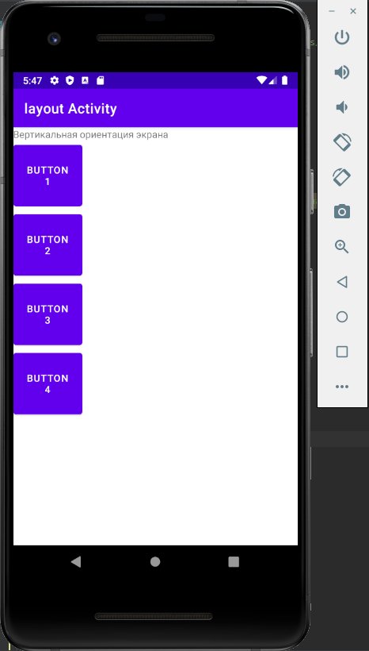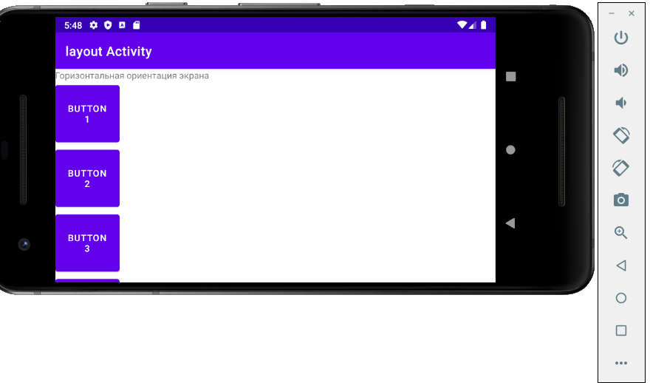

*Rlayout.xml*

<?xml version="1.0" encoding="utf-8"?>  
<RelativeLayout  
 xmlns:android="http://schemas.android.com/apk/res/android"  
 android:layout_width="match_parent"  
 android:layout_height="match_parent">  
 <TextView  
 android:id="@+id/label"  
 android:layout_width="match_parent"  
 android:layout_height="wrap_content"  
 android:text="Type here:">  
 </TextView>  
 <EditText  
 android:id="@+id/entry"  
 android:layout_width="match_parent"  
 android:layout_height="wrap_content"  
 android:layout_below="@+id/label"  
 android:background="@android:drawable/editbox_background">  
 </EditText>  
 <Button  
 android:id="@+id/ok"  
 android:layout_width="wrap_content"  
 android:layout_height="wrap_content"  
 android:layout_alignParentRight="true"  
 android:layout_below="@+id/entry"  
 android:layout_marginLeft="10dip"  
 android:text="OK">  
 </Button>  
 <Button  
 android:layout_width="wrap_content"  
 android:layout_height="wrap_content"  
 android:layout_alignTop="@+id/ok"  
 android:layout_toLeftOf="@+id/ok"  
 android:text="Cancel">  
 </Button>  
</RelativeLayout>

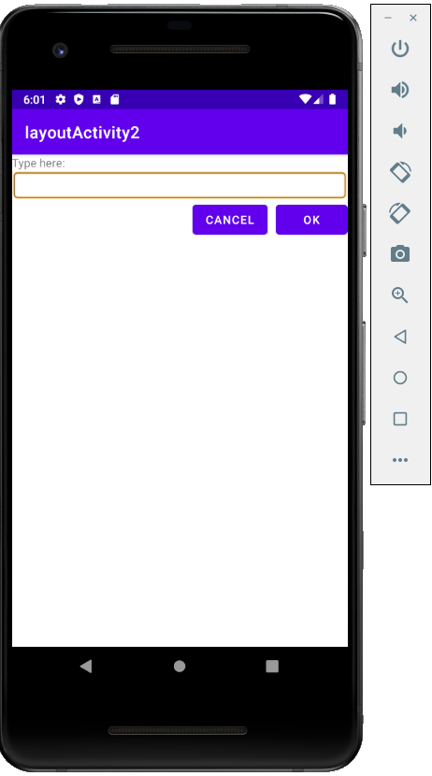

*activity_main*

<?xml version="1.0" encoding="utf-8"?>  
<LinearLayout  
 xmlns:android="http://schemas.android.com/apk/res/android"  
 android:layout_width="fill_parent"  
 android:layout_height="fill_parent"  
 android:orientation="horizontal">  
 <Button  
 android:id="@+id/button1"  
 android:layout_height="wrap_content"  
 android:layout_width="wrap_content"  
 android:text="B1"  
 android:layout_weight="1">  
 </Button>  
 <Button  
 android:id="@+id/button2"  
 android:layout_width="wrap_content"  
 android:layout_height="wrap_content"  
 android:text="B2"  
 android:layout_weight="3">  
 </Button>  
 <Button  
 android:layout_height="wrap_content"  
 android:layout_width="wrap_content"  
 android:id="@+id/button3"  
 android:text="B3"  
 android:layout_weight="2">  
 </Button>  
</LinearLayout>

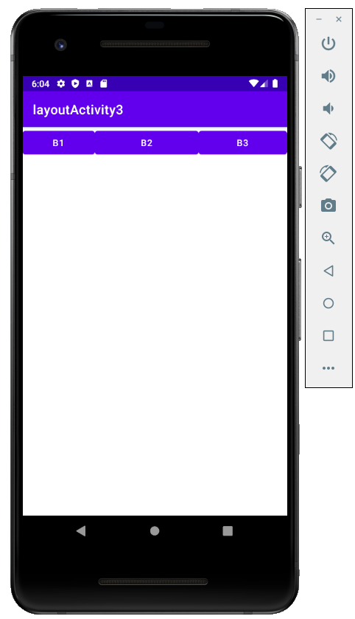

*grlayout*

<?xml version="1.0" encoding="utf-8"?>  
<LinearLayout  
 xmlns:android="http://schemas.android.com/apk/res/android"  
 android:orientation="vertical"  
 android:layout_width="match_parent"  
 android:layout_height="match_parent">  
 <FrameLayout  
 android:id="@+id/frameLayout1"  
 android:layout_width="match_parent"  
 android:layout_height="match_parent">  
 <Button  
 android:id="@+id/button1"  
 android:layout_width="wrap_content"  
 android:layout_height="wrap_content"  
 android:layout_gravity="top|left"  
 android:text="gravity = top left">  
 </Button>  
 <Button  
 android:id="@+id/button2"  
 android:layout_width="wrap_content"  
 android:layout_height="wrap_content"  
 android:layout_gravity="top|right"  
 android:text="gravity = top right">  
 </Button>  
 <Button  
 android:id="@+id/button3"  
 android:layout_width="wrap_content"  
 android:layout_height="wrap_content"  
 android:layout_gravity="bottom|left"  
 android:text="gravity = bottom left">  
 </Button>  
 <Button  
 android:id="@+id/button4"  
 android:layout_width="wrap_content"  
 android:layout_height="wrap_content"  
 android:layout_gravity="bottom|right"  
 android:text="gravity = bottom right">  
 </Button>  
 <Button  
 android:id="@+id/button5"  
 android:layout_width="wrap_content"  
 android:layout_height="wrap_content"  
 android:layout_gravity="center"  
 android:text="gravity = center">  
 </Button>  
 </FrameLayout>  
</LinearLayout>

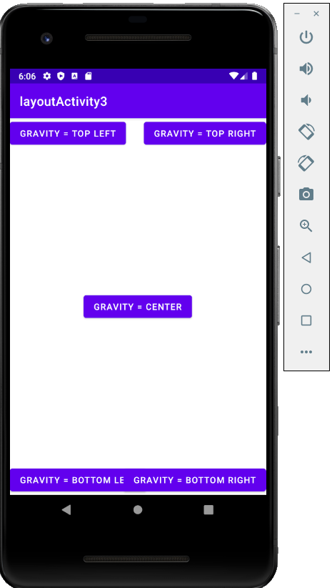

*marginlayout*

<?xml version="1.0" encoding="utf-8"?>  
<LinearLayout  
 xmlns:android="http://schemas.android.com/apk/res/android"  
 android:orientation="vertical"  
 android:layout_width="match_parent"  
 android:layout_height="match_parent">  
 <TableLayout  
 android:layout_height="wrap_content"  
 android:layout_width="match_parent"  
 android:id="@+id/tableLayout1">  
 <TableRow  
 android:id="@+id/tableRow1"  
 android:layout_width="wrap_content"  
 android:layout_height="wrap_content">  
 <Button  
 android:text="Button"  
 android:id="@+id/button1"  
 android:layout_width="wrap_content"  
 android:layout_height="wrap_content">  
 </Button>  
 <Button  
 android:text="Button"  
 android:id="@+id/button2"  
 android:layout_width="wrap_content"  
 android:layout_height="wrap_content">  
 </Button>  
 <Button  
 android:text="Button"  
 android:id="@+id/button3"  
 android:layout_width="wrap_content"  
 android:layout_height="wrap_content">  
 </Button>  
 </TableRow>  
 <TableRow  
 android:id="@+id/tableRow2"  
 android:layout_width="wrap_content"  
 android:layout_height="wrap_content">  
 <Button  
 android:text="Button"  
 android:id="@+id/button4"  
 android:layout_width="wrap_content"  
 android:layout_height="wrap_content">  
 </Button>  
 <Button  
 android:text="Margin"  
 android:id="@+id/button5"  
 android:layout_width="wrap_content"  
 android:layout_height="wrap_content">  
 </Button>  
 <Button  
 android:text="Button"  
 android:id="@+id/button6"  
 android:layout_width="wrap_content"  
 android:layout_height="wrap_content">  
 </Button>  
 </TableRow>  
 <TableRow  
 android:id="@+id/tableRow3"  
 android:layout_width="wrap_content"  
 android:layout_height="wrap_content">  
 <Button  
 android:text="Button"  
 android:id="@+id/button7"  
 android:layout_width="wrap_content"  
 android:layout_height="wrap_content">  
 </Button>  
 <Button  
 android:text="Button"  
 android:id="@+id/button8"  
 android:layout_width="wrap_content"  
 android:layout_height="wrap_content">  
 </Button>  
 <Button  
 android:text="Button"  
 android:id="@+id/button9"  
 android:layout_width="wrap_content"  
 android:layout_height="wrap_content">  
 </Button>  
 </TableRow>  
 </TableLayout>  
</LinearLayout>

