*Activity-main*

<?xml version="1.0" encoding="utf-8"?>  
<RelativeLayout xmlns:android="http://schemas.android.com/apk/res/android"  
 android:id="@+id/activity_main"  
 android:layout_width="match_parent"  
 android:layout_height="match_parent">  
  
 <ListView  
 android:id="@+id/countriesList"  
 android:layout_width="match_parent"  
 android:layout_height="match_parent">  
 </ListView>  
  
</RelativeLayout>

*Mainactivity*

package com.example.myapplication74;  
  
import androidx.appcompat.app.AppCompatActivity;  
import android.os.Bundle;  
import android.widget.ArrayAdapter;  
import android.widget.ListView;  
  
public class MainActivity extends AppCompatActivity {  
  
 // набор данных, которые свяжем со списком  
 String[] countries = { "Бразилия", "Аргентина", "Колумбия", "Чили", "Уругвай"};  
 @Override  
 protected void onCreate(Bundle savedInstanceState) {  
 super.onCreate(savedInstanceState);  
 setContentView(R.layout.*activity_main*);  
  
 // получаем элемент ListView  
 ListView countriesList = (ListView) findViewById(R.id.*countriesList*);  
  
 // создаем адаптер  
 ArrayAdapter<String> adapter = new ArrayAdapter(this,  
 android.R.layout.*simple_list_item_1*, countries);  
  
 // устанавливаем для списка адаптер  
 countriesList.setAdapter(adapter);  
 }  
}

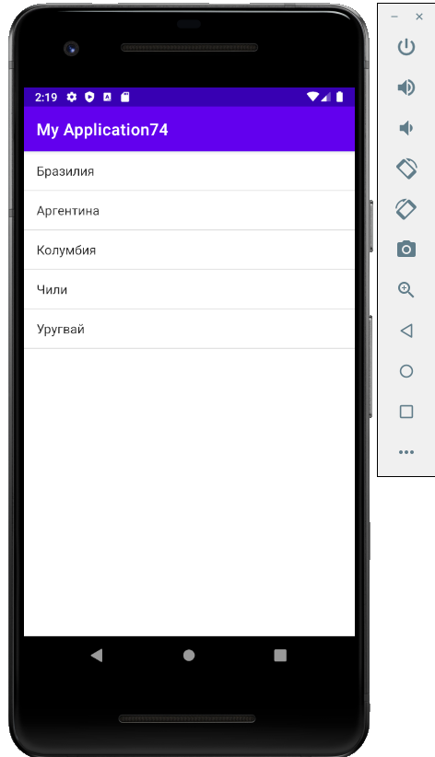

*Activity-main*

<?xml version="1.0" encoding="utf-8"?>  
<RelativeLayout xmlns:android="http://schemas.android.com/apk/res/android"  
 android:id="@+id/activity_main"  
 android:layout_width="match_parent"  
 android:layout_height="match_parent">  
  
 <ListView  
 android:entries="@array/countries"  
 android:id="@+id/countriesList"  
 android:layout_width="match_parent"  
 android:layout_height="match_parent">  
 </ListView>  
  
</RelativeLayout>

*Mainactivity*

package com.example.my1;  
  
import androidx.appcompat.app.AppCompatActivity;  
import android.os.Bundle;  
  
public class MainActivity extends AppCompatActivity {  
  
 @Override  
 protected void onCreate(Bundle savedInstanceState) {  
 super.onCreate(savedInstanceState);  
 setContentView(R.layout.*activity_main*);  
 }  
}

*countries*

<?xml version="1.0" encoding="utf-8"?>  
<resources>  
 <string-array name="countries">  
 <item>Бразилия</item>  
 <item>Аргентина</item>  
 <item>Колумбия</item>  
 <item>Чили</item>  
 <item>Уругвай</item>  
 </string-array>  
</resources>

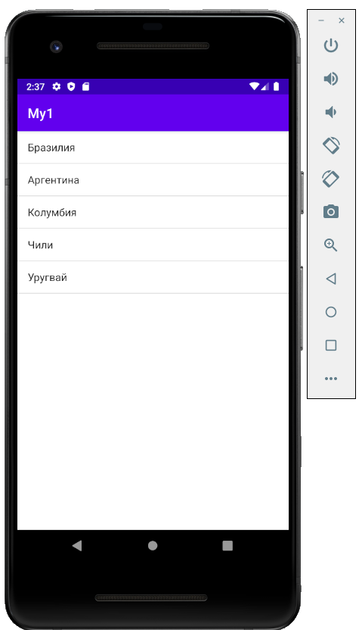

*Activity-main*

<?xml version="1.0" encoding="utf-8"?>  
<LinearLayout xmlns:android="http://schemas.android.com/apk/res/android"  
 android:id="@+id/activity_main"  
 android:layout_width="match_parent"  
 android:layout_height="match_parent"  
 android:orientation="vertical">  
  
 <TextView  
 android:id="@+id/selection"  
 android:layout_width="match_parent"  
 android:layout_height="wrap_content"  
 android:textSize="22sp" />  
 <ListView  
 android:id="@+id/countriesList"  
 android:layout_width="match_parent"  
 android:layout_height="match_parent" />  
  
</LinearLayout>

*Mainactivity*

package com.example.my1;  
  
import androidx.appcompat.app.AppCompatActivity;  
import android.os.Bundle;  
import android.view.View;  
import android.widget.AdapterView;  
import android.widget.ArrayAdapter;  
import android.widget.ListView;  
import android.widget.TextView;  
import android.widget.AdapterView.OnItemClickListener;  
  
public class MainActivity extends AppCompatActivity {  
  
 String[] countries = { "Бразилия", "Аргентина", "Колумбия", "Чили", "Уругвай"};  
 private TextView selection;  
 @Override  
 protected void onCreate(Bundle savedInstanceState) {  
 super.onCreate(savedInstanceState);  
 setContentView(R.layout.*activity_main*);  
  
 // получаем элемент TextView  
 selection = (TextView) findViewById(R.id.*selection*);  
 // получаем элемент ListView  
 ListView countriesList = (ListView) findViewById(R.id.*countriesList*);  
  
 // создаем адаптер  
 ArrayAdapter<String> adapter = new ArrayAdapter(this,  
 android.R.layout.*simple_list_item_1*, countries);  
 // устанавливаем для списка адаптер  
 countriesList.setAdapter(adapter);  
 // добвляем для списка слушатель  
 countriesList.setOnItemClickListener(new OnItemClickListener(){  
 @Override  
 public void onItemClick(AdapterView<?> parent, View v, int position, long id)  
 {  
 // по позиции получаем выбранный элемент  
 String selectedItem = countries[position];  
 // установка текста элемента TextView  
 selection.setText(selectedItem);  
 }  
 });  
 }  
}

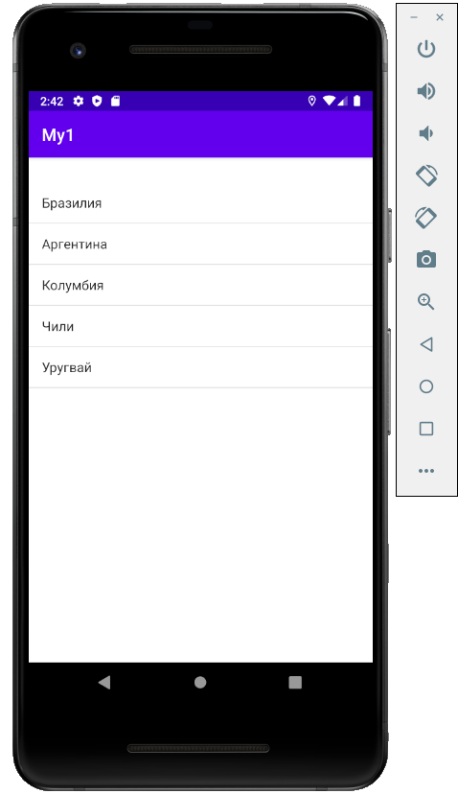

*Activity-main*

<?xml version="1.0" encoding="utf-8"?>  
<LinearLayout xmlns:android="http://schemas.android.com/apk/res/android"  
 android:id="@+id/activity_main"  
 android:layout_width="match_parent"  
 android:layout_height="match_parent"  
 android:orientation="vertical">  
  
 <TextView  
 android:id="@+id/selection"  
 android:layout_width="match_parent"  
 android:layout_height="wrap_content"  
 android:textSize="22sp" />  
 <ListView  
 android:choiceMode="multipleChoice"  
 android:id="@+id/countriesList"  
 android:layout_width="match_parent"  
 android:layout_height="match_parent" />  
  
</LinearLayout>

*Mainactivity*

package com.example.my1;  
  
import androidx.appcompat.app.AppCompatActivity;  
import android.os.Bundle;  
import android.util.SparseBooleanArray;  
import android.view.View;  
import android.widget.AdapterView;  
import android.widget.ArrayAdapter;  
import android.widget.ListView;  
import android.widget.TextView;  
import android.widget.AdapterView.OnItemClickListener;  
  
public class MainActivity extends AppCompatActivity {  
  
 String[] countries = { "Бразилия", "Аргентина", "Колумбия", "Чили", "Уругвай"};  
 TextView selection;  
 ListView countriesList;  
 @Override  
 protected void onCreate(Bundle savedInstanceState) {  
 super.onCreate(savedInstanceState);  
 setContentView(R.layout.*activity_main*);  
  
 // получаем элемент TextView  
 selection = (TextView) findViewById(R.id.*selection*);  
 // получаем элемент ListView  
 countriesList = (ListView) findViewById(R.id.*countriesList*);  
  
 // создаем адаптер  
 ArrayAdapter<String> adapter = new ArrayAdapter(this,  
 android.R.layout.*simple_list_item_multiple_choice*, countries);  
 // устанавливаем для списка адаптер  
 countriesList.setAdapter(adapter);  
 // добвляем для списка слушатель  
 countriesList.setOnItemClickListener(new OnItemClickListener(){  
 @Override  
 public void onItemClick(AdapterView<?> parent, View v, int position, long id)  
 {  
 SparseBooleanArray sp=countriesList.getCheckedItemPositions();  
  
 String selectedItems="";  
 for(int i=0;i < countries.length;i++)  
 {  
 if(sp.get(i))  
 selectedItems+=countries[i]+",";  
 }  
 // установка текста элемента TextView  
 selection.setText("Выбрано: " + selectedItems);  
 }  
 });  
 }  
}

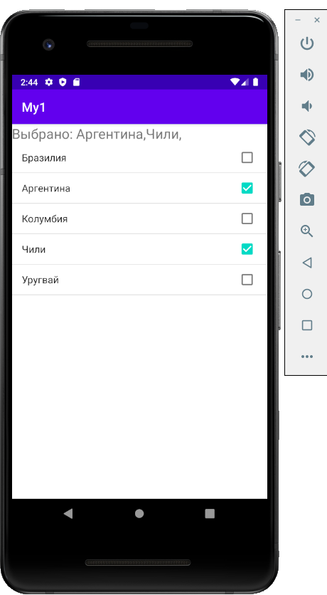

*Activity-main*

<?xml version="1.0" encoding="utf-8"?>  
<LinearLayout xmlns:android="http://schemas.android.com/apk/res/android"  
 android:layout_width="match_parent"  
 android:layout_height="match_parent"  
 android:orientation="vertical" >  
 <LinearLayout  
 android:layout_width="match_parent"  
 android:layout_height="wrap_content">  
 <EditText  
 android:id="@+id/phone"  
 android:layout_weight="4"  
 android:layout_width="0dp"  
 android:layout_height="wrap_content" />  
 <Button  
 android:layout_weight="1"  
 android:text="+"  
 android:layout_width="0dp"  
 android:layout_height="wrap_content"  
 android:onClick="add"/>  
 <Button  
 android:layout_weight="1"  
 android:text="-"  
 android:layout_width="0dp"  
 android:layout_height="wrap_content"  
 android:onClick="remove"/>  
 </LinearLayout>  
 <ListView  
 android:choiceMode="multipleChoice"  
 android:id="@+id/phonesList"  
 android:layout_width="match_parent"  
 android:layout_height="match_parent"/>  
</LinearLayout>

*Mainactivity*

package com.example.my1;  
  
import androidx.appcompat.app.AppCompatActivity;  
import android.os.Bundle;  
import android.view.View;  
import android.widget.AdapterView;  
import android.widget.ArrayAdapter;  
import android.widget.EditText;  
import android.widget.ListView;  
  
import java.util.ArrayList;  
  
public class MainActivity extends AppCompatActivity {  
  
 ArrayList<String> phones = new ArrayList();  
 ArrayAdapter<String> adapter;  
  
 ArrayList<String> selectedPhones = new ArrayList();  
 ListView phonesList;  
 @Override  
 protected void onCreate(Bundle savedInstanceState) {  
 super.onCreate(savedInstanceState);  
 setContentView(R.layout.*activity_main*);  
  
 phones.add("iPhone 7");  
 phones.add("Samsung Galaxy S7");  
 phones.add("Google Pixel");  
 phones.add("Huawei P10");  
 phones.add("HP Elite z3");  
  
 phonesList = (ListView) findViewById(R.id.*phonesList*);  
 adapter = new ArrayAdapter<String>(this, android.R.layout.*simple_list_item_multiple_choice*, phones);  
 phonesList.setAdapter(adapter);  
  
 // обработка установки и снятия отметки в списке  
 phonesList.setOnItemClickListener(new AdapterView.OnItemClickListener(){  
 @Override  
 public void onItemClick(AdapterView<?> parent, View v, int position, long id)  
 {  
 // получаем нажатый элемент  
 String phone = adapter.getItem(position);  
 if(phonesList.isItemChecked(position)==true){  
 selectedPhones.add(phone);  
 }  
 else{  
  
 selectedPhones.remove(phone);  
 }  
 }  
 });  
 }  
  
 public void add(View view){  
  
 EditText phoneEditText = (EditText) findViewById(R.id.*phone*);  
 String phone = phoneEditText.getText().toString();  
 if(!phone.isEmpty() && phones.contains(phone)==false){  
 adapter.add(phone);  
 phoneEditText.setText("");  
 adapter.notifyDataSetChanged();  
 }  
 }  
 public void remove(View view){  
 // получаем и удаляем выделенные элементы  
 for(int i=0; i< selectedPhones.size();i++){  
 adapter.remove(selectedPhones.get(i));  
 }  
 // снимаем все ранее установленные отметки  
 phonesList.clearChoices();  
 // очищаем массив выбраных объектов  
 selectedPhones.clear();  
  
 adapter.notifyDataSetChanged();  
 }  
}

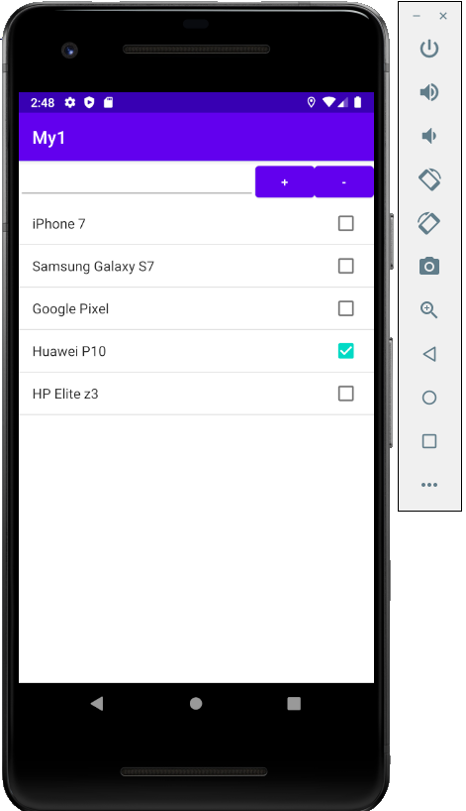

*Activity-main*

<?xml version="1.0" encoding="utf-8"?>  
<LinearLayout xmlns:android="http://schemas.android.com/apk/res/android"  
 android:layout_width="match_parent"  
 android:layout_height="wrap_content"  
 android:orientation="horizontal">  
  
 <ListView android:id="@+id/countriesList"  
 android:layout_height="match_parent"  
 android:layout_width="match_parent" />  
</LinearLayout>

*Mainactivity*

package com.example.my1;  
  
import androidx.appcompat.app.AppCompatActivity;  
import android.os.Bundle;  
import android.view.View;  
import android.widget.AdapterView;  
import android.widget.ListView;  
import android.widget.Toast;  
  
import java.util.ArrayList;  
import java.util.List;  
  
public class MainActivity extends AppCompatActivity {  
  
 private List<State> states = new ArrayList();  
  
 ListView countriesList;  
 @Override  
 protected void onCreate(Bundle savedInstanceState) {  
 super.onCreate(savedInstanceState);  
 setContentView(R.layout.*activity_main*);  
  
 // начальная инициализация списка  
 setInitialData();  
 // получаем элемент ListView  
 countriesList = (ListView) findViewById(R.id.*countriesList*);  
 // создаем адаптер  
 StateAdapter stateAdapter = new StateAdapter(this, R.layout.*list_item*, states);  
 // устанавливаем адаптер  
 countriesList.setAdapter(stateAdapter);  
 // слушатель выбора в списке  
 AdapterView.OnItemClickListener itemListener = new AdapterView.OnItemClickListener() {  
 @Override  
 public void onItemClick(AdapterView<?> parent, View v, int position, long id) {  
  
 // получаем выбранный пункт  
 State selectedState = (State)parent.getItemAtPosition(position);  
 Toast.*makeText*(getApplicationContext(), "Был выбран пункт " + selectedState.getName(),  
 Toast.*LENGTH_SHORT*).show();  
 }  
 };  
 countriesList.setOnItemClickListener(itemListener);  
 }  
 private void setInitialData(){  
  
 states.add(new State ("Бразилия", "Бразилиа", R.drawable.*brazilia*));  
 states.add(new State ("Аргентина", "Буэнос-Айрес", R.drawable.*argentina*));  
 states.add(new State ("Колумбия", "Богота", R.drawable.*columbia*));  
 states.add(new State ("Уругвай", "Монтевидео", R.drawable.*uruguai*));  
 states.add(new State ("Чили", "Сантьяго", R.drawable.*chile*));  
 }  
}

*State*

package com.example.my1;  
  
public class State {  
  
 private String name; // название  
 private String capital; // столица  
 private int flagResource; // ресурс флага  
  
 public State(String name, String capital, int flag){  
  
 this.name=name;  
 this.capital=capital;  
 this.flagResource=flag;  
 }  
  
 public String getName() {  
 return this.name;  
 }  
  
 public void setName(String name) {  
 this.name = name;  
 }  
  
 public String getCapital() {  
 return this.capital;  
 }  
  
 public void setCapital(String capital) {  
 this.capital = capital;  
 }  
  
 public int getFlagResource() {  
 return this.flagResource;  
 }  
  
 public void setFlagResource(int flagResource) {  
 this.flagResource = flagResource;  
 }  
}

*list_item*

<?xml version="1.0" encoding="utf-8"?>  
<LinearLayout xmlns:android="http://schemas.android.com/apk/res/android"  
 android:layout_width="match_parent"  
 android:layout_height="wrap_content"  
 android:orientation="horizontal"  
 android:padding="16dp">  
 <ImageView  
 android:id="@+id/flag"  
 android:layout_marginRight="16dp"  
 android:layout_marginEnd="16dp"  
 android:layout_width="70dp"  
 android:layout_height="50dp" />  
  
 <LinearLayout  
 android:orientation="vertical"  
 android:layout_width="match_parent"  
 android:layout_height="wrap_content">  
  
 <TextView  
 android:id="@+id/name"  
 android:layout_width="wrap_content"  
 android:layout_height="wrap_content"  
 android:text="Название" />  
  
 <TextView  
 android:id="@+id/capital"  
 android:layout_width="wrap_content"  
 android:layout_height="wrap_content"  
 android:text="Столица" />  
  
 </LinearLayout>  
</LinearLayout>

*StateAdapter*

package com.example.my1;  
  
import android.content.Context;  
import android.view.LayoutInflater;  
import android.view.View;  
import android.view.ViewGroup;  
import android.widget.ArrayAdapter;  
import android.widget.ImageView;  
import android.widget.TextView;  
  
import java.util.List;  
  
public class StateAdapter extends ArrayAdapter<State> {  
  
 private LayoutInflater inflater;  
 private int layout;  
 private List<State> states;  
  
 public StateAdapter(Context context, int resource, List<State> states) {  
 super(context, resource, states);  
 this.states = states;  
 this.layout = resource;  
 this.inflater = LayoutInflater.*from*(context);  
 }  
 public View getView(int position, View convertView, ViewGroup parent) {  
  
 View view=inflater.inflate(this.layout, parent, false);  
  
 ImageView flagView = (ImageView) view.findViewById(R.id.*flag*);  
 TextView nameView = (TextView) view.findViewById(R.id.*name*);  
 TextView capitalView = (TextView) view.findViewById(R.id.*capital*);  
  
 State state = states.get(position);  
  
 flagView.setImageResource(state.getFlagResource());  
 nameView.setText(state.getName());  
 capitalView.setText(state.getCapital());  
  
 return view;  
 }  
}

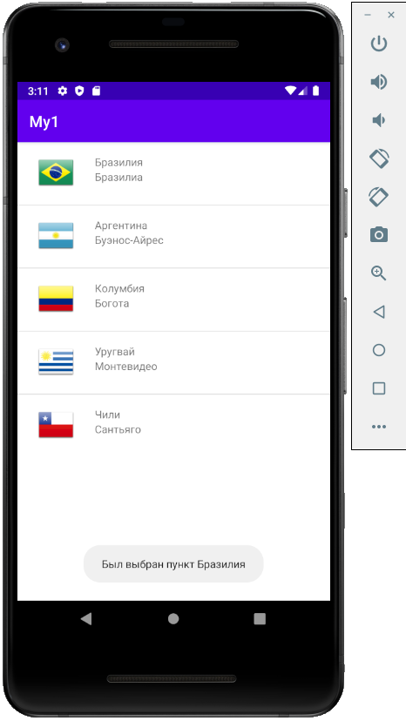

*Activity-main*

<?xml version="1.0" encoding="utf-8"?>  
<LinearLayout xmlns:android="http://schemas.android.com/apk/res/android"  
 android:layout_width="match_parent"  
 android:layout_height="match_parent">  
 <ListView  
 android:id="@+id/productList"  
 android:layout_width="match_parent"  
 android:layout_height="match_parent"/>  
</LinearLayout>

*Mainactivity*

package com.example.my2;  
  
import androidx.appcompat.app.AppCompatActivity;  
import android.os.Bundle;  
import android.widget.ListView;  
import java.util.ArrayList;  
  
public class MainActivity extends AppCompatActivity {  
  
 ArrayList<Product> products = new ArrayList();  
  
 ListView productList;  
 @Override  
 protected void onCreate(Bundle savedInstanceState) {  
 super.onCreate(savedInstanceState);  
 setContentView(R.layout.*activity_main*);  
  
 if(products.size()==0){  
 products.add(new Product("Картофель", "кг."));  
 products.add(new Product("Чай", "шт."));  
 products.add(new Product("Яйца", "шт."));  
 products.add(new Product("Молоко", "л."));  
 products.add(new Product("Макароны", "кг."));  
 }  
 productList = (ListView) findViewById(R.id.*productList*);  
 ProductAdapter adapter = new ProductAdapter(this, R.layout.*list_item*, products);  
 productList.setAdapter(adapter);  
 }  
}

*Product*

package com.example.my2;  
  
public class Product {  
 private String name;  
 private int count;  
 private String unit;  
  
 Product(String name, String unit){  
 this.name = name;  
 this.count=0;  
 this.unit = unit;  
 }  
 public String getUnit() {  
 return this.unit;  
 }  
 public void setCount(int count) {  
 this.count = count;  
 }  
  
 public int getCount() {  
 return count;  
 }  
 public void setName(String name){  
 this.name = name;  
 }  
 public String getName(){  
 return this.name;  
 }  
}

*list_item*

<?xml version="1.0" encoding="utf-8"?>  
<LinearLayout xmlns:android="http://schemas.android.com/apk/res/android"  
 android:layout_width="match_parent"  
 android:layout_height="wrap_content"  
 android:orientation="horizontal"  
 android:padding="16dp">  
  
 <TextView  
 android:id="@+id/nameView"  
 android:layout_width="0dp"  
 android:layout_height="wrap_content"  
 android:layout_weight="2"  
 android:textSize="18sp" />  
 <TextView  
 android:id="@+id/countView"  
 android:layout_width="0dp"  
 android:layout_height="wrap_content"  
 android:layout_weight="2"  
 android:textSize="18sp" />  
 <Button  
 android:id="@+id/addButton"  
 android:layout_width="0dp"  
 android:layout_height="wrap_content"  
 android:layout_weight="1"  
 android:text="+"/>  
 <Button  
 android:id="@+id/removeButton"  
 android:layout_width="0dp"  
 android:layout_height="wrap_content"  
 android:layout_weight="1"  
 android:text="-"/>  
</LinearLayout>

*ProductAdapter*

package com.example.my2;  
  
import android.content.Context;  
import android.view.LayoutInflater;  
import android.view.View;  
import android.view.ViewGroup;  
import android.widget.ArrayAdapter;  
import android.widget.Button;  
import android.widget.TextView;  
  
import java.util.ArrayList;  
  
class ProductAdapter extends ArrayAdapter<Product> {  
 private LayoutInflater inflater;  
 private int layout;  
 private ArrayList<Product> productList;  
  
 ProductAdapter(Context context, int resource, ArrayList<Product> products) {  
 super(context, resource, products);  
 this.productList = products;  
 this.layout = resource;  
 this.inflater = LayoutInflater.*from*(context);  
 }  
 public View getView(int position, View convertView, ViewGroup parent) {  
  
 final ViewHolder viewHolder;  
 if(convertView==null){  
 convertView = inflater.inflate(this.layout, parent, false);  
 viewHolder = new ViewHolder(convertView);  
 convertView.setTag(viewHolder);  
 }  
 else{  
 viewHolder = (ViewHolder) convertView.getTag();  
 }  
 final Product product = productList.get(position);  
  
 viewHolder.nameView.setText(product.getName());  
 viewHolder.countView.setText(formatValue(product.getCount(), product.getUnit()));  
  
 viewHolder.removeButton.setOnClickListener(new View.OnClickListener() {  
 @Override  
 public void onClick(View v) {  
 int count = product.getCount()-1;  
 if(count<0) count=0;  
 product.setCount(count);  
 viewHolder.countView.setText(formatValue(count, product.getUnit()));  
 }  
 });  
 viewHolder.addButton.setOnClickListener(new View.OnClickListener() {  
 @Override  
 public void onClick(View v) {  
 int count = product.getCount()+1;  
 product.setCount(count);  
 viewHolder.countView.setText(formatValue(count, product.getUnit()));  
 }  
 });  
  
 return convertView;  
 }  
  
 private String formatValue(int count, String unit){  
 return String.*valueOf*(count) + " " + unit;  
 }  
 private class ViewHolder {  
 final Button addButton, removeButton;  
 final TextView nameView, countView;  
 ViewHolder(View view){  
 addButton = (Button) view.findViewById(R.id.*addButton*);  
 removeButton = (Button) view.findViewById(R.id.*removeButton*);  
 nameView = (TextView) view.findViewById(R.id.*nameView*);  
 countView = (TextView) view.findViewById(R.id.*countView*);  
 }  
 }  
}

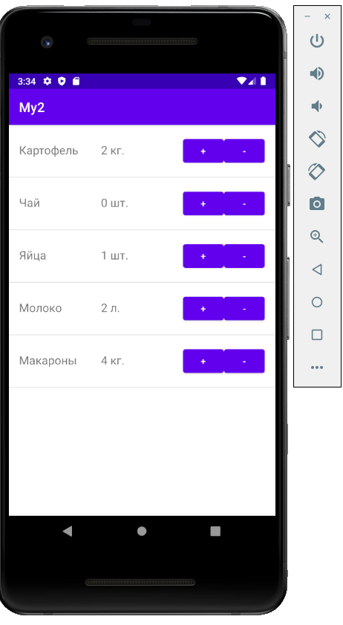

*Activity-main*

<?xml version="1.0" encoding="utf-8"?>  
<LinearLayout xmlns:android="http://schemas.android.com/apk/res/android"  
 android:layout_width="match_parent"  
 android:layout_height="wrap_content"  
 android:orientation="vertical">  
  
 <ListView android:id="@android:id/list"  
 android:layout_height="match_parent"  
 android:layout_width="match_parent" />  
</LinearLayout>

*Mainactivity*

package com.example.my3;  
  
import android.app.ListActivity;  
import android.os.Bundle;  
import android.view.View;  
import android.widget.AdapterView;  
import android.widget.ArrayAdapter;  
import android.widget.Toast;  
  
public class MainActivity extends ListActivity {  
  
 String[] countries = { "Бразилия", "Аргентина", "Колумбия", "Чили", "Уругвай"};  
  
 @Override  
 protected void onCreate(Bundle savedInstanceState) {  
 super.onCreate(savedInstanceState);  
  
 setContentView(R.layout.*activity_main*);  
  
 // создаем адаптер  
 ArrayAdapter<String> adapter = new ArrayAdapter<String>(this,  
 android.R.layout.*simple_list_item_1*, countries);  
 setListAdapter(adapter);  
  
 AdapterView.OnItemClickListener itemListener = new AdapterView.OnItemClickListener() {  
 @Override  
 public void onItemClick(AdapterView<?> parent, View v, int position, long id) {  
  
 Toast.*makeText*(getApplicationContext(), "Был выбран пункт " +  
 parent.getItemAtPosition(position).toString(), Toast.*LENGTH_SHORT*).show();  
 }  
 };  
 getListView().setOnItemClickListener(itemListener);  
 }  
}

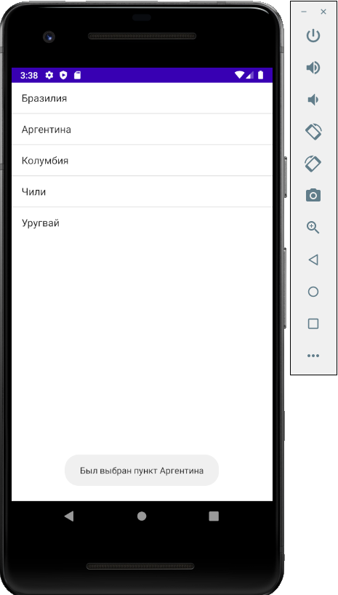

*Activity-main*

<?xml version="1.0" encoding="utf-8"?>  
<LinearLayout xmlns:android="http://schemas.android.com/apk/res/android"  
 android:layout_width="match_parent"  
 android:layout_height="match_parent"  
 android:orientation="vertical" >  
  
 <Spinner  
 android:id="@+id/cities"  
 android:layout_width="match_parent"  
 android:layout_height="wrap_content" />  
  
</LinearLayout>

*Mainactivity*

package com.example.my3;  
  
import androidx.appcompat.app.AppCompatActivity;  
import android.os.Bundle;  
import android.widget.ArrayAdapter;  
import android.widget.Spinner;  
  
public class MainActivity extends AppCompatActivity {  
  
 String[] cities = {"Москва", "Самара", "Вологда", "Волгоград", "Саратов", "Воронеж"};  
 @Override  
 protected void onCreate(Bundle savedInstanceState) {  
 super.onCreate(savedInstanceState);  
 setContentView(R.layout.*activity_main*);  
  
 Spinner spinner = (Spinner) findViewById(R.id.*cities*);  
 // Создаем адаптер ArrayAdapter с помощью массива строк и стандартной разметки элемета spinner  
 ArrayAdapter<String> adapter = new ArrayAdapter<String>(this, android.R.layout.*simple_spinner_item*, cities);  
 // Определяем разметку для использования при выборе элемента  
 adapter.setDropDownViewResource(android.R.layout.*simple_spinner_dropdown_item*);  
 // Применяем адаптер к элементу spinner  
 spinner.setAdapter(adapter);  
 }  
}

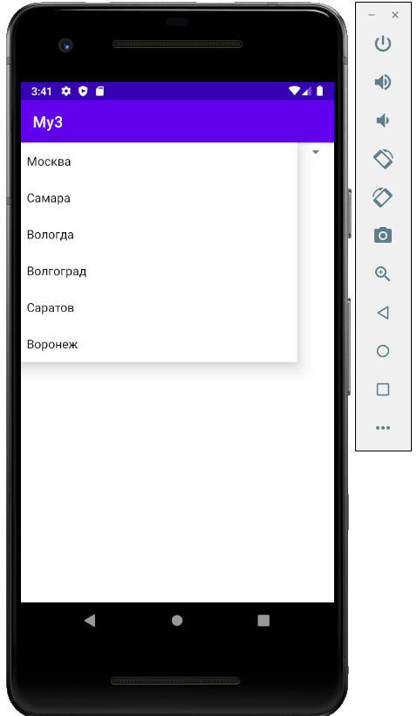

*Activity-main*

<?xml version="1.0" encoding="utf-8"?>  
<LinearLayout xmlns:android="http://schemas.android.com/apk/res/android"  
 android:layout_width="match_parent"  
 android:layout_height="match_parent"  
 android:orientation="vertical" >  
 <TextView  
 android:id="@+id/selection"  
 android:layout_width="match_parent"  
 android:layout_height="wrap_content">  
 </TextView>  
 <Spinner  
 android:id="@+id/cities"  
 android:layout_width="match_parent"  
 android:layout_height="wrap_content" />  
  
</LinearLayout>

*Mainactivity*

package com.example.my3;  
  
import androidx.appcompat.app.AppCompatActivity;  
import android.os.Bundle;  
import android.view.View;  
import android.widget.AdapterView;  
import android.widget.ArrayAdapter;  
import android.widget.Spinner;  
import android.widget.AdapterView.OnItemSelectedListener;  
import android.widget.TextView;  
  
public class MainActivity extends AppCompatActivity {  
  
 String[] cities = {"Москва", "Самара", "Вологда", "Волгоград", "Саратов", "Воронеж"};  
 TextView selection;  
 @Override  
 protected void onCreate(Bundle savedInstanceState) {  
 super.onCreate(savedInstanceState);  
 setContentView(R.layout.*activity_main*);  
  
 selection = (TextView) findViewById(R.id.*selection*);  
  
 Spinner spinner = (Spinner) findViewById(R.id.*cities*);  
 // Создаем адаптер ArrayAdapter с помощью массива строк и стандартной разметки элемета spinner  
 ArrayAdapter<String> adapter = new ArrayAdapter<String>(this, android.R.layout.*simple_spinner_item*, cities);  
 // Определяем разметку для использования при выборе элемента  
 adapter.setDropDownViewResource(android.R.layout.*simple_spinner_dropdown_item*);  
 // Применяем адаптер к элементу spinner  
 spinner.setAdapter(adapter);  
  
 OnItemSelectedListener itemSelectedListener = new OnItemSelectedListener() {  
 @Override  
 public void onItemSelected(AdapterView<?> parent, View view, int position, long id) {  
  
 // Получаем выбранный объект  
 String item = (String)parent.getItemAtPosition(position);  
 selection.setText(item);  
 }  
  
 @Override  
 public void onNothingSelected(AdapterView<?> parent) {  
  
 }  
 };  
 spinner.setOnItemSelectedListener(itemSelectedListener);  
 }  
}

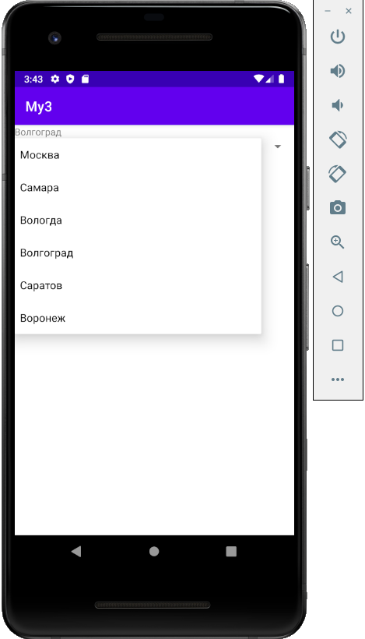

*Activity-main*

<?xml version="1.0" encoding="utf-8"?>  
<LinearLayout xmlns:android="http://schemas.android.com/apk/res/android"  
 android:layout_width="match_parent"  
 android:layout_height="match_parent"  
 android:orientation="vertical" >  
 <AutoCompleteTextView  
 android:id="@+id/autocomplete"  
 android:layout_width="match_parent"  
 android:layout_height="wrap_content"  
 android:completionHint="Введите город"  
 android:completionThreshold="1"/>  
  
</LinearLayout>

*Mainactivity*

package com.example.my3;  
  
import androidx.appcompat.app.AppCompatActivity;  
import android.os.Bundle;  
import android.widget.ArrayAdapter;  
import android.widget.AutoCompleteTextView;  
  
public class MainActivity extends AppCompatActivity {  
  
 String[] cities = {"Москва", "Самара", "Вологда", "Волгоград", "Саратов", "Воронеж"};  
 @Override  
 protected void onCreate(Bundle savedInstanceState) {  
 super.onCreate(savedInstanceState);  
 setContentView(R.layout.*activity_main*);  
  
 // Получаем ссылку на элемент AutoCompleteTextView в разметке  
 AutoCompleteTextView autoCompleteTextView = (AutoCompleteTextView) findViewById(R.id.*autocomplete*);  
 // Создаем адаптер для автозаполнения элемента AutoCompleteTextView  
 ArrayAdapter<String> adapter =  
 new ArrayAdapter<String>(this, R.layout.*support_simple_spinner_dropdown_item*, cities);  
 autoCompleteTextView.setAdapter(adapter);  
 }  
}

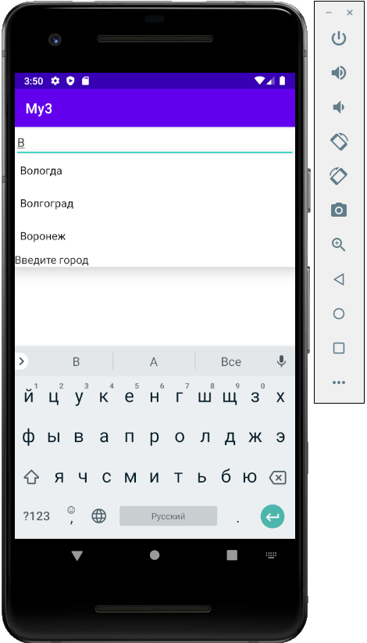

*Activity-main*

<?xml version="1.0" encoding="utf-8"?>  
<LinearLayout xmlns:android="http://schemas.android.com/apk/res/android"  
 android:layout_width="match_parent"  
 android:layout_height="match_parent"  
 android:orientation="vertical" >  
 <MultiAutoCompleteTextView  
 android:id="@+id/autocomplete"  
 android:layout_width="match_parent"  
 android:layout_height="wrap_content"  
 android:completionHint="Введите город"  
 android:completionThreshold="1"/>  
  
</LinearLayout>

*Mainactivity*

package com.example.my3;  
  
import androidx.appcompat.app.AppCompatActivity;  
import android.os.Bundle;  
import android.widget.ArrayAdapter;  
import android.widget.MultiAutoCompleteTextView;  
  
public class MainActivity extends AppCompatActivity {  
  
 String[] cities = {"Москва", "Самара", "Вологда", "Волгоград", "Саратов", "Воронеж"};  
 @Override  
 protected void onCreate(Bundle savedInstanceState) {  
 super.onCreate(savedInstanceState);  
 setContentView(R.layout.*activity_main*);  
  
 // Получаем ссылку на элемент AutoCompleteTextView в разметке  
 MultiAutoCompleteTextView autoCompleteTextView = (MultiAutoCompleteTextView) findViewById(R.id.*autocomplete*);  
 // Создаем адаптер для автозаполнения элемента AutoCompleteTextView  
 ArrayAdapter<String> adapter = new ArrayAdapter<String>(this, R.layout.*support_simple_spinner_dropdown_item*, cities);  
 autoCompleteTextView.setAdapter(adapter);  
 // установка запятой в качестве разделителя  
 autoCompleteTextView.setTokenizer(new MultiAutoCompleteTextView.CommaTokenizer());  
 }  
}

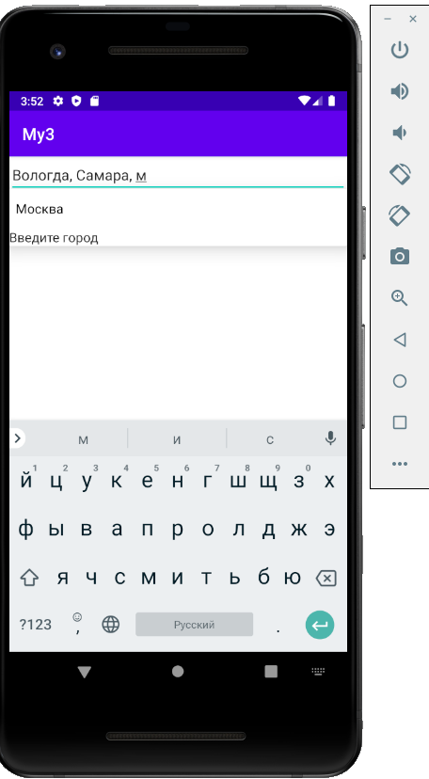

*Activity-main*

<?xml version="1.0" encoding="utf-8"?>  
<LinearLayout xmlns:android="http://schemas.android.com/apk/res/android"  
 android:layout_width="match_parent"  
 android:layout_height="match_parent"  
 android:orientation="vertical" >  
 <GridView  
 android:id="@+id/gridview"  
 android:layout_width="match_parent"  
 android:layout_height="match_parent"  
 android:numColumns="2"  
 android:verticalSpacing="16dp"  
 android:horizontalSpacing="16dp"  
 android:stretchMode="columnWidth" />  
  
</LinearLayout>

*Mainactivity*

package com.example.my3;  
  
import androidx.appcompat.app.AppCompatActivity;  
import android.os.Bundle;  
import android.view.View;  
import android.widget.AdapterView;  
import android.widget.ArrayAdapter;  
import android.widget.GridView;  
import android.widget.Toast;  
  
public class MainActivity extends AppCompatActivity {  
  
 String[] countries = { "Бразилия", "Аргентина", "Чили", "Колумбия", "Уругвай", "Парагвай"};  
 @Override  
 protected void onCreate(Bundle savedInstanceState) {  
 super.onCreate(savedInstanceState);  
 setContentView(R.layout.*activity_main*);  
  
 // получаем элемент GridView  
 GridView countriesList = (GridView) findViewById(R.id.*gridview*);  
  
 // создаем адаптер  
 ArrayAdapter<String> adapter = new ArrayAdapter<String>(this, android.R.layout.*simple_list_item_1*, countries);  
 countriesList.setAdapter(adapter);  
  
 AdapterView.OnItemClickListener itemListener = new AdapterView.OnItemClickListener() {  
  
 @Override  
 public void onItemClick(AdapterView<?> parent, View v,  
 int position, long id) {  
 Toast.*makeText*(getApplicationContext(),"Вы выбрали "  
 + parent.getItemAtPosition(position).toString(),  
 Toast.*LENGTH_SHORT*).show();  
 }  
 };  
 countriesList.setOnItemClickListener(itemListener);  
 }  
}

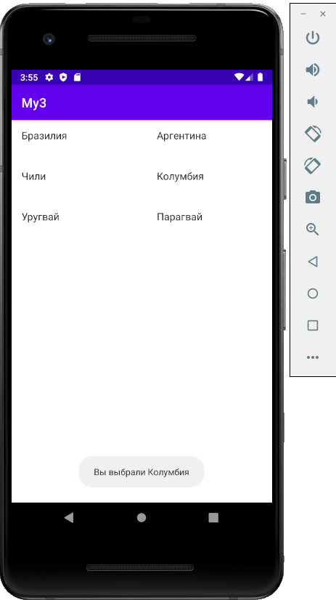

*Mainactivity*

package com.example.my3;  
  
import androidx.appcompat.app.AppCompatActivity;  
import android.os.Bundle;  
import android.view.Menu;  
  
public class MainActivity extends AppCompatActivity {  
  
 @Override  
 protected void onCreate(Bundle savedInstanceState) {  
 super.onCreate(savedInstanceState);  
 setContentView(R.layout.*activity_main*);  
 }  
  
 @Override  
 public boolean onCreateOptionsMenu(Menu menu) {  
  
 getMenuInflater().inflate(R.menu.*main_menu*, menu);  
 return true;  
 }  
}

*Main-menu*

<?xml version="1.0" encoding="utf-8"?>  
<menu xmlns:android="http://schemas.android.com/apk/res/android">  
 <item  
 android:id="@+id/action_settings"  
 android:orderInCategory="1"  
 android:title="Настройки" />  
 <item  
 android:id="@+id/save_settings"  
 android:orderInCategory="3"  
 android:title="Сохранить" />  
 <item  
 android:id="@+id/open_settings"  
 android:orderInCategory="2"  
 android:title="Открыть" />  
</menu>

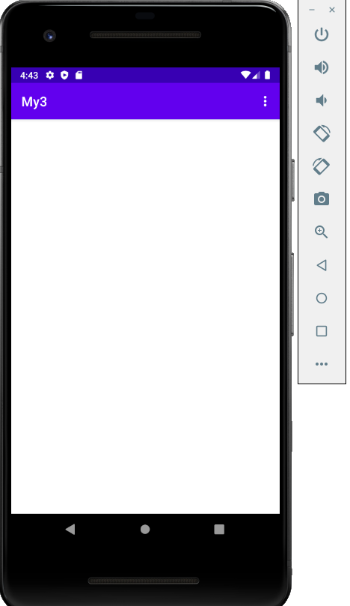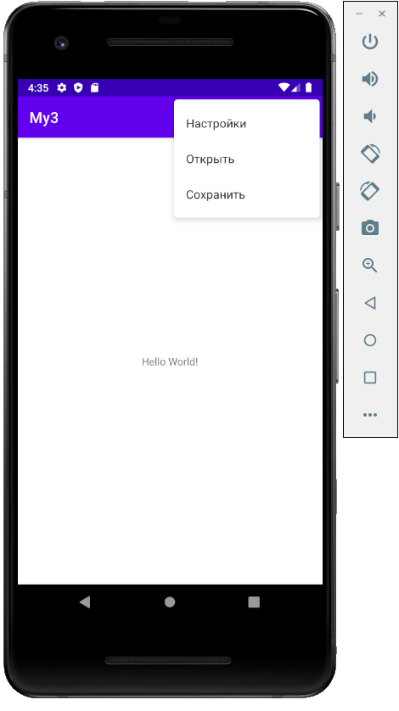

*Activity-main*

<?xml version="1.0" encoding="utf-8"?>  
<RelativeLayout xmlns:android="http://schemas.android.com/apk/res/android"  
 android:id="@+id/activity_main"  
 android:layout_width="match_parent"  
 android:layout_height="match_parent">  
  
 <TextView  
 android:id="@+id/header"  
 android:layout_width="wrap_content"  
 android:layout_height="wrap_content"  
 android:textSize="22sp" />  
</RelativeLayout>

*Mainactivity*

package com.example.my3;  
  
import androidx.appcompat.app.AppCompatActivity;  
import android.os.Bundle;  
import android.view.Menu;  
import android.view.MenuItem;  
import android.widget.TextView;  
  
public class MainActivity extends AppCompatActivity {  
  
 @Override  
 protected void onCreate(Bundle savedInstanceState) {  
 super.onCreate(savedInstanceState);  
 setContentView(R.layout.*activity_main*);  
 }  
  
 @Override  
 public boolean onCreateOptionsMenu(Menu menu) {  
  
 getMenuInflater().inflate(R.menu.*main_menu*, menu);  
 return true;  
 }  
  
 @Override  
 public boolean onOptionsItemSelected(MenuItem item) {  
 int id = item.getItemId();  
 TextView headerView = (TextView) findViewById(R.id.*header*);  
 switch(id){  
 case R.id.*action_settings* :  
 headerView.setText("Настройки");  
 return true;  
 case R.id.*open_settings*:  
 headerView.setText("Открыть");  
 return true;  
 case R.id.*save_settings*:  
 headerView.setText("Сохранить");  
 return true;  
 }  
 return super.onOptionsItemSelected(item);  
 }  
}

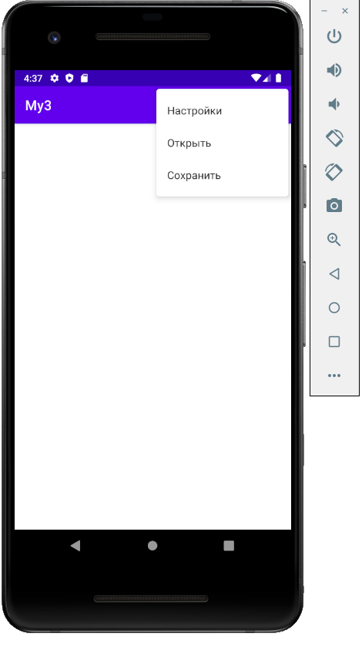

*Main-menu*

<?xml version="1.0" encoding="utf-8"?>  
<menu xmlns:android="http://schemas.android.com/apk/res/android">  
 <item  
 android:id="@+id/action_settings"  
 android:title="Настройки">  
 <menu>  
 <item android:id="@+id/save_settings"  
 android:title="Сохранить" />  
 <item android:id="@+id/open_settings"  
 android:title="Открыть" />  
 </menu>  
  
 </item>  
 <item  
 android:id="@+id/action_move"  
 android:title="Переход">  
 <menu>  
 <item android:id="@+id/forward"  
 android:title="Вперед" />  
 <item android:id="@+id/back"  
 android:title="Назад" />  
 </menu>  
  
 </item>  
</menu>

*Activity-main*

<?xml version="1.0" encoding="utf-8"?>  
<RelativeLayout xmlns:android="http://schemas.android.com/apk/res/android"  
 android:id="@+id/activity_main"  
 android:layout_width="match_parent"  
 android:layout_height="match_parent">  
  
 <TextView  
 android:id="@+id/header"  
 android:layout_width="wrap_content"  
 android:layout_height="wrap_content"  
 android:textSize="22sp" />  
</RelativeLayout>

*Mainactivity*

package com.example.my3;  
  
import androidx.appcompat.app.AppCompatActivity;  
import android.os.Bundle;  
import android.view.Menu;  
import android.view.MenuItem;  
import android.widget.TextView;  
  
public class MainActivity extends AppCompatActivity {  
  
 @Override  
 protected void onCreate(Bundle savedInstanceState) {  
 super.onCreate(savedInstanceState);  
 setContentView(R.layout.*activity_main*);  
 }  
  
 @Override  
 public boolean onCreateOptionsMenu(Menu menu) {  
  
 getMenuInflater().inflate(R.menu.*main_menu*, menu);  
 return true;  
 }  
  
 @Override  
 public boolean onOptionsItemSelected(MenuItem item) {  
 int id = item.getItemId();  
 TextView headerView = (TextView) findViewById(R.id.*header*);  
 if(!item.isChecked()) item.setChecked(true);  
 switch(id){  
 case R.id.*action_settings* :  
 headerView.setText("Настройки");  
 return true;  
 case R.id.*open_settings*:  
 headerView.setText("Открыть");  
 return true;  
 case R.id.*save_settings*:  
 headerView.setText("Сохранить");  
 return true;  
 }  
 return super.onOptionsItemSelected(item);  
 }  
}

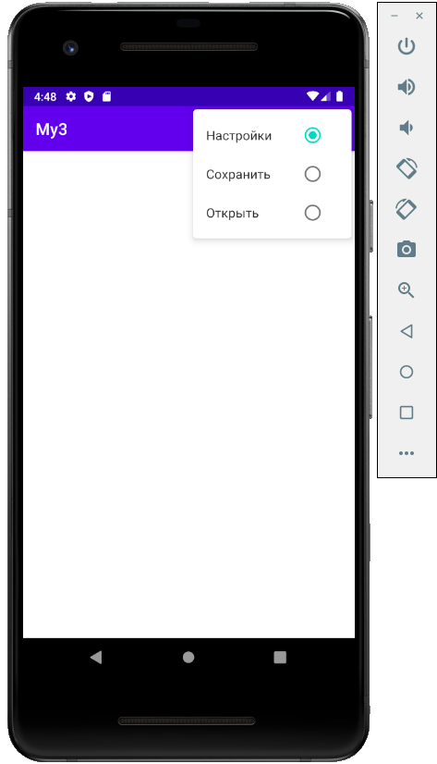

*Mainactivity*

