Boss Clinician
The platform + admin dashboard — a plain-English engineering overview
Audience: an engineer joining the project · bossclinician.callsphere.site · 5-minute read
1. What we're building
Yvette Howard is a licensed therapist who coaches other therapists on how to build their own private practice. She sells online courses, group coaching, a community, live events and digital resources.
Her whole business used to run on Kajabi — a rented all-in-one platform. We've replaced Kajabi with software we own. Same business, but the website, the course player, the checkout, the email marketing and the reporting are now ours: no monthly platform fee, no ceiling on what we can build, and every customer record belongs to her.
There are two halves. The public side is the marketing site plus a member portal where paying customers watch lessons, join the community and book coaching. The private side is the Admin Dashboard — one login where Yvette runs everything: her content, her products, her payments, her marketing and her numbers.
This is a coaching business, not a clinic. No patient data is involved, so there is no HIPAA scope here.
2. Architecture at a glance
Four small services on one server, talking to three outside providers. Nothing exotic.
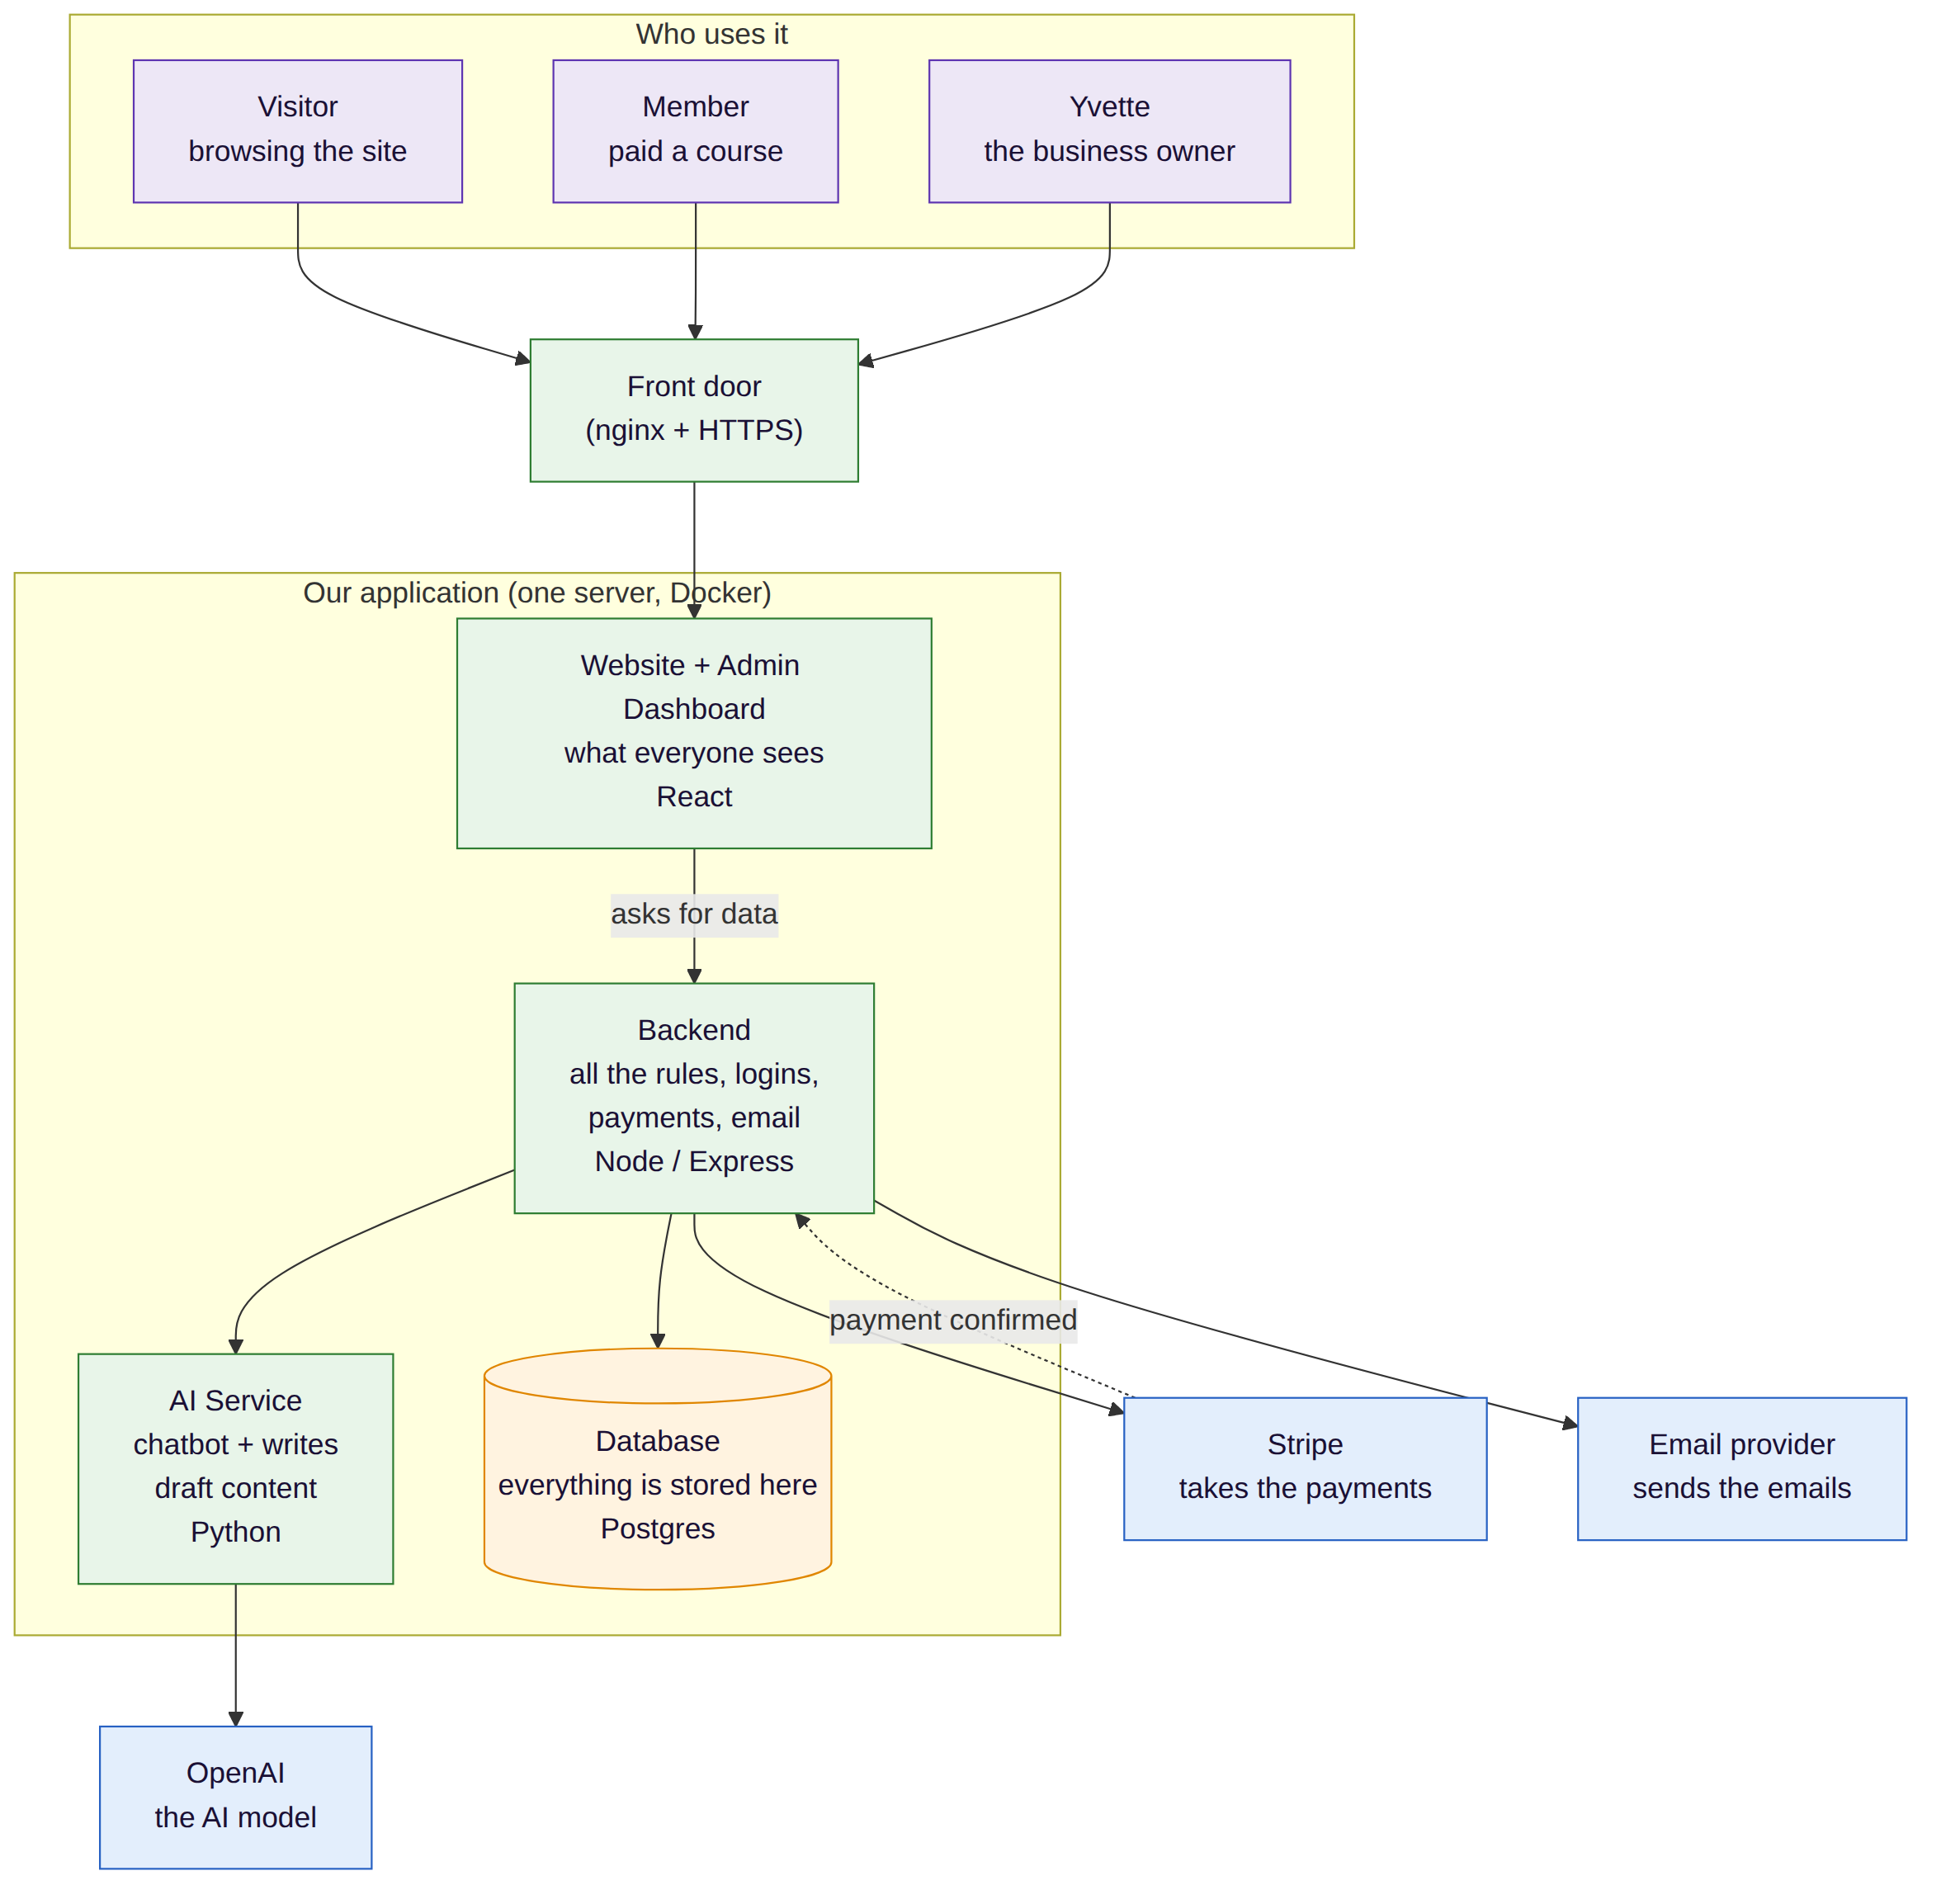
Figure 1 — Green = our code, orange = our database, blue = outside services we pay for.
Piece | What it does | Built with
Front door | Terminates HTTPS and routes each request to the right service. | nginx
Website + Admin | Everything anyone sees — public site, member portal, admin dashboard. | React + Vite + TypeScript
Backend | The rules: logins, permissions, content, checkout, email, reporting. | Node + Express + TypeScript
AI Service | The site chatbot, plus drafting blog posts and scoring incoming leads. | Python + FastAPI + OpenAI
Database | One place where all of it lives — content, contacts, orders, progress. | Postgres

It all runs in Docker on our own VPS, behind a real TLS certificate that renews itself. The browser never talks to the AI or the database directly — everything goes through the backend, so keys and data stay server-side.

3. The Admin Dashboard — the heart of the product
This is the part that replaces Kajabi. One login at /admin, six areas, and Yvette never has to touch another tool or ask a developer to change her own website.
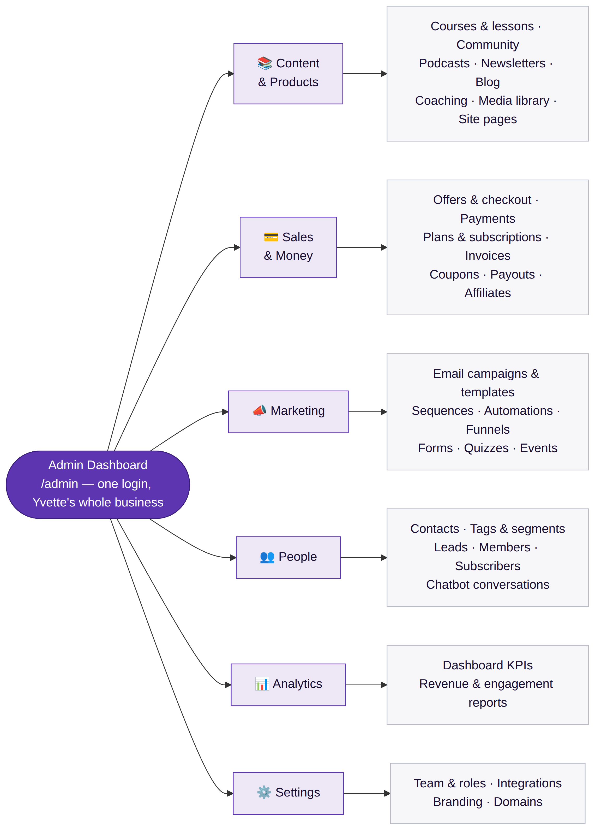
Figure 2 — The admin dashboard, grouped the way the sidebar is grouped.
Area | What she can do without any help
Content & Products | Build courses lesson by lesson, run the community, publish blog posts, podcasts and newsletters, upload images and video, edit the marketing pages themselves.
Sales & Money | Create an offer with its own checkout page, see payments and subscriptions, issue invoices and coupons, pay affiliate partners.
Marketing | Send campaigns, build automated email sequences, run funnels, forms, quizzes and event registrations — all triggered by what people actually do.
People | One record per person: what they opened, what they bought, how far they are through a course, every chatbot conversation. Tag and segment them.
Analytics | Revenue, signups, engagement and course completion, on a dashboard and in saved reports.
Settings | Invite team members with roles, connect outside tools, change branding and domains.

4. How a customer moves through it
Figure 3 — Stranger to member. Every step writes to the same contact record.
The thing worth understanding: this is one loop, not seven disconnected tools. A visitor who takes the quiz, a lead the chatbot talked to, a customer who bought last year and a member halfway through a course are all the same row in the database — so an email sequence can react to a purchase, and a report can tell you which blog post eventually produced a sale.
5. Where things stand & how you'd work on it
- Live in production. Public site, member portal, admin dashboard and chatbot are all deployed and running.
- Security pass done. Rate limiting, hashed passwords, JWT sessions, role checks, locked-down headers, non-root containers.
- Deploy is boring on purpose. One docker compose build + up on the server; no pipeline to learn.
- The contract is written down. ARCHITECTURE.md lists every API endpoint and database table; DEPLOY.md covers running it.
- Conventions. TypeScript strict on both ends, JSON is camelCase, no secrets in git, the site still renders if the API is down.
Good first task: pick one admin screen, follow it from the React page → the /api/admin route → the Postgres table. The whole codebase repeats that same three-step shape.

Appendix — diagram source (Mermaid)
Paste into any Mermaid renderer (GitHub, mermaid.live, VS Code) to edit the diagrams above.
Figure 1 — Architecture
flowchart TD
subgraph PEOPLE["Who uses it"]
V["Visitor<br/>browsing the site"]
M["Member<br/>paid a course"]
Y["Yvette<br/>the business owner"]
end
NG["Front door<br/>(nginx + HTTPS)"]
subgraph OURS["Our application (one server, Docker)"]
FE["Website + Admin Dashboard<br/>what everyone sees<br/>React"]
BE["Backend<br/>all the rules, logins,<br/>payments, email<br/>Node / Express"]
AI["AI Service<br/>chatbot + writes<br/>draft content<br/>Python"]
DB[("Database<br/>everything is stored here<br/>Postgres")]
end
STRIPE["Stripe<br/>takes the payments"]
OPENAI["OpenAI<br/>the AI model"]
MAIL["Email provider<br/>sends the emails"]
V --> NG
M --> NG
Y --> NG
NG --> FE
FE -->|"asks for data"| BE
BE --> DB
BE --> AI
AI --> OPENAI
BE --> STRIPE
STRIPE -.->|"payment confirmed"| BE
BE --> MAIL
classDef people fill:#EDE7F6,stroke:#5E35B1,color:#1A1035;
classDef app fill:#E8F5E9,stroke:#2E7D32,color:#1A1035;
classDef store fill:#FFF3E0,stroke:#E08600,color:#1A1035;
classDef ext fill:#E3EEFC,stroke:#2761C3,color:#1A1035;
class V,M,Y people;
class FE,BE,AI,NG app;
class DB store;
class STRIPE,OPENAI,MAIL ext;
Figure 2 — Admin dashboard map
flowchart LR
ADMIN(["Admin Dashboard<br/>/admin — one login, Yvette's whole business"])
ADMIN --> C["📚 Content<br/>& Products"]
ADMIN --> S["💳 Sales<br/>& Money"]
ADMIN --> MK["📣 Marketing"]
ADMIN --> P["👥 People"]
ADMIN --> AN["📊 Analytics"]
ADMIN --> ST["⚙️ Settings"]
C --> C1["Courses & lessons · Community<br/>Podcasts · Newsletters · Blog<br/>Coaching · Media library · Site pages"]
S --> S1["Offers & checkout · Payments<br/>Plans & subscriptions · Invoices<br/>Coupons · Payouts · Affiliates"]
MK --> M1["Email campaigns & templates<br/>Sequences · Automations · Funnels<br/>Forms · Quizzes · Events"]
P --> P1["Contacts · Tags & segments<br/>Leads · Members · Subscribers<br/>Chatbot conversations"]
AN --> A1["Dashboard KPIs<br/>Revenue & engagement reports"]
ST --> T1["Team & roles · Integrations<br/>Branding · Domains"]
classDef hub fill:#5E35B1,stroke:#3A1F7A,color:#FFFFFF;
classDef grp fill:#EDE7F6,stroke:#5E35B1,color:#1A1035;
classDef leaf fill:#F7F7F9,stroke:#B9BCC6,color:#1A1035;
class ADMIN hub;
class C,S,MK,P,AN,ST grp;
class C1,S1,M1,P1,A1,T1 leaf;
Figure 3 — Customer journey
flowchart LR
A["Finds the site<br/>blog, quiz, ad"] --> B["Chatbot answers<br/>questions"]
B --> C["Leaves an email<br/>free guide / masterclass"]
C --> D["Automated email<br/>sequence nurtures them"]
D --> E["Buys a course or<br/>coaching (Stripe)"]
E --> F["Becomes a member<br/>logs in to the portal"]
F --> G["Watches lessons,<br/>joins the community,<br/>books coaching"]
G --> H["Yvette sees all of it<br/>in the Admin Dashboard"]
classDef pre fill:#E3EEFC,stroke:#2761C3,color:#1A1035;
classDef buy fill:#FFF3E0,stroke:#E08600,color:#1A1035;
classDef post fill:#E8F5E9,stroke:#2E7D32,color:#1A1035;
class A,B,C,D pre;
class E buy;
class F,G,H post;

