Website Planning Document

Fairweatherweatherman.com

Site Purpose

The purpose for this site is to inform those locally of the weather forecast. This will help them prepare for rain or snow storms, natural disasters, water conservation, and fair weather activities.

Target Audience

The target audience of this site are those that live in the area and those that are traveling to the area. Mainly adults 20+ years old and the rare youth who are interested in these things. It is a good resource for homeowners and business owners alike.

Site Map

Color Scheme

#FFFF00

#FFC000

#0000FF

#00B050

#78F049

#00B0F0

These are the colors I will work with, but they are subject to change.

Typography

Times New Romans = Title/headings

Calibri = main text

Wire Frame

Large

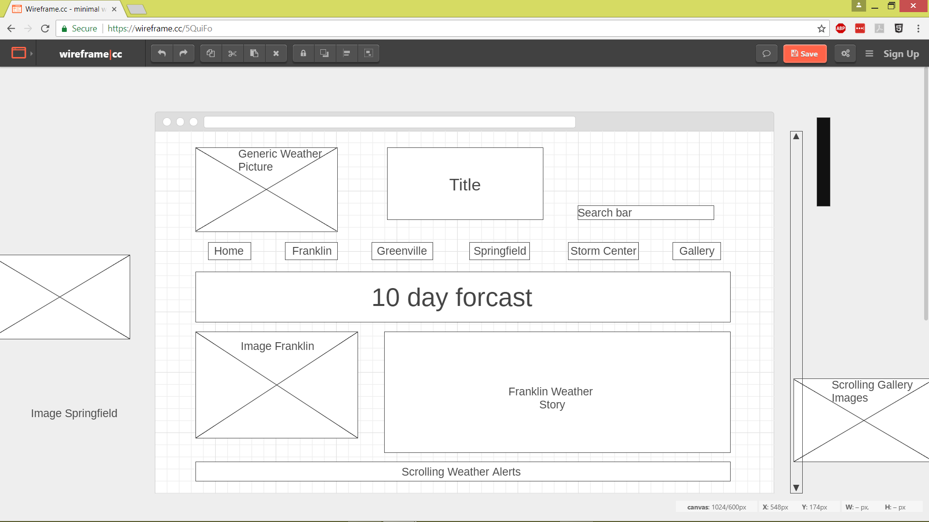

Medium

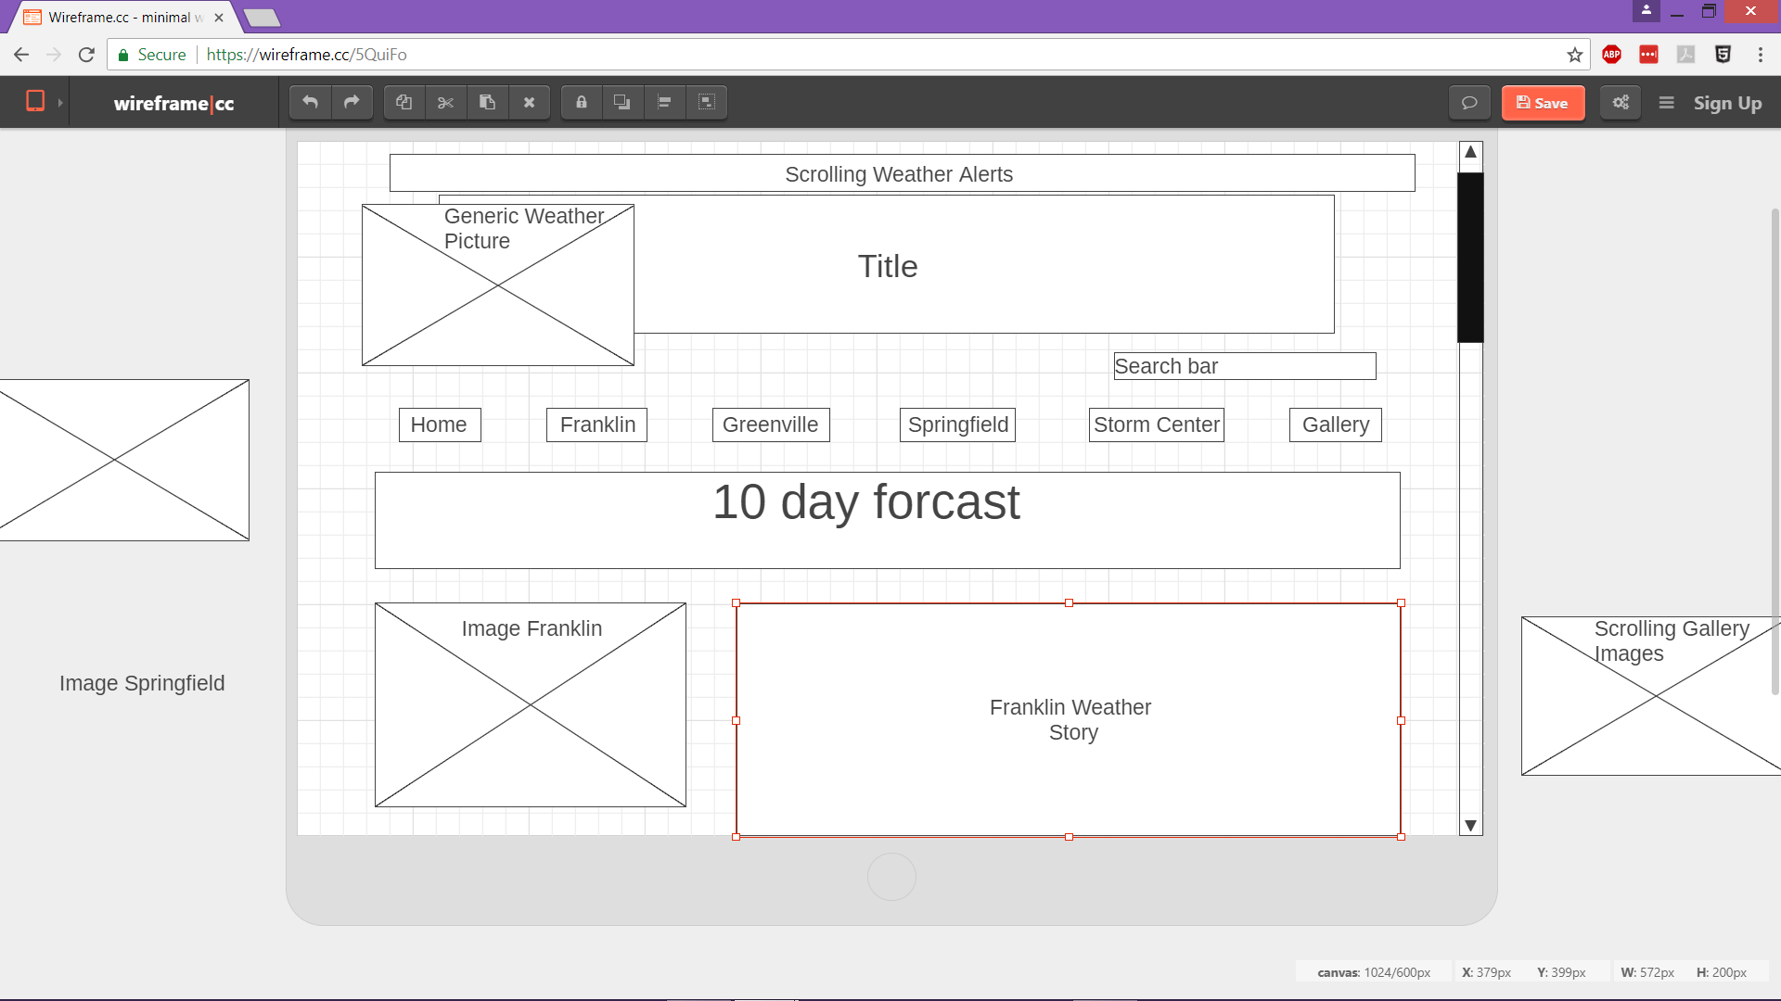

Small

