# Table of Contents

Table of Contents iii

1 Introduction 1

1.1 Background 1

1.2 Usage 1

2 Hydrologic Processes 2

2.1 Overview 2

2.2 Upper Catchment 2

2.3 Catchment Routing 2

2.4 Channel Routing 3

# Introduction

## Background

This user manual serves as documentation for the software package Mydro (Mannings-Hydrology). The Mydro software package consists of the Runoff-Routing software (Mydro) and the QGIS plugin for spatial subcatchment management (QMydro). Mydro facilitates end-to-end hydrologic analysis, providing autocalibration methods, rainfall file management, and generation of TUFLOW-ready input files. Drawing inspiration from URBS (Don Carroll, 2009), Mydro has reworked each stage of runoff-routing to minimize global parameter sensitivity, where global parameters in Mydro are primarily utilized for fine-tuning.

This manual is intended to provide an overview to the hydrologic principals, model schematization, and guidance for conducting hydrologic analysis using Mydro.

## Installation

The Mydro package consists of the Mydro User Manual, QMydro zip file for QGIS plugin installable from the QGIS plugin manager as in Figure 1, and the Mydro root folder with the Mydro executable.

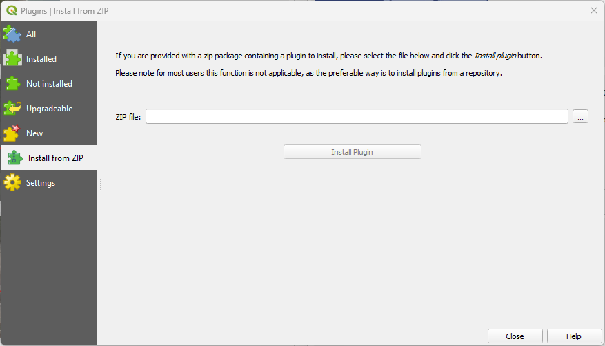

Figure 1: QMydro QGIS Installation

# QMydro User Manual

## Overview

The QMydro QGIS plugin is designed to estimate the required catchment characteristics for Mydro. The plugin uses raw Digital Elevation Models (DEMs) with user defined outlets, as vector line geometries. In addition to the subcatchment manager the QMydro plugin offers supplementary rainfall file generation for Australia by scraping ARR datahub, and a simulation manager designed to aid calibration efforts.

## Algorithms

The plugin employs the D8 algorithm to determine drainage direction. One notable drawback of the D8 algorithm is the “Snapping” of flow direction to a maximum of 22.5º. Alternative methods like that proposed of CatchmentSIM, uses a modification of Lea’s (1992) algorithm, where the drainage direction is defined as a vector. While this method can yield more precise results for flow path length and slope, the additional precision did not warrant the computational effort.

Both channel and catchment slopes are estimated from the Equal Area slope, where no substantial slope is determined a minimum of 0.0005m/m is adopted.

## Hydraulic Enforcements

The QMydro plugin offers optional user defined elevation “carving”, through vector line geometries to enforce flow through elevation embankments.

## Catchment Characteristics

Subcatchment characteristics as calculated from QMydro include:

* Subcatchment Area (km2)
* Main Channel Length (km)
* Characteristic Hill Length (km)
* Characteristic Hill Slope (m/m)
* Kappa (Dimensionless)
* Delta (Dimensionless)
* Subcatchment Routing Definition

Notably, there are significant differences in comparison to CatchmentSIM estimates of URBS parameters. The main channel length is defined as the maximum accumulation flow path to the subcatchment divide. An exception is made for self-contained subcatchments, where the main flow path is determined by upstream cells accounting for more than 12.5% of the subcatchment area. Similarly, Mydro’s hill slope is defined differently from CatchmentSIM’s estimation of Catchment Slope for URBS. The key distinction lies in the definition of hill length which is the distance from the top of the catchment to the main stream path.

The parameters of Kappa and Delta are calculated from the user defined subcatchment outlets which are used as channel cross-sections. It is recommended that the user defines outlets from lines that are representative of the channel cross section. Where Mydro is not confident that the user outlet represents a channel cross-section, kappa and delta are returned as zero. Where Mydro will interpret kappa and delta as default 0.3 and -0.3 respectively.

## Outputs

QMydro outputs several files that can be used for hydrological analysis including:

* Accumulation Raster
* Subcatchment Polygons
* Main Stream Path Vectors
* Mydro Routing Definition File
* Mydro Subcatchment Characteristics File

# Hydrologic Processes

## Overview

Mydro has three stages to rainfall runoff routing. Including upper catchment routing, catchment routing and channel routing, each stage is approached differently and is summarized in following sections and as in Figure 2.

Figure 2: Mydro Hydrologic Processes Overview

## Upper Catchment

When rainfall is first introduced to the subcatchment, the rainfall is transformed into catchment storage from volume of water down a characteristic hill slope (HS) with a defined characteristic hill length (HL). Velocity of water down the catchment relief was estimated using the catchment relief flow velocities from Department of Transport Queensland.

Table 1: Catchment Relief Flow Velocities

|  |  |  |
| --- | --- | --- |
| Catchment Relief | Flow Velocity (km/h) | Flow Velocity (m/s) |
| Flat (0 – 0.015) | 1.1 | 0.31 |
| Rolling Hills (0.015 – 0.04) | 2.5 | 0.69 |
| Hilly (0.04 – 0.08) | 3.2 | 0.89 |
| Steep (0.08 – 0.15) | 5.4 | 1.50 |
| Mountainous (>0.15) | 10.8 | 3.00 |

## Catchment Routing

Catchment routing is defined as the non-linear storage-discharge relationship of:

$Q= \sqrt[m]{\frac{S_{catch} ×{(1+U)}^{2}}{β L_{Hill} ×{(1+F)}^{2}}}$ (1)

Where; -

$Q$ = Discharge (m3/s)

= Catchment Storage (m3)

= Characteristic Hill Length (m)

$β$ = Catchment Lag Parameter (Default $β$ = 10)

$m$ = Catchment Non-Linearity Parameter (Default $m$ = 0.6)

$U$ = Fraction Urbanized

$F$ = Fraction Forested

## Channel Routing

Channel Routing is defined as the storage-discharge relationship of:

$Q=\frac{1}{1-x}\left\{\frac{1}{α ∙ n}A\sqrt{S_{c}} \left[κ\ln{(A)}+δ\right]\right\}-xI$ (2)

Where; -

$Q$ = Discharge (m3/s)

= Alpha Parameter (Channel Lag)

$A$ = Conveyance Area (Estimated from Storage/Channel Length)

$S_{c}$ = Channel Slope (m/m)

$κ$ = Kappa Parameter (Estimated from channel characteristics Default $κ$ = 0.3)

$δ$ = Delta Parameter (Estimated from channel characteristics Default $δ$ = -0.3)

$n$ = Mannings Roughness (Default $n$ = 0.03)

$x$ = Translation Parameter (Default $x$ = 0.0)

$I$ = Upstream Channel Inflow (m3/s)

# Running Mydro

## Overview

A typical Mydro model folder structure is suggested to look like that shown below.

.

└── ModelName/

├── Model/

│ ├── Catchment/

│ │ ├── Outputs/

│ │ │ ├── _RoutingFile.vec

│ │ │ ├── _SubcatFile.csv

│ │ │ ├── acc.tif

│ │ │ ├── NodalLinks.*

│ │ │ ├── streams.*

│ │ │ └── SubCatchments.*

│ │ ├── ModelName_CarveLayer_01.*

│ │ ├── ModelName_OutletsLayer_01.*

│ │ └── ModelName_Elevation_01.tif

│ └── Rainfall/

│ ├── RF/

│ │ └── RF_~AEP~_~DUR~.csv

│ ├── Temporal_Patterns/

│ │ └── ...

│ ├── ARFs.csv

│ ├── data.txt

│ ├── IFD.csv

│ ├── initialLosses.csv

│ └── ModelName_IL_PreBurst_001.trd

├── Recorded/

│ └── ModelName_RecordedFlows.csv

└── Run/

├── E1a/

│ ├── ~AEP~_~DUR~_~ENS~.csv

│ └── ~AEP~_~DUR~_~ENS~_local.csv

├── C1a/

│ ├── C1a_Jan2021_Output.csv

│ └── C1a_Jan2021_Output_Local.csv

├── csv/

│ ├── ModelName_E1a_dbase_01.csv

│ ├── ModelName_E1b_PMP_dbase_01.csv

│ ├── ModelName_C1a_Jan2021_505001_dbase_01.csv

│ ├── ModelName_C1b_Jan2021_505002_dbase_01.csv

│ ├── ModelName_C2a_Feb2022_505001_dbase_01.csv

│ └── ModelName_C2b_Feb2022_505002_dbase_01.csv

├── run_allModels.bat

├── run_E.bat

├── run_C.bat

├── run_C1a.bat

├── ModelName_E1a_01.mcf

├── ModelName_E1b_PMP_01.mcf

├── ModelName_E2a_CC_01.mcf

├── ModelName_C1a_Jan2021_505001_01.mcf

├── ModelName_C1b_Jan2021_505002_01.mcf

├── ModelName_C2a_Feb2022_505001_01.mcf

└── ModelName_C2b_Feb2022_505002_01.mcf

## Routing Definition File

The routing file format is used to define network routing order. The QMydro QGIS plugin can be used in aid to the development of the routing definition file. Additionally, hydrograph routing can be routed through defined storages which can be defined through the storage discharge pairs: {STORAGE (ML), Discharge (Cumecs)}. A typical Routing Definition file is shown below.

MODELNAME

RAIN #3

STORE.

RAIN #4

GET.

ROUTE THRU #2

ADD RAIN #2

STORE.

RAIN #5

STORE.

RAIN #6

DAM ROUTE VBF = 0 NUMBER = 6 {Volume Before Flow = 0}

0.000 0

30.000 3.3

65.000 7.7

80.000 18.7

120.000 29.8

165.000 100.5

GET.

ROUTE THRU #1

ADD RAIN #1

GET.

END OF CATCHMENT DATA.

## Subcatchment Characteristics File

The subcatchment characteristics file is used to define subcatchment characteristics used in the routing definition file. Required characteristics include:

* Index
* Area (km2)
* L – Main Channel Length (km2)
* Sc – Equal Area Channel Slope (m/m)
* HL – Characteristic Hill Length
* HS – Equal Area Characteristic Hill Slope (m/m)

Optional characteristics include:

* N – Mannings n (Default 0.03)
* k – Kappa (A value of zero defaults to 0.3)
* d – Delta (A value of zero defaults to -0.3)
* I – Fraction Impervious (1.0 is 100% Impervious)
* UL – Low Density Residential (1.0 is 100% Coverage)
* UM – Medium Density Residential (1.0 is 100% Coverage)
* UH – High Density Residential (1.0 is 100% Coverage)
* UF – Urban Forest (1.0 is 100% Coverage)

A Typical subcatchment characteristics file is shown below utilizing all characteristics.

Index,Area,L,Sc,N,HL,HS,k,d,I,UL,UM,UH,UF

1,1.87,2.34,0.0005,0.020,0.72,0.003,0.33,-0.476,0.7,0.0,0.9,0.1,0.0

2,1.76,2.51,0.0038,0.035,0.39,0.014,0.00, 0.000,0.0,0.0,0.0,0.0,0.8

3,0.87,2.16,0.0119,0.040,0.29,0.025,0.50,-0.912,0.2,0.7,0.0,0.0,0.0

4,2.01,2.70,0.0100,0.040,0.66,0.016,0.65,-1.404,0.1,0.5,0.0,0.0,0.0

5,0.73,1.59,0.0024,0.040,0.37,0.020,0.49,-1.138,0.1,0.4,0.0,0.0,0.0

6,0.96,2.12,0.0080,0.035,0.24,0.016,0.40,-0.674,0.0,0.0,0.0,0.0,1.0

## Database File

## Mydro Control File

Mydro is controlled through a Mydro Control File (.mcf). Example format Mydro Control Files are shown below.

Single run Mydro Control File:

! Mandatory Args

run=single

cat=..\Model\catch\Outputs\_SubcatFile.csv

vec=..\Model\catch\Outputs\_RoutingFile.vec

IL=35

CL=1.0

dbase=bc_dbase_single.csv

! Optional Args

X=0.0

N=1.0

a=1.0

b=10

m=0.6

output=Output.csv

Batch Processing Mydro Control File:

! Mandatory Args

run=batch

cat=..\Model\catch\Outputs\_SubcatFile.csv

vec=..\Model\catch\Outputs\_RoutingFile.vec

IL=..\Model\EPR_InitialLosses.csv

CL=1.7

! Design Runs

dbase=bc_dbase_des.csv

aep=063,039,020,010,005,002,001

dur=015m,020m,030m,045m,060m,090m,120m,180m,270m,360m

ensemble=E0,E1,E2,E3,E4,E5,E6,E7,E8,E9

! Optional Args

X=0.1

N=1.0

a=1.0

b=10

m=0.6

! Optional Output File Names

outputDir=output

## Initial Loss Database

## Databases