CIST1300-001 Assignment 1

Due Date- 02/20/2019 11:50 PM

Points- 50

Objective- This assignment expects you to create 1 web-page using HTML and CSS.

1. Now that we are familiar with Git and gitlab, in your local workstation create a folder named “Assignment1” no space between the word Assignment and1.
2. In the Assignment1 folder please create a new file index.html
3. Please check the screenshot below or visit the website (<http://blastcleanersdirectory.com/index.html>), the problem with the current website is it isn’t responsive. When you try to use the inspect element and try to use a smaller device such as phone the menu options overlap, please check the figure 2.

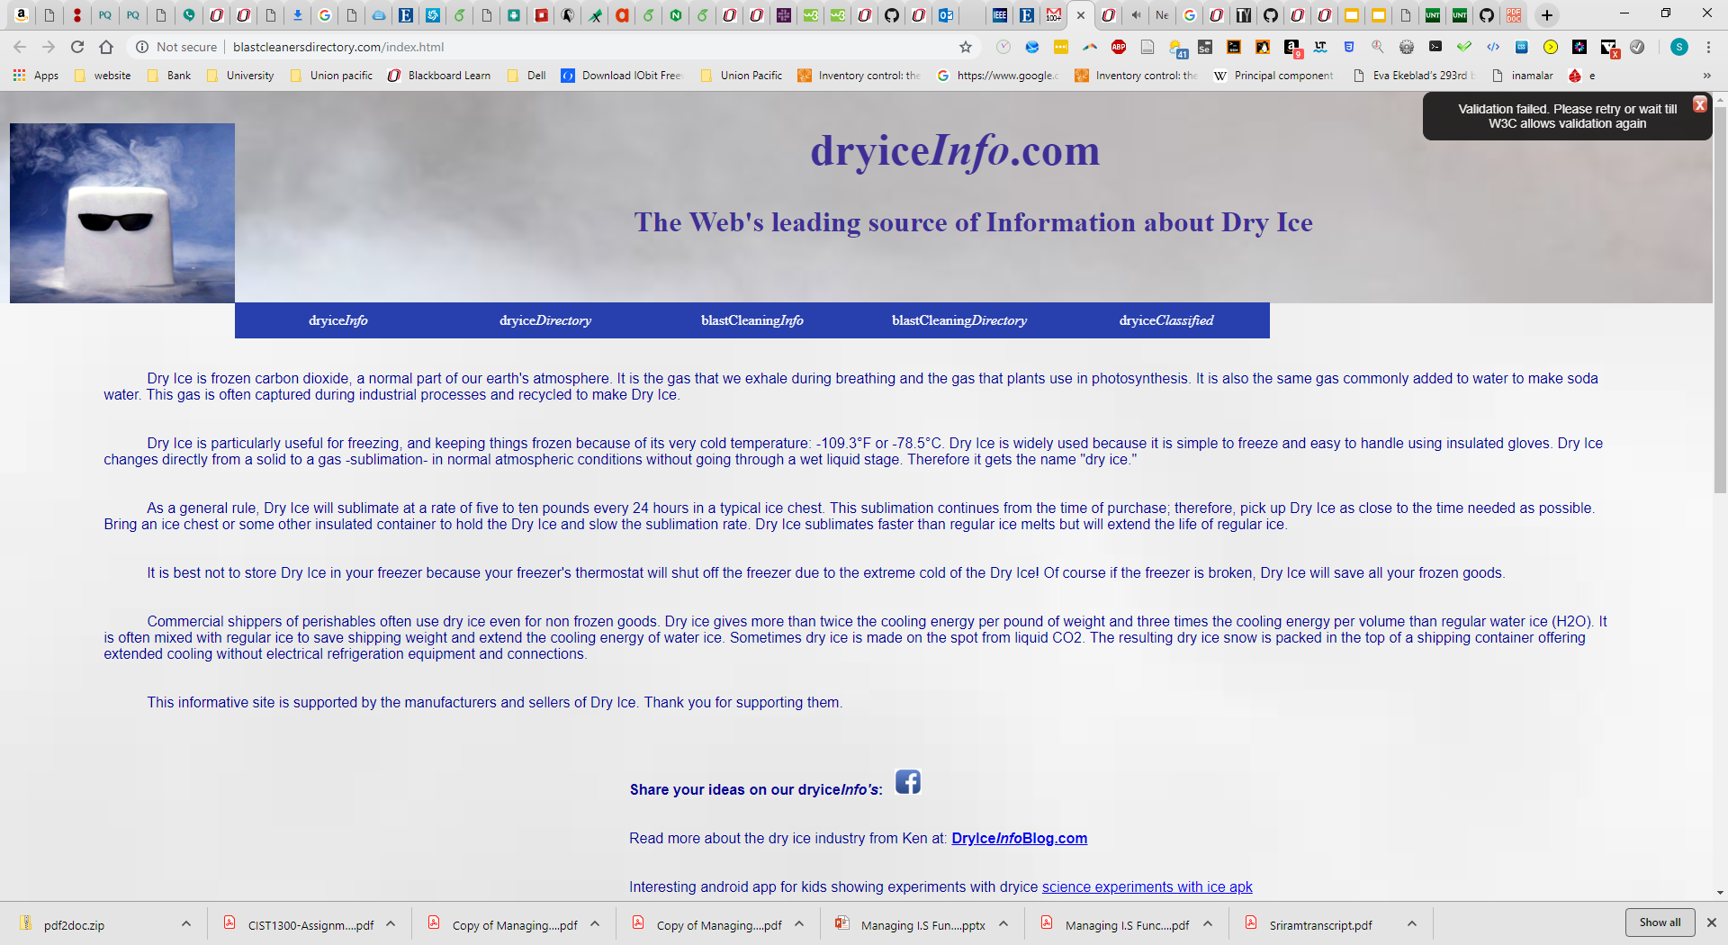

Figure 1:- Screenshot website

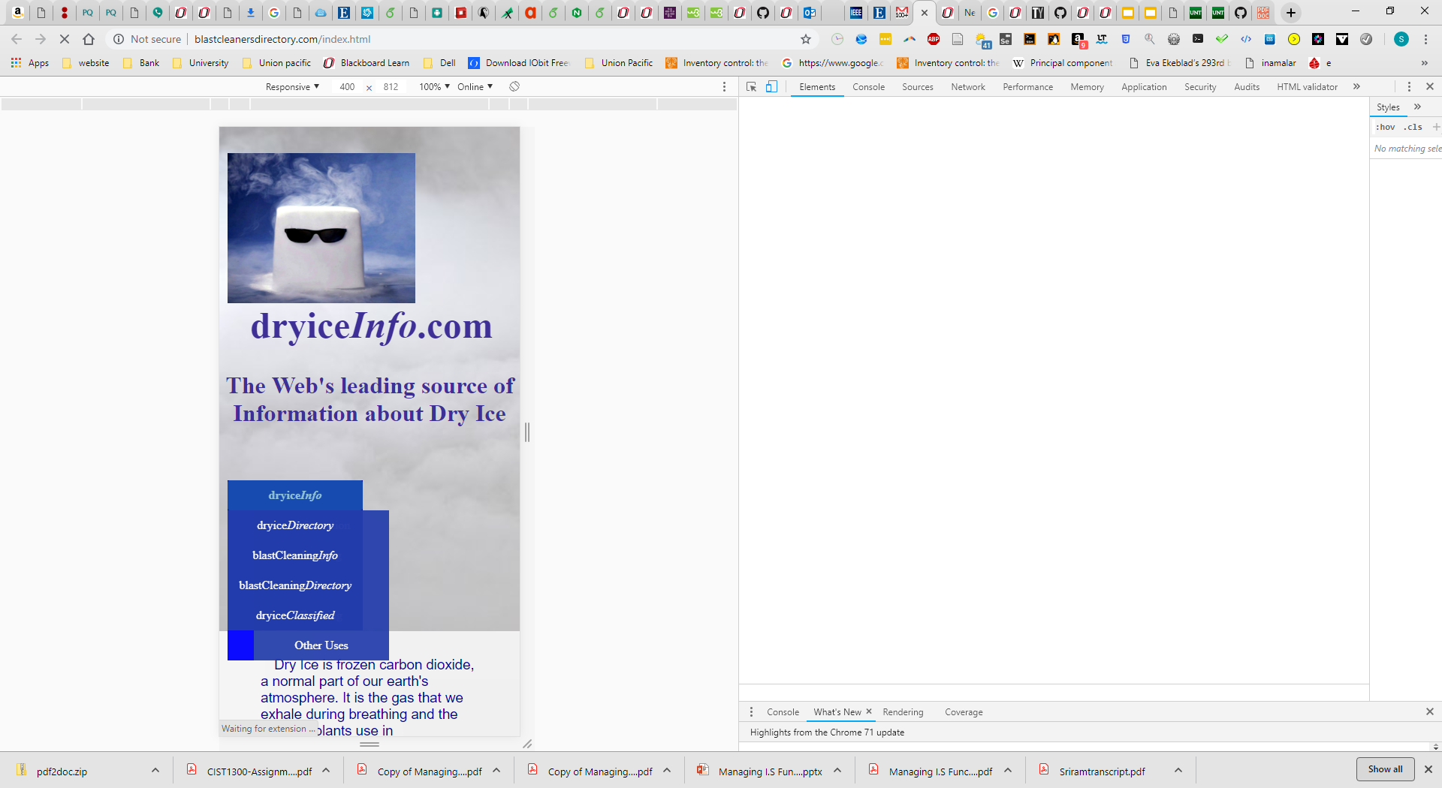

**Figure 2:- Menu options overlap**

I want everyone to redesign the webpage. You can use a different pic, however, the menu shouldn’t overlap. Please re-design just the header section of the webpage, make it user-friendly and responsive. When I say responsive the menu shouldn’t overlap when I try to use other devices such as phone or tablet.

1. Please use the necessary HTML elements such as menu, links, and various text formatting elements to make the website menu option organized.
2. This lab involves you to be creative, you have the content already. All you need is to design the webpage to be responsive and mobile-friendly.
3. The menu options contain a link to other pages, you don’t need to explicitly redirect to those links, you can just redirect to your home page or google.
4. Develop locally, once ready after testing, push to git and Loki and complete the reflection.

Grading Rubric:-

|  |  |
| --- | --- |
| Design | 10 |
| Usage of Proper HTML | 20 |
| Elements & website responsiveness |  |
| Sync Git, push to Loki, code | 10 |
| Quality & reflection |  |