Cyber Security Fundamentals Assessment Report
Submitted by: Abhishek Singh

1. Introduction
This report summarizes the tasks completed as part of the Cyber Security Fundamentals Assessment. The assessment involved setting up a Kali Linux virtual machine, researching common cybersecurity vulnerabilities and attacks, developing a Python script to test website connectivity, and documenting the learning experience gained during the process. The objective was to strengthen fundamental cybersecurity knowledge and demonstrate practical skills in Linux, security concepts, programming, and documentation.

2. Findings

Task 1: Kali Linux Installation
Objective: Install Kali Linux in a virtual environment and configure networking.
Findings:
- Successfully installed Kali Linux using VirtualBox.
- Configured network connectivity.
- Verified internet access.
- Explored the available security tools.

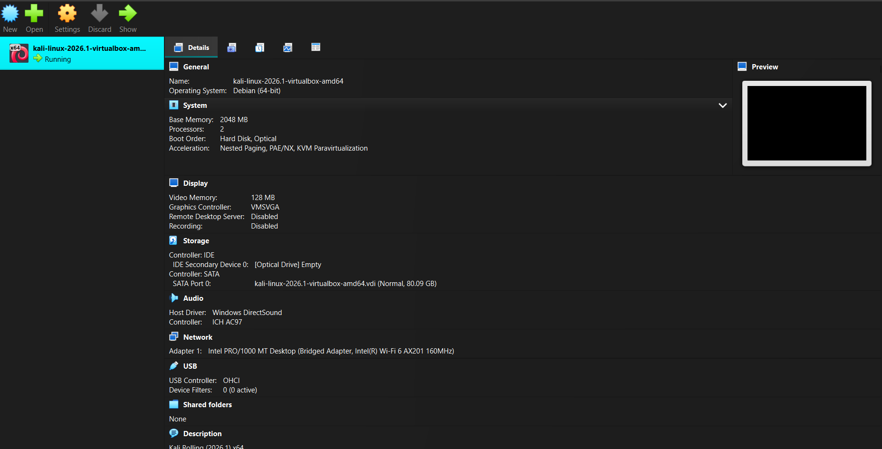

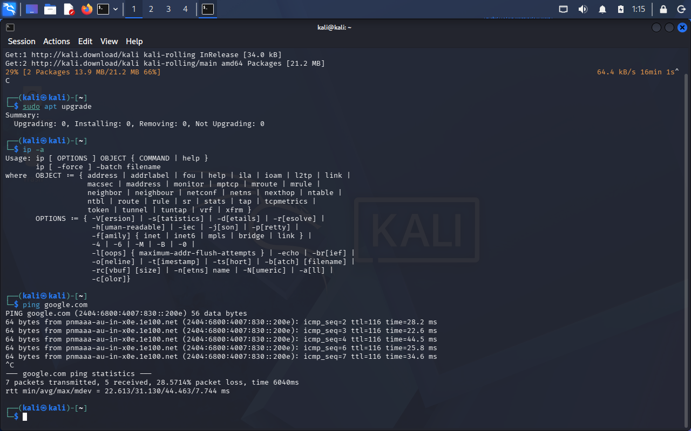

Task 2: Cybersecurity Concepts
Topics Studied:
• SQL Injection (SQLi) – Database attack through unsanitized input.
• Cross-Site Scripting (XSS) – Injection of malicious scripts into web pages.
• Cross-Site Request Forgery (CSRF) – Tricks authenticated users into performing actions.
• Phishing – Social engineering attack used to steal sensitive information.

Task 3: Python Script
Objective: Create a script that accepts a URL, checks website availability, displays the status code, measures response time, and saves results to a text file.
Findings:
- Successfully developed and tested the script.
- Verified functionality using multiple websites.
- Implemented file output for recording results.

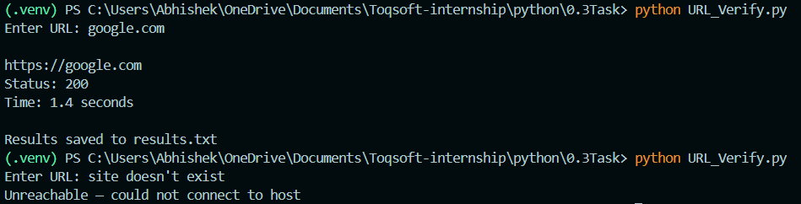

3. Challenges Faced
Understanding the differences between similar vulnerabilities such as XSS and CSRF required additional research. The Python script required testing and debugging to ensure correct output formatting and error handling.

4. Learning Outcome
Through this assessment, I gained practical experience in Virtual Box Kali Linux installation and configuration, improved my understanding of SQL Injection, XSS, CSRF, and Phishing, and strengthened my Python programming skills. The assessment also refine my ability to document technical work professionally.

5. Conclusion
This assessment provided valuable exposure to cybersecurity fundamentals and practical technical tasks. The knowledge gained will support further learning and development in cybersecurity and related technologies.

