Source Code Summary

Filename | Production or Test? | Lines of Code
App.tsx | Production | 59
main.tsx | … | 7
index.css | … | 27
GameBoard.tsx | … | 48
GameHeader.tsx | … | 10
GameSetupPanel.tsx | … | 47
GameStatePanel.tsx | … | 26
Board.ts | … | 203
Board.test.ts | Test | 82
DiamondBoard.ts | Production | 10
EnglishBoard.ts | … | 12
HexagonBoard.ts | … | 16
Game.ts | … | 84
Game.test.ts | Test | 49
index.ts | Production | 7
Total |  | 689

Production Code vs User stories/Acceptance Criteria

User Story ID & Name | AC ID | Class Name | Method Name | Status | Notes?
1: Choose board size | 1.1 | GameSetupPanel.tsx / App.tsx / Game.ts | State variable | Complete | When a user chooses the size from a dropdown, it is stored as a state variable in App.tsx. Upon game creation, this state variable is passed to Game.ts’s constructor to handle initialization. Input-level validation in GameSetupPanel.tsx prevents invalid board sizes.
2: Select board layout | 2.1 | GameSetupPanel.tsx / App.tsx / Game.ts | State variable | Complete | See above. User picks from dropdown of three options in GameSetupPanel, the value is stored in App.tsx as a state variable to be passed to Game.ts.
3: Initialize board | 3.1 | Board.ts | Constructor | Complete
4: Execute valid jump | 4.1 | Board.ts | executeMove(from: Coordinate, to: Coordinate) | Complete
4.2: Attempt invalid jump | 4.2 | Board.ts | executeMove(from: Coordinate, to: Coordinate) | Complete | This method will return false and no state will be changed if a jump is invalid.
5: Game conclusion and rating assignment | 5.1 | Game.ts | updateStatus() / ratingFor(remainingPegs) | Complete | updateStatus() is called often to check if the game is over. When it is, ratingFor assigns a rating based on the number of remaining pegs.

User Stories/Acceptance Criteria vs. Tests

For this section, the table required us to state the method name of the test code, but Vitest unit tests do not use method names for each individual test. It does not use classes, either, instead relying on suites of tests. As a result, I have instead replaced those columns with the filename and the exact line number corresponding to the test.

User Story ID & Name | AC ID | Class Name of Test Code | Method Name of the Test Code | Status
1: Choose board size | 1.1 | Board.test.ts | Lines 15-38 | Complete
2: Select board layout | 2.1 | Board.test.ts | ^ | Complete
3: Initialize board | 3.1 | Board.test.ts | ^ | Complete
4: Execute valid jump | 4.1 | Board.test.ts | Lines 44-67 | Complete
4.2: Attempt invalid jump | 4.2 | Board.test.ts | Lines 69-84 | Complete
5: Game conclusion and rating assignment | 5.1 | Game.test.ts | Lines 29-49 | Complete

All above unit tests were generated by the model used for development at the time of development. This was the prompt:

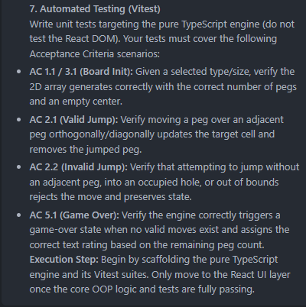

The agent then returned a plan for implementation, and this was the section of the plan corresponding to the tests:

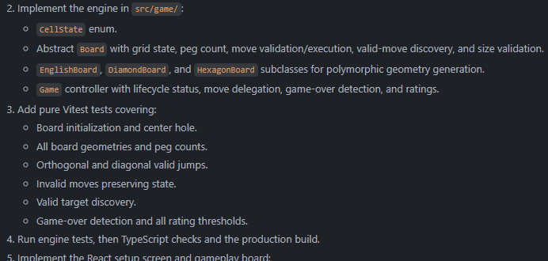

I checked the resulting tests as I thoroughly inspected the codebase, before I started working on the tables above. Even when I checked the tests, they were successful, because, since the agent was told to make sure the tests passed before it continued to the UI, when the tests failed during code generation, it returned to the code and persisted until it passed.

The full LLM prompt is included in the next page.
The Prompt
(At first, I hashed out this prompt with Gemini and then had it create the agent’s prompt for me. We make the bots talk to the bots so they speak each other’s language.)

Objective:
You are an AI coding agent executing Sprint 2 of a Peg Solitaire (BrainVita) web application. Your goal is to build the core game engine and the React UI for initializing and playing the game, adhering strictly to the constraints, mathematics, and user stories provided below.
1. Tech Stack & Architectural Constraints
- Language & UI: TypeScript, React (Vite).
- Testing: Vitest.
- Architecture Rule (Strict OOP): You must heavily utilize Object-Oriented Programming (classes, inheritance, polymorphism) for the game logic. The React UI must be entirely decoupled from the game rules. React components should only read state from the OOP engine and dispatch coordinate-based moves. Do not put move validation or grid math inside React hooks.
2. The Pure Game Engine (TypeScript OOP)
Build a class hierarchy to manage the game state:
- CellState Enum: INVALID, EMPTY, PEG.
- Board (Abstract Base Class): Manages the 2D grid, board size, piece counts, move execution, and move availability.
- Subclasses (EnglishBoard, HexagonBoard, DiamondBoard): Inherit from Board and override the grid generation logic.
- Game (Controller): Manages the game status (IN_PROGRESS, GAME_OVER), the board instance, and calculates the final rating.
3. Board Geometries & Mathematics
The board size, $N$, must strictly be an odd integer between 7 and 15. The exact center coordinate is always $c=\frac{N-1}{2}$. Generate the 2D array by looping through rows $r$ and columns $col$ from $0$ to $N-1$, marking a cell as PEG (or EMPTY for the exact center) if it meets the following shape conditions, otherwise INVALID:
- English Board: Valid if the cell falls in the central vertical or horizontal band of width $\lceil N / 3 \rceil$.
- Diamond Board: Valid if $\vert{}r - c\vert{} + \vert{}col - c\vert{} \le c$.
- Hexagon Board: Valid if $\vert{}r - c\vert{} \le c$ AND $\vert{}col - c\vert{} \le c$ AND $\vert{}(r - c) + (col - c)\vert{} \le c$.
4. Gameplay Rules & Move Mechanics
- Initial State: All valid spaces are filled with pegs except the central hole, which remains completely empty.
- Valid Moves: A player can jump a peg orthogonally or diagonally over an adjacent peg into an empty hole exactly two positions away.
- Execution: The moved peg occupies the new hole, and the jumped peg is removed. Invalid moves must be rejected without altering the state.
5. Game Over & Scoring
The game automatically detects when no valid orthogonal or diagonal jumps remain. Upon conclusion, the engine assigns a rating based on remaining pegs:
- 1 peg: Outstanding
- 2 pegs: Very Good
- 3 pegs: Good
- 4+ pegs: Average
6. User Interface (React) & Input Handling
- Setup Screen: Include an input field for Board Size (validate for odd integers 7-15), radio buttons for Board Type (English, Hexagon, Diamond), and a "New Game" button to initialize the board.
- Gameplay Interaction (Two-Click): The user clicks a peg to select it. The UI should highlight the selected peg and any valid empty target holes. The user then clicks a valid target hole to execute the move.
7. Automated Testing (Vitest)
Write unit tests targeting the pure TypeScript engine (do not test the React DOM). Your tests must cover the following Acceptance Criteria scenarios:
- AC 1.1 / 3.1 (Board Init): Given a selected type/size, verify the 2D array generates correctly with the correct number of pegs and an empty center.
- AC 2.1 (Valid Jump): Verify moving a peg over an adjacent peg orthogonally/diagonally updates the target cell and removes the jumped peg.
- AC 2.2 (Invalid Jump): Verify that attempting to jump without an adjacent peg, into an occupied hole, or out of bounds rejects the move and preserves state.
- AC 5.1 (Game Over): Verify the engine correctly triggers a game-over state when no valid moves exist and assigns the correct text rating based on the remaining peg count.
Execution Step: Begin by scaffolding the pure TypeScript engine and its Vitest suites. Only move to the React UI layer once the core OOP logic and tests are fully passing.

