Project Sprint #1

The Solitaire game is described in CS449HomeworkOverview. You should read the description very carefully.

In this assignment, you aim to specify the requirements (i.e., user stories and acceptance criteria) of the target software that allows a human player to play a Solitaire game. These requirements will be fully implemented by the end of sprint 3. The minimum features include choosing the board size and type, starting a new game, making a move, determining if a game is over. The following is a sample GUI layout.

Board size
7
Board Type  - English  - Hexagon  - Diamond | 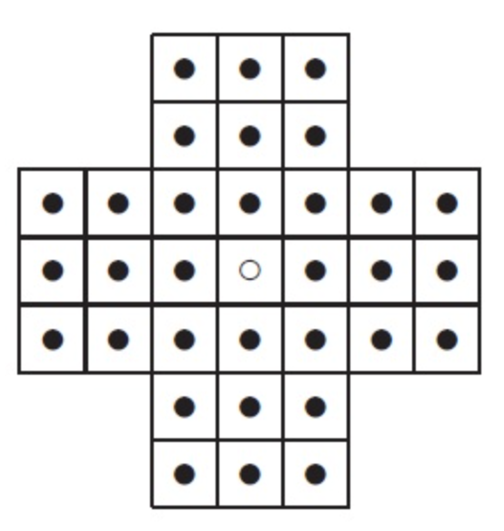 | New Game
Figure 1. Sample GUI layout of the first working program by the end of Sprint 3

Use the following tables to document your user stories and acceptance criteria.

You are required to use the free ChatGPT or another LLM to complete two user stories and two of their respective acceptance criteria. You must ensure that the generated user stories are correct and fix them if not. At the end of the submission, provide screenshots of your LLM prompts and answers, along with the description of errors the LLM made that you had to correct. Points will be deducted if no screenshots/description are provided.

For the other user stories and acceptance criteria, you are not required to use LLM.

- User Stories (3 points)

- User Story Template: As a <role>, I want <goal> [so that <benefit>]

ID | User Story Name | User Story Description | Priority | Estimated effort (hours)
1 | Choose a board size | As a human player, I want to start a new game using my selected board size and type so that the board initializes with all valid spaces filled with pegs except for the central hole. | High | 3
2 | Choose the board type | As a human player, I want to select a board type (English, Hexagon, or Diamond) so that I can play on my preferred layout. | Medium | 2
3 | Start a new game of the chosen board size and type | As a human player, I want to start a new game using my selected board size and type so that the board generates correctly with all valid spaces filled except the center. | High | 3
4 | Make a move in a game | As a human player, I want to jump a peg over an adjacent peg into an empty hole so that the jumped peg is removed and I can progress toward clearing the board. | High | 6
5 | A game is over | As a human player, I want the system to automatically detect when I have no valid moves left so that the game ends and assigns me a performance rating. | High | 5

- Acceptance Criteria (AC) (12 points): Add/delete rows as needed.

User Story ID and Name | AC  ID | Description of Acceptance Criterion | Status (completed, toDo, inPprogress)
1. Choose a board size | 1.1 | AC 1.1  Given: the player has selected a board type (like English, Hexagon, or Diamond) and a specific board size  When: the player clicks the "New Game" button  Then: the GUI renders the board to the chosen specifications, placing a peg in every valid position except for the center hole, which remains completely empty. | toDo
2. Selecting a board layout | 2.1 | AC 2.1  Given: the player is interacting with the game UI  When: the player toggles the radio button for a specific Board Type  Then: the system updates the active layout state for the upcoming game. | toDo
3. Initializing the board | 3.1 | AC 3.1  Given: the player has set their desired board type and size  When: the player clicks the "New Game" button  Then: the GUI renders the board, placing a peg in every valid position while leaving the central hole completely empty. | toDo
4. Executing a valid jump | 4.1 | AC 4.1  Given: a game is actively in progress and it is the player's turn  When: the player moves a peg orthogonally or diagonally over an adjacent peg, landing in an empty hole exactly two positions away  Then: the moving peg occupies the new hole, and the jumped peg is instantly removed from the board | toDo
4.2: Attempting an invalid jump | 4.2 | AC 4.2  Given: a game is actively in progress and it is the player's turn  When: the player attempts to move a peg without jumping over an adjacent peg, tries to land in an already occupied hole, or attempts a jump that is not exactly two positions away orthogonally or diagonally  Then: the move is completely rejected, and the board state remains exactly the same. | toDo
5.1 Game conclusion and rating assignment | 5.1 | AC 5.1  Given: a manual game is currently in progress  When: only one marble is left, or no valid jumps can be made over an adjacent peg into an empty hole  Then: the system ends the game and outputs a rating of Outstanding, Very Good, Good, or Average based on the number of marbles left. | toDo

- LLM Usage Overview

This is a link to the accompanying chat with Gemini Pro, used to accomplish this assignment. Above, I bolded the two user stories and the accompanying three acceptance criteria that it created after the initial two prompts. After creating those user stories, I had to correct the model on how it defined the first user story (e.g. including starting the game), and had to deal with it, for lack of a better word, arguing back, before I got it to output what was required. The description of the assignment said that LLM usage was not required for the rest of the user stories, but required is not disallowing, so I proceeded to use it for the other user stories. After a few messages to point it in the right direction, it created sufficient user stories that properly planned out the game’s future development.

