行程/路程问题：
- A car travels at an average speed of 80 kilometers per hour during a 6-hour trip and averages 75 kilometers per hour for the first 4 hours of the trip. Which of the following distance-versus-time graphs is consistent with this information?
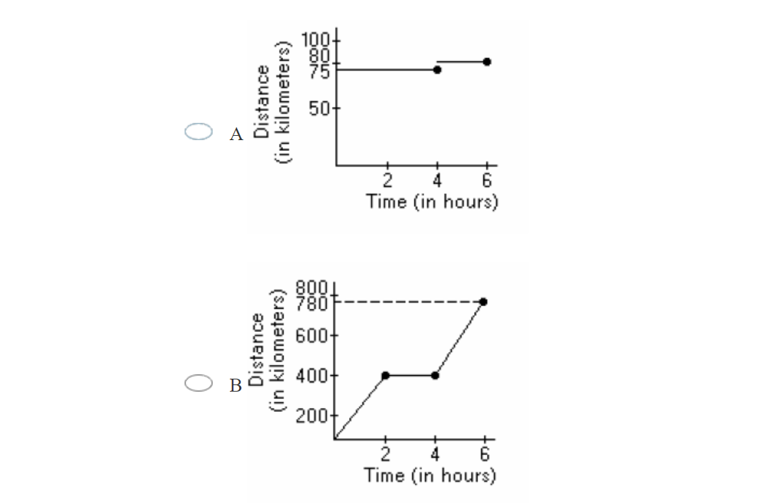
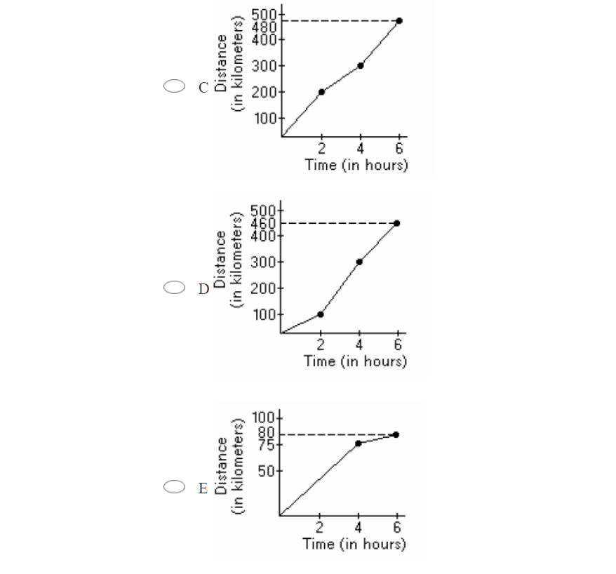
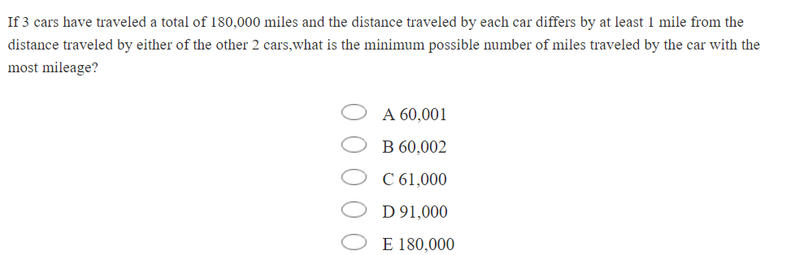
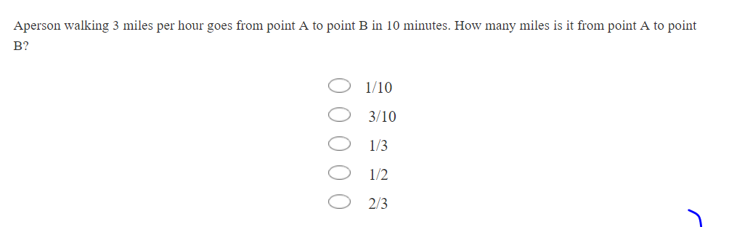
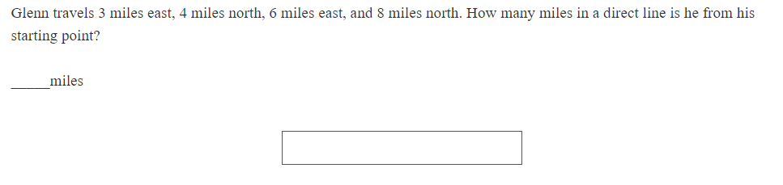
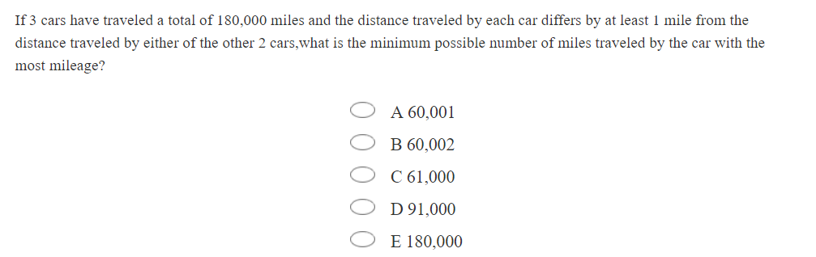

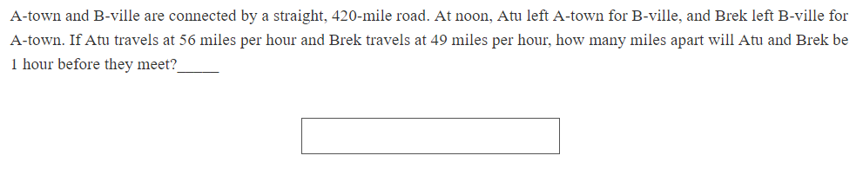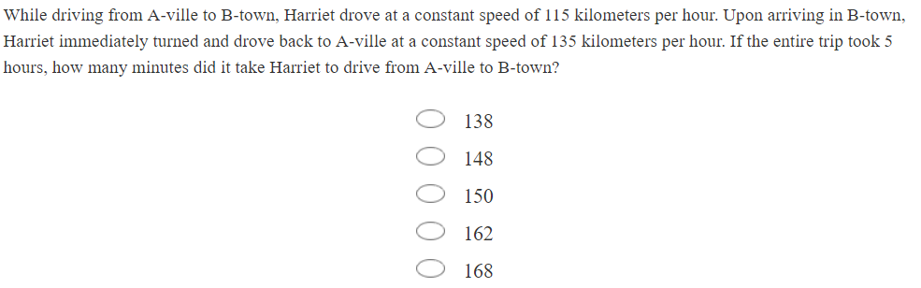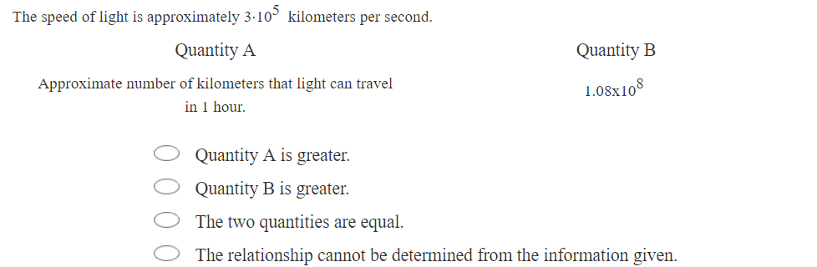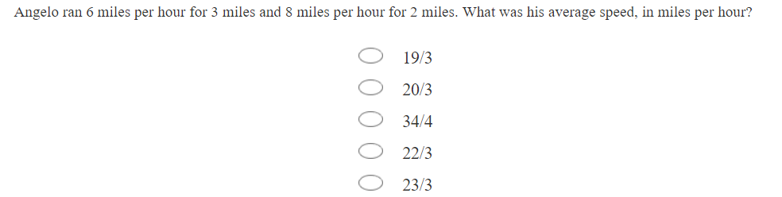
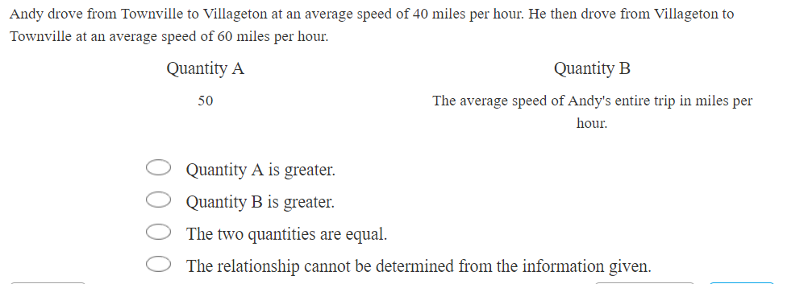
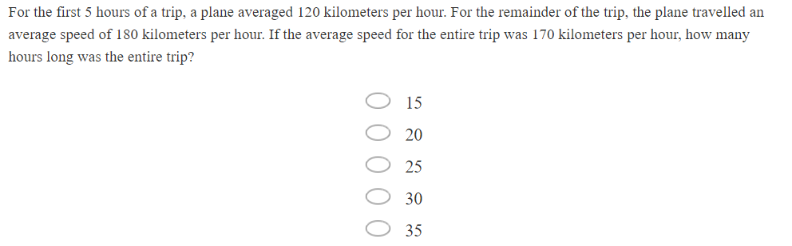
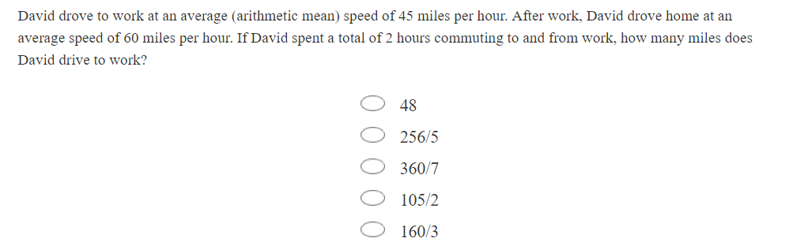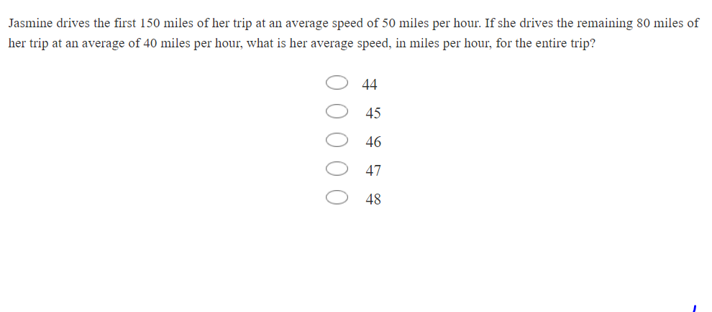
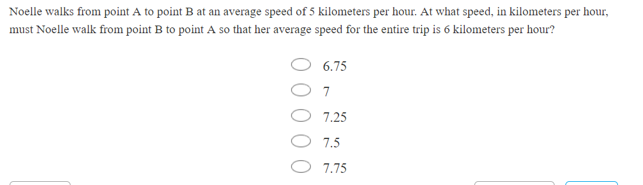

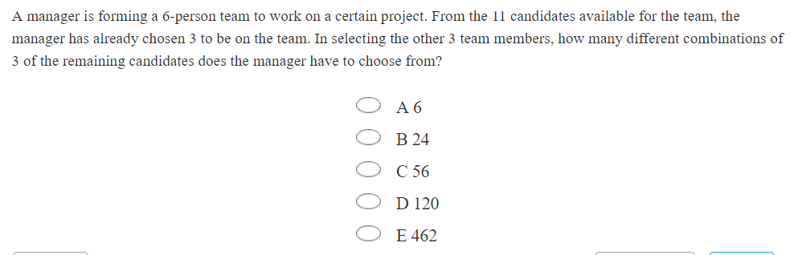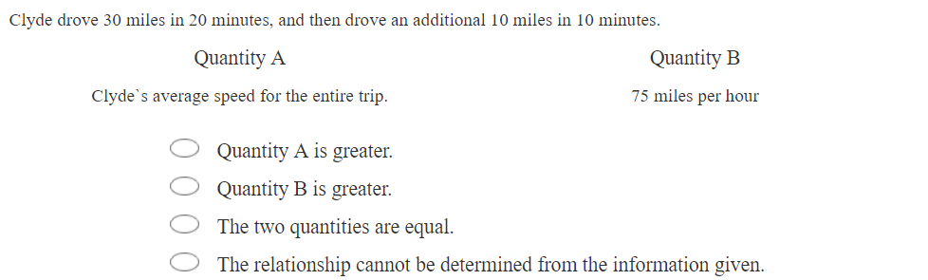

进水/出水问题/容器/体积类问题
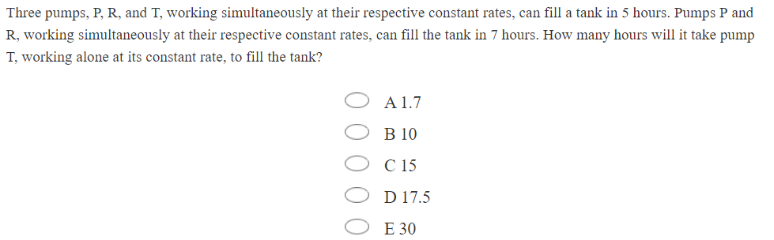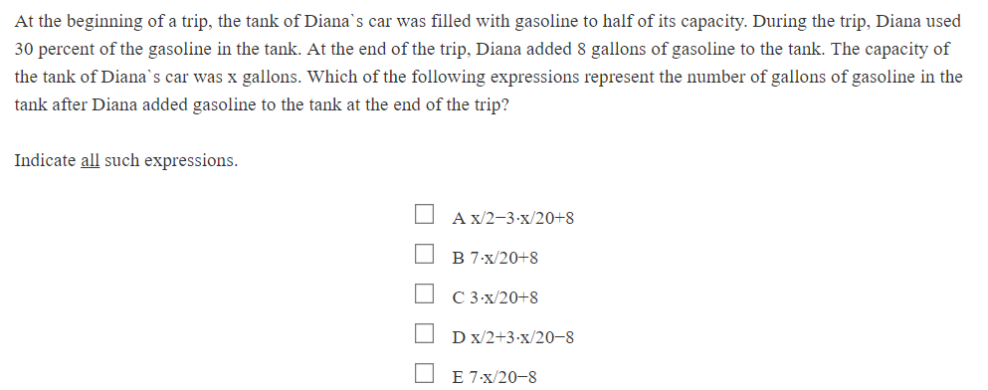
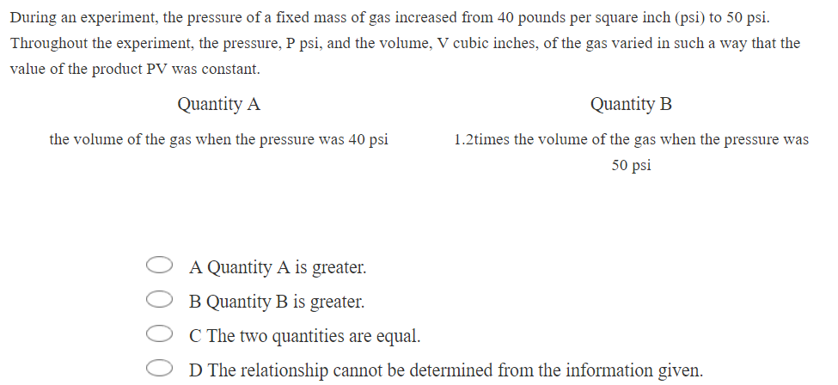

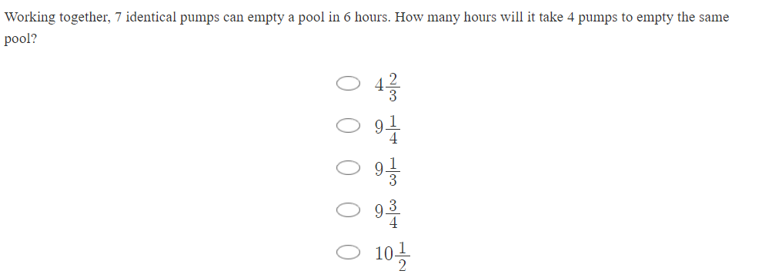
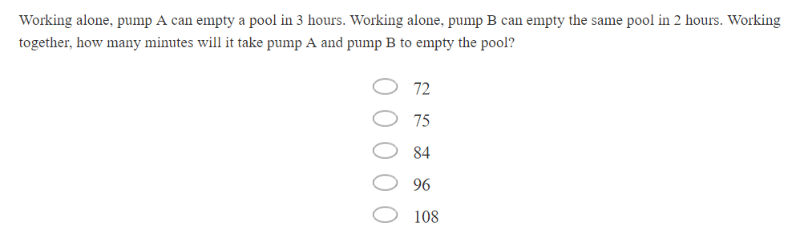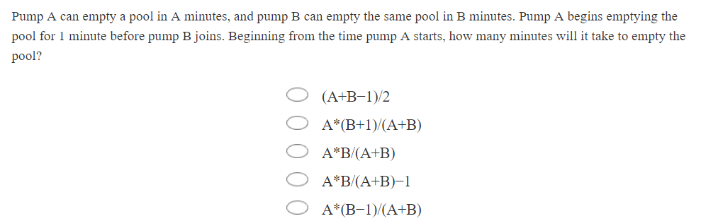
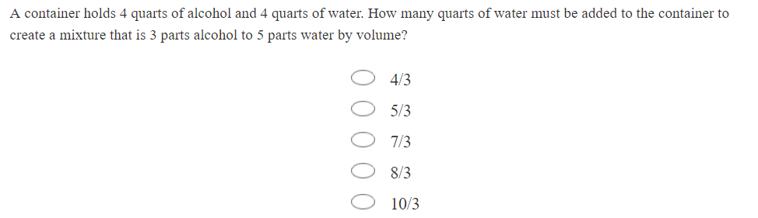

浓度问题
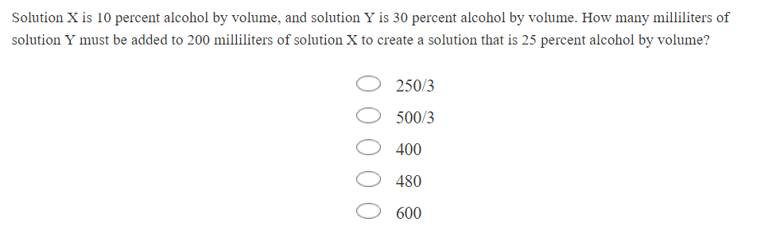
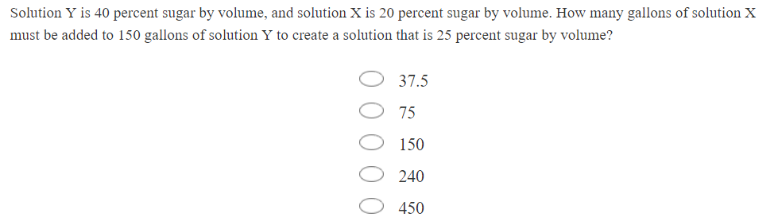

利润/打折等问题

工程问题
