VitalIQ
Compliance Traceability Matrix
Requirement → Implementation → How It Complies
Field | Detail
Project | VitalIQ — native Android (Kotlin + Jetpack Compose)
Author | Brandon Galli
Course | DEV322 — Native Android Engineering
Document | Compliance Traceability Matrix
Date | June 26, 2026
Build status | assembleDebug SUCCESSFUL (APK produced; Room KSP code generated)
Source root | kotlin/app/src/main/java/com/vitaliq/app/

Every reference below points to a real file and class/method in the submitted build. File paths are relative to kotlin/app/src/main/java/com/vitaliq/app/ unless a different root is shown. This matrix is the index a reviewer can use to verify each requirement directly in the codebase.

Table of Contents
Right-click and choose “Update Field” to build the Table of Contents.

0. Resolution of the Prior Architectural Violation
The earlier submission was rejected because each ViewModel declared private val api = RetrofitClient.apiService and called the API directly, making the ViewModel responsible for data access. That coupling has been removed project-wide.
Concern raised | Before | After (submitted build)
ViewModel knows the data source | private val api = RetrofitClient.apiService inside each ViewModel. | ViewModels take a Repository INTERFACE in their constructor; no ViewModel imports Retrofit, Room, a DAO, AppDatabase, or okhttp.
ViewModel performs network calls | load() called api.dashboardSummary() / api.getProfile(). | load() calls repo.getDashboardSummary() / repo.getProfile(); the network call lives in DashboardRepositoryImpl.
“Replace Retrofit with Room → only the Repository changes” | Failed — every ViewModel owned Retrofit calls. | Holds — data-source wiring is centralized in di/ServiceLocator.kt; swapping a source edits only the *RepositoryImpl + one wiring line, no ViewModel.
SRS vs. code consistency | SRS said Repository is the sole data-access layer; code contradicted it. | Code now matches the SRS; the Final Report and GP6 docs were reconciled to the as-built design.

Verification: a repository-wide search of the UI layer (ui/) for RetrofitClient | AppDatabase | ApiService | okhttp | retrofit2 | androidx.room | .dao( returns ZERO matches. The only file that references RetrofitClient.apiService and AppDatabase.getInstance is di/ServiceLocator.kt.

1. Approved Architectural Stack
Requirement | Where in code | How it complies
Jetpack Compose for UI | ui/screens/**/*Screen.kt; ui/components/*; ui/theme/VitalTheme.kt | All six screens are @Composable functions; MainActivity hosts the Compose tree via setContent { VitalIQTheme { AppNavigation() } }.
ViewModel for UI state ownership | ui/screens/**/*ViewModel.kt (6 ViewModels) | Each screen has a dedicated androidx.lifecycle.ViewModel that owns the screen's state.
Coroutines with viewModelScope | Every ViewModel, e.g. DashboardViewModel.load() | All async work is launched in viewModelScope.launch { } and cancelled automatically in onCleared().
Repository abstraction layer | data/repository/*Repository.kt (5 interfaces) + *RepositoryImpl.kt | ViewModels depend on the interfaces; the impls are the only classes that touch ApiService + Room DAOs.
Room for persistence | data/local/AppDatabase.kt; data/local/dao/* (7); data/local/entity/* (7) | @Database(version=2) with 7 DAOs/entities; codegen via KSP (AppDatabase_Impl generated at build).
Navigation component with NavHost | navigation/AppNavigation.kt | NavHost with six composable destinations (home, workout, log, insights, profile, history) + bottom navigation.
Flow / StateFlow for reactive state | Every ViewModel: private MutableStateFlow + public StateFlow | State is exposed as immutable StateFlow<UiState>; screens collect it reactively.
No extra DI / state / concurrency framework | di/ServiceLocator.kt; app/build.gradle.kts | Manual composition root in plain Kotlin (allowed). No Hilt/Dagger/Koin/@Inject anywhere; no alt state-management or concurrency library.

2. Core Platform Integration
Requirement | Where in code | How it complies
≥ 2 distinct hardware sensors | ui/screens/workout/WorkoutViewModel.kt — registerSensors() | Registers Sensor.TYPE_ACCELEROMETER and Sensor.TYPE_STEP_COUNTER via SensorManager.registerListener().
Sensor data is not decorative / drives observable state | WorkoutViewModel.onSensorChanged(); emitActiveState() | Accelerometer magnitude classifies activity (stationary/walking/mixed/running) and the step counter yields live steps; both flow into WorkoutUiState.Active (StateFlow) and the saved WorkoutDto.
Sensors run by default (not simulated) | app/build.gradle.kts — SIMULATE_SENSORS | BuildConfig flag defaults to "false", so a clean build reads the real accelerometer + step counter; simulation is opt-in for emulators only.
Sensor runtime permission | AndroidManifest.xml; ui/screens/workout/WorkoutScreen.kt | ACTIVITY_RECOGNITION declared and requested at runtime (rememberLauncherForActivityResult) on API 29+ before a workout starts.
≥ 1 external network API via coroutines | data/api/ApiService.kt; data/api/RetrofitClient.kt | Retrofit interface of suspend functions (GET/POST/PUT/Multipart) to a FastAPI backend; called from repositories.
API interaction influences behavior | DashboardRepositoryImpl, InsightsRepositoryImpl, etc. | Dashboard summary, AI insights, history, and logging all come from / post to the API and change the rendered state.
≥ 2 navigable destinations in a Nav graph | navigation/AppNavigation.kt | Six destinations defined in one NavHost graph.
Navigation state survives configuration changes | navigation/AppNavigation.kt — rememberNavController() | The back stack is saved/restored across rotation (rememberSaveable internally; saveState/restoreState on tab switches). No manual Intent wiring.
All network operations off the main thread | data/repository/*RepositoryImpl.kt | Every suspend data method is wrapped in withContext(Dispatchers.IO).
Persist domain data via Room through a Repository | *RepositoryImpl.kt → data/local/dao/* | Repositories write API results through to Room (dao.insert) and read from Room on failure; the UI never touches a DAO.

3. Architecture Requirements
Requirement | Where in code | How it complies
Separate UI / ViewModel / Repository | ui/screens/** ; data/repository/** ; data/local + data/api | Three distinct packages; the UI talks only to the ViewModel, the ViewModel only to a Repository interface, the Repository to the data sources.
ViewModel is the single source of truth | Every ViewModel: _uiState (MutableStateFlow) / uiState (StateFlow) | Screen state is owned by the ViewModel and exposed read-only; the UI renders purely from it.
Activity/Composable owns no long-lived state | MainActivity.kt; *Screen.kt | MainActivity only hosts Compose; screens keep only ephemeral UI state (text-field drafts, isRefreshing) — all domain state lives in the ViewModel.
All data flows through a Repository before the ViewModel | *ViewModel constructors take *Repository interfaces | ViewModels receive data exclusively from repository methods (e.g. repo.listWorkouts()).
No direct DB/network access from UI or ViewModel | Verified across ui/ (grep) ; di/ServiceLocator.kt | Zero Retrofit/Room/DAO references in any screen or ViewModel; the only data-source construction is in ServiceLocator.
UI updates reactively to state changes | *Screen.kt — collectAsStateWithLifecycle() | Each screen collects the StateFlow with collectAsStateWithLifecycle() and recomposes on emission.
Handle configuration changes without data loss | ViewModel + StateFlow; rememberNavController() | The ViewModel survives rotation (state retained); navigation back stack is preserved. Verified by lifecycle logs (Activity recreated, ViewModel NOT cleared).
Lifecycle logging, consistent tag, Logcat-visible | MainActivity.kt; every ViewModel; VitalIQApp.kt | Single tag "VitalIQ": MainActivity logs onCreate/onResume/onPause/onStop/onDestroy; each ViewModel logs init + onCleared; VitalIQApp logs onCreate. Filter Logcat by "VitalIQ" to demonstrate.

Representative evidence — ViewModel depends only on the Repository interface and logs its lifecycle:
class DashboardViewModel(private val repo: DashboardRepository) : ViewModel() {
private val _uiState = MutableStateFlow<DashboardUiState>(DashboardUiState.Loading)
val uiState: StateFlow<DashboardUiState> = _uiState
init { Log.d("VitalIQ", "DashboardViewModel created") }
fun load() = viewModelScope.launch {
try { /* repo.getDashboardSummary(); repo.getProfile() */ }
catch (e: Exception) { _uiState.value = Error(...) }
}
override fun onCleared() { Log.d("VitalIQ", "DashboardViewModel cleared") }
}

4. Concurrency and State Discipline
Requirement | Where in code | How it complies
All disk and network IO off the main thread | *RepositoryImpl.kt; ProfileViewModel.importFile() | Repository IO uses withContext(Dispatchers.IO); the profile file read also runs in withContext(Dispatchers.IO).
No blocking calls on the main thread | WorkoutViewModel timer; all ViewModels | The workout timer uses kotlinx.coroutines.delay (suspending), not Thread.sleep; no blocking I/O on Main.
No runBlocking on the main thread | Whole module (static scan) | runBlocking does not appear anywhere in the codebase.
Appropriate dispatchers | *RepositoryImpl.kt | Network + Room run on Dispatchers.IO; UI state updates run on the Main-confined viewModelScope.
IO on Dispatchers.IO unless justified otherwise | *RepositoryImpl.kt (withContext(Dispatchers.IO)) | Every network/disk operation is on Dispatchers.IO; no undocumented alternative.
Long-running operations don't block rendering | viewModelScope.launch in every ViewModel | Loads/saves are suspend functions on background dispatchers; the UI shows Loading/Submitting states meanwhile.
Thread boundaries identifiable in the architecture diagram | documents/diagrams/arch_layered.png; build_diagrams.py | The layered diagram marks the Main→IO boundary (withContext(Dispatchers.IO)) and Main/IO/Default bands; activity & sequence diagrams show the same boundaries.

5. Resilience and Professional Behavior
Requirement | Where in code | How it complies
Gracefully handle network failure with a meaningful UI state | *UiState.Error; DashboardScreen/HistoryScreen/ProfileScreen/InsightsScreen | Each loading flow has a sealed Error state rendered as a visible message; failures are caught in the ViewModel and mapped to Error.
Visible UI state + recovery path | DashboardScreen/HistoryScreen/ProfileScreen/InsightsScreen Error branch | Error UI shows a warning + message and a Retry button wired to viewModel.load(); Insights also shows a degraded local-estimate banner (usedFallback).
Avoid crashes (sensor / rotation / network) | WorkoutViewModel.onCleared(); try/catch in repos; rememberNavController | Sensor listeners + timer cancelled in onCleared(); repository calls are guarded; rotation retains the ViewModel; missing step sensor handled (stepCounterAvailable).
Network failure demonstrable (airplane mode / API failure) | *RepositoryImpl.kt offline fallback | With the backend unreachable, repositories catch the exception and return cached Room data; if no cache, the ViewModel surfaces an Error state. Both are demonstrable by toggling airplane mode.
Error states are visible and intentional | Sealed UiState hierarchies (Loading/Success/Error/Empty/…) | Errors are first-class states, not silent failures; the UI renders a distinct, intentional error layout.

Representative evidence — repository network-first with Room offline fallback:
override suspend fun listWorkouts(): List<WorkoutDto> = withContext(Dispatchers.IO) {
try {
val workouts = api.listWorkouts()
dao.insertAll(workouts.map { it.toEntity() }) // write-through to Room
workouts
} catch (e: Exception) {
val cached = dao.getAll() // offline fallback
if (cached.isEmpty()) throw e else cached.map { it.toDto() }
}
}

6. Architectural Documentation & Defense
Requirement | Where | How it complies
Documentation matches the submitted build | documents/build_final_report.py; build_gp6.py; build_srs.py; kotlin/README.md | All architecture docs were reconciled to the as-built Repository + Room design and regenerated; the legacy memory/PRD.md is marked superseded.
Architectural claims verifiable in the codebase | This matrix (every row cites a file + symbol) | Each documented claim maps to a concrete file/class/method that a reviewer can open.
Diagrams include class names | documents/diagrams/arch_layered.png; seq_insights_week5.png | The layered diagram labels real classes (DashboardViewModel, *Repository, ApiService, AppDatabase, ServiceLocator); the sequence diagram names the same participants.
Layered architecture diagram (UI/VM/Repo/sources/thread boundaries) | documents/diagrams/arch_layered.png (Figure 3.1 in the Final Report) | Shows all four layers, the composition root, both data sources, the Main→IO boundary, and Main/IO/Default dispatcher bands — reflecting the implemented design, not an idealized one.
Diagram indicates Main / IO / Default dispatchers | documents/diagrams/arch_layered.png; act_*.png | Explicit MAIN THREAD and IO DISPATCHER bands; the boundary is annotated withContext(Dispatchers.IO); sensor classification noted as Default-eligible.

6.1 Where the “Why” Answers Live in the Code
The required defense questions map to concrete implementation decisions:
Question | Concrete answer in this codebase
Why a ViewModel exists | State must survive rotation: the ViewModel + StateFlow retain DashboardUiState/WorkoutUiState across config changes (lifecycle logs show the Activity recreates while the ViewModel does not).
Why coroutines instead of raw threads | viewModelScope ties work to the ViewModel lifecycle (auto-cancel in onCleared); withContext(Dispatchers.IO) moves IO off Main without manual thread/handler management.
Why Room instead of manual SQLite | AppDatabase + DAOs give compile-time-checked queries and generated implementations (KSP) instead of hand-written SQL/cursor code; entities map cleanly to DTOs via toEntity()/toDto().
Why reactive state collection | StateFlow + collectAsStateWithLifecycle() make the UI a pure function of state and stop collection when not in the STARTED lifecycle, avoiding wasted work/leaks.
Why a navigation graph instead of manual intents | A single NavHost owns the back stack and survives rotation (rememberNavController), versus brittle startActivity/Intent wiring and manual state restoration.

7. Demonstration Criteria — Where Each Is Supported
Each required demonstration item is backed by the code below; the live actions are performed during the presentation (the FastAPI backend must be running for API-backed flows).
Demonstration item | Backed by | How to show it
Sensor interaction | WorkoutViewModel (accelerometer + step counter) | Start a workout; live steps + activity classification update from real sensors.
API interaction | ApiService via repositories | Open Dashboard/Insights; data loads from the backend through the repository.
Local persistence | Room AppDatabase via repositories | Load data online (caches to Room), then read it back; inspect with App Inspection → Database.
Reactive UI updates | StateFlow + collectAsStateWithLifecycle | Log an entry / generate insights; the screen recomposes from new state immediately.
Rotation survival | ViewModel + StateFlow + rememberNavController | Rotate during an active workout; state + nav position are retained (Logcat "VitalIQ" shows Activity recreate, ViewModel retained).
Graceful simulated network failure | Repository offline fallback + Error UI states | Enable airplane mode; reads fall back to cached Room data, or an Error state with Retry appears — no crash.

8. Thread & Dispatcher Boundary Summary
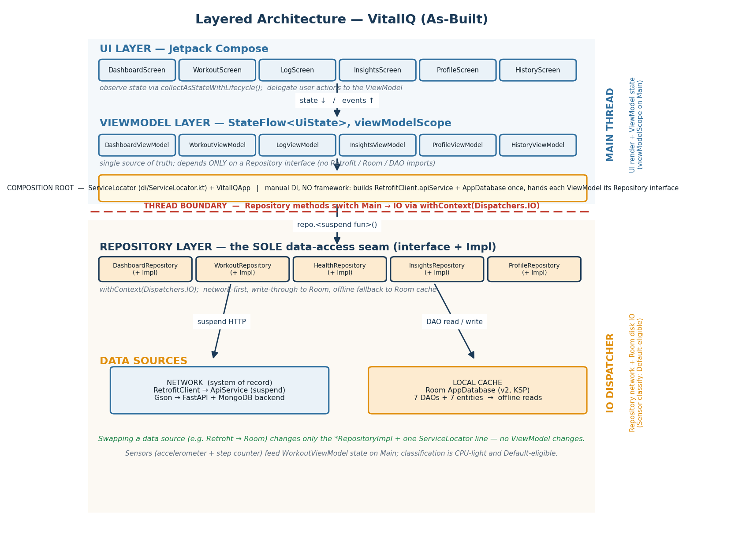
Layered architecture with Main→IO thread boundary and dispatcher bands (as-built).
Operation | Thread / Dispatcher | Where
UI rendering / recomposition | Main | *Screen.kt (Compose)
ViewModel state updates (StateFlow) | Main (viewModelScope) | *ViewModel.kt
Composition-root wiring (lazy build) | Main (caller) | di/ServiceLocator.kt
Network calls (Retrofit suspend) | IO | *RepositoryImpl.kt withContext(Dispatchers.IO)
Room reads/writes (DAO) | IO | *RepositoryImpl.kt → data/local/dao/*
Profile file read (ContentResolver) | IO | ProfileViewModel.importFile()
Sensor activity classification | Main callback (Default-eligible, CPU-light) | WorkoutViewModel.onSensorChanged()

9. Summary Scorecard
Requirement area | Status
Approved architectural stack (Compose/VM/coroutines/Repository/Room/Nav/StateFlow) | Met
No prohibited DI / state / concurrency framework | Met (manual ServiceLocator)
Two hardware sensors driving observable state | Met
External network API via coroutines, off main thread | Met
≥ 2 nav destinations; survive configuration change | Met
Persist via Room through a Repository | Met
UI / ViewModel / Repository separation; no direct data access in UI/VM | Met
ViewModel single source of truth; reactive UI | Met
Configuration-change survival; lifecycle logging (tag "VitalIQ") | Met
Concurrency discipline (IO off Main, no runBlocking, Dispatchers.IO) | Met
Graceful network-failure handling with visible state + recovery | Met
Documentation matches build; layered diagram with class names + thread boundaries | Met
Build compiles & runs (assembleDebug SUCCESSFUL; Room KSP generated) | Met

The instructor's specific architectural violation — ViewModels instantiating and invoking RetrofitClient.apiService — is fully resolved: data access is mediated by the Repository layer, ViewModels are data-source agnostic, and the documentation now matches the implemented architecture.

