Outputs for illustration

1. Seeding DB with mock data and retrieving the records

1. Adding a new book by editing line 6-7 in file post.py and verifying by retrieving records.

1. Reinserting same data again, we get the message that book already exists.

1. Updating a book, mention book attributes on lines 6-7 in put.py file. We can observe modifications for book with id 3

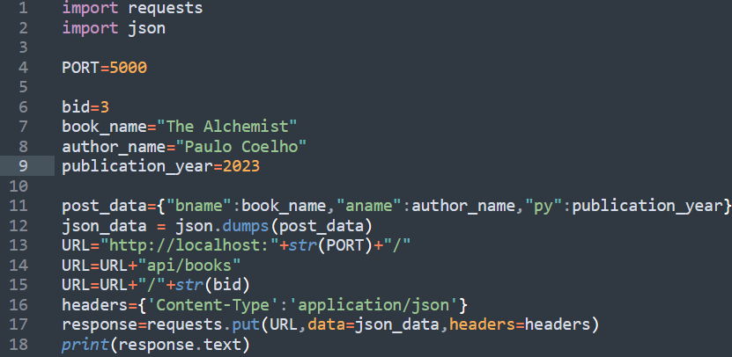

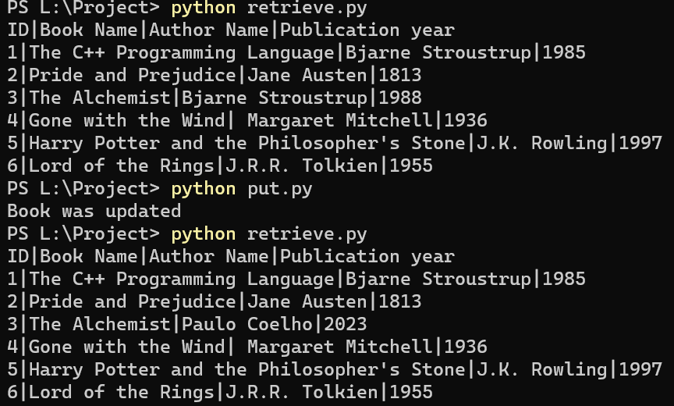

1. Updating a book that does not exist, mention book id that does not exist in record. Then, you get the below message.

