**University of Brighton**

**Computing Division**

in

**CI453**

**Working in the Computing Industry**

**Callum Barnett**

**Jay**

**Denis**

**Joa**

**Introduction**

The overall aim of this project is to successfully create a website to introduce the fundamentals of information, computer, and network security to students starting secondary school using materials from the National Cyber Security Centre’s Website and other sources. Throughout this project we established objectives that we set in place to specifically match our goal, to create a website in such a way to specifically accommodate for young students.

**How the assessment brief has been met:**  
  
The assessment brief states we need to create a website that should give students:

* An understanding of security mechanisms that can protect information systems.
* An understanding of the issues around privacy in business information systems.
* An appreciation of techniques for mitigating privacy threats through appropriate security controls.

Before we began discussions regarding the website, we as a group established ways of communicating. We opted to create a Snapchat group where discussions outside of campus could take place.

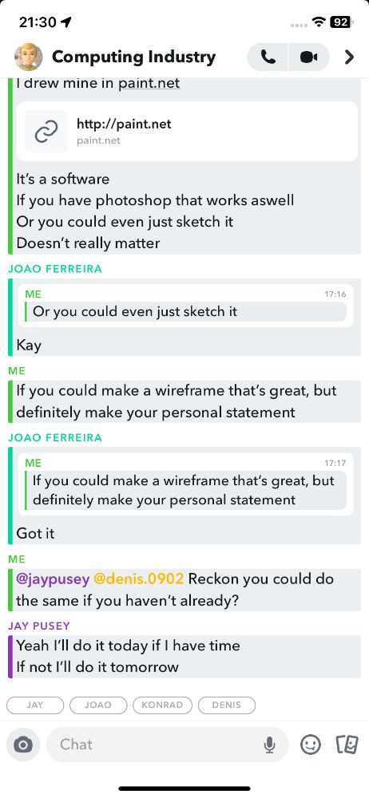

After establishing ways of communicating, we got to work discussing ideas for our website but more importantly, how to match our target audience. To get more ideas on how we should design our website, we referred to other websites that are tailored to a similar target audience as ours.

To meet the assessment brief, we as a group decided to set the home page with three links pertaining to each task of the three tasks. This is not only simple so that the young students have a clear understanding of what the page covers, but it also organises the website in such a way that students can’t get lost when navigating the website. By using a range of sources, including the NSCS website, we collectively wrote detailed information regarding the fundamentals of information, computer, and network security on the 3 linked webpages. Each week we decided who was going to work on each task and to set goals in mind so that we didn’t fall behind in our progress.

To appeal to secondary students, we were adamant on making sure the website was interactive to make the website more engaging with the user. We felt that promoting interactivity was important especially for first year secondary students as students in this age group may struggle to pay attention. We also included the use of images. We also made sure that while designing the website it was easily readable and accessible through big font sizes and images whilst also keeping a simple design so that students did not becoming confused or feel lost when navigating the website.

In addition to this, we also believed it was a good idea to allow a reference list on the pages so that the user could navigate the website instead of scrolling up and down.

When discussing ideas for the overall design of the website, we took the collaborative effort of each sketching a wireframe for an overall design of our website. We discussed which one we thought would best suit our needs between us and decided to go with the one with the Header and 3 linked pages centred on the screen mainly for its simplicity.

(INSERT WIREFRAME IMAGES HERE)

We also made sure our website was responsive, meaning the dimensions of the website were adjusted to tailor to the size and dimensions of the device the student was currently using to view to website. This was important specifically for our goal because young students could have access to a host of different devices, such as mobile phones, laptops, desktop computers, and more.

In our group we allowed for ideas and discussions to take place, including criticism of our ideas. For example, there were situations where we felt that some people in our group weren’t doing their share of work.

**Ethical Issues:**

* **Copyright**
* **Plagiarism**
* **Language for kids**

**References:**

* **The National Cyber Security Centre**

**Individual statements:**

**Callum:**

As the leader of the group, I encouraged everyone to finish their work on time and in full. We established ways of communication so we could keep up to date with everyone's progress whenever we needed it, and to also decide what to do next. In the week we first established our group I prompted to make a basic website, so that we not only had something to work with but to also discuss further ideas on how to match our target audience, such as the overall design of the website, the use of images, the formality of our language etc. Being a somewhat savvy web developer, I used HTML, CSS and JavaScript to make visual effects for the website, such as the animated header in the home page, which may help young students to keep engaged on the website. Using CSS and some JavaScript, I also made the background image alternate every 30 seconds. I made this with the idea that it might prompt young students to refocus on the website if they “doze off”, a typical occurrence in people of that age group.

In addition to making the overall design of the website, I handled the “  
an appreciation of techniques for mitigating privacy threats through appropriate security controls” task. When writing this, I fervently wrote in a format that young students would understand whilst also keeping a professional standard.

**Jay:**  
  
**Denis:**  
  
**Joao:**