# C# Game Report – Flo

*Sophie Darby, 170025581 Callum Darling, 170014082*

For our C# game, we decided to make our own version of flow free. The objective of the game is to connect the coloured boxes to each other without overlapping or cutting through the other ‘flows’ in the quickest time.

**Our Approach**

The first decision to be made was which game we were going to make. We had 3 choices, a winning chess move simulator, Flow game and Sudoku. The chess move simulator and Sudoku seemed overly difficult to code with the knowledge and time we had so we decided to make Flow.

After we picked the game, we had to decide the size of the 2D array we were going to create. This is when we chose to have easy, medium and hard options. Each option would need a different sized array; easy 5x5, medium 6x6 and hard 7x7.

Our next port of call was to sketch the window for our game (*Fig1 below*)

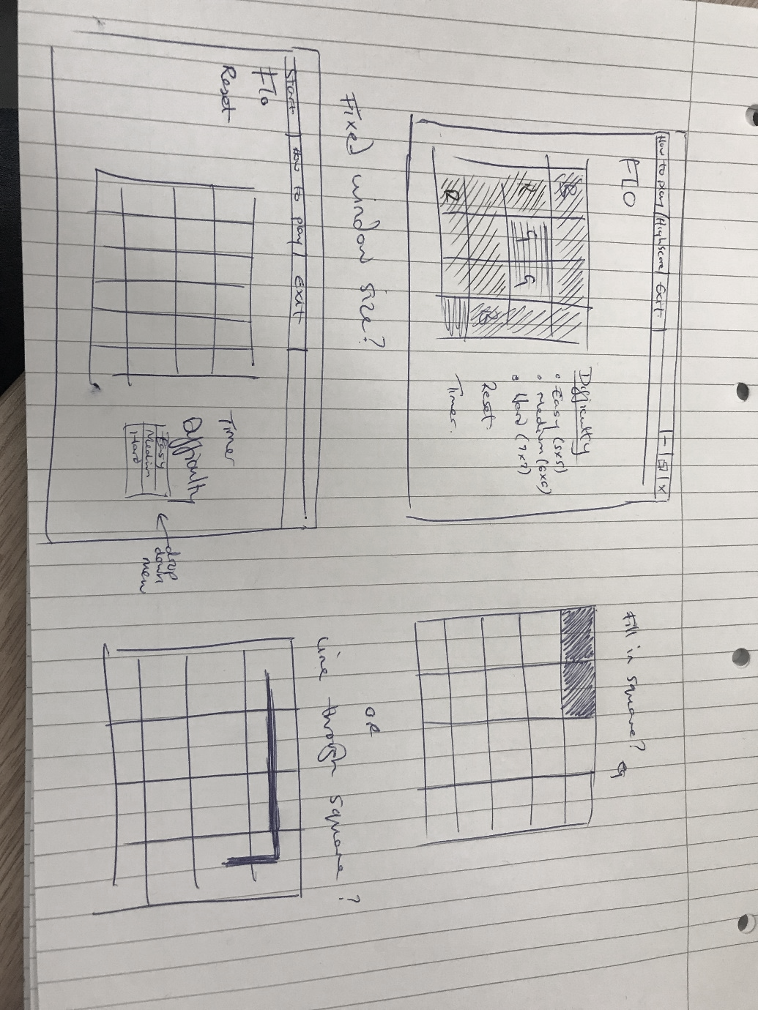

**Difficulties**

We had several difficulties when creating the game. Our first issue was when making the 2D array. The array was displayed and changed size from 5x5 to 6x6 to 7x7 when the appropriate radio button was clicked. However, when we tried to click easy again after the hard or medium was selected, the array wouldn’t go back to 5x5.