# CSC2024 Database Technology Coursework 1

This piece of coursework is worth 10% of the total assessment for this module. It is based on the first part of this module. You are expected to make use of MySQL to complete this coursework. Submit a **single** answer document to NESS containing your answers to this coursework. NESS will accept .doc/.docx and .pdf files.

**Aims:**

To assess your ability to:

* Interpret an entity-relationship diagram and implement a relational database from the design.
* Construct SQL queries over the resulting database implementation.
* Modify an entity-relationship diagram.

**Learning Outcomes:**

* To design part of a relational database.
* To create a MySQL database.
* To formulate SQL queries.

The transport department of a city council would like to implement a database for bus users indicating where bus routes go, how frequently they run and how to contact the relevant bus operator.

The council has identified some data items they would like to be recorded and also have provided some sample data (this can be found at the very end of this assignment).

For the bus operators, the council simply want to store their name (unique) and some basic contact details such as address, telephone and e-mail.

For bus stops, they wish to store each stop’s unique reference number (or ID) and a description of that stop’s location, e.g. “Railway Station.”

For the bus routes, they wish to store the route number (unique), the starting and destination bus stops and the frequency – the number of buses per hour. Note that the inclusion of both start and end bus stops makes the relationship between stop and route a 2-many relationship. They would also like to know which bus operators work each route. Some routes are shared between multiple operators with each operator working a proportion of the journeys on that route.

The council started producing a sketch of an entity-relationship (E-R) diagram for their planned database. It is nearly finished but this is not quite complete. Note that the “Proportion” descriptive attribute on the “Operates” relationship indicates how a route is shared between operators. A proportion of 50 for a route and an operator indicates that the operator operates 50% of all journeys on that route and a proportion of 100 indicates that all journeys on that route are provided by that operator.

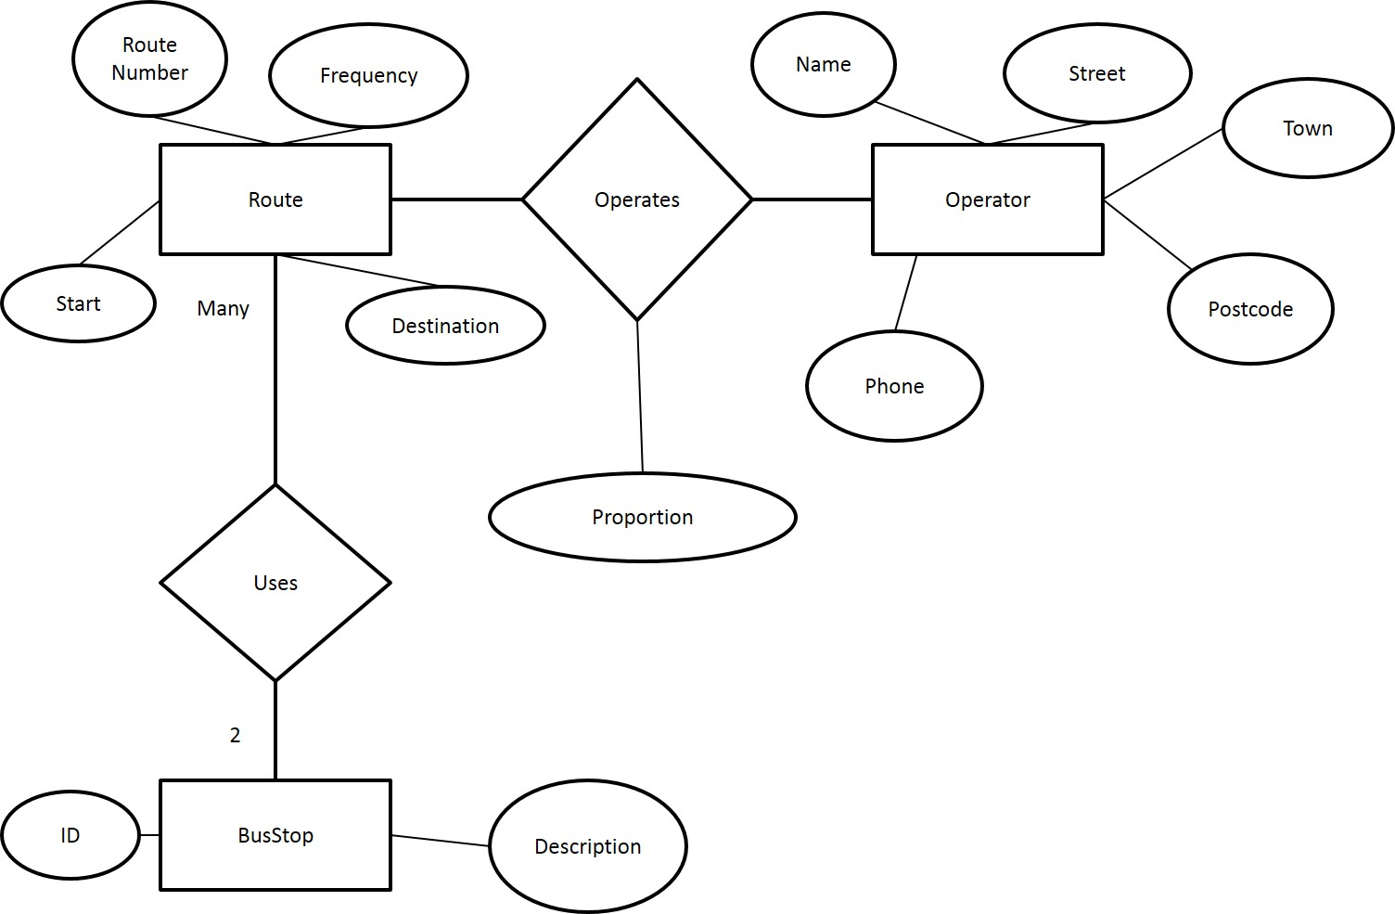

**Tasks**

i) Complete the diagram so that it correctly represents the scenario described above. You can download a PowerPoint slide containing the diagram from <http://homepages.cs.ncl.ac.uk/john.colquhoun/DB/2024/Task1.pptx> if you wish to do so. **5 marks.**

ii) Decide on the database tables you will need to implement the database, using the E-R diagram to help you. Create ALL of these tables in MySQL. In your answer document, you MUST show the CREATE TABLE statements you use. Populate your database with the sample data given at the end of this assignment. **17 marks.**

iii) Give the SQL for the following and show screenshots of the results for each query. If you are unsure of how to take a screenshot, please see <http://www.take-a-screenshot.org/>

**17 marks.**

1. What is the location of the bus stop with the highest stop ID?
2. List as briefly as you can, the name and phone number of the bus operators serving the Shopping Centre.
3. How many bus journeys per hour are operated by Venture Travel? **Hint:** Think about how to work this out and then look back at the slides on arithmetic in SQL queries.
4. How many bus stops serve as the starting point for a bus route but have no routes which terminate there?

iv) The council is considering extending the database so that it also includes the contact details for some key members of staff at each of the bus operators. This would enable the council to get in touch with the relevant person if there is a query or a complaint about the bus service that is being provided. The council are uncertain of how many such contacts they will need for each operator though it is likely to be at least 2. For each person, the council needs to know their name and job title. In addition to the company contact details, the council also needs to have a direct e-mail address and mobile phone number for each person. You may assume that each person works for only one of the bus operators and has only one direct e-mail address and mobile number.

Modify the entity-relationship diagram to include this extension.

**Notes:**

Remember that Task i) includes a link to a PowerPoint slide containing the original diagram which you can use if you wish. You will not be marked again on any of the modifications made in Task i).

You do NOT need to create any new tables in MySQL.

**5 marks.**

v) The scenario in this assignment said that the council only wanted to store the start and destination of each bus route. However, they are now considering a more detailed approach which would store every single bus stop served by each route. You may assume there is no limit on the number of stops that can be served by a route and that the council do not want to distinguish which of these stops is the start and which is the destination.

List the changes you would need to make to the E-R diagram and the database if this approach was to be used.

**Note:**

You should NOT alter the diagram and you do NOT need to implement the changes. This question requires a list (bullet points will be fine).

**6 marks.**

**This is the end of the assignment; however the sample data for this exercise is on the following pages and there is also an FAQ sheet for this coursework on BB under “Assessment”.**

**Sample Data**

(**Note:** this data is entirely fictitious!!)

**Bus operators:**

Venture Travel, Venture House, Consett, DH8 8SV, e-mail: info@venturetravel.co.uk, phone 01207 222 145.

OK Travel, Bondgate, Durham, DH2 2BC, e-mail: passengerservices@ok.com, phone 0191 301 3012.

Lockey’s, The Garage, Durham, DH1 1AB, e-mail: contact@lockeysbuses.co.uk, phone 0191 340 1934.

Bond Brothers, Coronation Terrace, Durham, DH2 3AG, e-mail: jeff.bond@bondbuses.com, phone 0191 333 1234.

Diamond Buses, Diamond Buildings, Newcastle, NE2 5JH, e-mail: info@diamondbuses.co.uk, phone 0191 267 8937.

**Bus Stops:**

1015: Quayside.

1023: Ferry terminal.

1500: City Centre.

6700: Airport

7628: Shopping Centre.

9015: Railway Station.

9016: Railway Station.

9022: Park Gates.

**Bus Routes:**

Route 1: Railway Station (Stop 9015) to Park Gates, 2 per hour, operated entirely by Venture Travel.

Route 16: Shopping Centre to City Centre, 6 per hour, operated entirely by Diamond Buses.

Route 16a: Shopping Centre to Park Gates, 2 per hour, operated entirely by Diamond Buses.

Route 21: Ferry Terminal to Quayside, 4 per hour, operated entirely by Bond Brothers.

Route 22: Ferry Terminal to City Centre, 1 per hour, operated entirely by Bond Brothers.

Route 30: Quayside to City Centre, 4 per hour, operated entirely by Bond Brothers.

Route 64: Railway station (Stop 9015) to Shopping Centre, 6 per hour, operated entirely by Lockey’s.

Route 88: Railway Station (Stop 9016) to Quayside, 2 per hour, operated entirely by Venture Travel.

Route 100: Airport to City Centre, 4 per hour, operated entirely by OK Travel.

Route 111: Airport to Railway Station (Stop 9016), 4 per hour, operated equally by Venture Travel and OK Travel.