**PART 1**

* Great job
* Goals: Good
* Success Evaluation: Close, just needed to be more specific - how much increase in profit?

**I’ll be more specific in my success evaluation by providing measurable points that prove success (literal profit margin or figure)**

* Target Audience: Correct audience and some good points but some generic points.
* Flowchart: Great
* References: Good
* Content: Well organised
* Navigation & images: Navigation works correctly, and images are correctly sized. Good supporting images (+1 for giving my nostalgia with Horseshoe Bay)
* HTML & CSS:Great use of HTML and css, good use of classed divs
* Interface and info design: The weakest part of your website. Design is safe but bland. Times new roman font makes me sad and bored. Needed just a bit more colour. No titles of food on menu page. Same size image on menu item page - should be a little bigger at least

**I intend to improve interface and design by using different fonts where appropriate. I will be adding a light blue along the title to add to the ‘oceanside’ café aesthetic and to improve site based on feedback above. Will increase the size of images on item specific page. This will be the primary focus for my second submission.**

**Part 2 Design Rationalisation**

**Home Page with content written to rank well on search engines (including meta data)**

**In line with A1 feedback, I will make some changes to Fonts: Heading changed to Fredoka in order to enhance site aesthetic.**

**Colours: Change footer and heading to light shade of blue which will add to the oceanside café aesthetic. As per the feedback I will be adding additional colour on all pages. The colours and fonts chosen will be light and easy to read as I do not want them detracting from the website goals and been overbearing.**

Keep home page banner image

Maintain sign up button location on banner. Additional use of css on button to round it off.

**Specials describes current sale items**

The specials and newsletter sign up will be shared on a page. I will have a title indicating the location of newsletter signup (bottom of page) and at the top of the page display special items.

**Product Detail pages give information about each particular item**

Images: Images will differ to the menu images. I will add multiple images or increase image size to minimise the amount of excessive white space on the page.

**Contact Us Page gives information about organisers details and contact information**

I intend to merge the ‘About page’ in order to establish a ‘contact’ page**.** This page will provide information about the business as well as contact information. The primary text will begin at the top of the page with a selection of images to compliment the local area below. Additionally, contact information can be found in the footer.

**Newsletter Signup**

The signup button will be located on the home page and will be easy to locate. After user clicks on button they will be re-directed to sign-up for a newsletter. I will also keep the ‘specials’ option in the navbar as an alternate link.

JavaScript will be implemented to validate some user input in the form. Once the user submits a valid form they will be directed to a new page (essentially home page) displaying a thankyou message and summary of the form inputs.

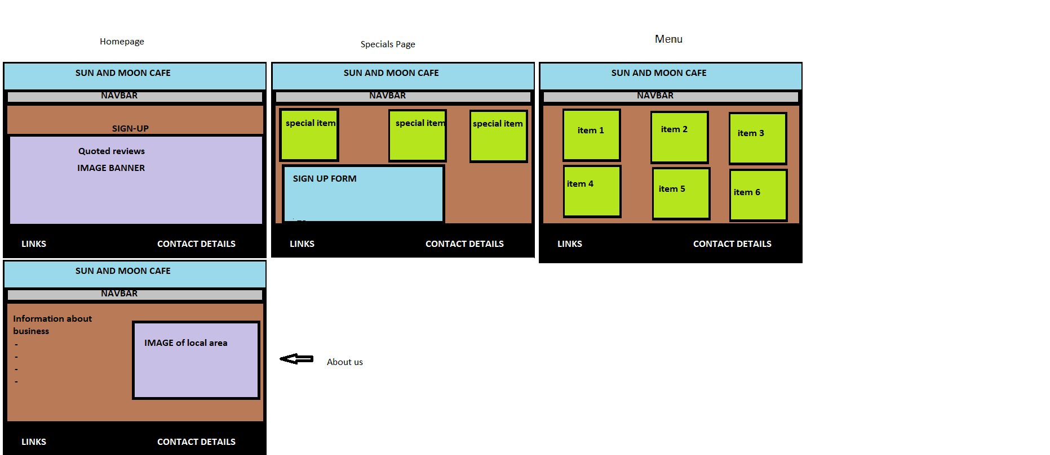**Mockups**

**Part 3 Usability Testing**

**Pre-Testing Questions**

1. What do you think the goal of the site is?
2. Does the website feel legitimate and safe?

Tester Number 1 response:

1. I think the goal of the site is to provide potential customers with information regarding the café’s products.
2. The website seems legitimate and safe however it does seem basic.

Tester Number 2 response:

1. I think the goal of the site is to have people sign-up for specials to gain returning customers.
2. The website does feel legitimate and would be comfortable using it.

**4 tasks for users to complete**

1. Find the signup form
2. Find the address
3. Locate the business contact details
4. Find the Cheeseburger on the menu

**Observations:** Both testers completed all the tasks without any delay or ambiguity.

**2 post testing questions**

1. Did you ever feel lost or confused when navigating the website?
2. Was there a particular feature of information that you felt was missing or could be improved?

Tester Number 1 response:

1. No, the site was quite easy to navigate around. The headings in the top bar took me to information I expected to see.
2. The sign-up button on the home page looked a bit generic and out of place.

Tester Number 2 response:

1. I thought it was simple to find information and didn’t get confused.
2. Didn’t see any things that I would expect to be missing. The sign-up form looked a bit basic.

**Changes to implement to further development based off feedback:**

* Improve the styling of the sign-up button on the home page to look like it ‘belongs’ to the site.
* Improve the styling of the sign-up form. I will add some colour to the form background and a border to enhance its aesthetic.