SHOREBIRD POPULATIONS, HABITAT SELECTION RELATIVE TO THE USE OF AREAS COVERED BY MOTUS STATIONS IN THE HUNTER ESTUARY: VARIABILITY ACROSS SPECIES.
METHODS: Definition of Available time VS Used time – Attached to Figure 1

- Tide information: Tide table informs for Low and High tide peaks. Half of the period between peak n and peak n-1 is taken, added to the period between peak 1 and peak n+1, then expanded in hours for further analysis. The tide associated to peak n defines its period (i.e. red lines below is high tide since peak n is high tide).
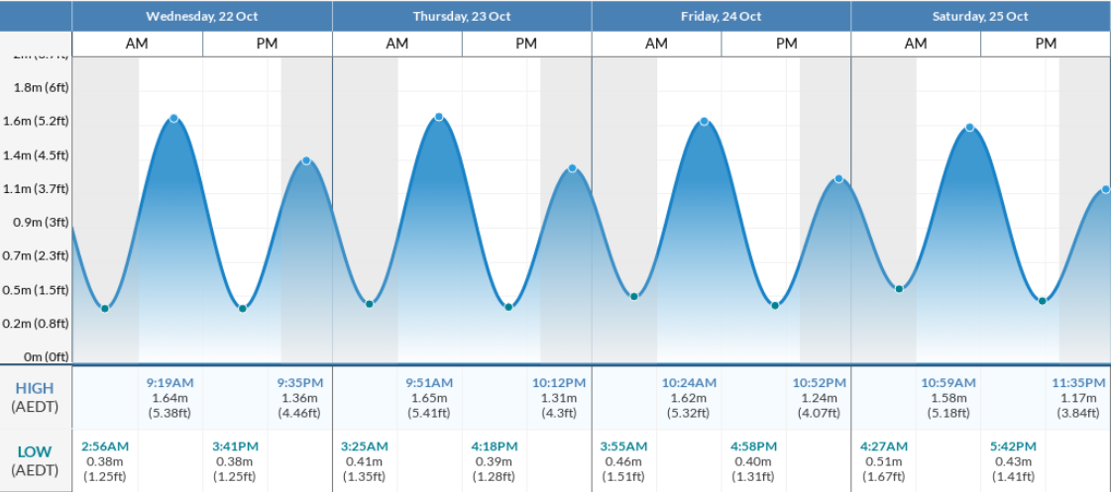
n+1
n
n-1

- Available Time: Time of one MOTUS station (SG receiver) is reached by the use of activity table: each row is a record of noise or a tag with the datetime.
  - We need first to define the temporal coverage of each station, starting from deployment date to the last activity datetime.
  - We expand this complete period in hours.
  - Then we keep the ON period only.
One ON period is defined until there is a gap of records greater than 24h, therefore defining a OFF period.
- Used time: Time used for birds is defined by multiplying the number of detections by the duration of a pulse (pulse interval). Duration differs depending tags.

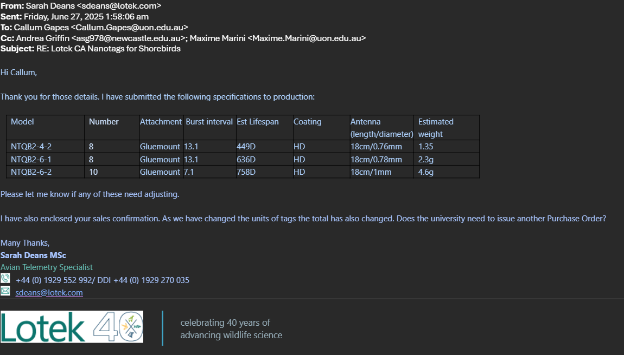

For each MOTUS station, Available time is defined. Each bird individuals have a Used time per MOTUS station.
Hours 0 1 2 3 4 5 6 7 8 9
NSW Tide table
Receiver dep.
Receiver ON
Bird tag period
Bird detected

Available (4h)
Used (3h)
MOTUS station 1

