**Blue Prism Technical Test**

# **Initial Thoughts**

* .NET Core Console App
* The dictionary File contains words larger than 4 characters do I need to worry about these? Can these be discarded when reading in the file contents?
* Will sorting the List alphabetically help?
* Will using dependency injection help when creating tests?

**DictionaryFile** – string

**StartWord** – string

**EndWord** – string

**ResultFile** - string

These values will be passed in command line arguments.

# **First Approach**

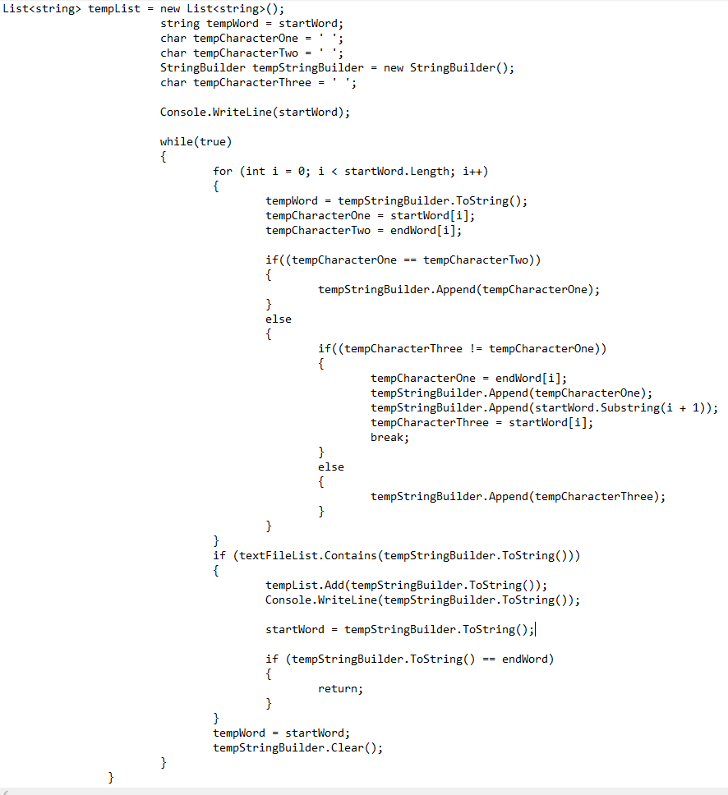

Compare the start word with the end word and change the character of the start word to the character of the end word and then check the dictionary file for this word. If we have changed 1 character then keep the rest the same, use a string builder to build up the word. I.e.

## Example 1

SPIN -> SPAT

SPIN -> SPAN-> SPAT (WORKED)

## Example 2

WINO -> WISH

WINO -> WISO (NOT A REAL WORD)

WINO -> WINH (NOT A REAL WORD)

At this point this approach failed.

# **Second Approach**

Try to create some sort of tree using a List<List<string>>.

