# Resistors

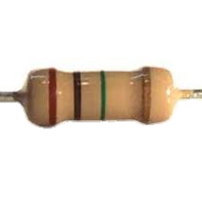

When reading a resistor, hold it so the three colour bands that are close together are on you left, you now read the bands from left to right.

Example:

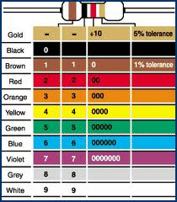

So therefore this resistor value is 560 ohms + or – 28 (5%)

This equals a value between 532 ohms and 588 ohms

5%+ -

6

0

5

|  |  |  |  |  |  |  |
| --- | --- | --- | --- | --- | --- | --- |
| Resistor | Band 1 | Band 2 | Band 3 | OHMS | - | + |
|  | Green 5 | Blue 6 | Brown 0 | 560 | 532 | 588 |
|  |  |  |  |  |  |  |
|  |  | Violet |  |  |  |  |
|  |  |  |  |  |  |  |
|  |  | Grey |  |  |  |  |
|  |  |  |  |  |  |  |

Explain in detail below why we use resistors in a circuit.

In the box on the right draw or paste from the Internet a circuit symbol for a resistor