ASSIGNMENT 3
Attack and Defend Web Application
DVWA Defense Validation Report
Rasaq Abdulwahab Ayomide (Calm Ay) | University of Lagos | May 2026

1. Executive Summary
This report documents the execution of SQL Injection (SQLi) and Cross-Site Scripting (XSS) attacks against a Damn Vulnerable Web Application (DVWA) instance, followed by the deployment of a ModSecurity Web Application Firewall (WAF) using the OWASP Core Rule Set (CRS v4.25.0), and a re-test demonstrating that the WAF successfully blocks the same attacks.
All seven attack payloads succeeded against the unprotected DVWA instance, allowing full credential extraction, database fingerprinting, session cookie theft, and persistent malicious script injection. After deploying the WAF, every single one of the same payloads was blocked with an HTTP 403 Forbidden response. Twelve unique OWASP CRS rules were triggered across the attack set, demonstrating defense-in-depth detection.

2. Lab Architecture
The lab was deployed using Podman (Docker-compatible) on Parrot OS. Two containers were configured:
- DVWA container (vulnerables/web-dvwa) running on the internal lab-net network, not directly exposed to the host.
- WAF reverse proxy container (owasp/modsecurity-crs:nginx) exposed on host port 8090, forwarding traffic to the DVWA backend.
This architecture forces all traffic to pass through ModSecurity before reaching DVWA, replicating a real-world WAF deployment pattern.

Docker Compose Configuration
services:
dvwa:
image: vulnerables/web-dvwa
networks: [lab-net]

waf-proxy:
image: owasp/modsecurity-crs:nginx
ports: ["8090:8080"]
environment:
- BACKEND=http://dvwa:80
- PARANOIA=1
- ANOMALY_INBOUND=5
- MODSEC_RULE_ENGINE=On
volumes:
- ./modsec/rules:/etc/modsecurity.d/custom-rules:ro

3. Attack Phase (Before WAF)
With ModSecurity initially set to DetectionOnly mode (effectively disabled blocking), the following seven attacks were executed against DVWA at security level Low.

3.1 SQL Injection - Authentication Bypass
Payload:
1' OR '1'='1' -- -
The boolean condition forces the WHERE clause to evaluate true for every row, dumping the entire users table. Five user records were returned (admin, Gordon Brown, Hack Me, Pablo Picasso, Bob Smith).
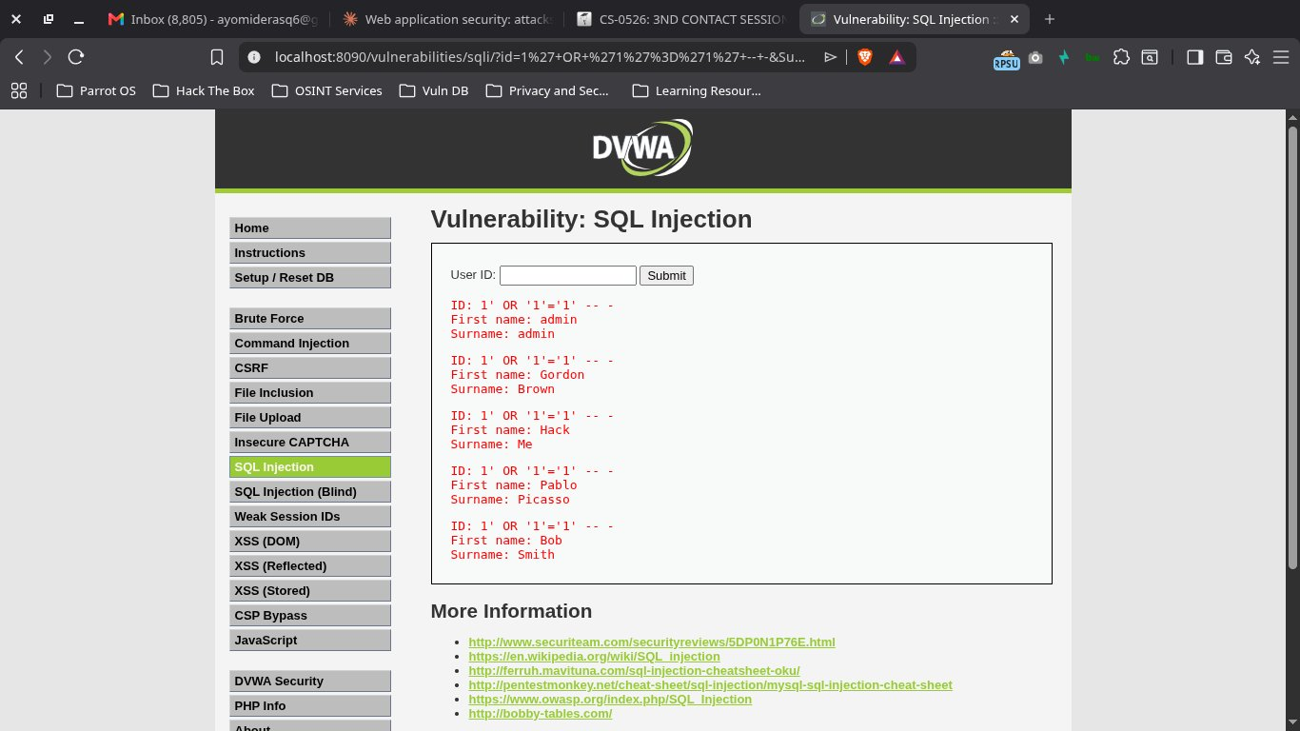
Figure 1: SQLi authentication bypass — all DVWA user records dumped

3.2 SQL Injection - UNION-Based Data Extraction
Payload:
1' UNION SELECT user, password FROM users -- -
The UNION clause appends the contents of the users table (username + password hash columns) to the original query result. All five MD5 password hashes were extracted, allowing offline cracking.
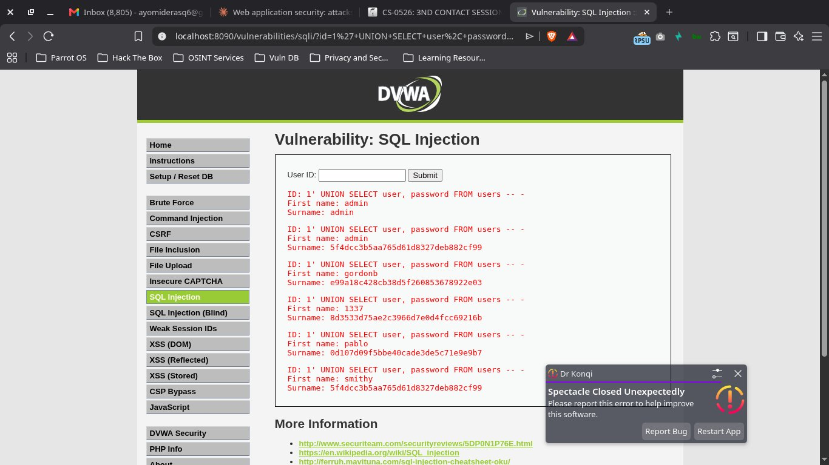
Figure 2: UNION-based extraction — MD5 password hashes leaked for all users

3.3 SQL Injection - Database Schema/Version Disclosure
Payload:
1' UNION SELECT database(), version() -- -
Information disclosure attack that leaks the database name and DBMS version. Confirmed backend is MariaDB 10.1.26-0+deb9u1 with database name 'dvwa'. In a real engagement this is the fingerprinting step before searching for version-specific CVEs.
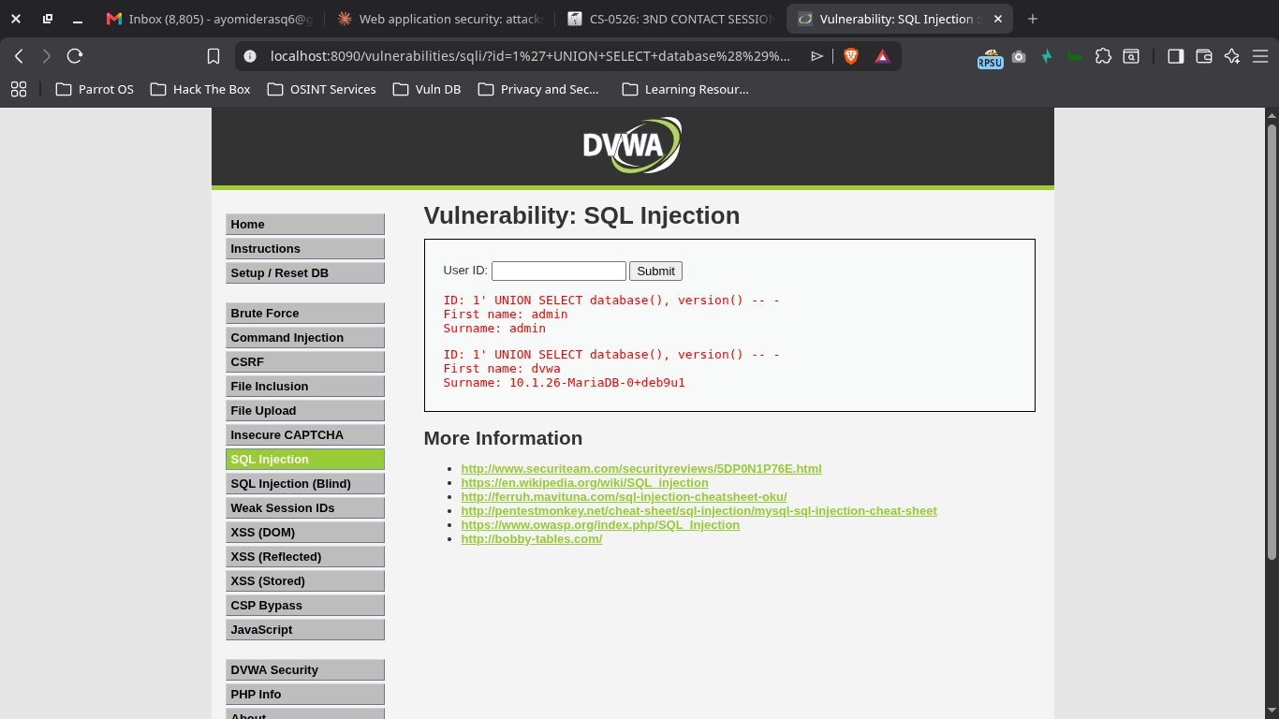
Figure 3: Schema disclosure — database name and MariaDB version exposed

3.4 Reflected XSS - Custom Payload Execution
Payload:
<script>alert('XSS-Reflected-CalmAy')</script>
The unsanitized input is reflected directly back into the response and executed as JavaScript. The personalized string in the alert dialog proves attacker-controlled code execution in the victim's browser context.
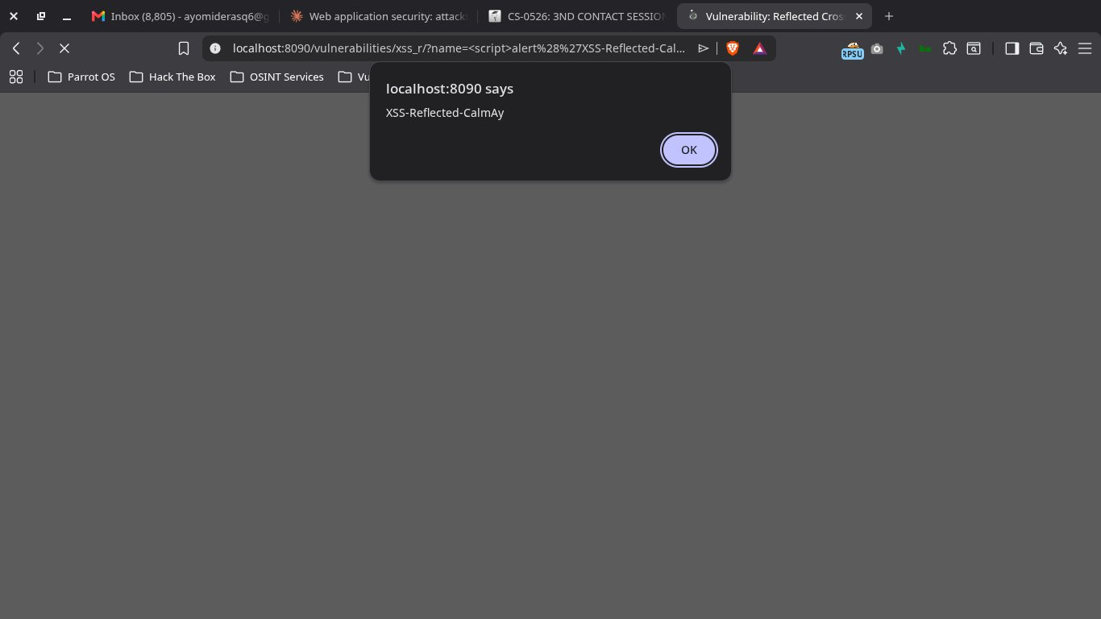
Figure 4: Reflected XSS — attacker payload executed in browser

3.5 Reflected XSS - Session Cookie Theft
Payload:
?name=<script>alert(document.cookie)</script>
Demonstrates the real impact of reflected XSS. The session cookie (PHPSESSID=nvhis4808o1672vjrc6ph6c956; security=low) is exfiltrated to the attacker. In a real attack the cookie would be sent to an attacker-controlled server, enabling session hijacking.
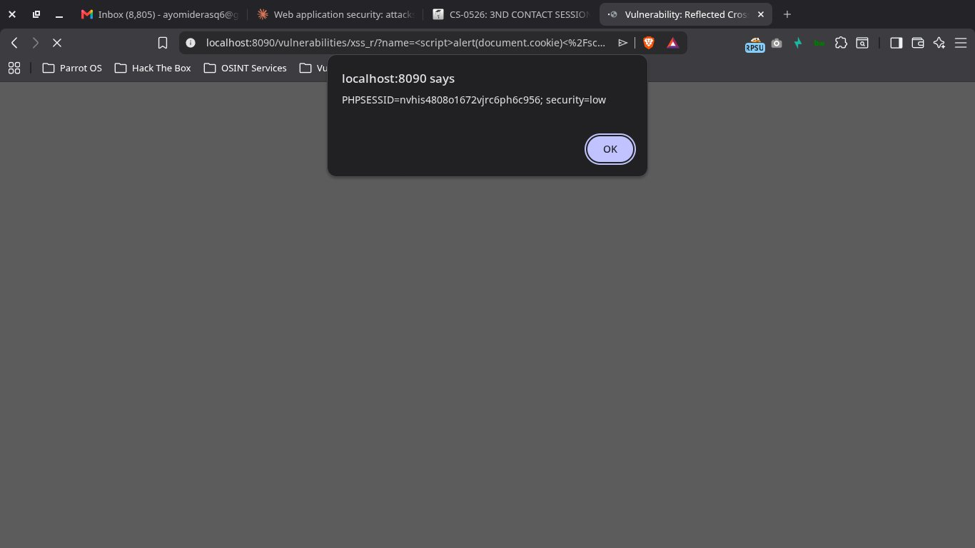
Figure 5: Reflected XSS — session cookie disclosed via document.cookie

3.6 Stored XSS - Persistent Payload
Payload (submitted via guestbook form):
<script>alert('Stored-XSS-Persistent')</script>
The malicious script is saved to the database via the guestbook submission. Every subsequent visitor to the page — including administrators — will trigger the payload. This is the most severe XSS variant because it does not require social engineering to deliver the payload.
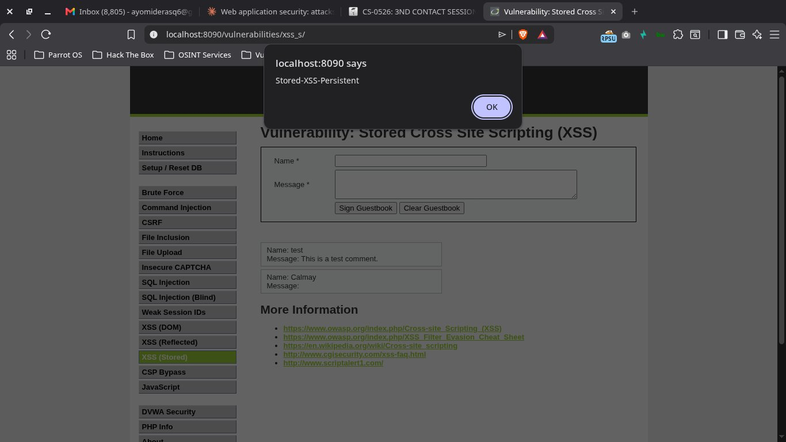
Figure 6: Stored XSS — payload fires on guestbook page
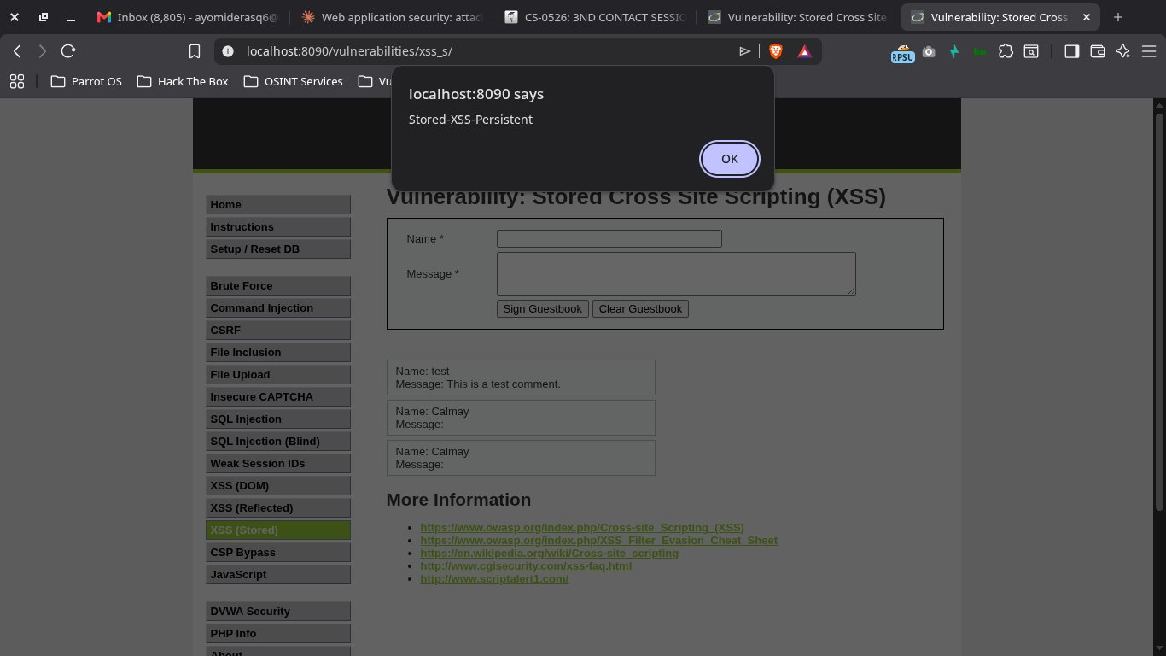
Figure 7: Persistence proof — payload re-executes on page refresh / new visits

4. Defense Phase - WAF Configuration
ModSecurity v3.0.15 with the OWASP Core Rule Set (CRS) v4.25.0 was activated by switching the SecRuleEngine directive from DetectionOnly to On. A custom rules file was also deployed to supplement the CRS detection.

4.1 Custom Rules File
File: modsec/rules/REQUEST-900-CUSTOM-RULES.conf
# Custom SQLi rule
SecRule ARGS "@detectSQLi" \
"id:1001, phase:2, deny, status:403, log,
msg:'CUSTOM-RULE: SQL Injection attempt detected',
tag:'attack-sqli', severity:'CRITICAL'"

# Custom XSS rule
SecRule ARGS "@detectXSS" \
"id:1002, phase:2, deny, status:403, log,
msg:'CUSTOM-RULE: XSS attempt detected',
tag:'attack-xss', severity:'CRITICAL'"

# Block SQLi keywords (belt + braces)
SecRule ARGS "@rx (?i)(union.*select|or\s+1\s*=\s*1|--\s)" \
"id:1003, phase:2, deny, status:403, log,
msg:'CUSTOM-RULE: Suspicious SQL keyword',
tag:'attack-sqli', severity:'CRITICAL'"

# Block script tags
SecRule ARGS "@rx (?i)<\s*script[^>]*>" \
"id:1004, phase:2, deny, status:403, log,
msg:'CUSTOM-RULE: Script tag injection',
tag:'attack-xss', severity:'CRITICAL'"

4.2 CRS Configuration
- Paranoia Level: 1 (production default - low false positive rate)
- Inbound Anomaly Threshold: 5 (requests scoring ≥5 are blocked)
- Outbound Anomaly Threshold: 4
- Rule Engine: On (active blocking enabled)
- Total CRS rules loaded: 847

5. Re-Test Phase (After WAF)
With the WAF active, every payload from Section 3 was re-submitted against the same DVWA endpoints. All requests were intercepted by ModSecurity and returned HTTP 403 Forbidden before reaching the backend application.

5.1 SQLi Attacks - All Blocked
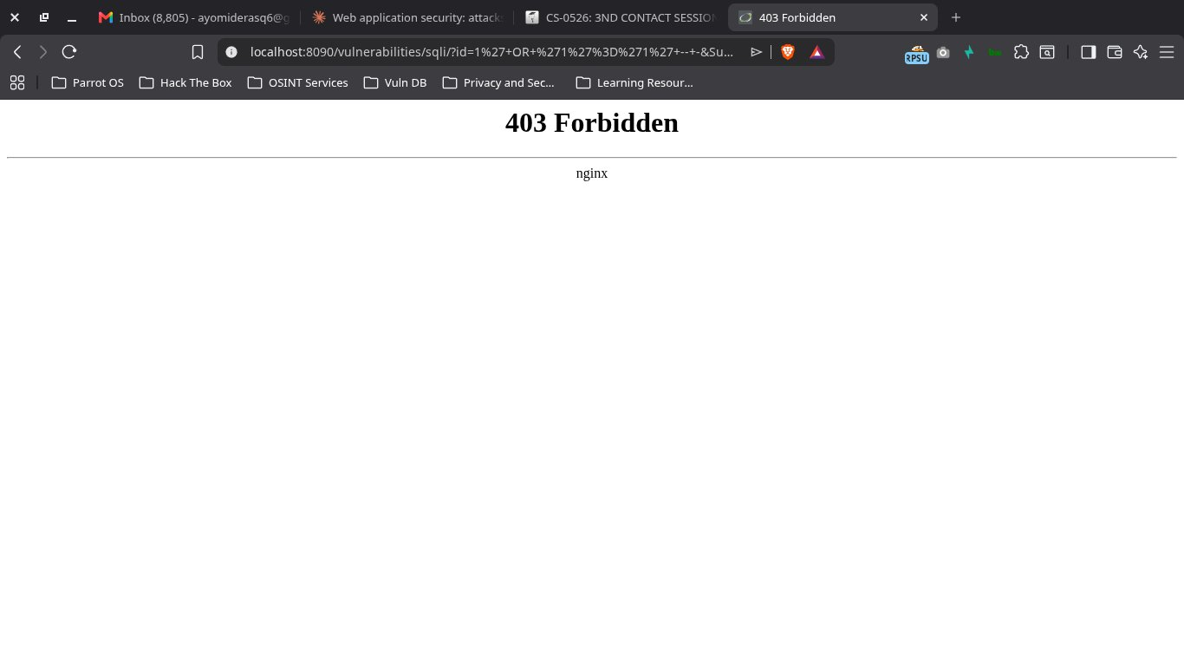
Figure 8: SQLi authentication bypass — BLOCKED with 403 Forbidden
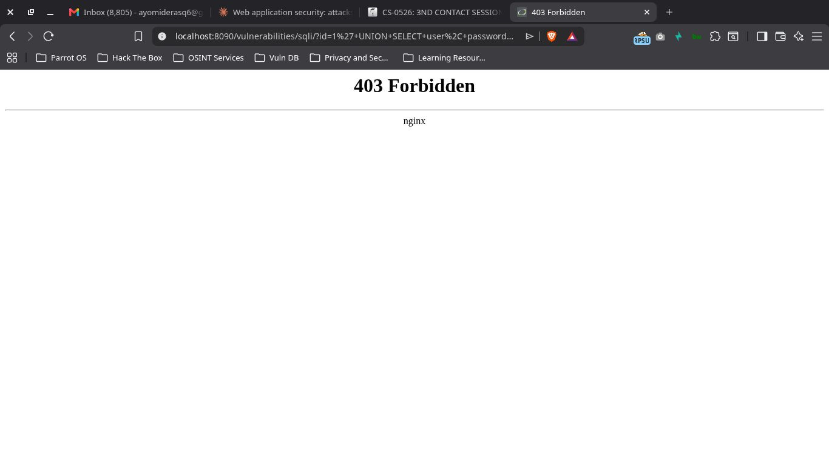
Figure 9: SQLi UNION-based extraction — BLOCKED with 403 Forbidden
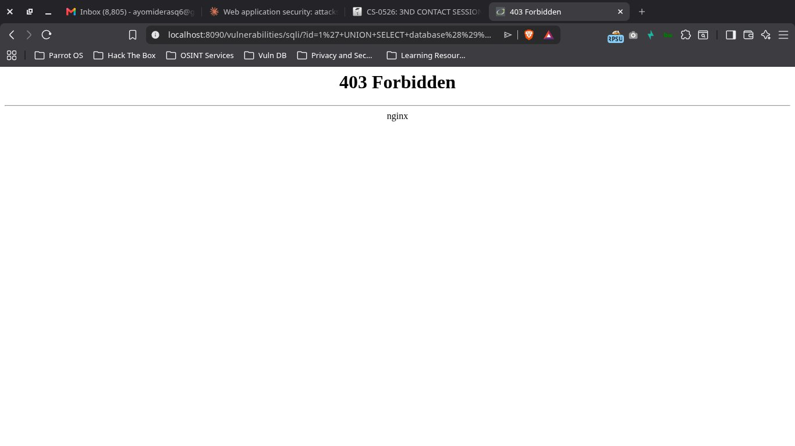
Figure 10: SQLi schema disclosure — BLOCKED with 403 Forbidden

5.2 XSS Attacks - All Blocked
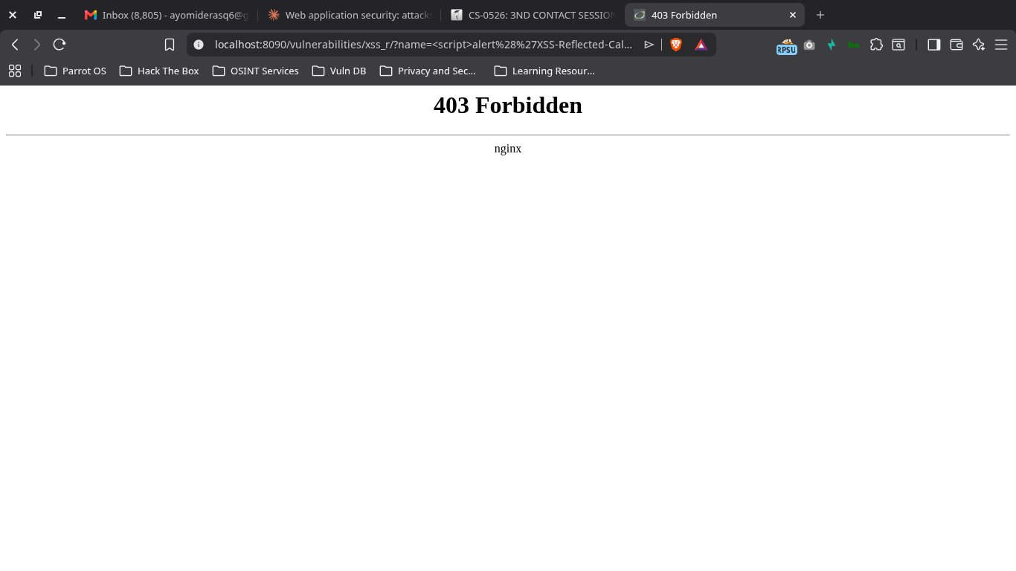
Figure 11: Reflected XSS custom payload — BLOCKED with 403 Forbidden
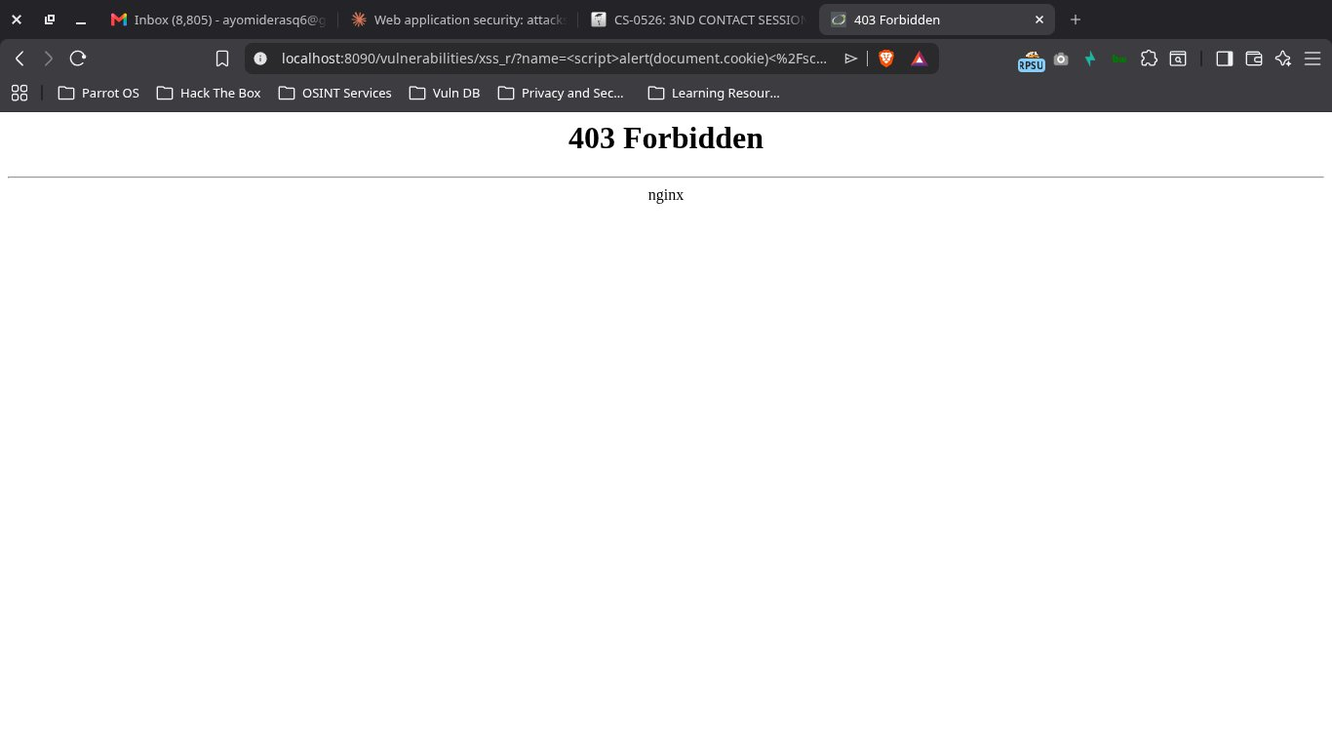
Figure 12: Reflected XSS cookie theft — BLOCKED with 403 Forbidden
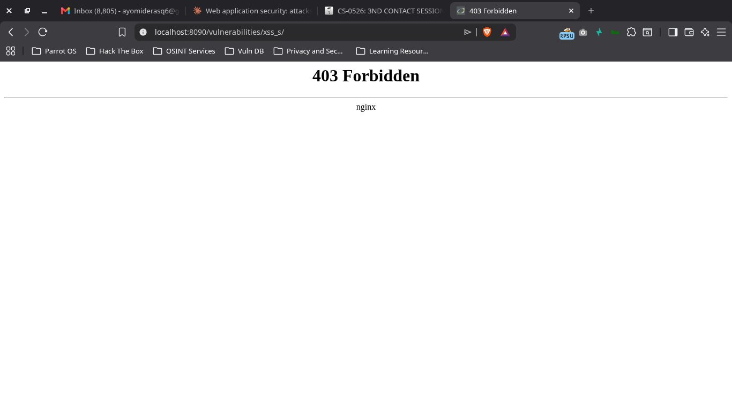
Figure 13: Stored XSS POST request — BLOCKED with 403 Forbidden

6. Log Evidence
ModSecurity logged every blocked request with full forensic detail. Below is a representative log entry for the SQLi UNION-based extraction attempt:
2026/05/25 13:45:22 [error] [client 10.89.0.3]
ModSecurity: Access denied with code 403 (phase 2).
Matched "Operator `Ge' with parameter `5' against variable
`TX:BLOCKING_INBOUND_ANOMALY_SCORE' (Value: `20')
[id "949110"] [msg "Inbound Anomaly Score Exceeded (Total: 20)"]
[severity "0"] [ver "OWASP_CRS/4.25.0"]
[hostname "localhost"] [uri "/vulnerabilities/sqli/"]
request: "GET /vulnerabilities/sqli/
?id=1%27+UNION+SELECT+user%2C+password+FROM+users+--+-
&Submit=Submit HTTP/1.1"

6.1 Triggered Rules Summary
Twelve unique OWASP CRS rules were triggered across the attack set, demonstrating layered (defense-in-depth) detection:
Rule ID | Rule Description | What It Caught
941100 | XSS Attack Detected via libinjection | All XSS payloads (generic detector)
941110 | XSS Filter - Category 1: Script Tag Vector | <script> tag pattern
941160 | NoScript XSS InjectionChecker: HTML Injection | HTML tag injection patterns
941180 | Node-Validator Deny List Keywords | document.cookie keyword
941390 | Javascript method detected | alert() function call
942100 | SQL Injection Attack Detected via libinjection | All SQLi payloads (generic detector)
942140 | SQL Injection Attack: Common DB Names Detected | database() function call
942151 | SQL Injection Attack: SQL function name detected | database(), version() functions
942190 | Detects MSSQL code execution attempts | UNION SELECT pattern
942270 | Looking for basic SQL injection | union...select...from regex match
942360 | Detects concatenated SQL injection attempts | '1 UNION SELECT start pattern
949110 | Inbound Anomaly Score Exceeded | Final blocking trigger (score ≥ 5)

7. Defense Validation Summary
Attack Type | Before WAF | After WAF | Anomaly Score
SQLi - Authentication Bypass | SUCCESS | BLOCKED (403) | 5 (1 rule)
SQLi - UNION Data Extraction | SUCCESS | BLOCKED (403) | 20 (5 rules)
SQLi - Schema/Version Disclosure | SUCCESS | BLOCKED (403) | 25 (6 rules)
XSS - Reflected (custom payload) | SUCCESS | BLOCKED (403) | 20 (4 rules)
XSS - Reflected (cookie theft) | SUCCESS | BLOCKED (403) | 25 (5 rules)
XSS - Stored (persistent) | SUCCESS | BLOCKED (403) | 20 (POST body)
All six attack categories that succeeded against the unprotected application were successfully blocked by ModSecurity. The anomaly scoring model worked as designed — every attack accumulated enough score (≥5) from multiple matching rules to trigger the final blocking decision at rule 949110.

8. Analysis & Observations

Defense in Depth
Even simple attacks triggered multiple detection rules. The UNION SELECT payload alone was caught by five separate rules (942100, 942190, 942270, 942360, 949110). This means an attacker would need to evade all five rules simultaneously to bypass detection — a much harder task than bypassing a single signature.

Backend Never Reached
Because the WAF sits as a reverse proxy in front of DVWA, malicious requests are rejected before they reach the application. The backend logs show no record of the blocked attacks, meaning no database queries were executed, no XSS payloads were stored, and no application resources were consumed by attack traffic.

POST Body Inspection
The stored XSS attack was delivered via a POST request to the guestbook form. ModSecurity correctly inspected the POST body (not just URL parameters) and blocked the request. Many simpler WAF implementations only inspect GET parameters and would miss this attack class entirely.

Custom Rule Validation
In addition to the CRS rules, the custom rules (IDs 1001-1004) were registered and active. While the CRS rules triggered first due to lower IDs and higher specificity, the custom rules provide a redundant safety net and demonstrate the ability to extend ModSec for organization-specific signatures.

9. Conclusion
The ModSecurity WAF, configured with OWASP CRS v4.25.0 at paranoia level 1, successfully blocked all SQL Injection and Cross-Site Scripting attack variants tested in this assignment. Detection was layered, logs were forensically rich, and no manual rule tuning was required to achieve full coverage of the OWASP Top 10 categories tested.
Recommendations for production deployment:
- Maintain paranoia level 1 for general traffic; increase to PL2 or PL3 for high-value endpoints (admin panels, payment flows).
- Forward ModSec logs to a SIEM (e.g., ELK, Splunk) for correlation and alerting.
- Periodically review false positives via the CRS exclusion framework rather than disabling rules outright.
- Combine WAF protection with secure coding practices — the WAF is the second line of defense, not the first.
- Enable concurrent audit logging in production for compliance and forensic requirements.
— End of Report —

