Network Attack Detection & Reporting
Cowrie Honeypot Lab Report
Name | Rasaq Ayomide
Operating System | Parrot OS
Lab Type | Single-machine local simulation
Tools Used | Cowrie, Nmap, Wireshark, SSH Client
Date | 09 May 2026

1. Objective
The objective of this lab was to build and run a honeypot, simulate a basic network attack against it, capture the network traffic, and prepare an incident report using the evidence collected.

2. Lab Setup
This lab was performed as a single-machine local simulation on Parrot OS. Cowrie Honeypot was installed locally and used as the target system, while Nmap, SSH, and Wireshark were used from the same machine to simulate attacker activity and capture evidence.
Attacker Machine | Parrot OS
Honeypot Machine | Parrot OS running Cowrie Honeypot
Attacker IP | 127.0.0.1
Honeypot IP | 127.0.0.1
Target Port | 2222/tcp
Capture Interface | lo / Loopback

3. Evidence Collected

3.1 Screenshot of Honeypot Running
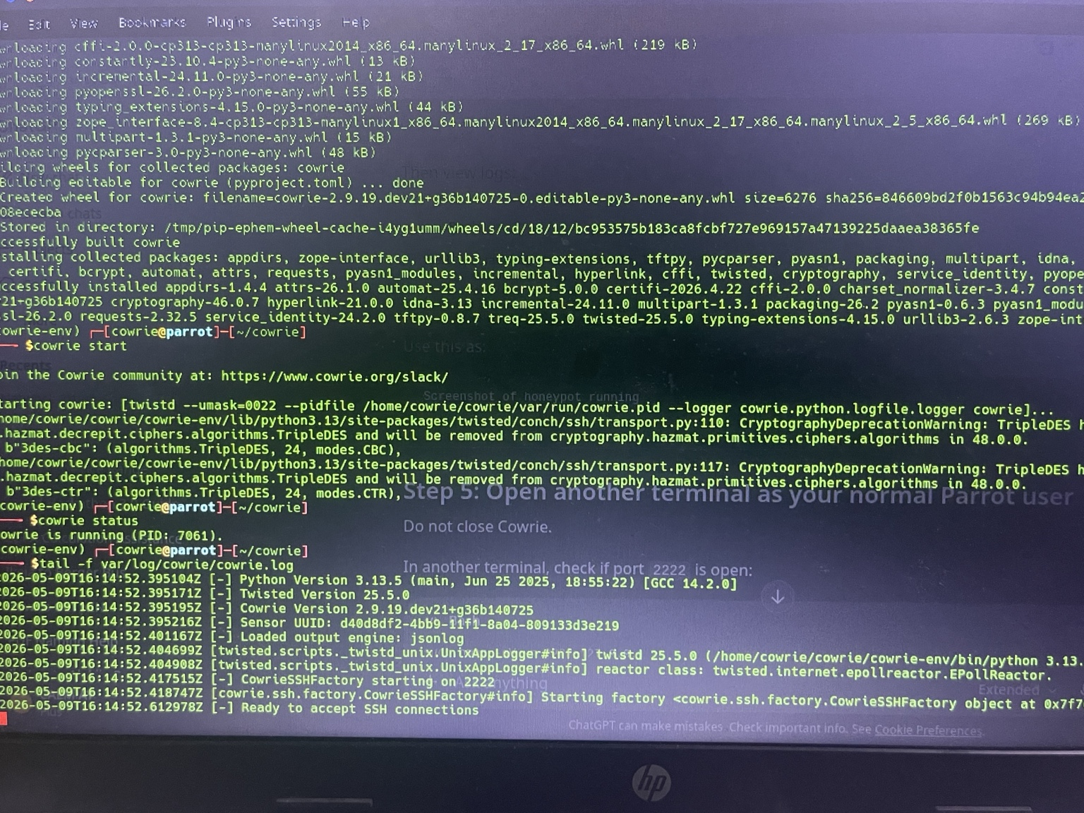
Figure 1: Cowrie Honeypot running successfully on Parrot OS and ready to accept SSH connections on port 2222.

3.2 Nmap Scan Results
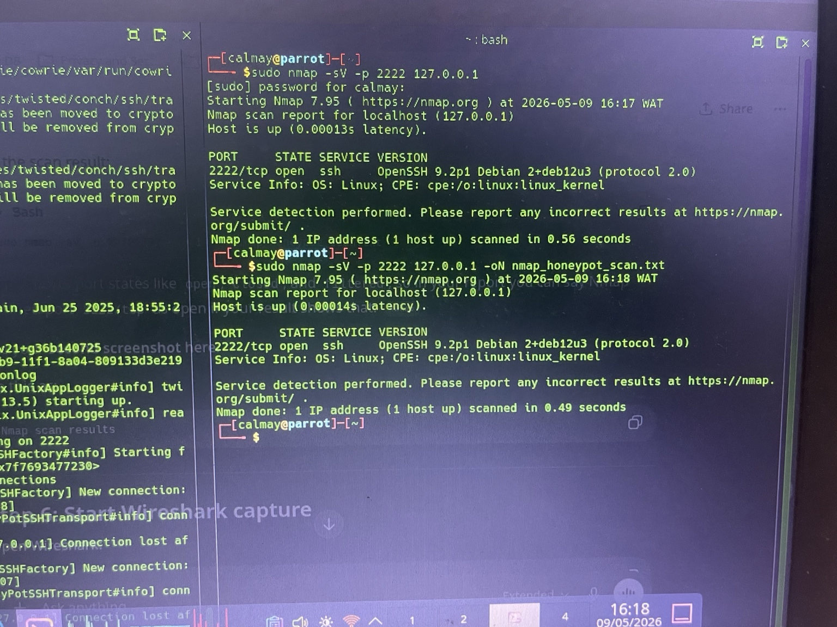
Figure 2: Nmap scan result showing that port 2222/tcp is open on localhost 127.0.0.1.
The Nmap result confirms that an SSH service was reachable on port 2222. In this lab, that service was the Cowrie honeypot running locally.

3.3 Wireshark Capture Evidence
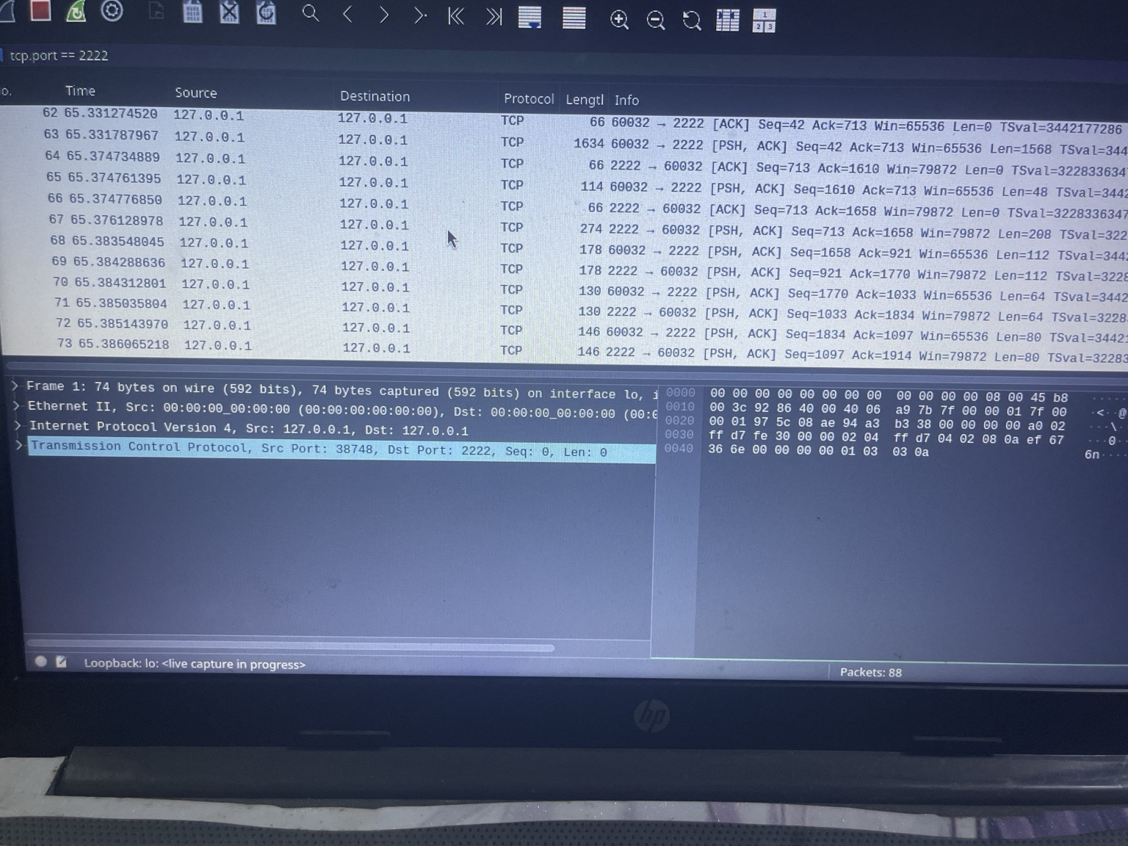
Figure 3: Wireshark capture on the loopback interface showing TCP traffic between 127.0.0.1 and 127.0.0.1 on port 2222.
The packet capture shows local TCP communication to the honeypot port. The Wireshark capture file was saved separately as cowrie_attack_capture.pcapng.

3.4 Cowrie Log Evidence
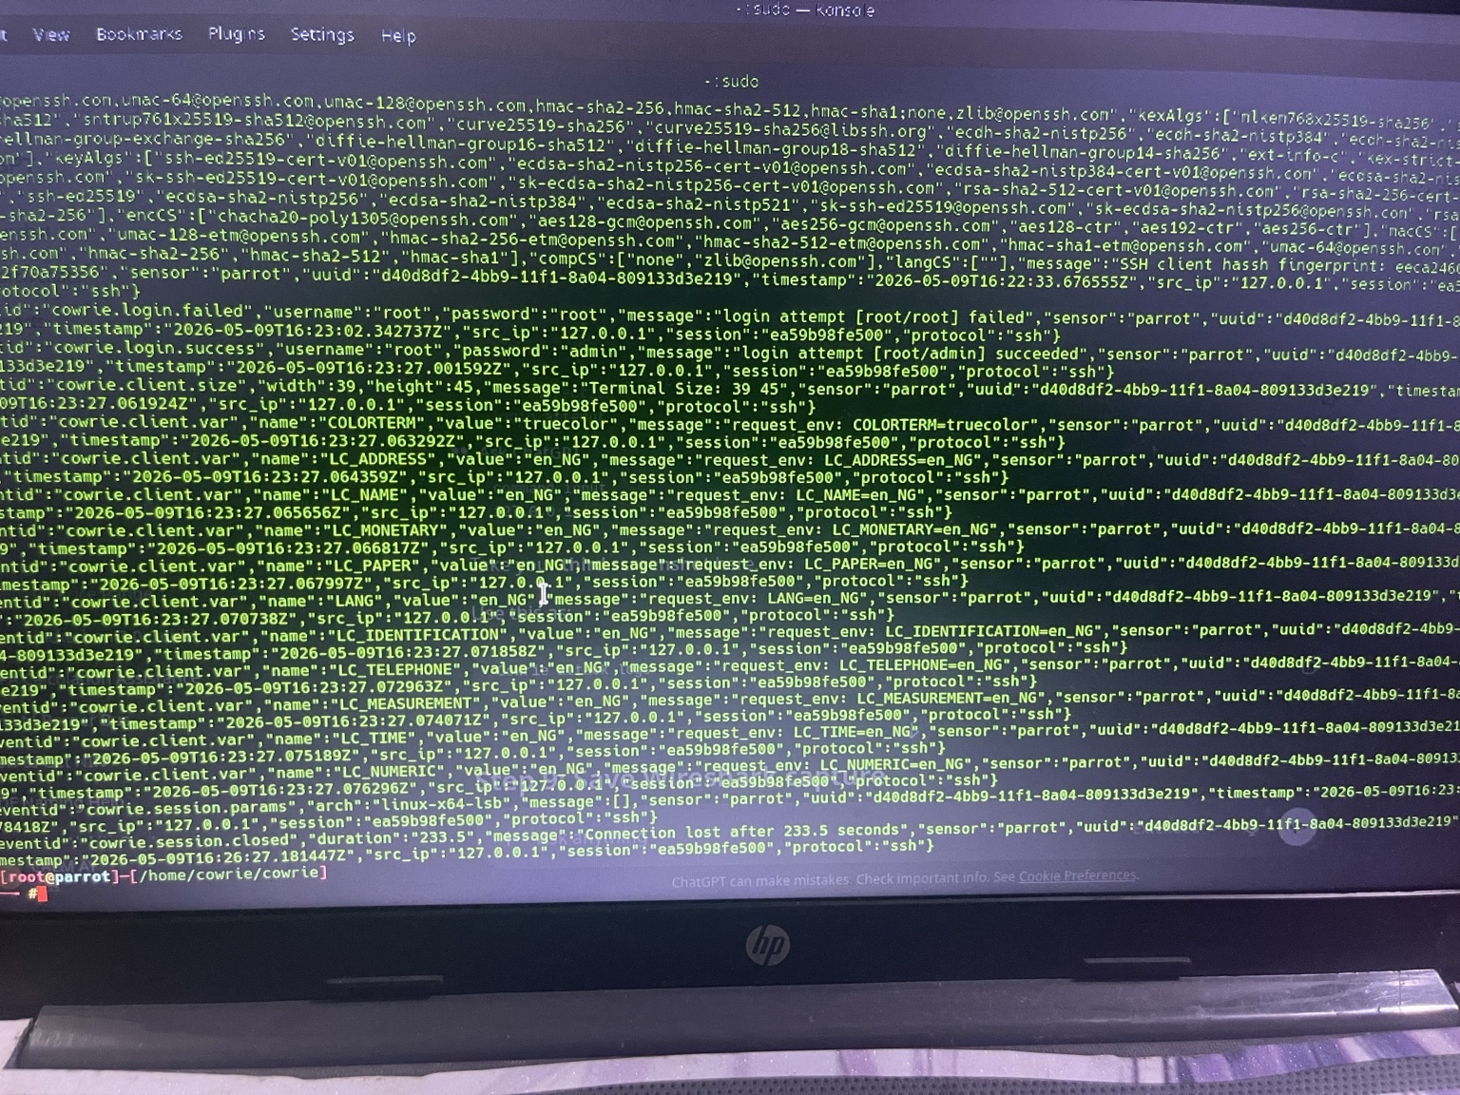
Figure 4: Cowrie JSON log showing SSH login activity from 127.0.0.1 to port 2222, including failed and successful authentication events.
The Cowrie logs show SSH session activity, including login attempts using the root account and authentication events recorded by the honeypot.

4. One-page Incident Report
Attack Summary: A controlled SSH attack simulation was performed against a Cowrie honeypot running locally on Parrot OS. Nmap was first used to scan localhost and identify the open SSH honeypot service on port 2222/tcp. After the scan, SSH login attempts were made using common credentials. Cowrie captured the connection attempts, authentication activity, and session details, while Wireshark captured the network traffic on the loopback interface.
Key Indicators: Source IP: 127.0.0.1; Destination IP: 127.0.0.1; Destination Port: 2222/tcp; Protocol: TCP/SSH; Attack Type: Port scanning and SSH login attempt; Tools Used: Nmap, SSH client, Wireshark, Cowrie.
Evidence Summary: The Cowrie status screenshot confirms that the honeypot was running and ready to accept SSH connections. The Nmap screenshot shows port 2222/tcp open on localhost. The Wireshark screenshot confirms TCP traffic on port 2222 through the loopback interface. The Cowrie log screenshot records SSH login activity, including failed and successful authentication events.
Impact: No real system was compromised because the activity was performed in a controlled local lab environment. The simulation demonstrated how reconnaissance and unauthorized SSH login attempts can be detected and logged using a honeypot.
Defense Suggestions: SSH services should not be exposed unnecessarily. Access should be restricted using firewall rules, trusted IP allowlisting, key-based authentication, multi-factor authentication, and regular log monitoring. Repeated failed login attempts should trigger alerts or blocking rules. Honeypots like Cowrie can also help detect suspicious activity and study attacker behavior.

5. Submission Note
This Google Docs report contains the required screenshots and incident report. The Wireshark packet capture file should be uploaded separately with the submission as cowrie_attack_capture.pcapng.

