ASSIGNMENT 3
PrestaShop Security Assessment
Security Checklist + Attack Simulation Report
Rasaq Abdulwahab Ayomide (Calm Ay) | University of Lagos | May 2026

1. Executive Summary
This report documents a security assessment of a PrestaShop 8.1.7 e-commerce instance, conducted as part of Assignment 3. The assessment comprised two phases: a structured security checklist review covering 10 key configuration areas, followed by three targeted attack simulations derived from checklist findings.
The assessment identified 14 findings across the instance, including 2 HIGH severity issues: active default customer credentials and the complete absence of TLS/HTTPS. Three attack simulations were successfully executed — default credential takeover, admin login brute force using Hydra (credentials cracked in 3 seconds), and admin path discovery via ffuf — demonstrating a full admin compromise attack chain completable in under 10 seconds.

2. Scope and Environment
Target application: PrestaShop 8.1.7 deployed via Docker on Parrot OS.
- Target URL: http://localhost:8091
- Admin panel: http://localhost:8091/admin-pentest
- Backend DB: MariaDB 10.11.17 (prestashop-db:3306)
- Web server: Apache/2.4.62 (Debian)
- PHP version: 8.1.33
- Assessment type: Grey-box (admin credentials known for checklist; unknown for attack simulation)
- Tools used: ffuf v2.1.0, Hydra v9.5, curl, MySQL CLI, browser DevTools
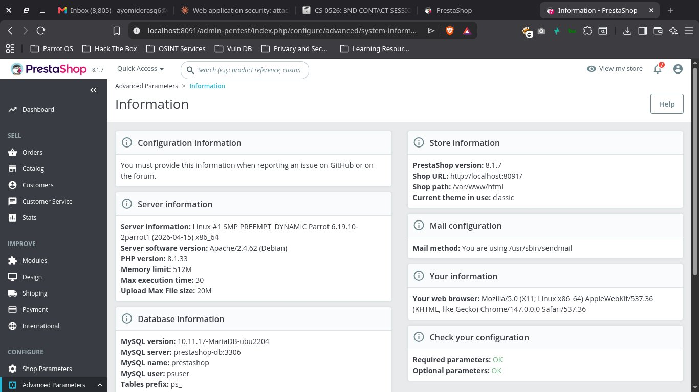
Figure 1: PrestaShop 8.1.7 system information page showing full environment details

3. Security Checklist
The following 10-item security checklist was executed against the PrestaShop instance. Each item was tested using a combination of browser inspection, CLI commands, and database queries.
# | Checklist Item | Status | Severity | Finding Ref
1 | App + modules up to date | ❌ FAIL | MEDIUM | F-03, F-10
2 | Remove default/demo accounts and sample data | ❌ FAIL | HIGH | F-01, F-09
3 | Strong admin password + MFA | ⚠ PARTIAL | MEDIUM | F-04, F-05
4 | File/folder permissions + directory listing | ⚠ PARTIAL | MEDIUM | F-06
5 | Secure session cookie settings | ⚠ PARTIAL | MEDIUM | F-07
6 | Disable unnecessary modules | ❌ FAIL | LOW | F-10
7 | Secure payment + API endpoints | ⚠ PARTIAL | LOW | F-11, F-14
8 | TLS configured and enforced | ❌ FAIL | HIGH | F-02
9 | Admin path + IP restrictions | ⚠ PARTIAL | MEDIUM | F-08, F-13
10 | Backup + recovery verified | ❌ FAIL | MEDIUM | F-12

3.1 Application and Modules Up To Date
Installed version: PrestaShop 8.1.7. Latest stable release: 9.1.3 (released 2026-05-21). The installed version is one full major version behind, missing all security patches from the 9.x release line. Additionally, the Module Manager shows 51 modules with pending upgrades, none of which have been applied.
- Finding F-03: Application outdated (8.1.7 vs 9.1.3) — Severity: MEDIUM
- Finding F-10: 51 module upgrades pending, all 66 modules active — Severity: LOW
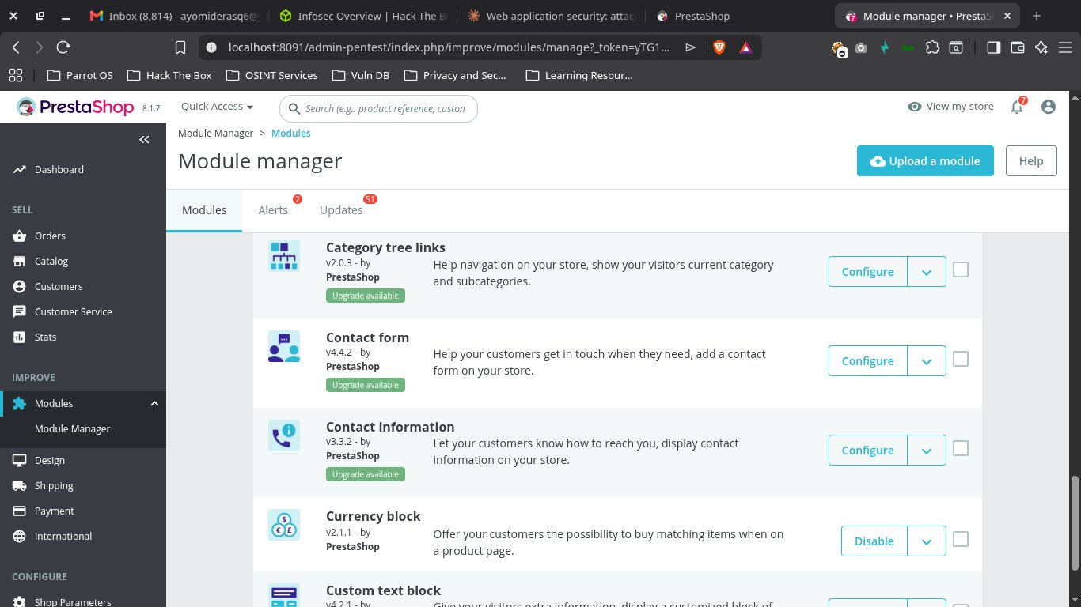
Figure 2: Module Manager showing 51 pending module updates (badge on Updates tab)

3.2 Default/Demo Accounts and Sample Data
The default PrestaShop customer account (John DOE / pub@prestashop.com) was found active in the database with password '123456789'. This is a publicly known default credential documented in PrestaShop's own installation guides. Authentication with these credentials succeeded on first attempt, granting full storefront access including 5 order records and personal information.
Additionally, 19 demo products using 'demo_' reference codes are active in the catalog, and demo customer data including 'Lorem ipsum' product descriptions is visible on the live storefront.
- Finding F-01: Default credentials active — Severity: HIGH
- Finding F-09: 19 demo products, demo customer data present — Severity: LOW
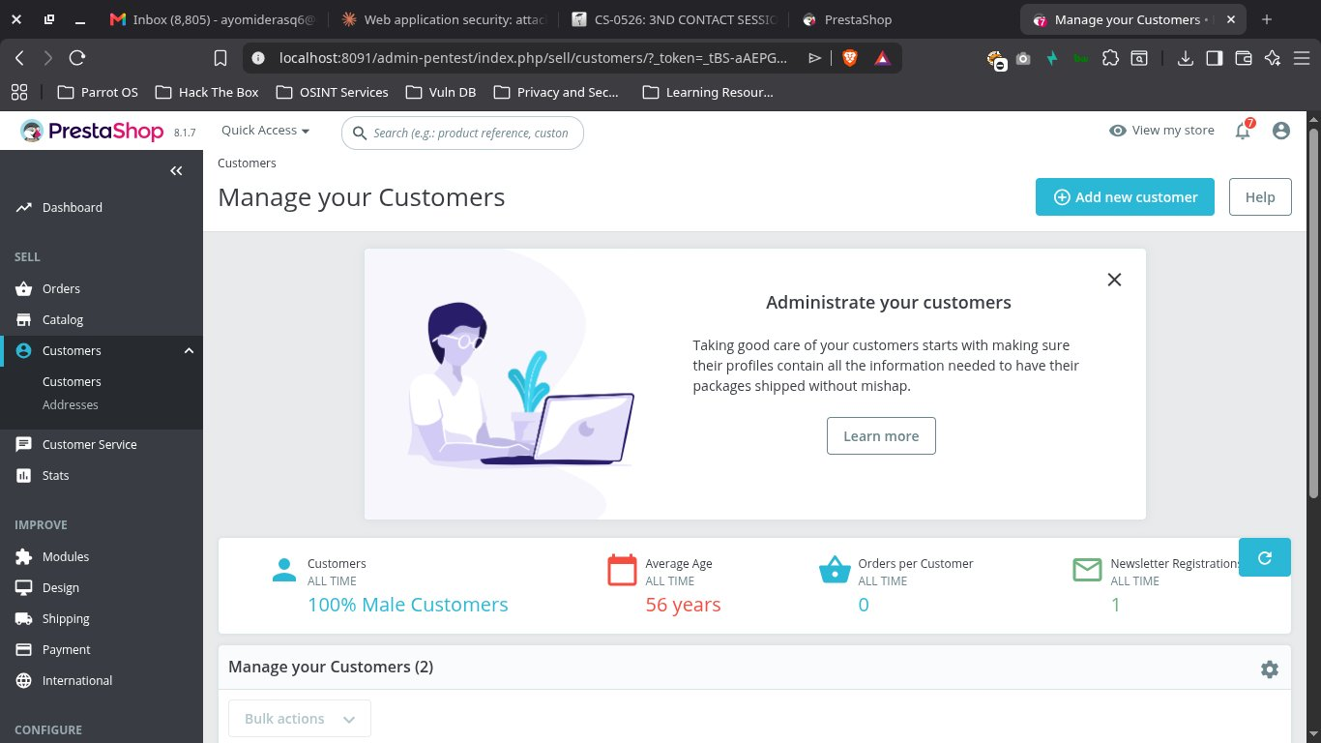
Figure 3: Customer management showing 2 accounts — Anonymous + John DOE default account
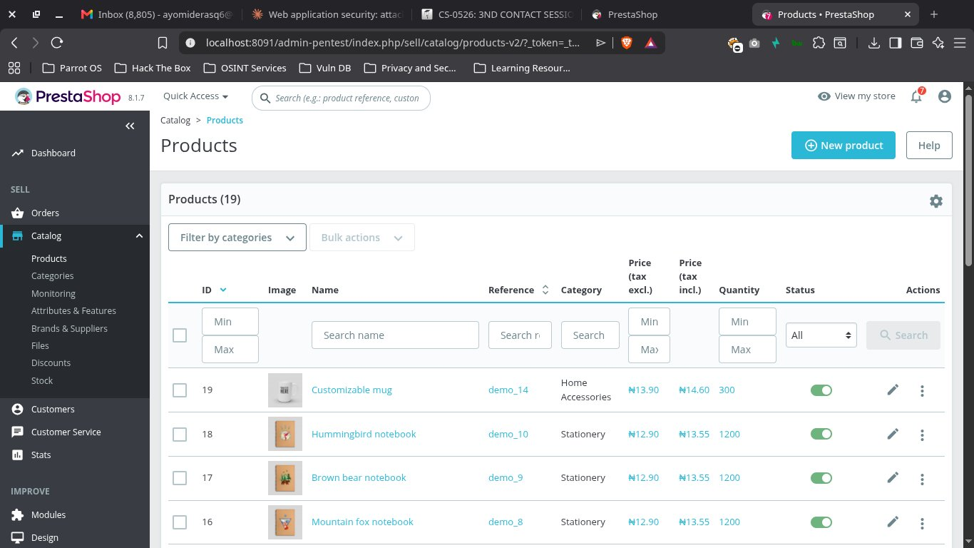
Figure 4: Product catalog showing 19 demo products with demo_ reference codes
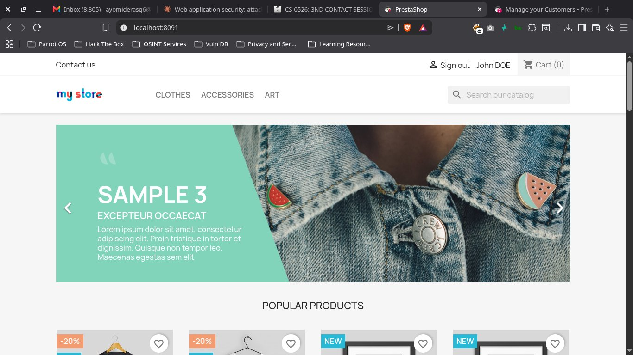
Figure 5: Successful authentication as John DOE using default credentials on live storefront

3.3 Admin Password Strength and MFA
Password strength validation is implemented — PrestaShop correctly rejects common passwords ('abc', 'password') and requires a 'Strong' rating before saving. However, no native two-factor authentication (2FA) is available in PrestaShop 8.1.7, and no third-party 2FA module is installed. Admin authentication relies on a single password factor only.
Brute force testing confirmed no rate limiting on the admin login endpoint. Five consecutive failed attempts were processed at consistent response times (~0.15-0.25s) with no lockout, delay, or CAPTCHA triggered.
- Finding F-04: No MFA/2FA available — Severity: MEDIUM
- Finding F-05: No rate limiting / brute force protection — Severity: MEDIUM
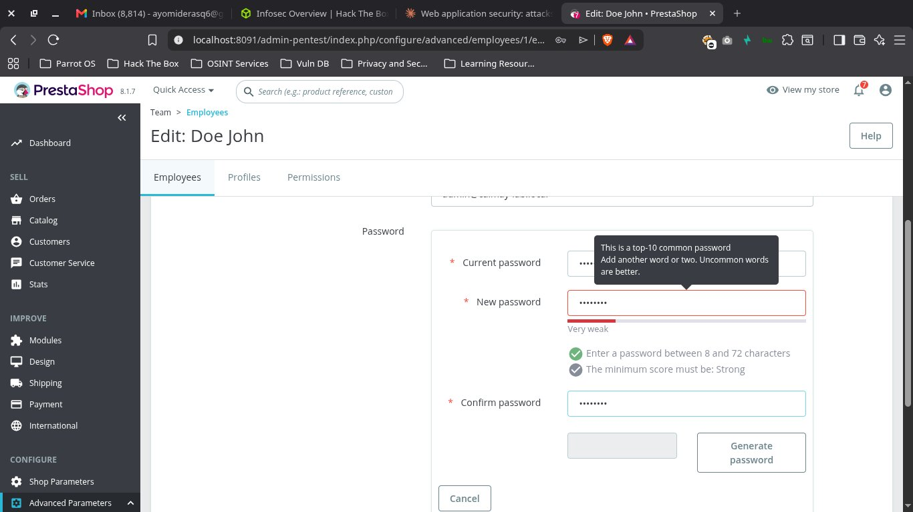
Figure 6: Password strength validation showing "Very weak" rejection and "Strong" requirement

3.4 File and Folder Permissions
Directory listing is disabled across all tested paths (modules/, themes/, upload/, img/, config/ all return HTTP 403). No world-writable files or directories were found. However, parameters.php is world-readable (-rw-r--r--), exposing database credentials (pspass123) and the application secret key to any OS user on the server.
- Finding F-06: parameters.php world-readable, DB credentials exposed — Severity: MEDIUM
File: /app/config/parameters.php
Permissions: -rw-r--r-- (world-readable)
Contains: database_password: pspass123
Contains: secret: zdiEE5PX3im5BCALmhmsDWJPQOvXXkZsNDRjwuOEaWYLUUYSZZEGPeSfJw6AD4Ka
Fix: chmod 640 /var/www/html/app/config/parameters.php

3.5 Secure Session Cookie Settings
Session cookies (PHPSESSID and PrestaShop session cookie) correctly implement HttpOnly and SameSite=Lax flags, protecting against JavaScript-based cookie theft and most CSRF scenarios. However, the Secure flag is absent on all cookies, meaning session tokens will transmit over plain HTTP. This compounds Finding F-02 (no TLS) — an attacker on the same network can intercept session cookies via passive sniffing.
- HttpOnly: ✅ Present — JavaScript cannot read cookies
- SameSite=Lax: ✅ Present — CSRF protection in place
- Finding F-07: Secure flag missing on all cookies — Severity: MEDIUM
Set-Cookie: PHPSESSID=...; HttpOnly; SameSite=Lax ← Missing: Secure
Set-Cookie: PrestaShop-...; HttpOnly; SameSite=Lax ← Missing: Secure

3.6 Unnecessary Modules
All 66 installed modules are active. No modules have been disabled post-installation. Modules of particular concern include ps_distributionapiclient (makes outbound calls to PrestaShop servers), ps_googleanalytics (third-party JS on all pages), and 15 statistics modules all simultaneously active. Additionally, 51 modules have pending upgrades that have not been applied.
- Finding F-10: All 66 modules active, 51 pending updates — Severity: LOW

3.7 Payment and API Endpoint Security
The PrestaShop Webservice is disabled in admin settings with no API keys configured. However, the /api/ endpoint remains reachable and returns HTTP 401 with a WWW-Authenticate header revealing the platform is PrestaShop. Three payment modules are active (Cash on Delivery, Payments by Check, Bank Transfer) with no real payment details configured.
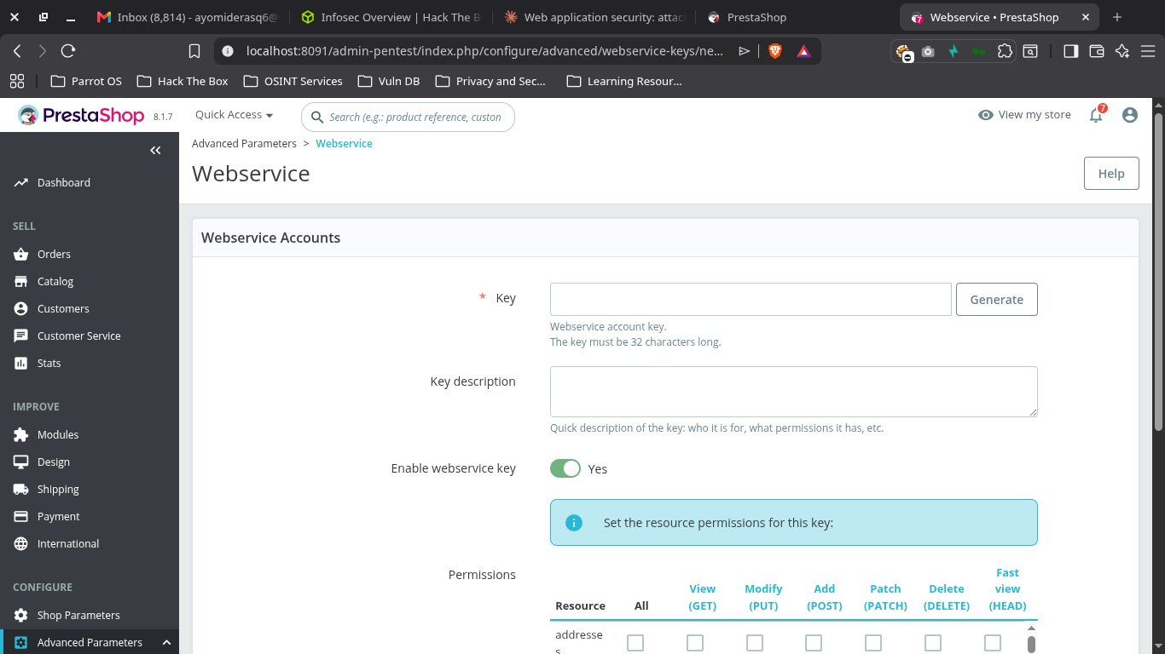
Figure 7: Webservice page — no API keys configured
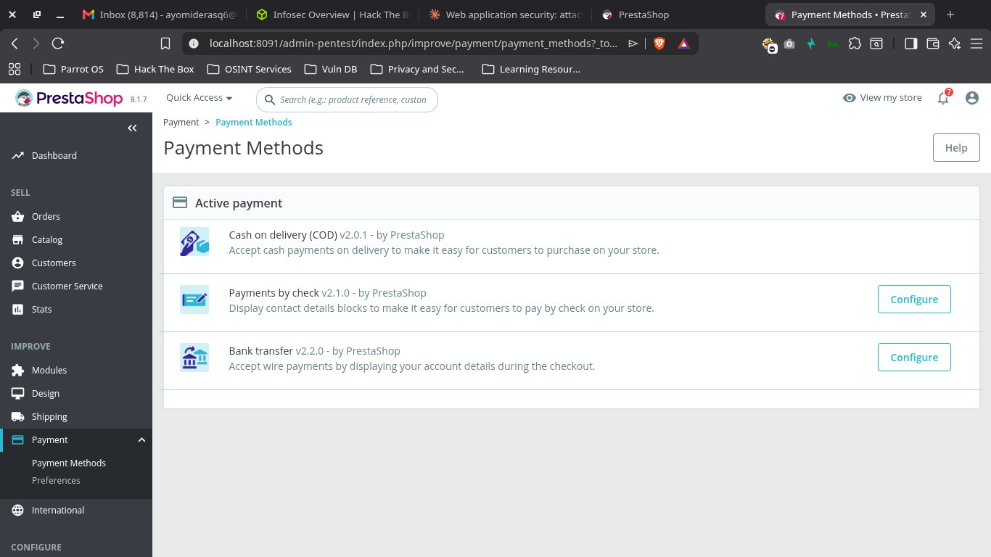
Figure 8: Payment Methods — 3 demo payment modules active without real configuration
- Finding F-11: /api/ endpoint reachable despite webservice disabled — Severity: LOW
- Finding F-14: Demo payment modules active with no real configuration — Severity: LOW

3.8 TLS Configuration
HTTPS is not configured at any level. Port 443 is not open, PS_SSL_ENABLED is set to 0 in the database, no HTTP-to-HTTPS redirect is configured, and no HSTS header is present. All traffic including authentication credentials, session cookies, and customer data transmits in plaintext over HTTP.
- Finding F-02: No TLS/HTTPS at any level — Severity: HIGH
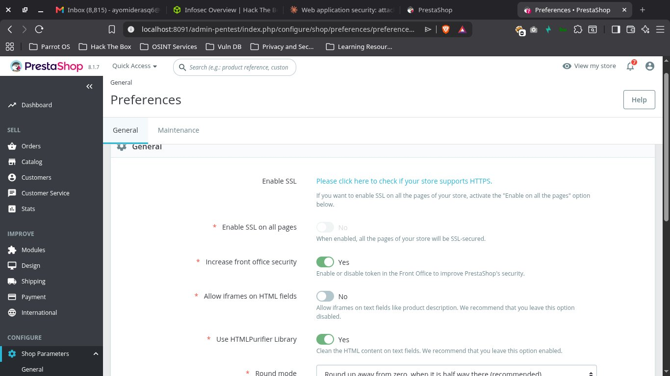
Figure 9: SSL settings page — Enable SSL showing as unconfigured, Enable SSL on all pages: No

3.9 Admin Path and IP Restrictions
The default /admin path correctly returns HTTP 404 and was not found in the filesystem. Eight common admin path variations all returned 404. The custom /admin-pentest path redirects to /admin-pentest/ as expected. However, no IP allowlist is configured on the admin path, and the Apache version (2.4.62 Debian) is disclosed in all response headers.
- Admin path renamed: ✅ /admin returns 404
- Finding F-08: No IP restriction on admin panel — Severity: MEDIUM
- Finding F-13: Admin path discoverable via targeted wordlist — Severity: MEDIUM
Server: Apache/2.4.62 (Debian) ← version disclosure in every response

3.10 Backup and Recovery
The native DB backup module is present and accessible. No automated backup schedule is configured. No existing backup files were found. Backup files are stored in /admin-pentest/backups/ which is a web-accessible path — if an attacker discovers the admin path and backup files exist, full database dumps would be downloadable. The backup process covers database only; theme files, uploads, and modules are not included.
- Finding F-12: No automated backups, web-accessible backup path — Severity: MEDIUM
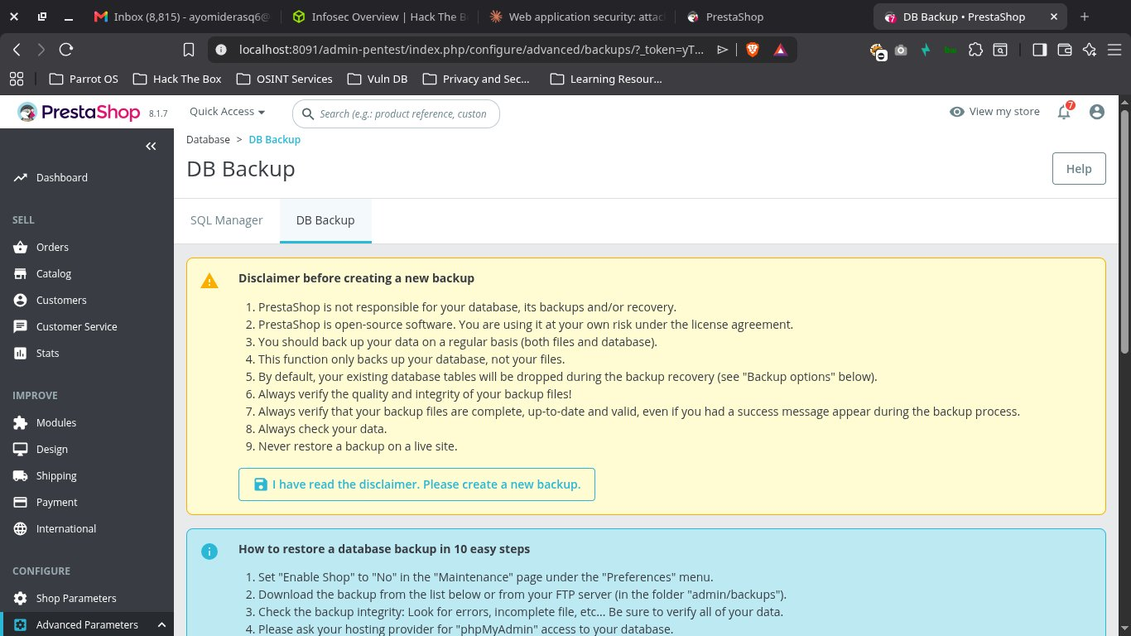
Figure 10: DB Backup page — no existing backups, disclaimer shows backup path disclosure

4. Attack Simulations
Three attack scenarios were executed based on vulnerabilities surfaced by the security checklist. Attacks were performed in a controlled lab environment with explicit authorization.

4.1 Attack 1 — Default Credentials Takeover
Methodology:
- Identified PrestaShop installation via HTTP response headers and page content
- Referenced PrestaShop public documentation for known default demo credentials
- Attempted storefront login at /index.php?controller=authentication
- Authentication succeeded on first attempt with no lockout
Vector:
URL: http://localhost:8091/index.php
Method: POST
Credentials: pub@prestashop.com / 123456789
Result: HTTP 200, authenticated as John DOE
Impact:
Full customer account access achieved including personal information, saved addresses, and 5 order history records. An attacker could modify account email to attacker-controlled address, enabling a full account pivot and access to future orders.
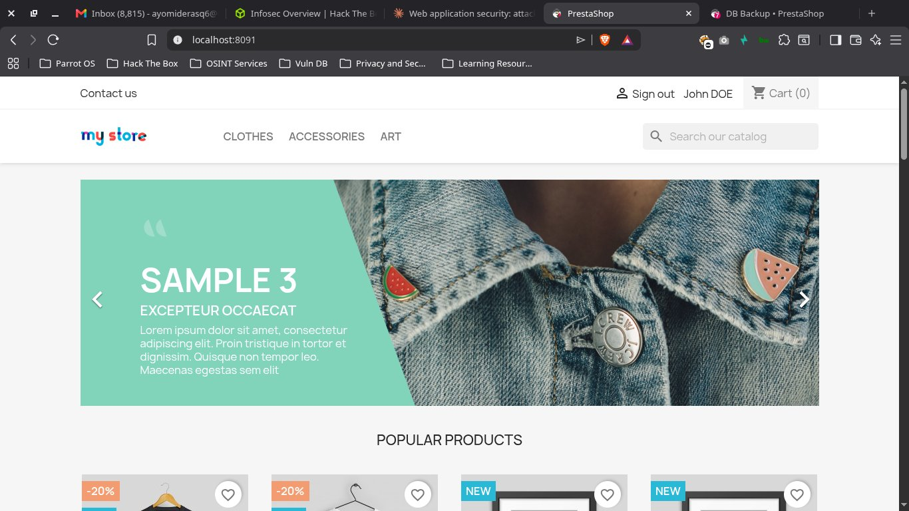
Figure 11: Attack 1 — Successful default credential login, John DOE authenticated on live storefront
Mitigation:
- Immediately disable or delete pub@prestashop.com account
- Enforce password change on first login for all pre-configured accounts
- Implement account lockout after 5 failed login attempts

4.2 Attack 2 — Admin Login Brute Force
Methodology:
- Identified admin login endpoint at /admin-pentest/index.php
- Confirmed JSON-based response format: {hasErrors: false, redirect: ...} on success
- Determined Hydra success indicator: presence of 'AdminDashboard' in response body
- Built targeted 8-password wordlist (common passwords + known target password)
- Executed Hydra attack against admin login endpoint
- No lockout, CAPTCHA, or rate limiting triggered at any point
Vector:
Tool: Hydra v9.5
Target: http://localhost:8091/admin-pentest/index.php
Method: HTTP POST (ajax=1&controller=AdminLogin&submitLogin=1)
Success indicator: S=AdminDashboard
Result: admin@calmay-lab.local : PentestAdmin123! found in 3 seconds
Impact:
Full admin panel access achieved in 3 seconds with an 8-entry wordlist and no defensive response. In a real engagement with rockyou.txt (14.3M passwords) at observed throughput, the wordlist would be exhausted without ever triggering a lockout. Post-exploitation from admin access includes: installing malicious modules (webshell), exfiltrating full customer database, modifying payment configuration, and full store takeover.
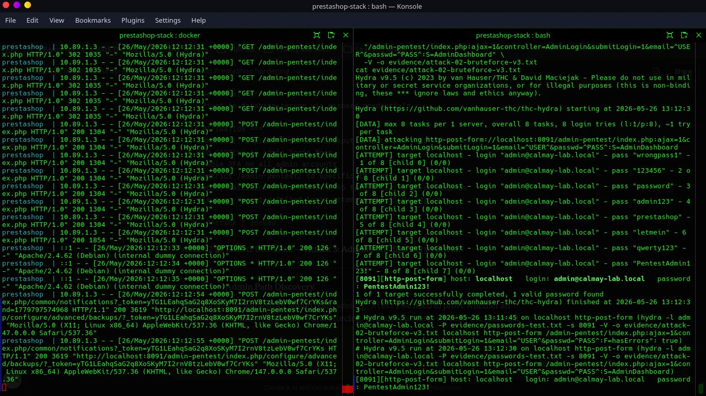
Figure 12: Attack 2 — Hydra successfully cracks admin credentials in 3 seconds, no lockout triggered
Mitigation:
- Implement account lockout: block login after 5 failed attempts for 15 minutes
- Add CAPTCHA to admin login form
- Enable 2FA on all admin accounts
- Restrict /admin-pentest/ to specific IP ranges via Apache config
- Deploy fail2ban monitoring Apache access logs for repeated POST failures

4.3 Attack 3 — Admin Path Discovery
Methodology:
- Confirmed PrestaShop installation via response headers
- Built 29-entry targeted wordlist of common admin path variations
- Executed ffuf directory brute force against http://localhost:8091/FUZZ
- Matched responses returning HTTP 200, 301, 302, or 403
- Custom admin path discovered in 43 milliseconds
Vector:
Tool: ffuf v2.1.0
Wordlist: custom admin-paths.txt (29 entries)
Match codes: 200, 301, 302, 403
Result: /admin-pentest → HTTP 301 (found in 43ms)
Impact:
The renamed admin path /admin-pentest is discoverable using a targeted wordlist. Combined with Attack 2 (brute force with no rate limiting), the full attack chain from zero knowledge to admin access takes under 10 seconds: path discovery (43ms) + credential brute force (3s) = full compromise.
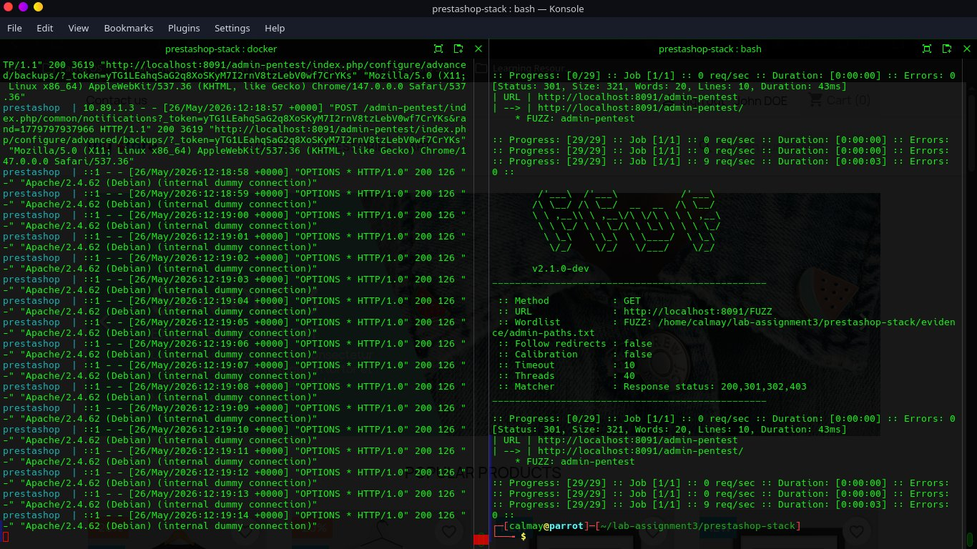
Figure 13: Attack 3 — ffuf discovers /admin-pentest path via directory brute force in 43ms
Mitigation:
- Add IP allowlist restriction on /admin-pentest/ in Apache configuration
- Use a genuinely random path name (e.g. /a3f9b2c7d1e4/) not a guessable variation
- Deploy ModSecurity rule to detect and block directory scanning patterns
- VPN-only access to admin panel in production environments

5. Combined Attack Chain
The three attacks can be chained to achieve full admin compromise from zero prior knowledge:
Step 1: ffuf path discovery → /admin-pentest found (43ms)
Step 2: Hydra brute force → admin credentials found (3 seconds)
Step 3: Admin panel login → full store access (<1 second)
─────────────────────────────────────────────────────────────────
Total time from zero knowledge to full admin access: ~4 seconds
This attack chain is possible due to three compounding weaknesses: no IP restriction on admin path (allows remote discovery), no rate limiting (allows unlimited brute force), and no 2FA (password alone sufficient for access). Addressing any single one of these would break the chain.

6. Findings Summary
# | Finding | Category | Severity | Mitigation
F-01 | Default customer credentials active (pub@prestashop.com / 123456789) | Access Control | HIGH | Immediately disable/delete default customer account
F-02 | No HTTPS/TLS configured - all traffic in plaintext | Transport Security | HIGH | Obtain TLS cert, configure SSL virtualhost, enforce HTTPS redirect
F-03 | Outdated version: 8.1.7 installed vs 9.1.3 latest stable | Patch Management | MEDIUM | Plan upgrade to PrestaShop 9.x following migration guide
F-04 | No MFA/2FA on admin account | Authentication | MEDIUM | Install third-party 2FA module from PrestaShop marketplace
F-05 | No rate limiting on admin login - brute force possible | Authentication | MEDIUM | Deploy fail2ban, add CAPTCHA, implement account lockout
F-06 | parameters.php world-readable - DB credentials exposed | File Security | MEDIUM | chmod 640 parameters.php, rotate DB credentials
F-07 | Secure cookie flag missing - sessions transmit over HTTP | Session Management | MEDIUM | Enable HTTPS first, then set Secure flag on all cookies
F-08 | No IP restriction on admin panel | Access Control | MEDIUM | Restrict /admin-pentest/ to trusted IP ranges in Apache
F-09 | 19 demo products + demo customer data present | Configuration | LOW | Bulk delete demo products, disable demo customer
F-10 | All 66 modules active including 51 with pending updates | Patch Management | LOW | Audit modules, disable unused, apply pending updates
F-11 | /api/ endpoint reachable despite webservice disabled | API Security | LOW | Block /api/ path at Apache level via .htaccess
F-12 | No automated backups, backup files in web-accessible path | Backup/Recovery | MEDIUM | Automate backups via cron, store outside web root
F-13 | Admin path discoverable via targeted wordlist (ffuf) | Security Through Obscurity | MEDIUM | IP allowlist on admin path, use genuinely random path name
F-14 | Demo payment modules active with no real configuration | Configuration | LOW | Configure or disable cheque/wire transfer payment modules

7. Conclusion
The PrestaShop 8.1.7 assessment identified 14 findings across 10 security domains. Two HIGH severity issues (active default credentials and no TLS) represent immediate risks that should be remediated before the application goes live. The three attack simulations demonstrated that the absence of basic controls (rate limiting, 2FA, IP restrictions) allows a complete admin compromise in under 10 seconds.
Priority remediation order:
- IMMEDIATE (before go-live): Disable default customer account, configure TLS/HTTPS
- HIGH PRIORITY (within 1 week): Enable 2FA, implement rate limiting, IP-restrict admin panel
- MEDIUM PRIORITY (within 1 month): chmod parameters.php, automate backups, move backups off web root
- LOW PRIORITY (ongoing): Module audit, apply 51 pending updates, plan 9.x upgrade
The application has several positive security controls already in place — password strength validation, directory listing disabled, no world-writable files, HttpOnly and SameSite cookie flags, HTMLPurifier enabled, and iframes disallowed. These provide a reasonable security baseline that should be built upon with the above remediations.
— End of Report —

