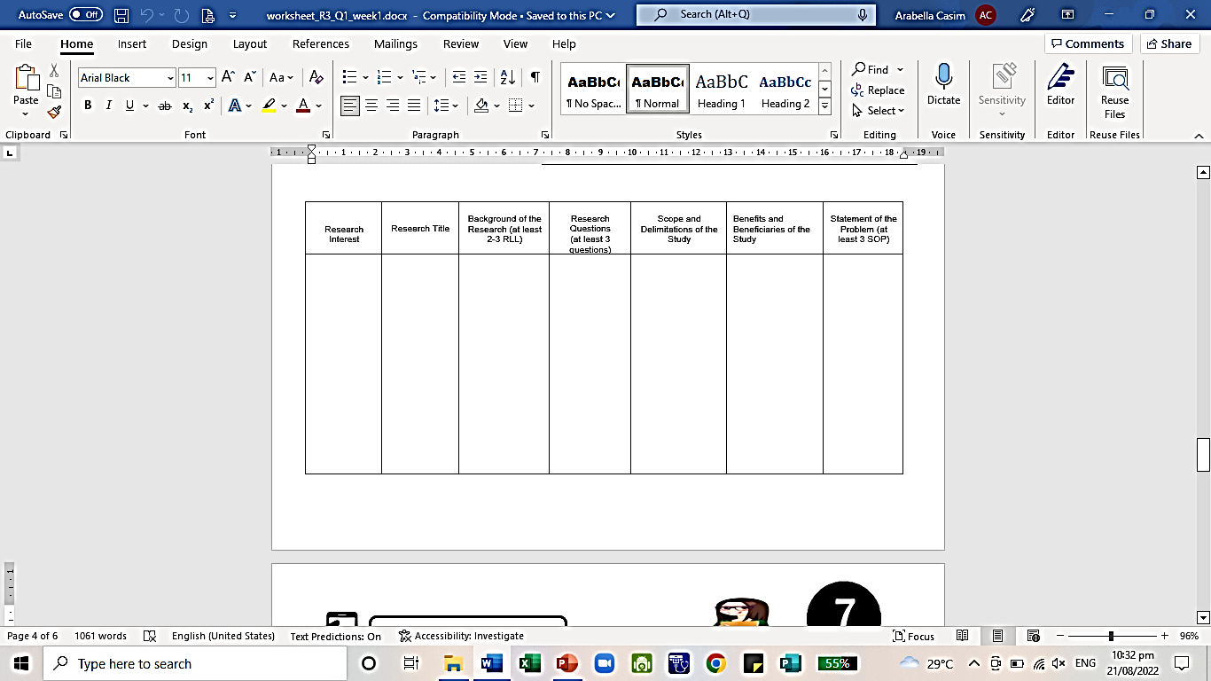
This will benefit everyone with skin ailments (excluding people with nut allergies) by treating and removing bacteria in the applied skin. This will also give Talisay a more valuable purpose.

•
•
•
• Will Talisay be effective as a medical topical ointment?
• How many resources will it take to make an ointment out of Talisay?
• How is an ointment out of Talisay going to be made?
Manzur et al. (2011), evaluated the methanol, acetone and N, N-dimethylformamide extracts of Talisay leaves to determine its antibacterial and antifungal activity. The Talisay extracts showed significant antibacterial activity, unlike the commercially used antibiotics. [1] Studies also looked into Talisay as an alternative to the use of chemicals and antibiotics in the aquaculture industry. Results showed eradication of Trichodina, fish ectoparasites, at 800 ppm. [2] Talisay leaves are also proven to treat dermatitis, a skin irritation that usually involves itchy, dry skin or a rash on swollen, reddened skin. [3]
References:
1. 17 AWESOME BENEFITS OF THE TROPICAL ALMOND. (2020, August 8). Global Food Book. https://globalfoodbook.com/17-awesome-benefits-of-the-tropical-almond/
Manzur, A., Raju, A. and Rahman, S. (2011). Antimicrobial Activity of Terminalia catappa Extracts Against Some Pathogenic Microbial Strains, Pharmacology & Pharmacy, Vol. 2 No. 4, pp. 299-305.
2. Talisay/Terminalia catappa/Indian Almond /La ren Shu: Medicinal Herbs/Philippine Alternative Medicine. (n.d.). STUARTXCHANGE. http://www.stuartxchange.org/Talisay/
3. Health Benefits of Talisay Tree. (2019). DrFarrahMD. https://drfarrahmd.com/2019/10/health-benefits-of-talisay-tree/
Talisay(Terminalia catappa) as a Medical Ointment
In the Philippines there are many Talisay trees that does not get noticed and I thought maybe we can make something useful out of Talisay that would help people with their ailments.

