Group Number: 2
Name of Members:
Marc Philip Landicho
Atasha Mariz Marasigan
Kate Ramielle Zurbito
Ashlee Macmac
Research Title: Acceptability of Rabbit Manure as Alternative Briquette
Date and Time of Conduct: September 2, 2023, 10 AM
Treatment: Pre-treatment
Materials:
Rabbit manure
Water
Mortar and pestle
Molder
Syringe
Procedure:
1. Pulverize the manure using the mortar and pestle.
2. Measure the pulverized manure.
The molder is currently being used as a measuring substitute, 2 units per briquette.
3. Measure the water using the syringe, 10 mL per briquette.
4. Mix the pulverized manure and water until it gains shape.
5. Mold to shape using the molder.
6. (In progress) Dry under the sun for 3 days.
Previous Problem Encountered:
Ignition was slow.
Observation:
Pending (Procedure 6 in progress)
Problem Encountered:
Pending (Procedure 6 in progress)
Pictures:
During
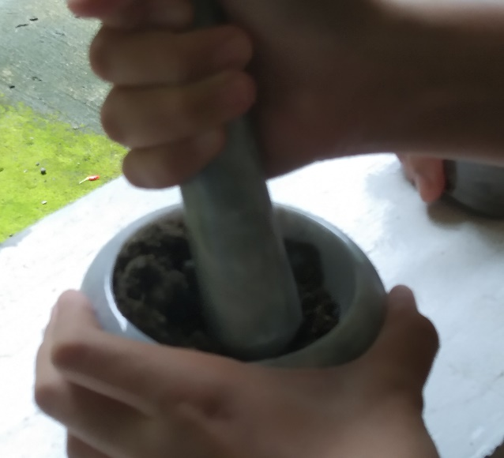 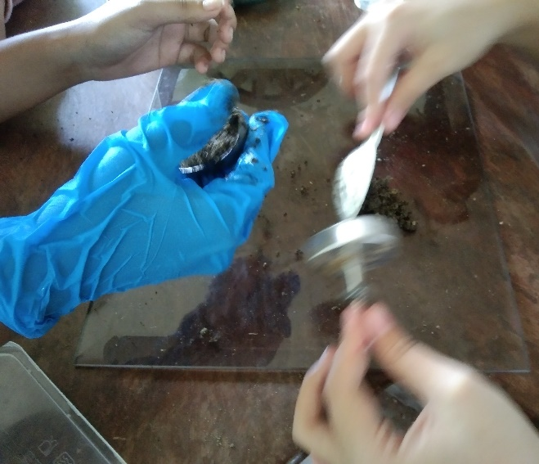
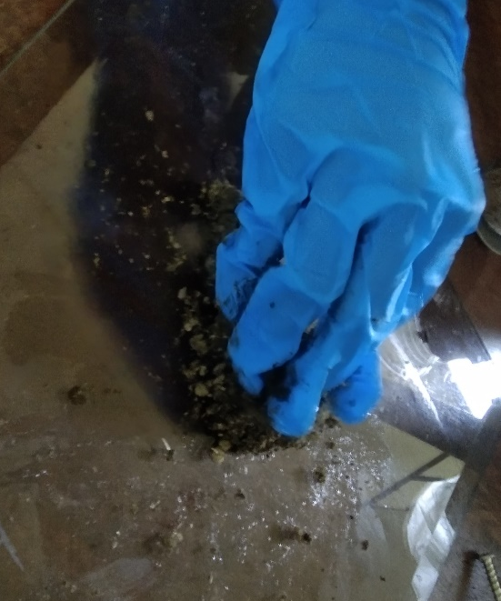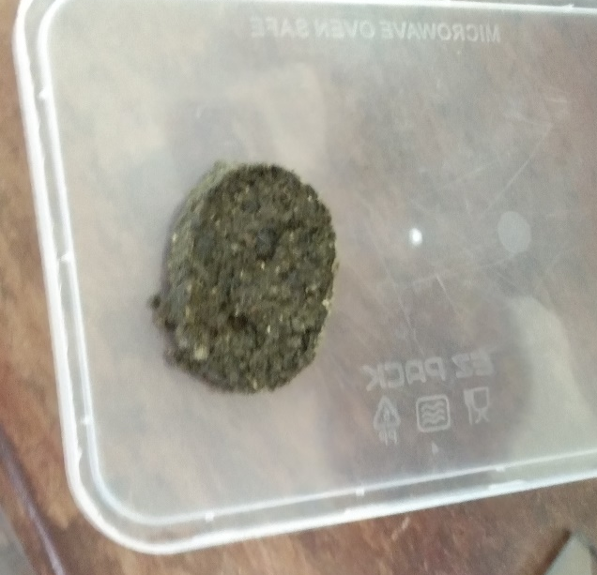

Contribution of members during conduct:
Kate was the one who pulverized the manure. Everyone experienced mixing and molding the manure, but most of the molding was Ashlee. We bought the syringe in the same day using Atasha’s money (Php 10), might pay it back. I am the one who is storing the manure and materials. I am also currently performing procedure 6, the rainy weather might interfere with that. About the substitutional use of the molder for measurement, both Atasha and Kate brought weighing scales of different types. But small amounts of manure cannot be measured due to its light mass. We are finding a solution to that.
Aside from conducting, we also tested our previous test batches. We found out that the black burnt briquettes ignite faster and the fire last longer than the others. Anyway, everyone contributed in any other way.
- Marc Philip Landicho
Images from testing previous test batches in the same day:
