Question 1:
If we add another field to the dataset, say, Civil Status in between Firstname and Birthdate, will the modules or procedures you made will still be applicable?
Yes, the modules and procedures will still be applicable, but they will require minor modifications to support the new field.
The overall program structure including file handling, input validation, menu system, and CRUD operations (Add, Edit, Delete, Sort, and Filter) can still be reused because the program was designed in a modular way using functions and a structured data type.
Question 2:
Discuss the processes that will be involved in implementing the changes.
The first change was my structure
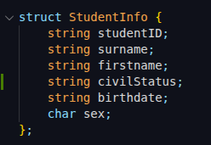
OLD NEW
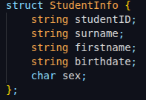

however my structure doesn’t have string limit because c++ doesn’t have string limit so I only use input validation like “if (students->surname.length() > 20)” to limit
I use vector for basic datastructure

saveData() function change
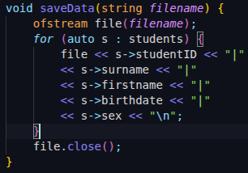
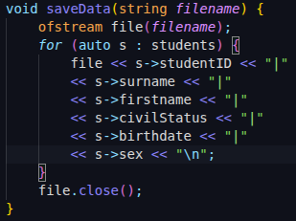
OLD NEW

in the 2nd image I insert the s→civilSatus after the s→firstname then you can see my save function has “|” to separate the save strings

loadData() function change
OLD NEW
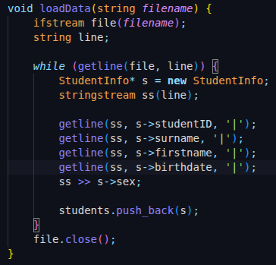
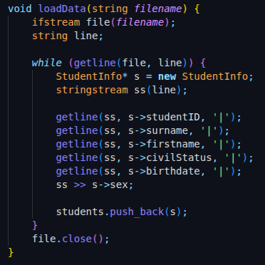

however if we load to an old txt file that doesn’t have the civil status it well cause an error to my vector<StudentInfo*> students; because the flow of civilStatus well store the birthdate and so on

System flow
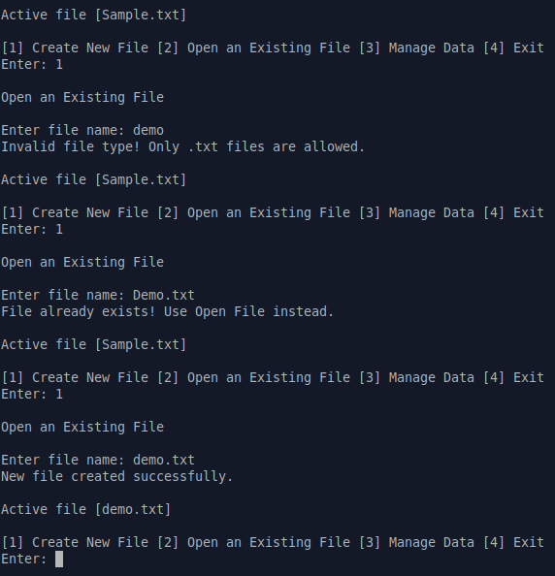

as you can see it has a validation for creating a new file to make it sure the system well not cause error also after successfully creating a new file it well automatically use as active file [demo.txt]

Manage Data
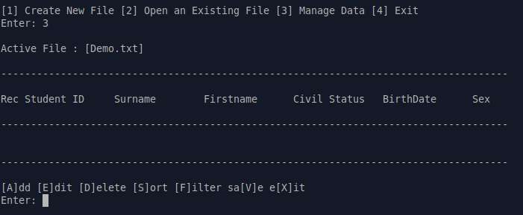

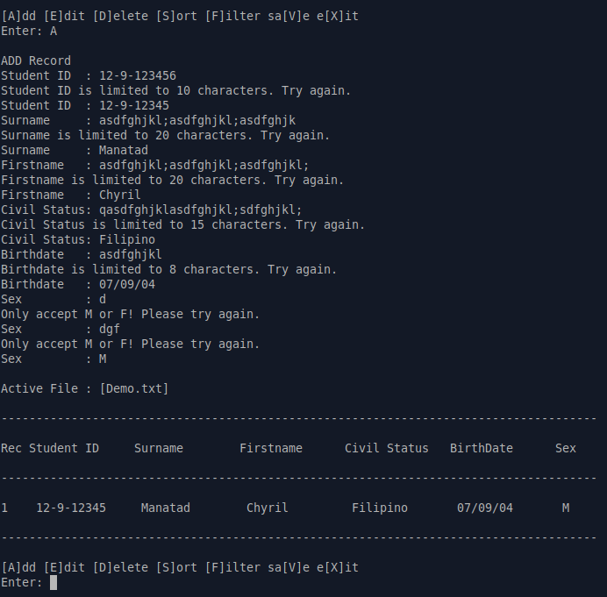
Add students data

Code of addData()
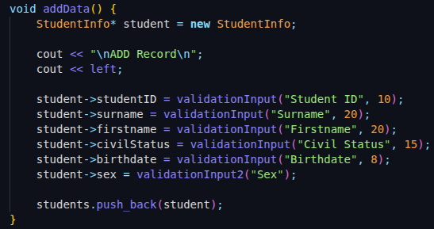

Input Buffer for cin
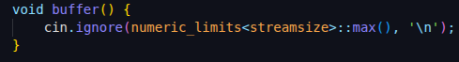

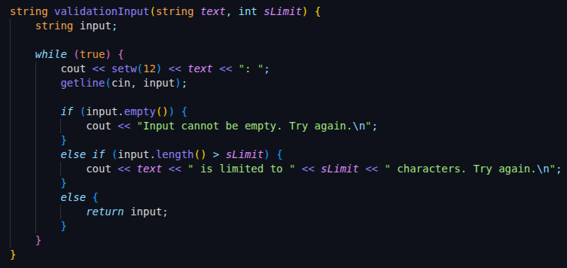
Validation input to string

Validation input for char
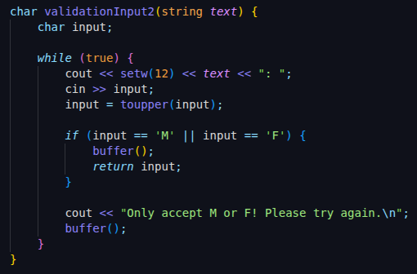

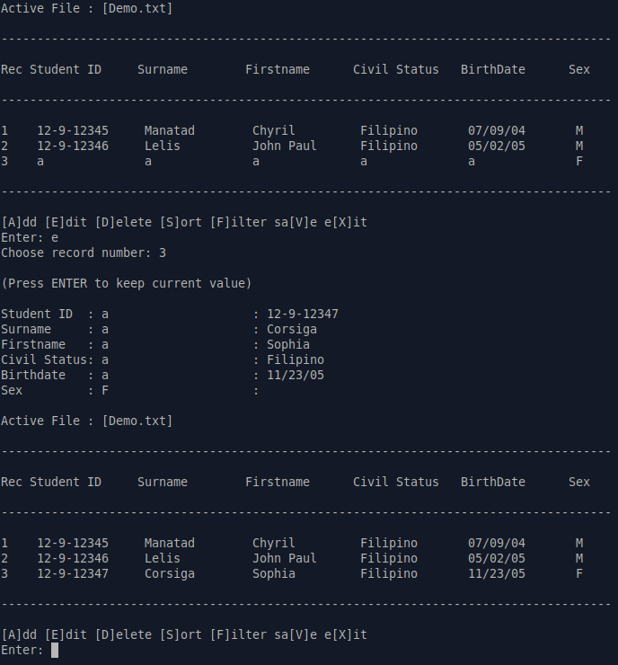
Edit student data
editData() Function
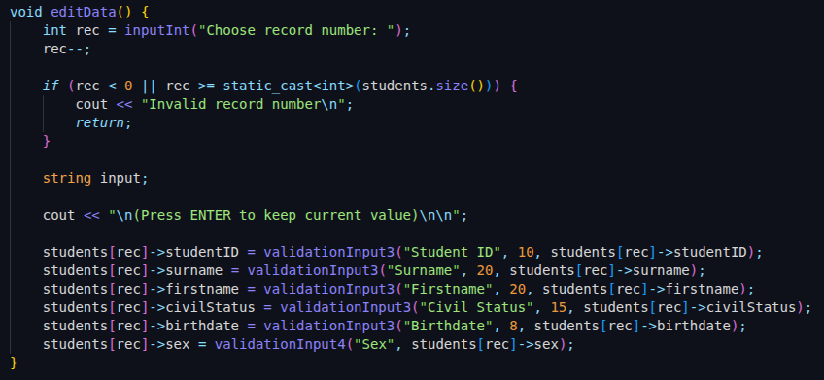
string input validaiton
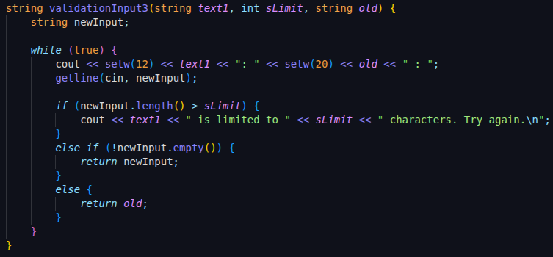

char input validation
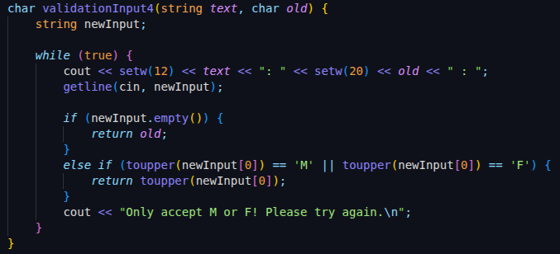

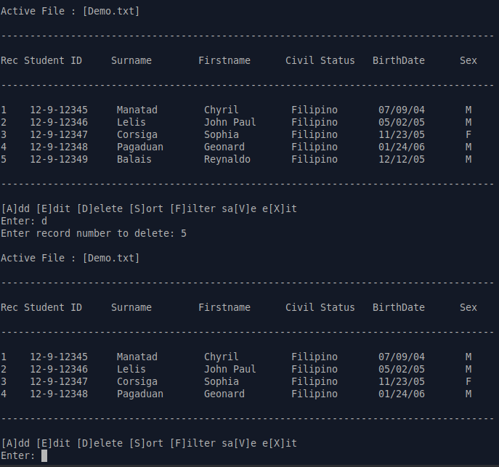
Delete student data
deleteData() function
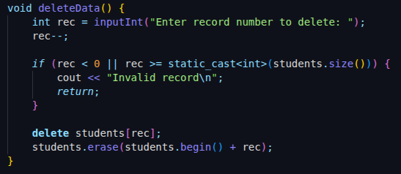

Sort Data

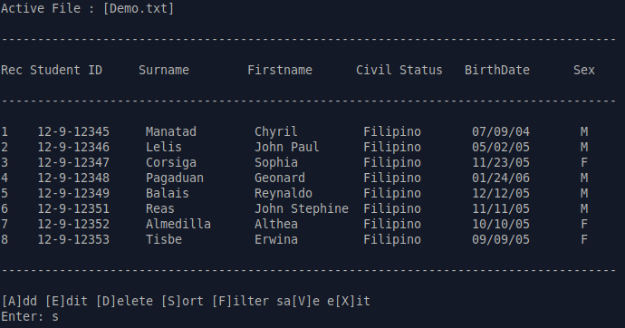
Sort by Descending
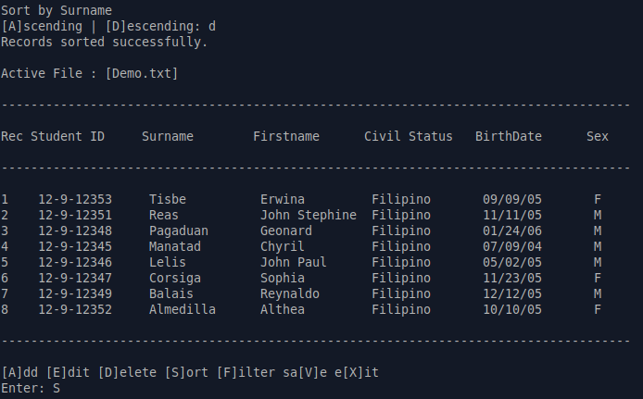
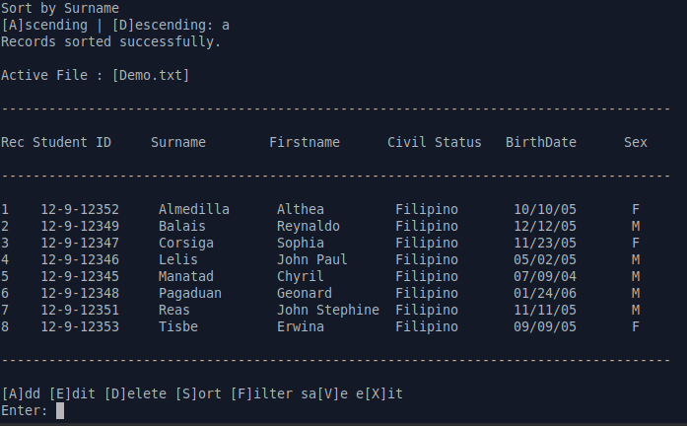

Sort By Ascending

sortData() function

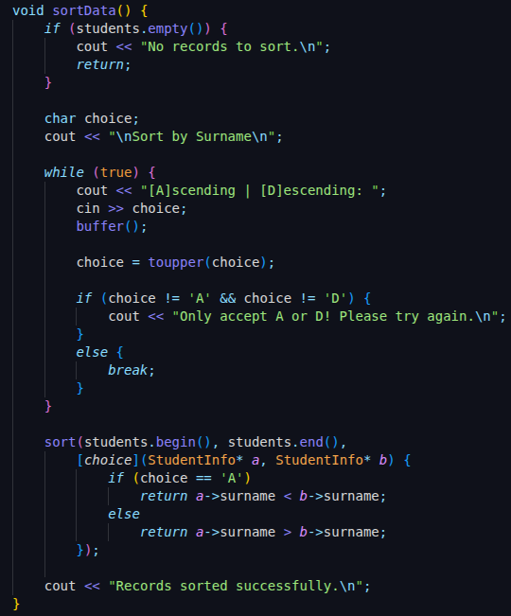

Sort by Male
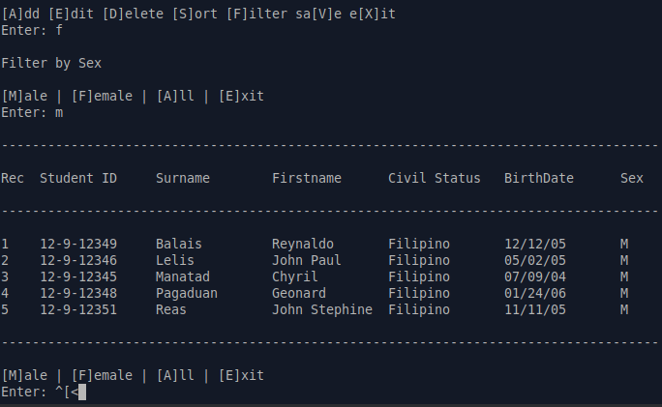

Filter by Female
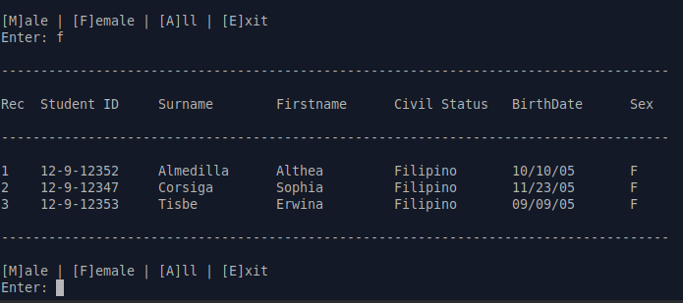

Sort to All
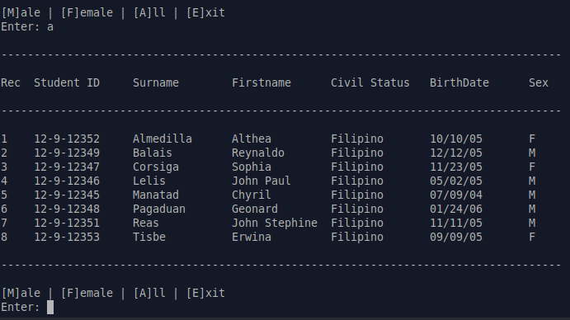

filterData() function

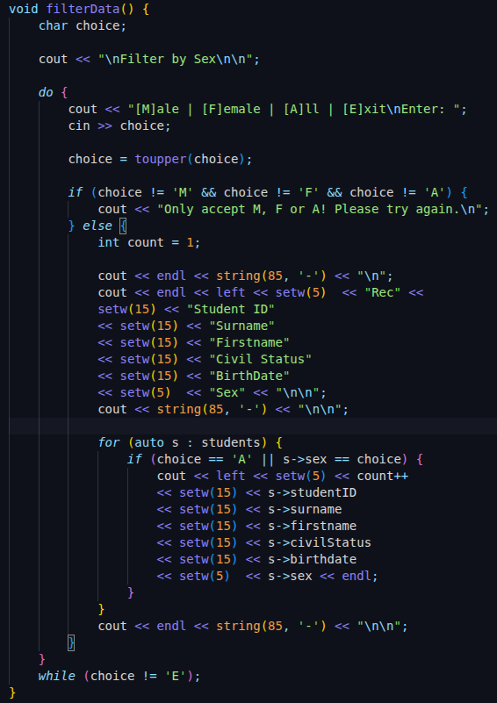

Save Data
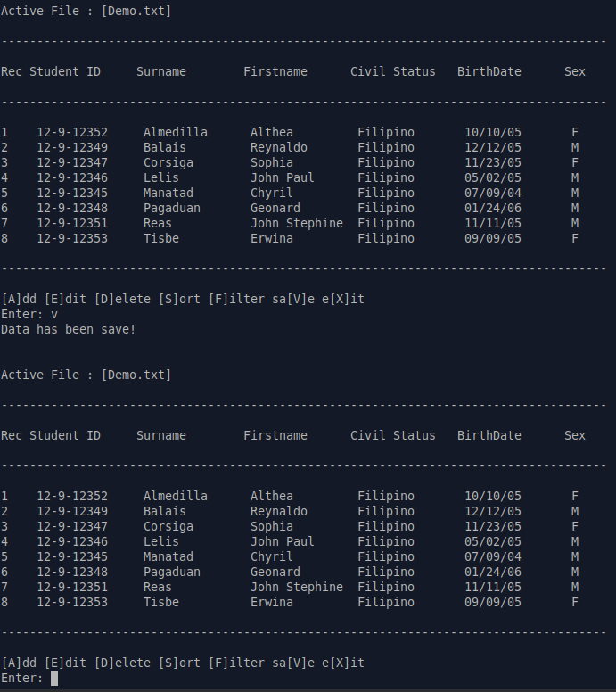

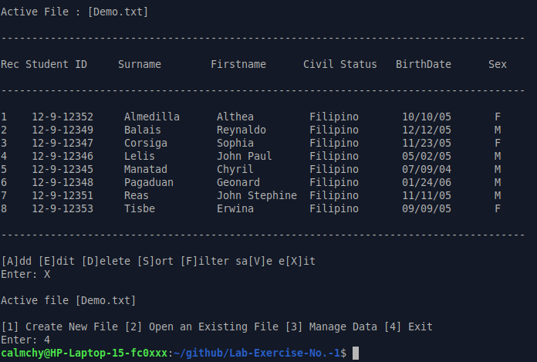
Exit

REVISED AND EXPANDED DISCUSSION
Question 1:
If we add another field to the dataset, say, Civil Status in between Firstname and Birthdate, will the modules or procedures you made still be applicable?
Yes, the modules and procedures will still be applicable, but they will require minor modifications to support the new field. The overall program structure including file handling, input validation, menu system, and CRUD operations (Add, Edit, Delete, Sort, and Filter) can still be reused because the system was designed in a modular manner using functions and a structured data type.
However, adding a new field affects the file format. Existing text files created before the addition of the Civil Status field will no longer match the expected data layout. If such files are loaded without modification, the program may misinterpret the data fields. Therefore, either the old files must be updated to include the new field, or the loadData() function must be enhanced to handle missing fields safely.
Question 2:
Discuss the processes that will be involved in implementing the changes.
1. Modification of the Data Structure
The StudentInfo structure is updated by adding a new string variable for Civil Status. Since C++ strings do not have fixed size limits, length restrictions are enforced through input validation instead of the data type itself.
2. Input Validation Adjustments
Existing input validation functions remain reusable. A new validation call is added during record insertion and editing to ensure that the Civil Status field is properly validated.
3. saveData() Function Changes
The saveData() function is modified to write the Civil Status field to the text file using the same delimiter ('|'). The new field is placed between Firstname and Birthdate to maintain logical data order.
4. loadData() Function Changes
The loadData() function is updated with an additional getline() call to correctly read the Civil Status field. Loading old files without this field can cause data misalignment, which demonstrates a limitation of file-based systems.
5. Display and System Flow Adjustments
Table headers, record displays, and system flow remain mostly unchanged, aside from adding the new Civil Status column. File validation ensures that newly created files follow the updated format, preventing runtime errors.
Conclusion
The addition of a Civil Status field requires updates across multiple modules, but the core program logic remains intact. This demonstrates the benefits of modular design and highlights the rigidity of file-based data management systems when structural changes are introduced.

