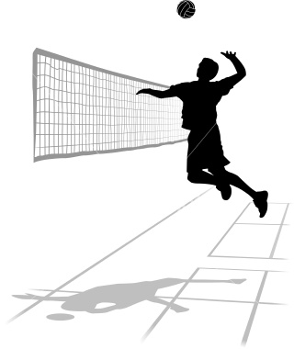

**Calne Comets Volleyball Club**

**Administration Form (Under 18’s) SEASON 2013 - 2014**

|  |  |  |  |  |  |
| --- | --- | --- | --- | --- | --- |
| **Name of Player:** | **Date of Birth:** | **Age Group**  **U** |  | **Gender** | |
| **M** | **F** |
| **Address:**  **Post Code:** | **Home Telephone:** | | | | |
| **Mobile Telephone:** | | | | |
| **Email Address:** | | | | | |
| **Please give details of any medical conditions which may be relevant for the Coach:** | | | | | |
| **Please state any allergies your child may have:** | | | | | |
| **How did you hear about the club:** | | | | | |

|  |  |
| --- | --- |
| **Contact (1) Name:** | **Contact (2) Name:** |
| **Address: (contact 1)**  **Post Code:** | **Address: (contact 2)**  **Post Code:** |
| **Telephone no: (contact 1)** | **Telephone no: (contact 2)** |
| **Email Address: (contact 1)** | **Email Address: (contact 2)** |

**Calne Comets Volleyball Club** 

**Name of Player: ____________________________________**

**To be completed by parent/guardian of junior members participating in the Volleyball training/tournaments/other events 2013 - 2014**

**By returning this completed form, I agree to my son/daughter/child in my care taking part in the activities of the club.**

**I understand that I will be kept informed of these activities – for example timing and transport details.**

**I understand that in the event of any injury or illness all reasonable steps will be taken to contact me, and to deal with that injury/illness appropriately.**

**I consent to Calne Volleyball Club photographing my child (name ……………………………………………………………………….) during their involvement in volleyball. I will register my details with organisers before carrying out any such photography during training sessions or tournaments.**

**Name of parent/guardian: ______________________________________________**

**Signature of parent/guardian: ______________________________________________**

**Date: ______________________________________________**

Calne Comets Volleyball Club recognises the need to ensure the welfare and safety of all young people in sport. We will not permit photographs, video or other images of young people to be taken without the consent of the parents/carers and children.

In line with the recommendations in the Volleyball England Club Child Protection Policy, it will be required for any person wishing to engage in any video or close range photography to register their details with event organisers, and all reasonable steps will be taken to ensure that these images are used solely for the purposes they are intended.

If you become aware that any images are being used inappropriately you should inform the coach, child welfare officer or organiser immediately.

**We would ask that you let the coach know if you do not wish your child to be photographed during the 2013 - 2014 Volleyball season.**