Daniel Prieto Rodríguez

D. Alfredo Abad01/23

**Account Management on Windows/Linux**

Content

Objective of practice 2

Operation 2

Windows 10 3

Linux Desktop 8

Linux server 11

Inventory of required equipment 13

Final considerations 13

# Objective of the practice

Learn how to add, delete, and manage users and groups on Windows and Linux.

# Operation

Miguel Aguado

Jose Luis Lopez

Any other user

Marcos de la iglesia

Enrique del Moral

Jose Miguel Soriano

Raul Mitrado

Guests

Manager

Commercial

Receptionist

# Windows 10

To begin, we must go to a command prompt with administrator privileges and write the following command: "netplwiz"

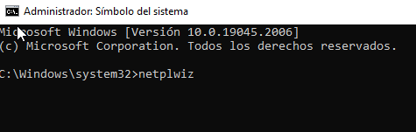

The following panel will open, in which we must go to "advanced options" and again "advanced options"

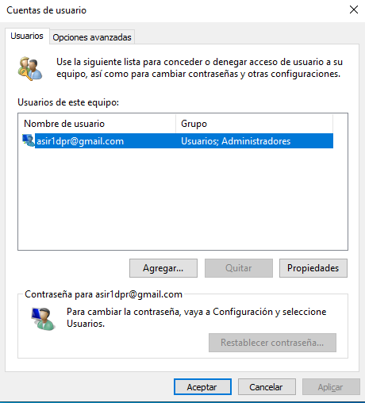

At the end we will open this following panel:

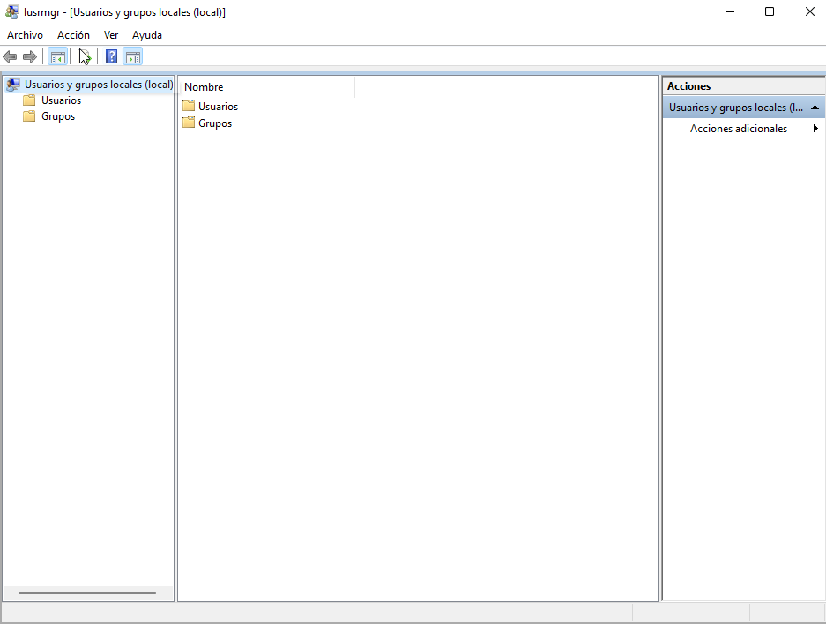

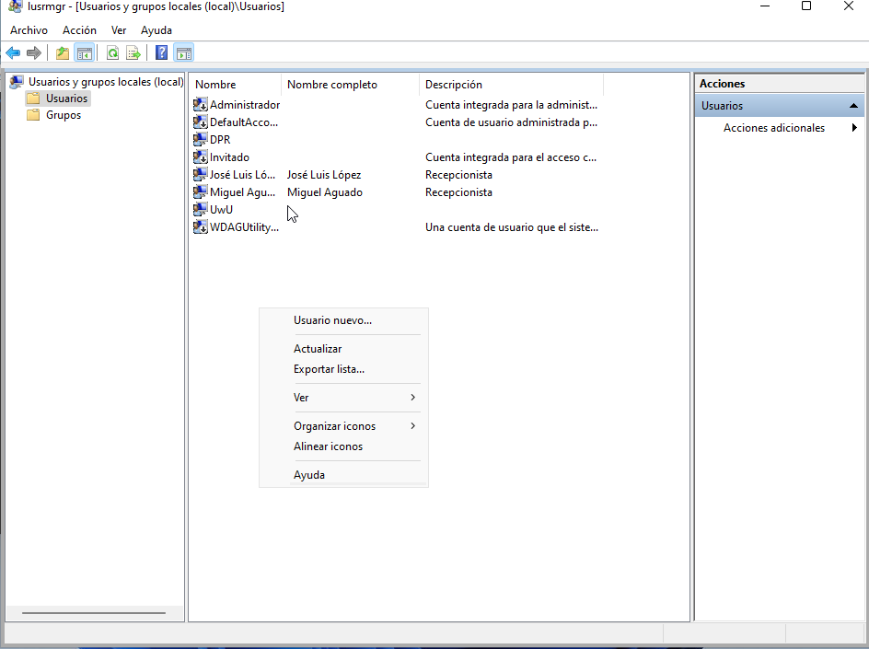

At this point you just have to right click and add users:

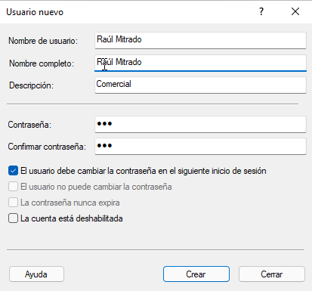

Here we will give you your name, descriptions, password and how we want you to be able or not to change the password

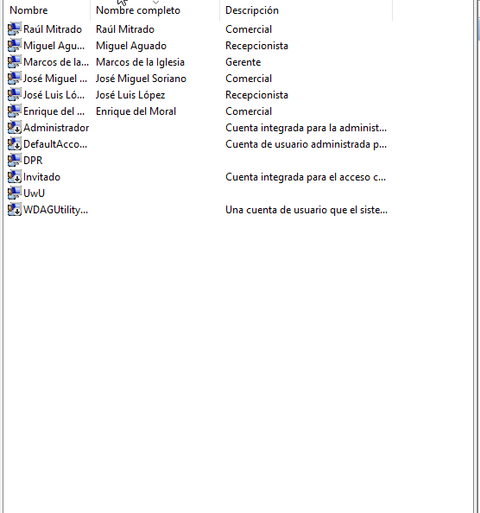

We will create all the users we need and then the groups

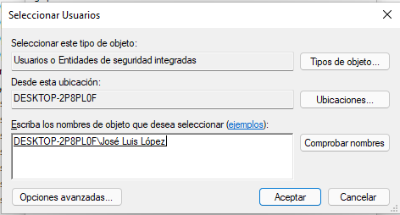

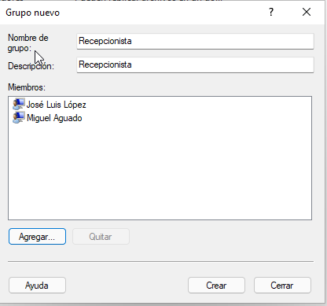

In groups simply by creating the groups we can add directly to the users already created, checking their names and adding them.

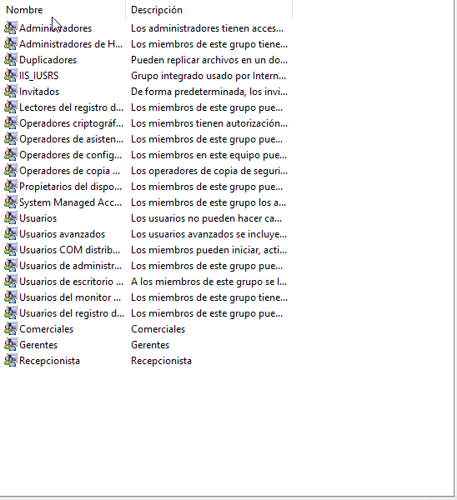

The guest account and user will not need to create them because they come by default

# Linux Desktop

To begin with, we will download the necessary tools with "sudo apt install gnome-system-tools"

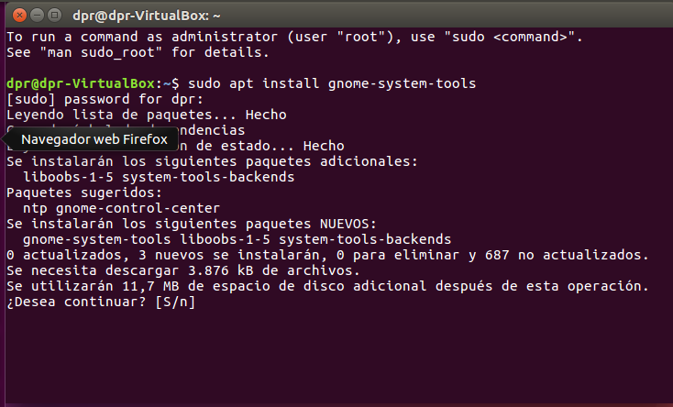

Once installed we will go to the search engine, and we will write "users and groups" and execute it

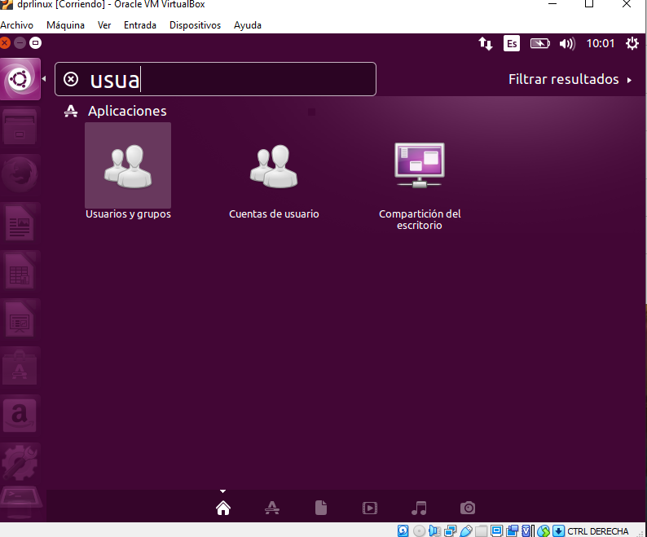

Once executed we will add all the users we need first

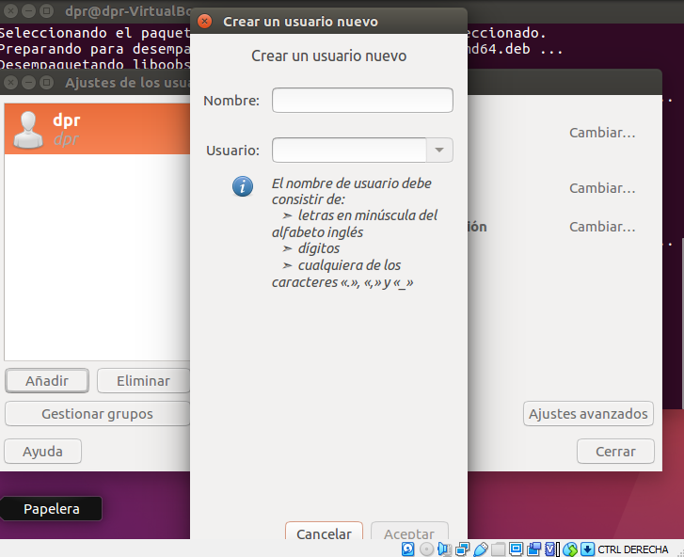

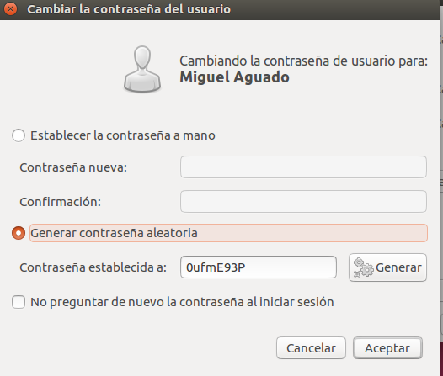

Once finished adding users, we will start with the management of groups, adding the groups that we need:

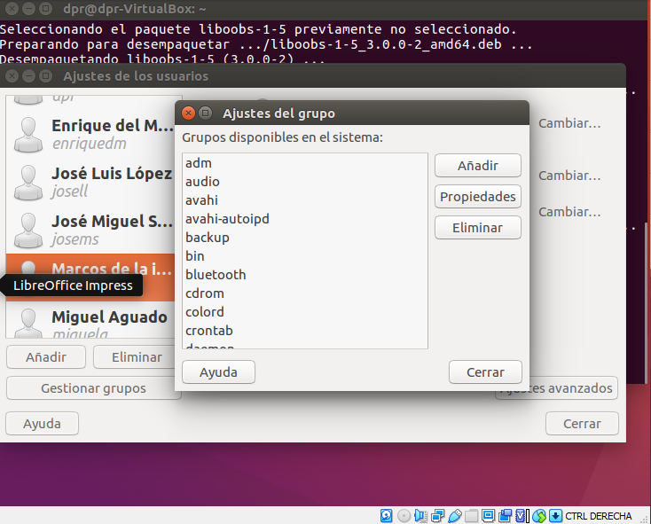

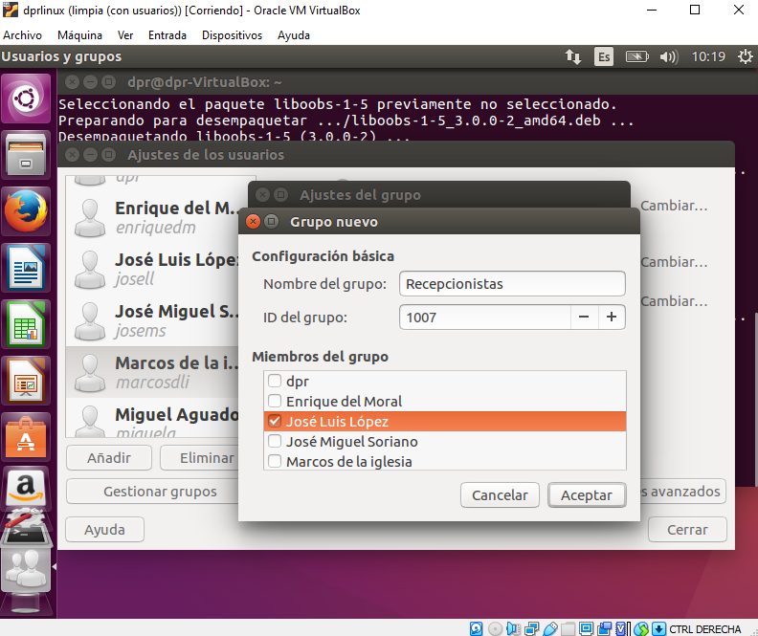

The guest account and user will not need to create them because they come by default

# Linux server

To start, we will create the users with the command "adduser [name]"

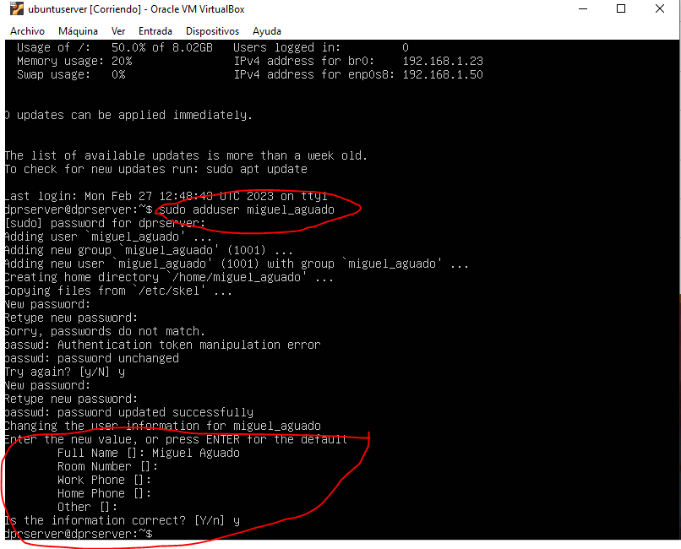

Once you use the command (with sudo) it will not force you to set a password and a series of information that the created user will have

To create the groups we will use the command "groupadd [group name]"

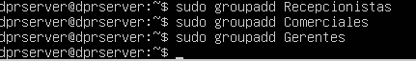

With the command "cat /etc/group/" we can see the users and groups created:

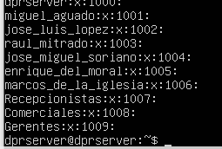

Once the groups are created we will add the users by commands to these groups, we will use the command "adduser [username] [group name]":

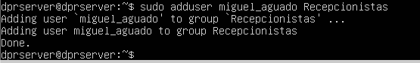

Once finished if we use the "cat" command again, we will confirm that we have added the users to the corresponding groups.

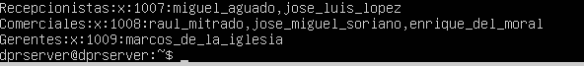

If we want to delete a user we will use "deluser [username]"

If we want to delete a group we will use "groupdel [Group name]"

# Inventory of necessary material

We will need three virtual machines W10 Desktop, Linux Desktop and Linux server.

# Final considerations

A simple and easy to learn job, good to familiarize yourself with the management of groups and users that is usually common to use.