Daniel Prieto Rodriguez

Mr. Alfredo Abad 04/23

**ConfigRedWinLinux**

Content

Objective of practice 2

Inventory of required equipment 2

Name, addressing system, and name resolution 2

(Windows) 2

Name 2

Addressing and name resolution system 3

Linux (Chart) 4

Name 4

Addressing and name resolution system 5

Linux (Server) 7

Name 7

Addressing and name resolution system 7

Basic Firewall Configuration (Windows and Linux graphics) 8

Windows (Graphics) 8

Linux (Chart) 9

Offline file setup methods (Windows only) 10

Network icon operations (windows only) 11

Final considerations 11

# Objective of the practice

We will learn in this document to find various basic configurations such as names, addressing systems, firewall, network... both on a graphical Windows and Linux as well as a Linux sever.

# Inventory of required equipment

Three Windows and Linux Chart virtual machines and one Linux Server machine

# Name, addressing system, and name resolution

# (Windows)

### Name

🡪We will go to the Control Panel Security and System 🡪 System:

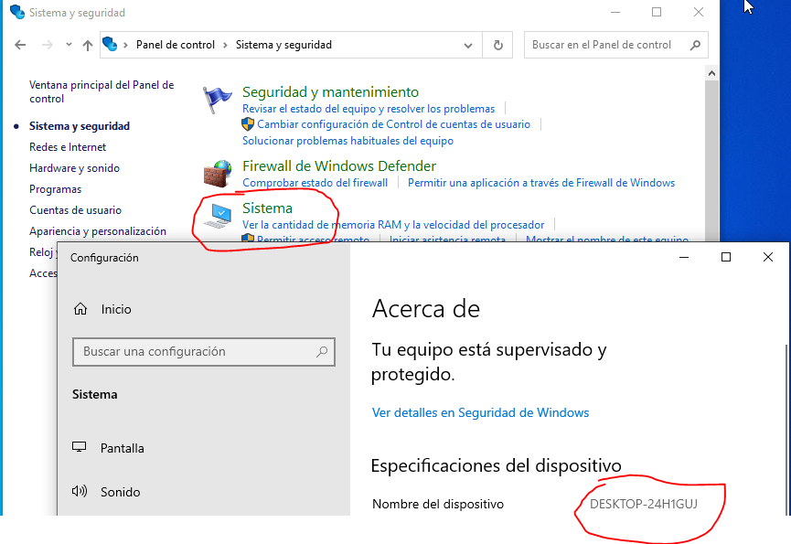

### Addressing and name resolution system

In order to get there and see this section, we must open the control panel, inside we will click "networks and internet" then "network and shared resources center" the last steps will be to click the word "ethernet" on the upper right side to open the connection that is active right now, by clicking "details" we will see the following, all the information of that network if on the contrary we click "properties" and look for the IPv4 or IPv6 we can also find the manual configuration of IP or name resolution

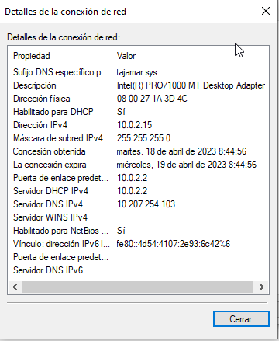

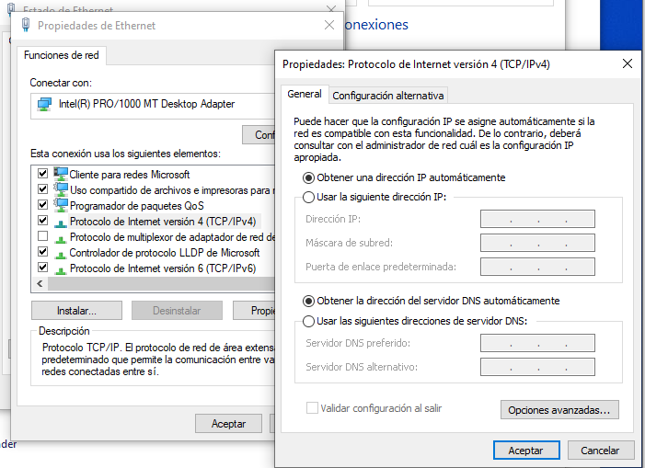

## Linux (Graphic)

### Name

We will click on the upper right wheel of the monitor and we will give "system configuration" 🡪 Details: and we will see the Name

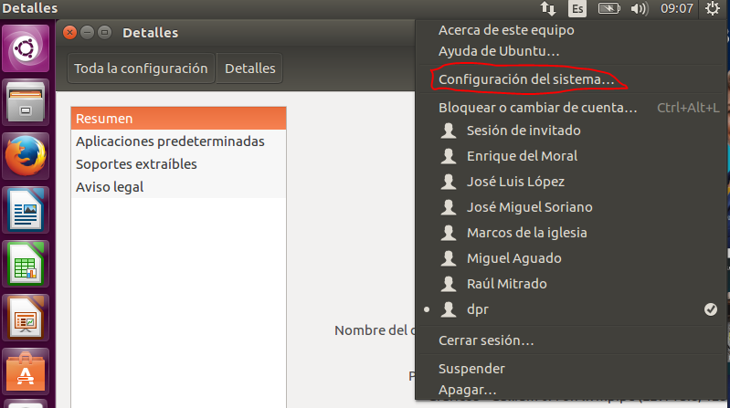

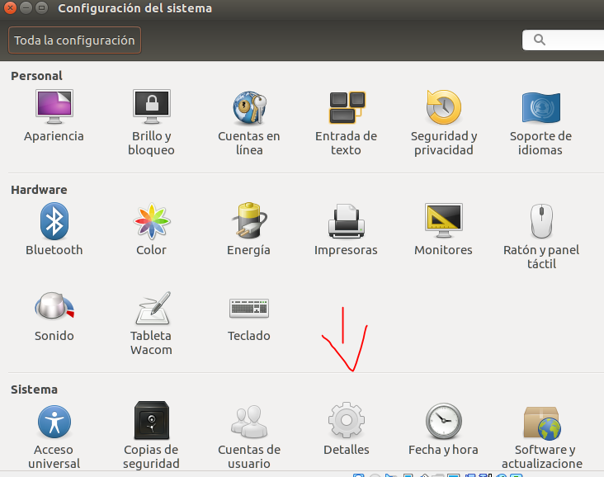

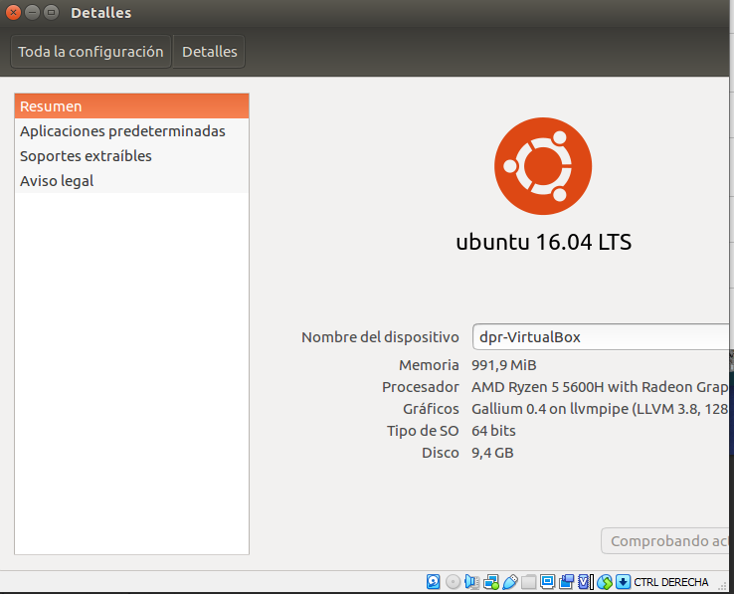

### Addressing and name resolution system

Here simply instead of hitting the nut in the upper right, we will click on the up and down arrows, giving then to connection information

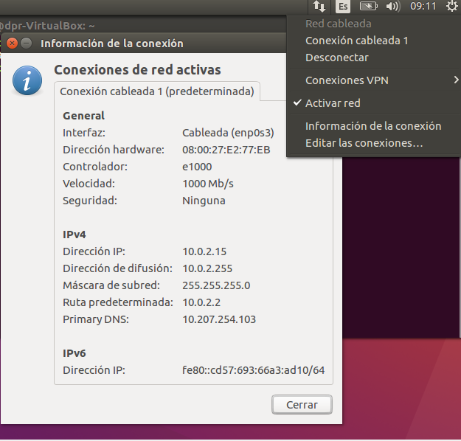

If we want to edit it in the same place we will click on "edit connections" looking for the one we want and giving it to "edit"

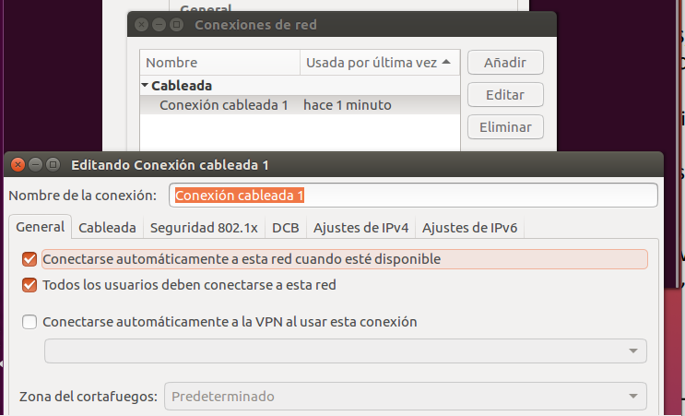

## Linux (Server)

### Name

We must write the command "hostname" without having to do sudo

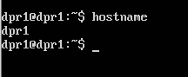

### Addressing and name resolution system

To view the network settings, we will use the command "ip to"

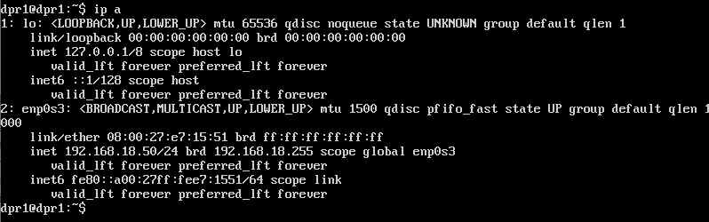

To see the name resolution we will write: "cat /etc/ resolv.conf | grep nameserver"

# Basic Firewall Configuration (Windows and Linux Graphics)

## Windows (Graphics)

We will enter the control panel 🡪 System and security 🡪 Firewall

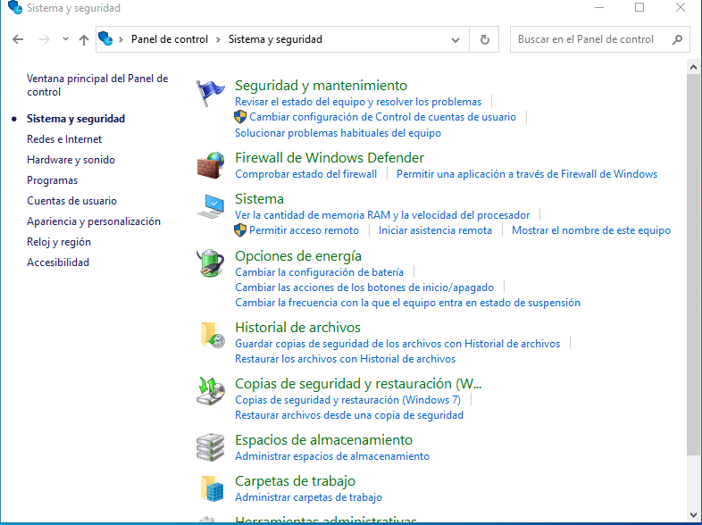

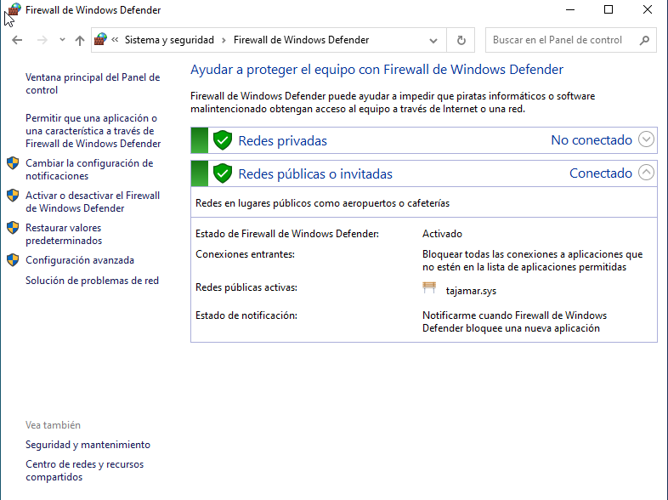

In this section we will have the most basic of the Firewall such as: Activate or deactivate it, change basic configurations and the entrance to the advanced configurations in Windows

## Linux (Graphic)

To have it we will have to install it by the command line using the "sudo apt-get install gufw" when we have it we will open it with a "sudo gufw" and we will have our firewall of graphical environment in Linux

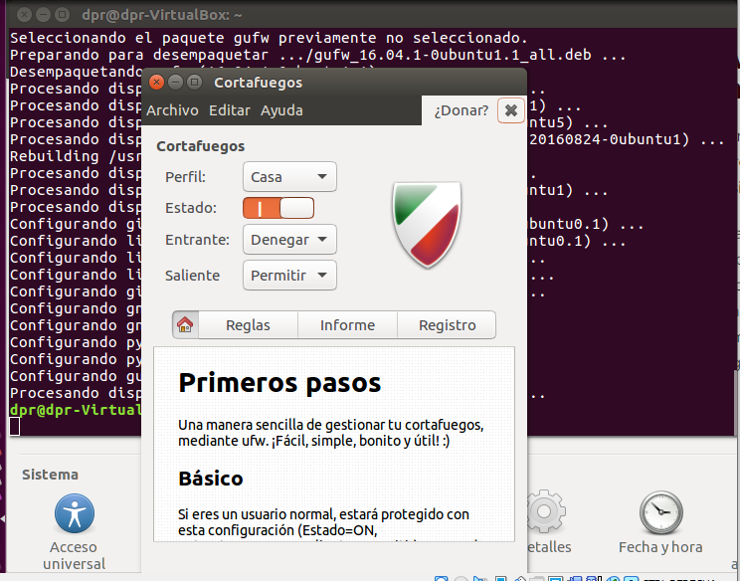

# Offline file setup methods (Windows only)

1. Synchronize the network drive to local drive

* Access the shared folder on the network drive Right click on the shared folder, 🡪 then select Map Network Drive from the context menu 🡪 Now, you can go to the offline files folder or its sub-folder, right-click and choose "Offline" Always available from the context menu

1. **Method 1:** Activate offline files in Windows 10/11

* Click "Start", Type "Sync Center" in the search box and then select it from the list 🡪 Click "Manage Files" offline in the left panel and then you will see an offline files window 🡪 YOU CAN CLICK "Enable offline files under the general tab and Restart your computer, to activate the offline file folder

**Method 2**: Enable Offline Files in W10/11 Using GPOs

* Type "Group Policy" in the search box and then select "Edit Group Policy" from the list in the initial menu 🡪 Expand your computer's settings > Administrative Templates > Network > Offline Files In this order, find and double-click the "Allow" or "deny" features to use the Offline Files features, check "Enable" and click "Apply and OK" to exit the window

Method 3: Enable Offline Files in Windos 10/11 Using the Registry

* Type "record" in the search box, select it and open it. Then, goes the following key, right-click on the blank, select new and DWORD value (32-bit) sets its name as start and value to 1 🡪 Now go to the key below and set the startup value to 2 🡪 Restart your computer and make any changes that are available

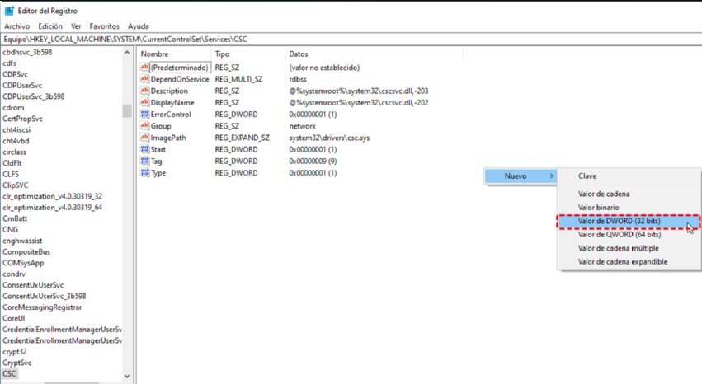

More information 🡪 [Here](https://recoverit.wondershare.es/computer-backup/enable-offline-files-in-windows-10.html)

# Network icon operations (windows only)

To get there, we can do it from the control panel, for example, moving to networks and internet, here we will have the option to "change adapter options" where clicking we will get the networks we have, from here we can activate them, deactivate them, repair them, make bridge connection ...

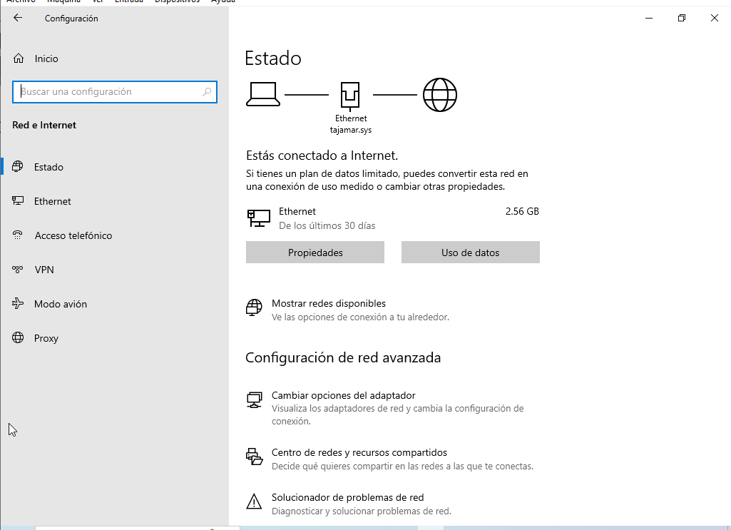

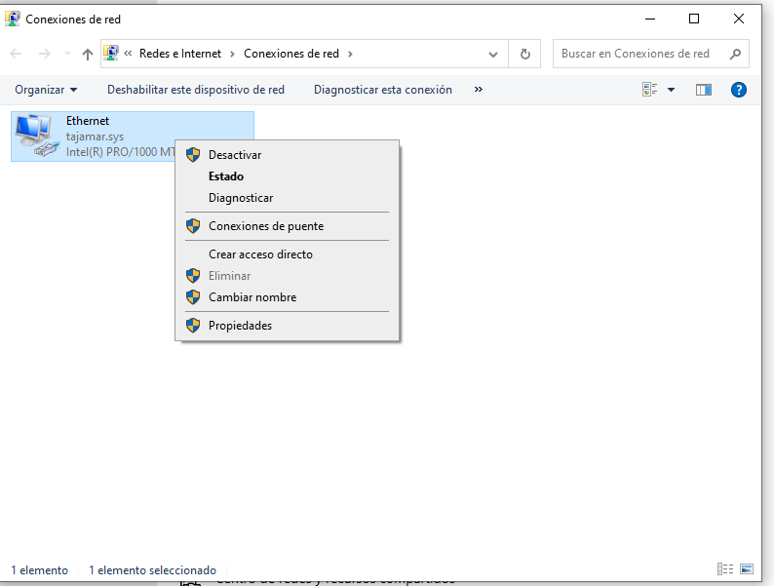

And what is the bridge connection? (It can only be used if I have more than one network adapter.) They are basically used to connect independent network segments and act as routes between two nodes. When connected by a bridge, the segments communicate as if they were a single network segment.

# Final considerations

Simple practice to guide us in the basic environments of Windows and Linux