Daniel Prieto Rodríguez

D. Alfredo Abad 04/23

**ICS-Win-Linux**

Content

Objective of practice 2

Inventory of required equipment 2

Initial Configuration 2

Configuring Windows ICS on the second NIC 3

Configuring the network in Linux 4

Final considerations 5

# Objective of the practice

We will learn in this document to share our internet access with another machine that does not have it, making that machine reach ours by internal network and end up going out to the internet.

# Inventory of required equipment

Two machines, one Windows with two network cards, one in NAT and one in internal and one Linux with one internal network card.

# Initial setup

Windowns with ICS

IP: 192.168.0.1 IP: DHCP

Internet

LAN

Linux

IP: 192.168.0.2

# Configuring Windows ICS on the second NIC

We will go to the network that we want to share, in this case it is the "Ethernet" we will click and we will give it to properties where we will later give it to "shared use" and we will enable it

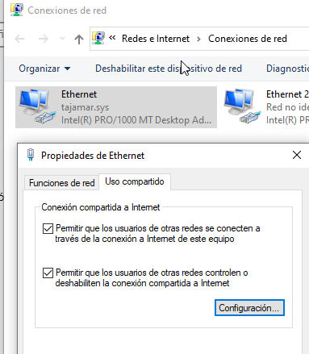

Now we will configure the second adapter with the IP that we indicated in the previous graph

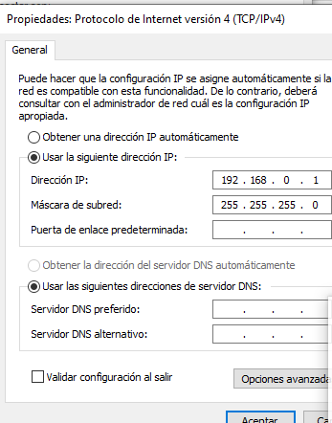

# Configuring the network on Linux

We will enter "/etc/network/interfaces" once inside we will configure the network in this way and restart the service:

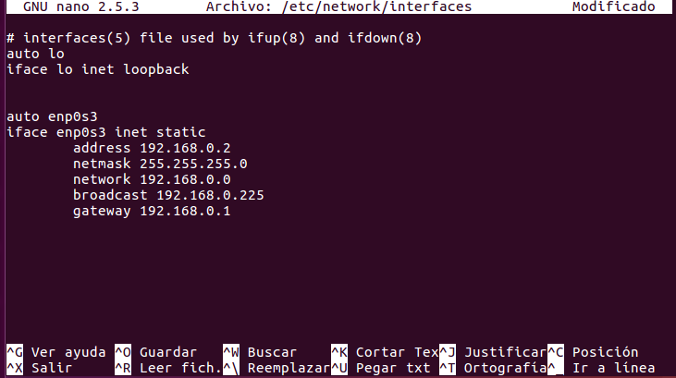

Once the service is restarted with "sudo service networking restart" and we have verified that it works, we will edit the name resolver in "/etc/resolvf.conf"

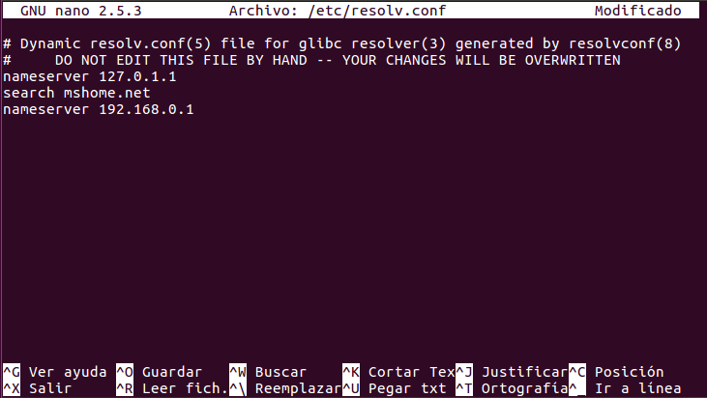

We will check that it works with the command "ifconfig"

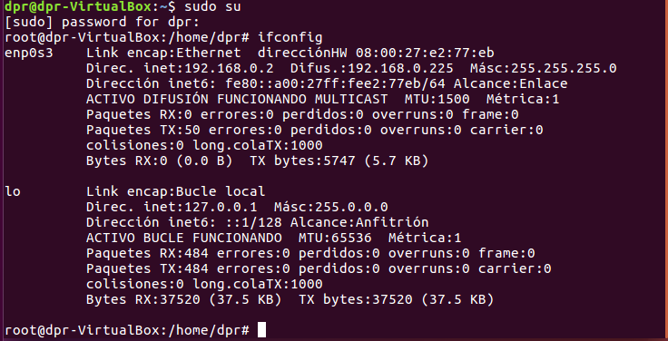

Once configured we will try to ping to verify that they work

The ping will be at 192.168.0.2

192.168.0.1 (the other machine)

8.8.8.8 (We will not go because, when doing it in class, the tajamar network does not allow us to receive the packages, only send them)

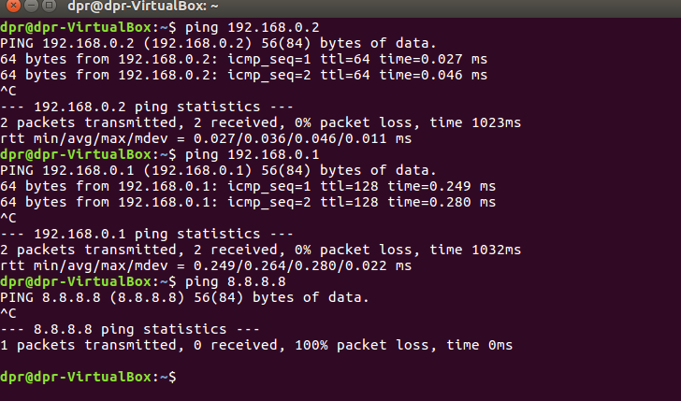

# Final considerations

Quick and easy practice, useful when making router a machine like windows