Concepcion Holy Cross College, Inc

**COLLEGE OF COMPUTER STUDIES**

Case Study

in

Application Development and Emerging Technologies

Submitted By:

**Edmar Lindo**

**Justin Cayas**

**Kieroh Suarez**

**Gideon David**

**Christine joy Castro**

Submitted To:

**Sir, Arjay Balberan**

Date:

Table of Contents

List of Figures 2

A. Type of Website 4

B. Case Analysis #1 5

B.1 Topic 5

B.2 Presentation of Website 5

B.3 Explanation of Source Code 5

C. References 6

[1]

# List of Figures

Figure 1 Sample Figure 4

Figure 2 Sample Figure 2 4

Figure 3Sample Figure 3 5

Figure 4 Sample Figure 4 6

# Definition

OWN INFORMATION WEBSITE -The person who created your website owns the design and code, but can give you ownership right. You own your content. [1]

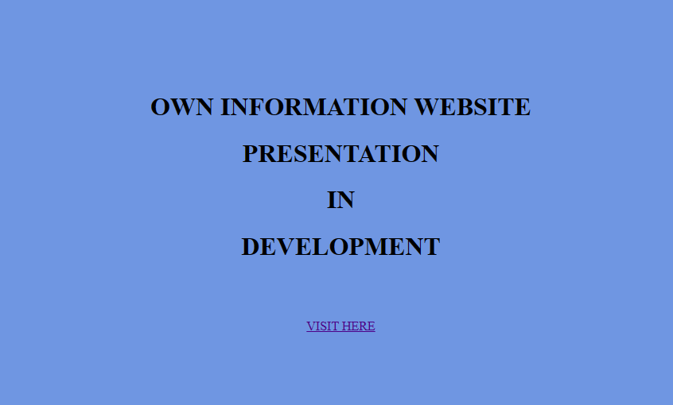

Figure 1 Sample Figure

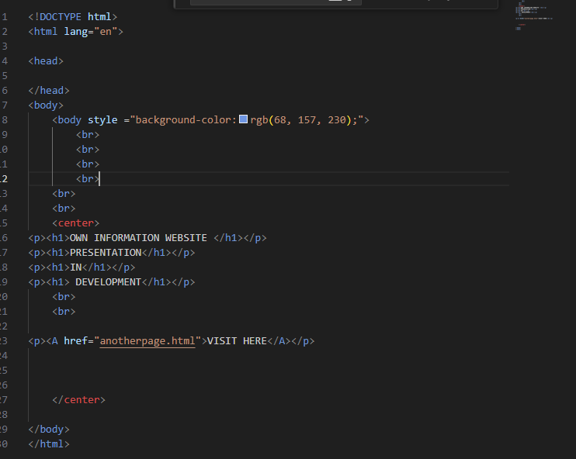

Figure 2 Sample Figure 2

# Case Analysis #1

## Topic

Own information website is a website where in you can visit and see the personal information and personal hobby/hobbies of Group 1.

## Presentation of Website

We will present our website and explain the implementation that has done in this website. 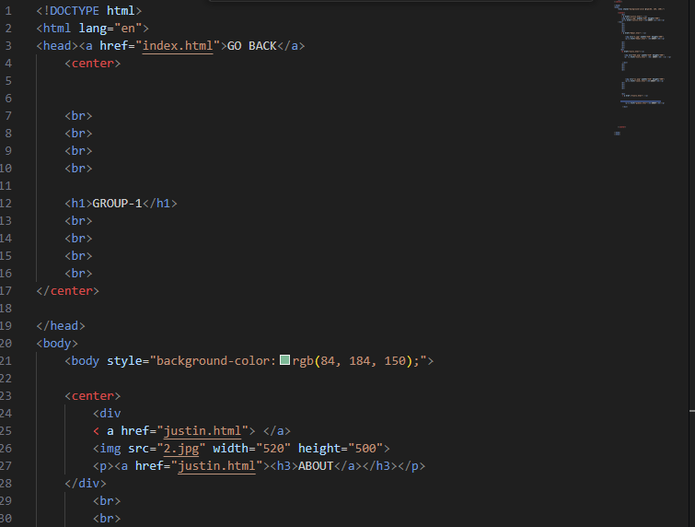

Figure 3Sample Figure 3

## Explanation of Source code

## We use different kind of Html tags and with the use of visual studio code, we implement the website and search some information how to add some additional design specifically the background color and the pictures we put. [2]

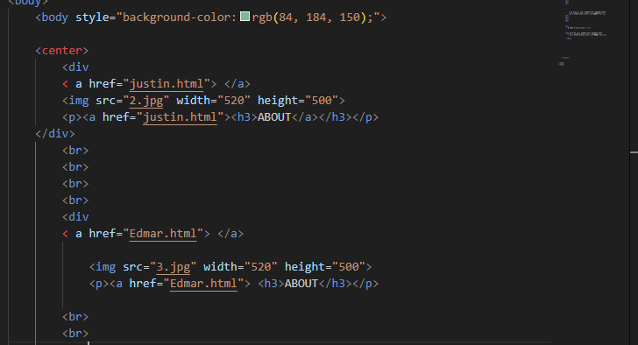

Figure 4 Sample Figure 4

# References

# References

|  |  |
| --- | --- |
| [1] | S. Abalos, What is Website Ownership?, 2017. |
| [2] | w3school, html.styles, 1999-2023. |
|  |  |

1.