**Evaluation Only. Created with Aspose.Words. Copyright 2003-2023 Aspose Pty Ltd.**



**Created with an evaluation copy of Aspose.Words. To discover the full versions of our APIs please visit: https://products.aspose.com/words/**

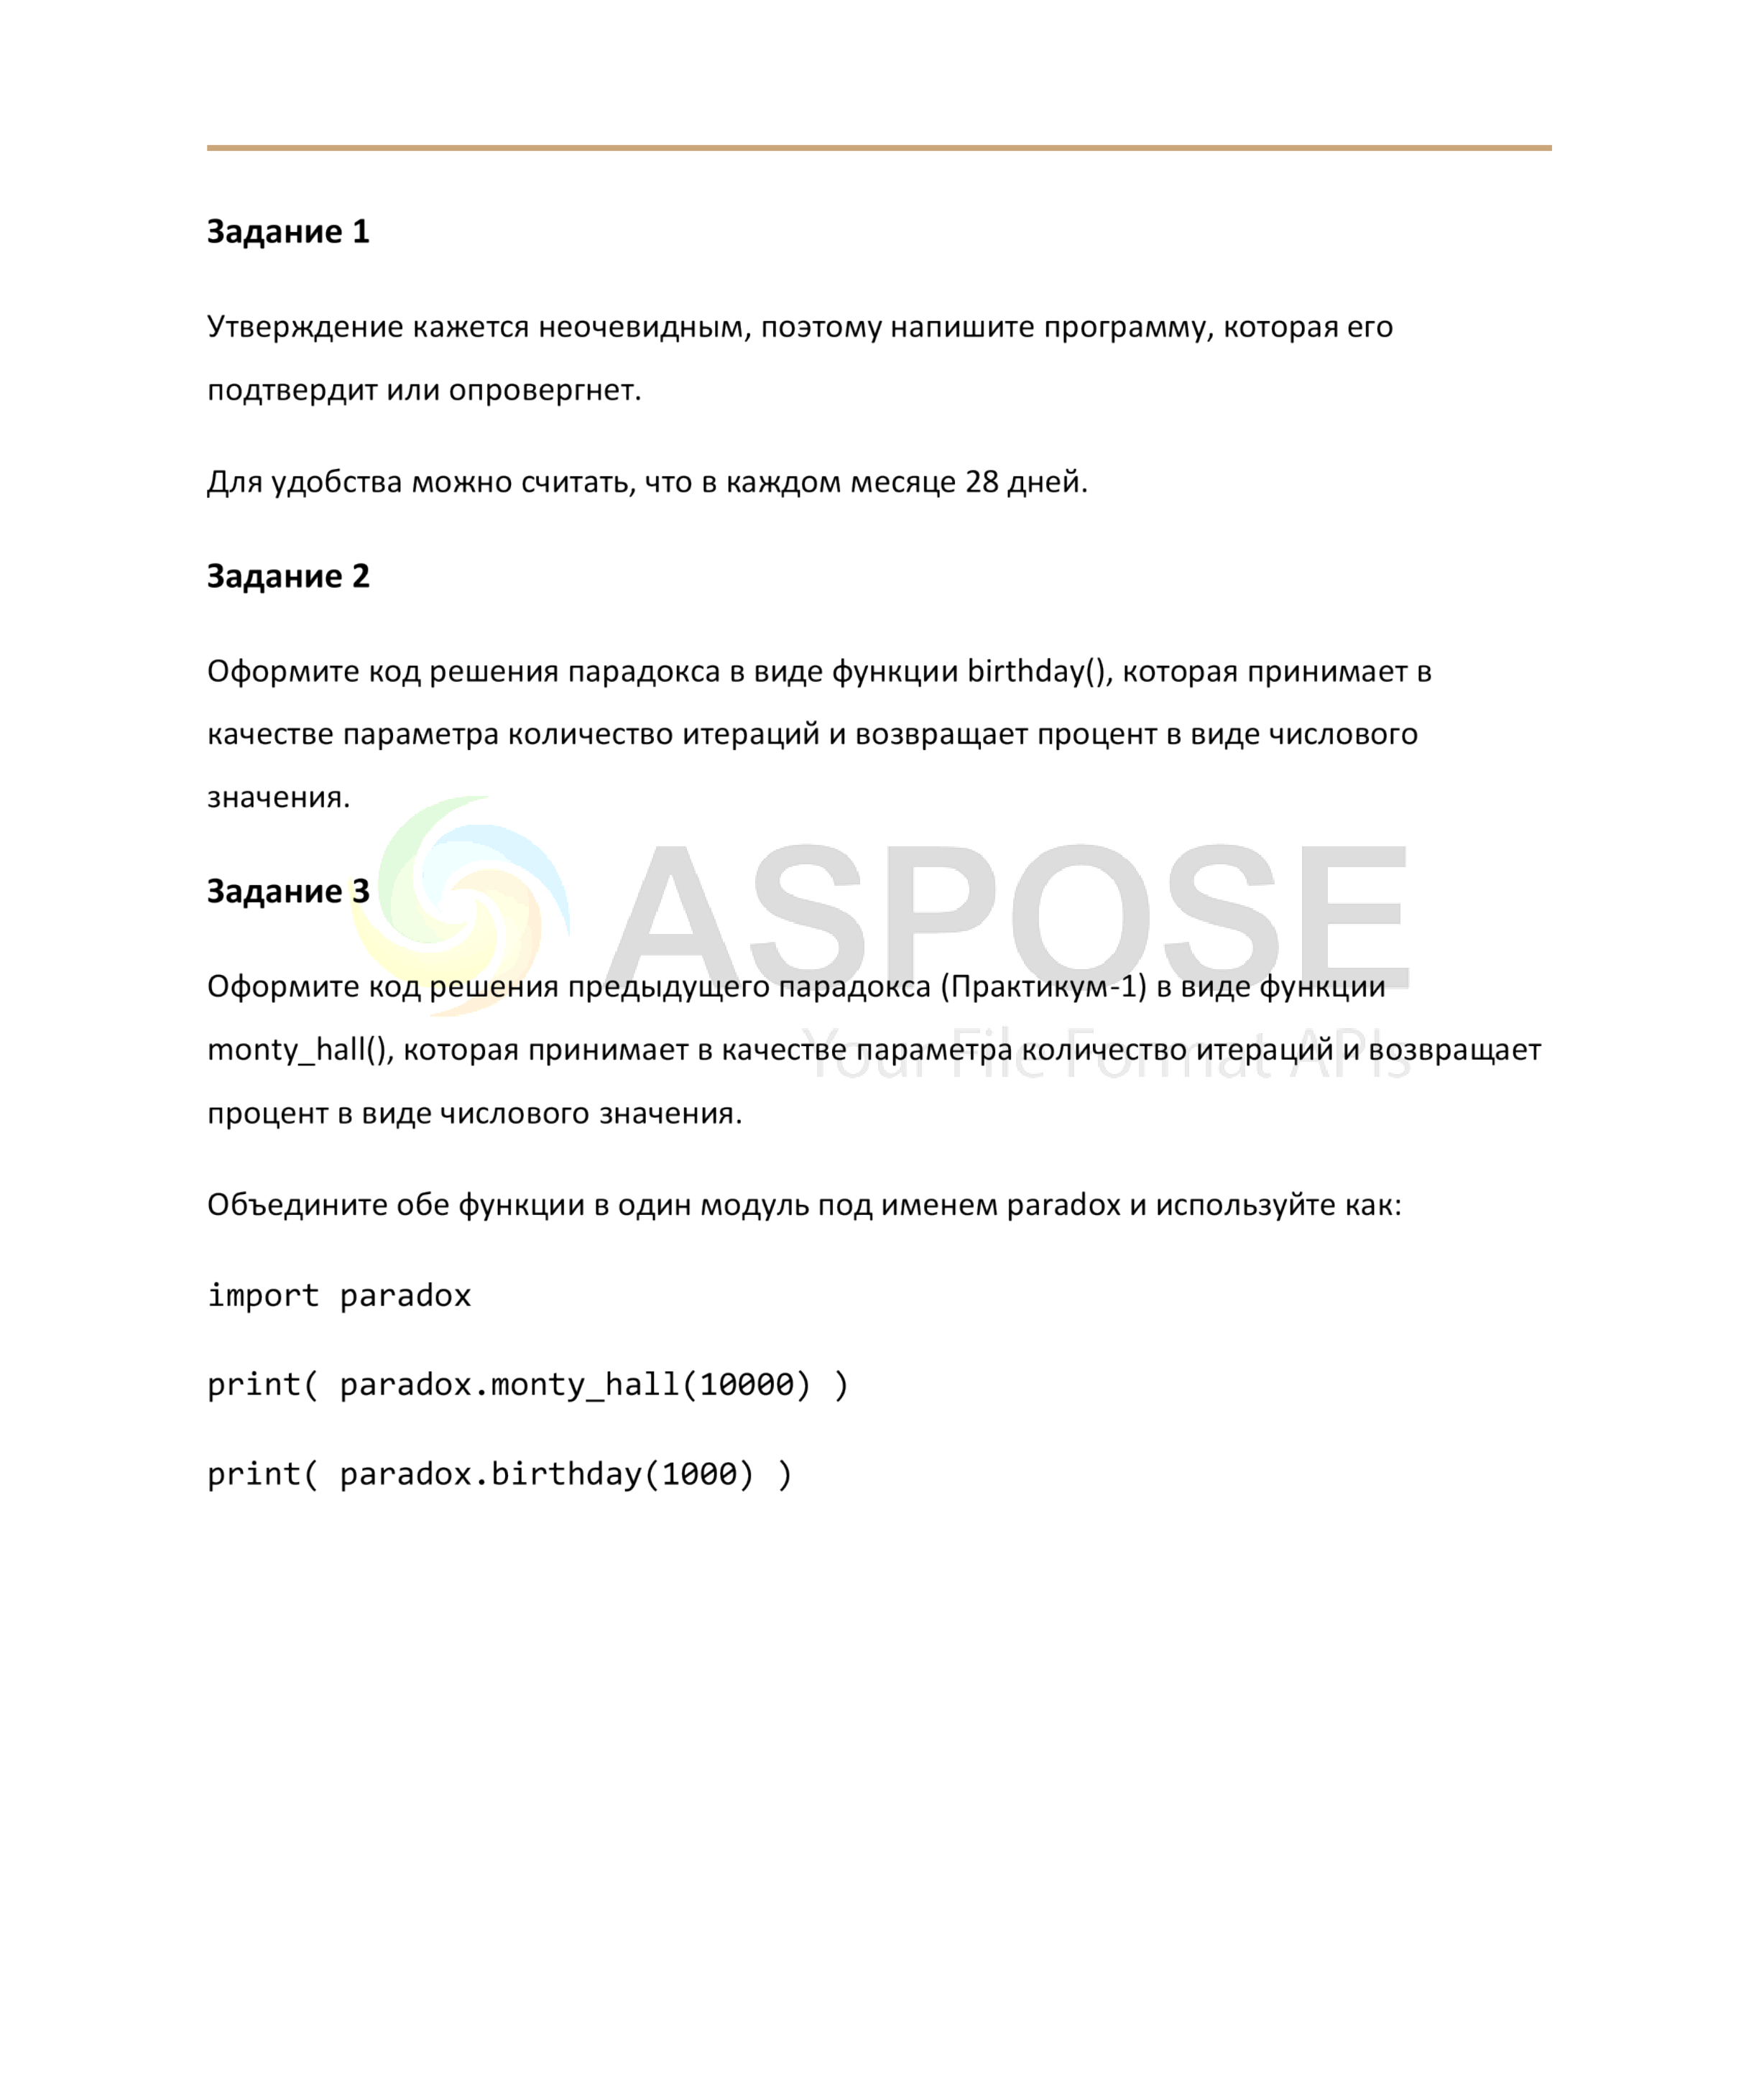

**Created with an evaluation copy of Aspose.Words. To discover the full versions of our APIs please visit: https://products.aspose.com/words/**

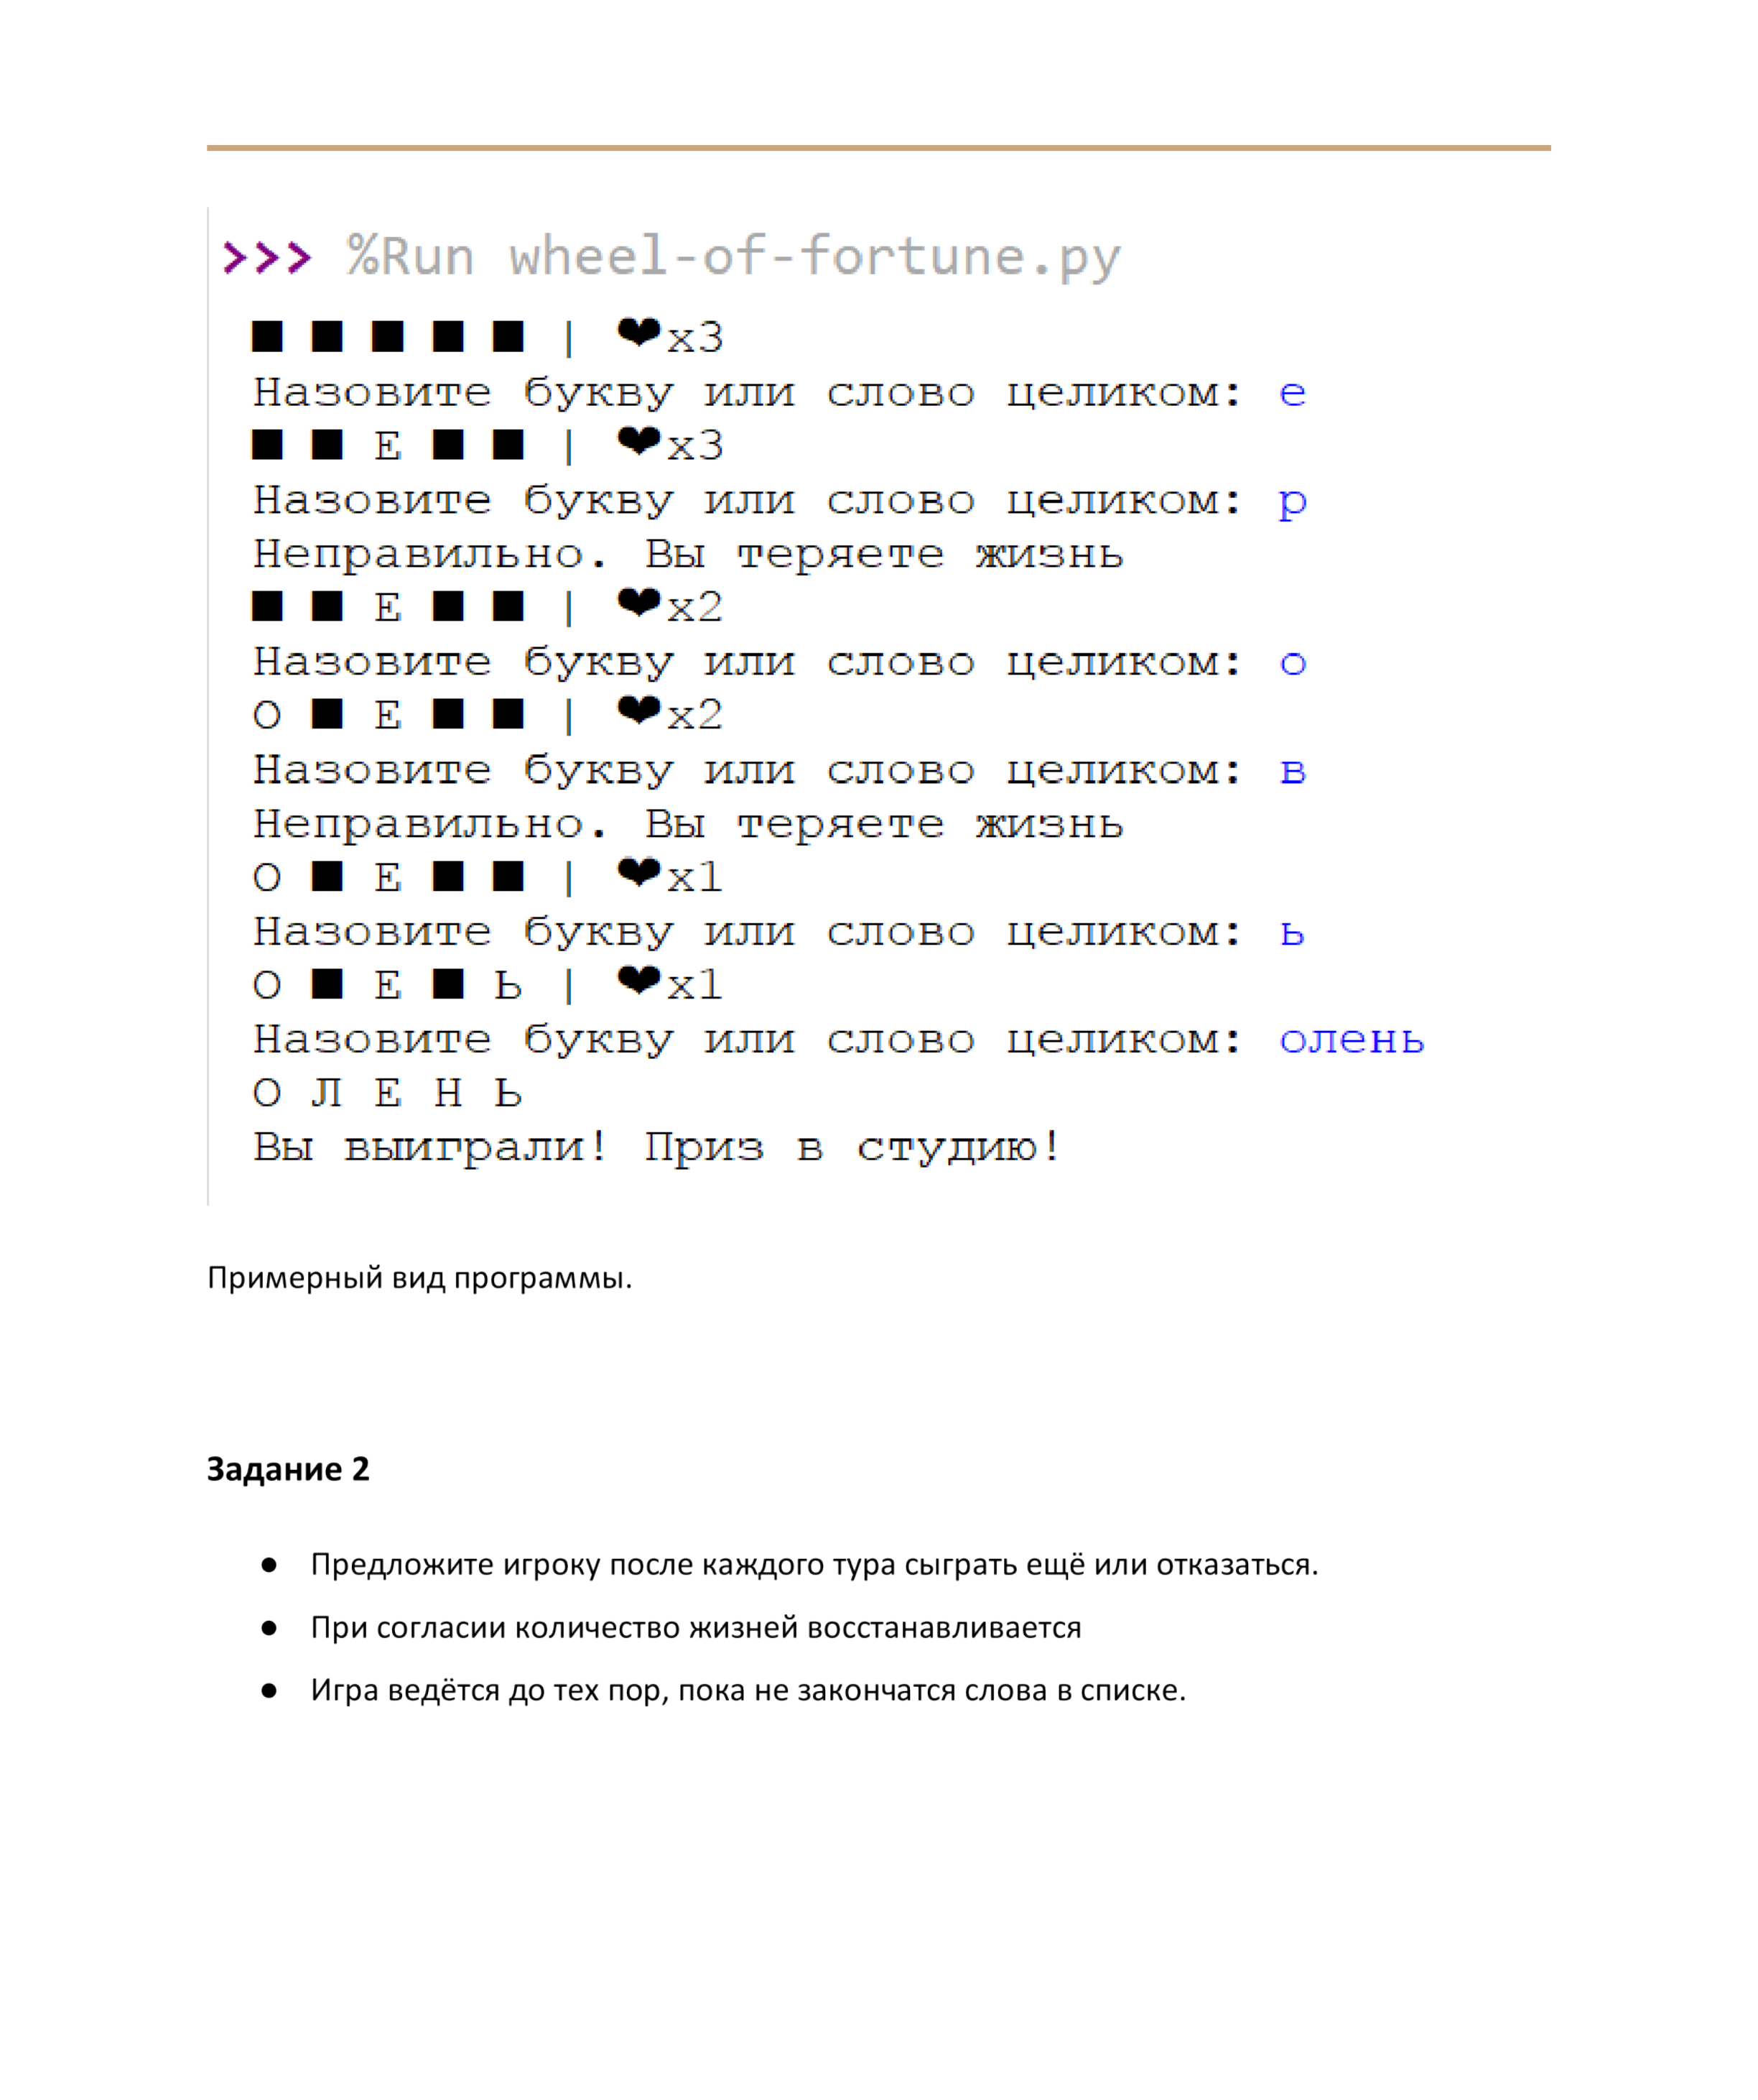

**Created with an evaluation copy of Aspose.Words. To discover the full versions of our APIs please visit: https://products.aspose.com/words/**

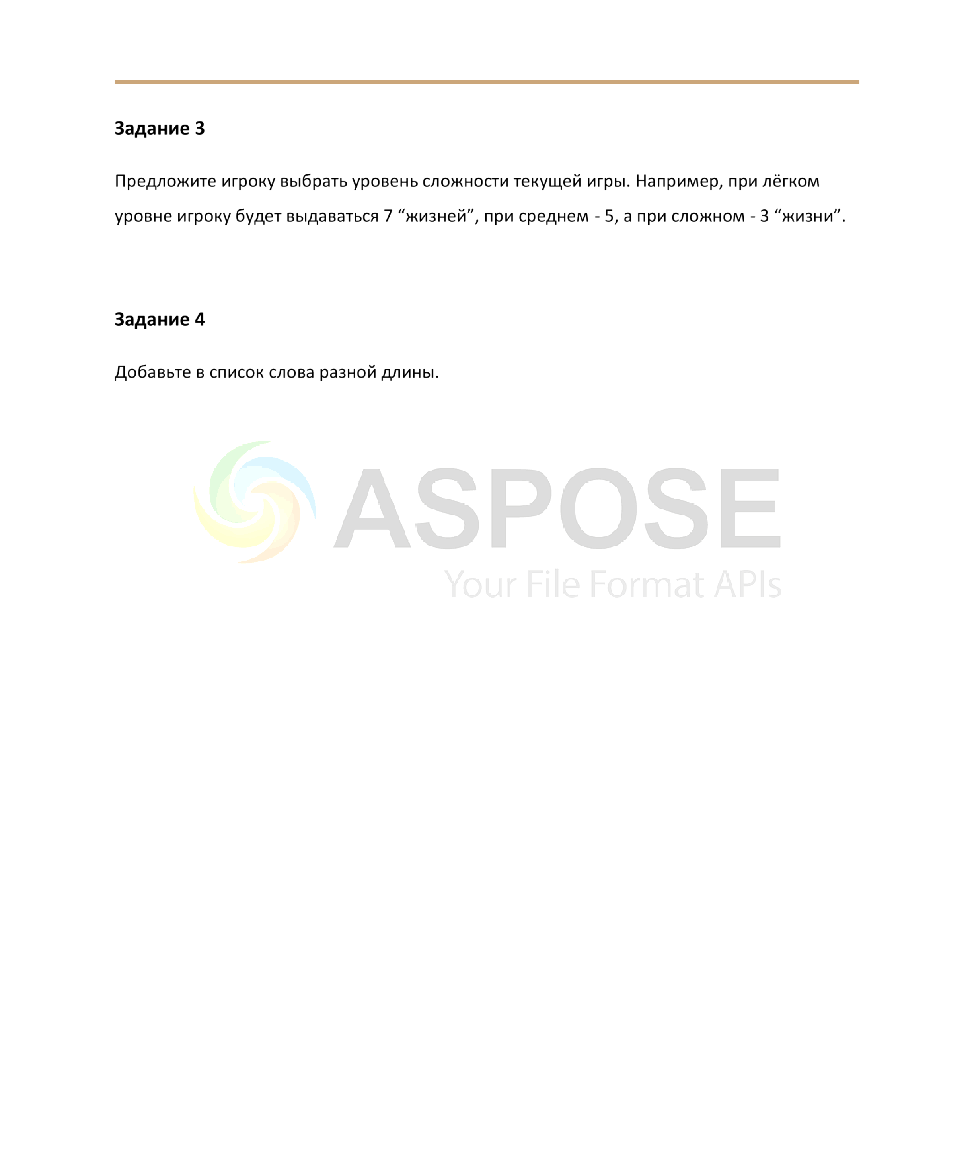

**Created with an evaluation copy of Aspose.Words. To discover the full versions of our APIs please visit: https://products.aspose.com/words/**

**Дополнение к практической работе №3**

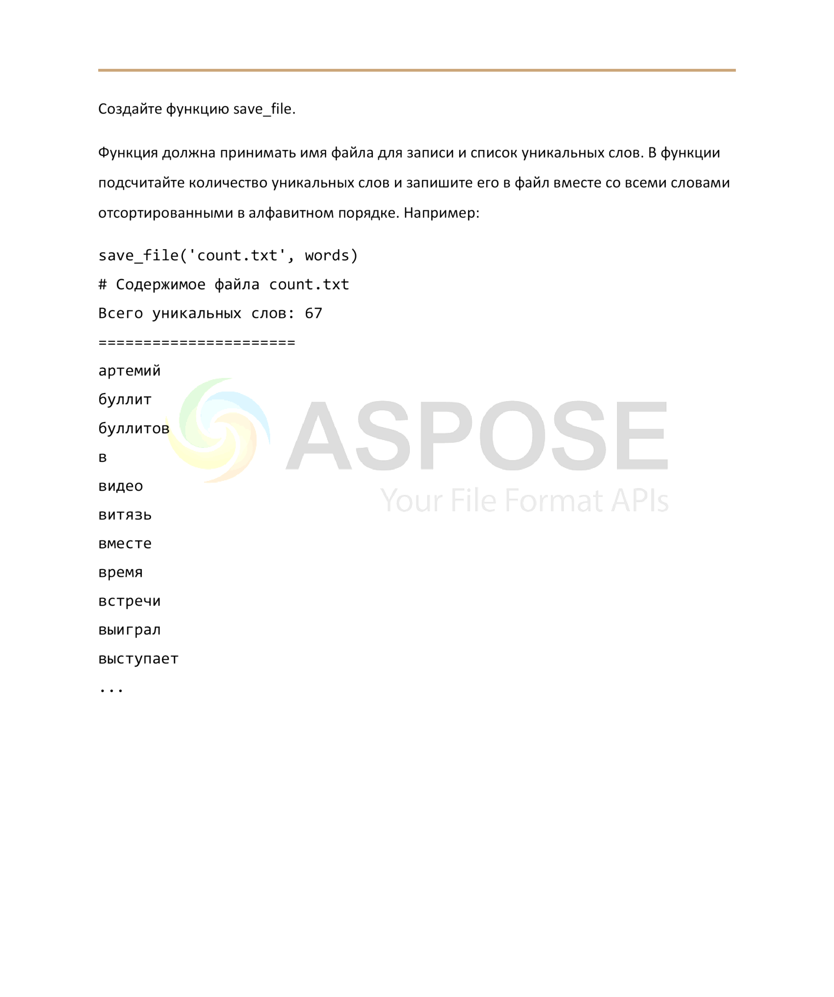

**Created with an evaluation copy of Aspose.Words. To discover the full versions of our APIs please visit: https://products.aspose.com/words/**

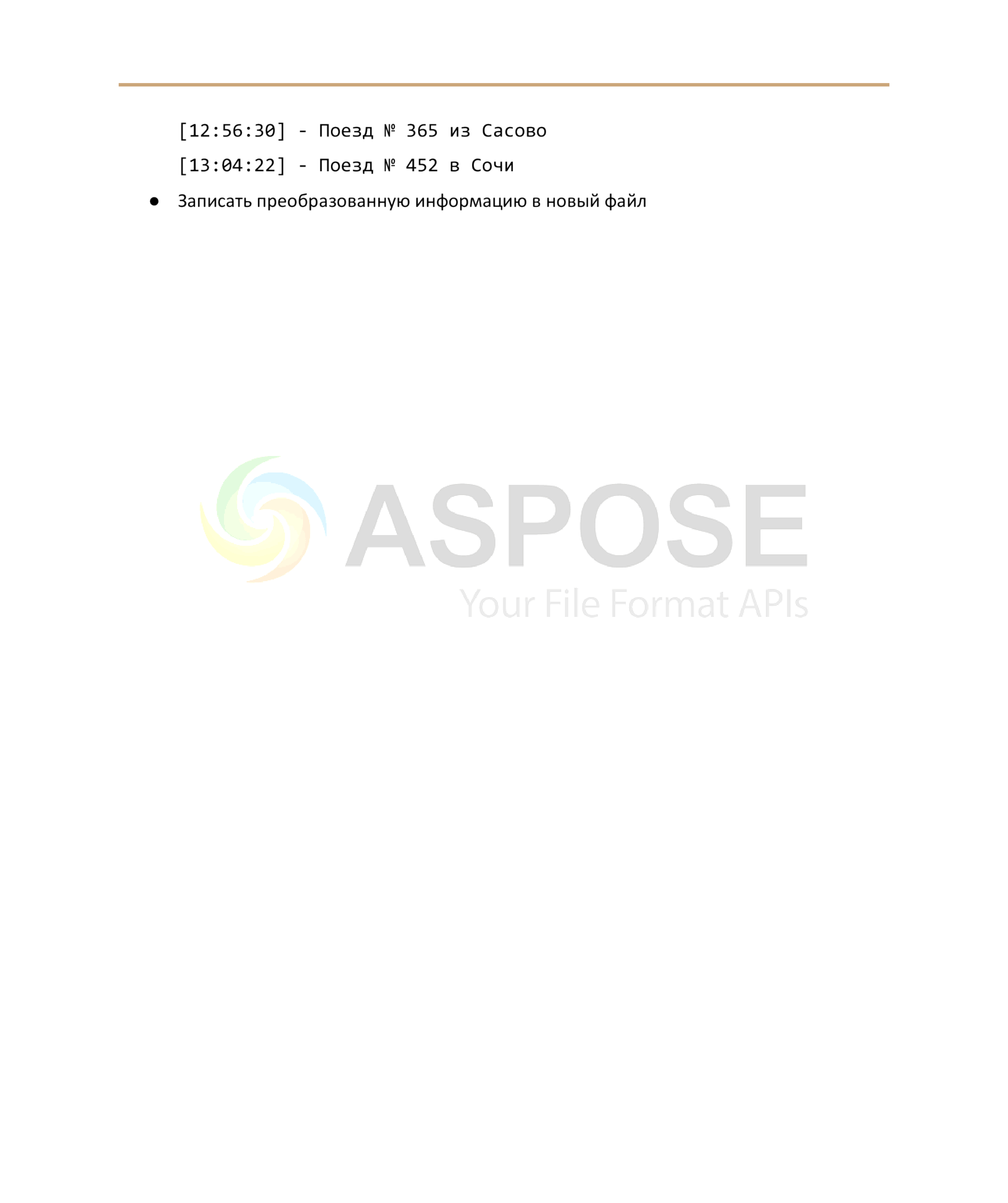

**Created with an evaluation copy of Aspose.Words. To discover the full versions of our APIs please visit: https://products.aspose.com/words/**

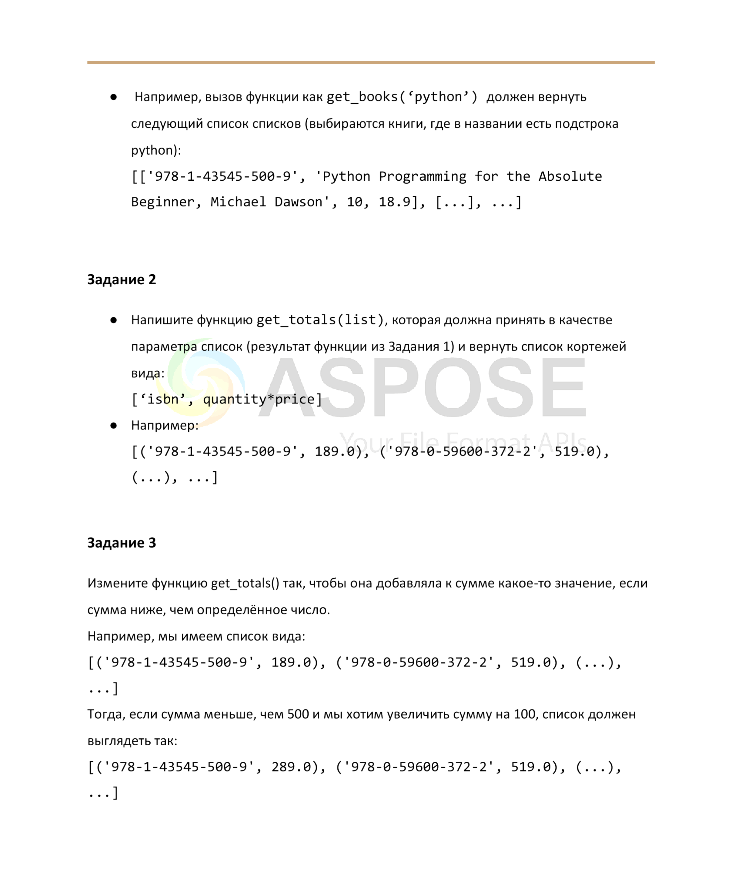

**Created with an evaluation copy of Aspose.Words. To discover the full versions of our APIs please visit: https://products.aspose.com/words/**

**Практическая работа №9. Модуль OS. Взаимодействие с компонентами операционной системы**

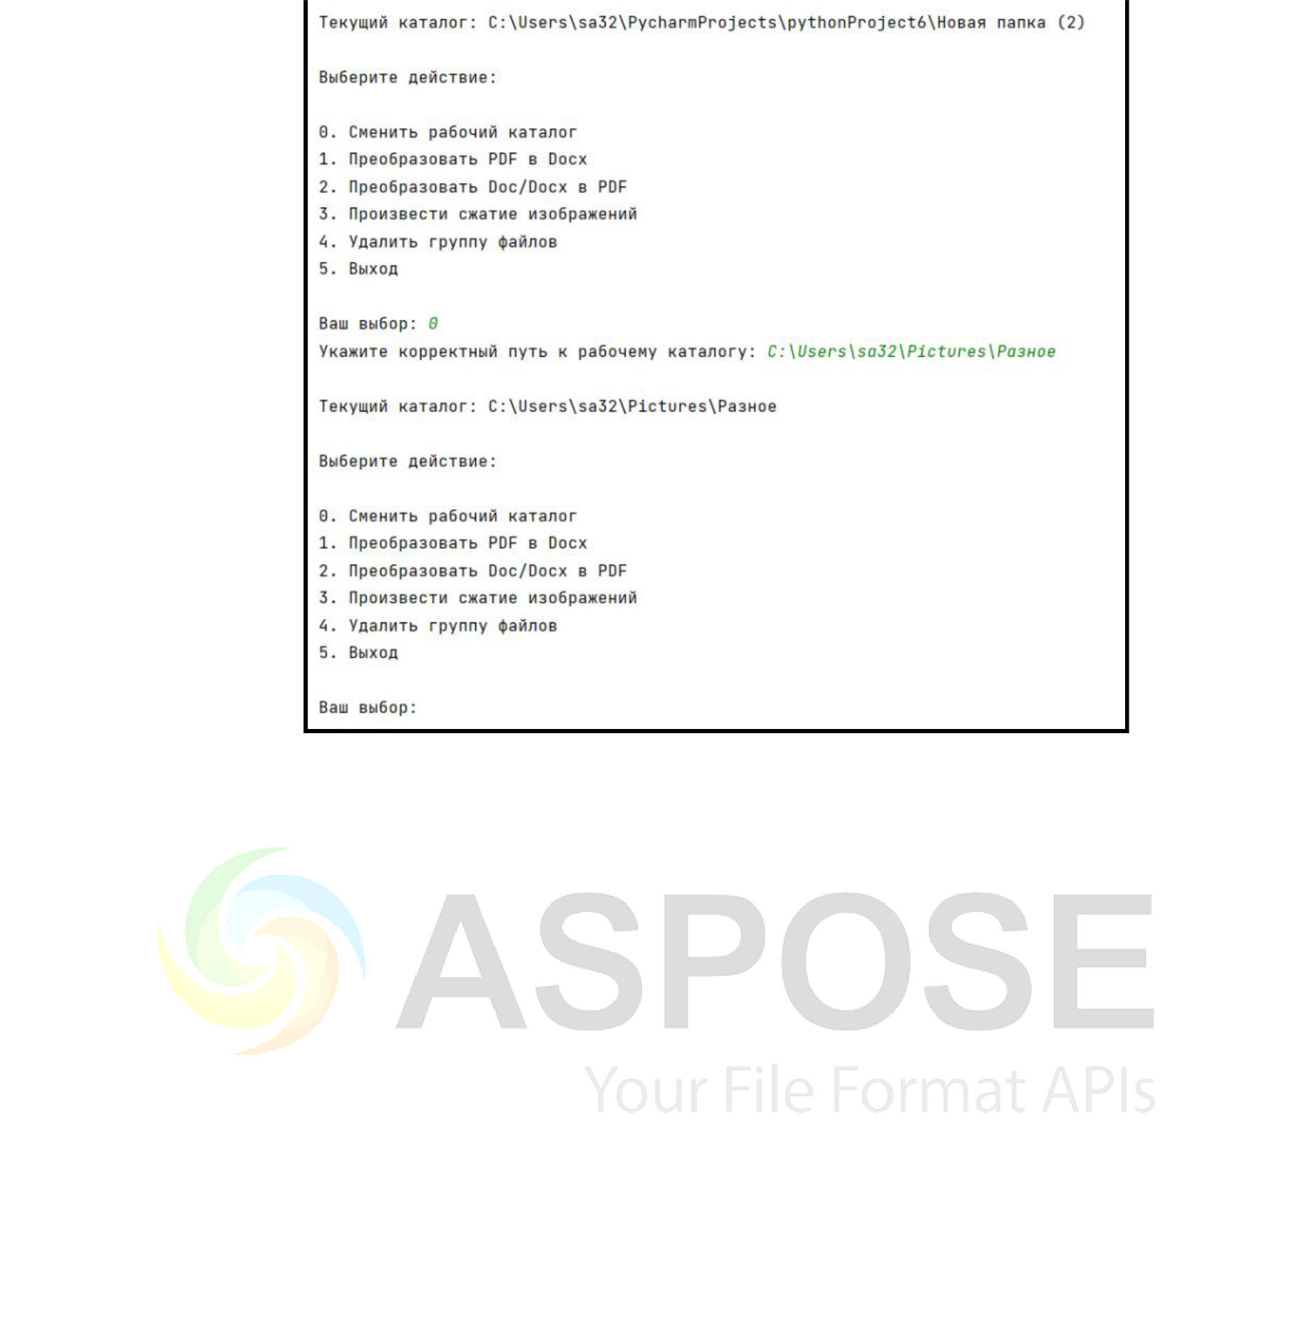

**Created with an evaluation copy of Aspose.Words. To discover the full versions of our APIs**

**please visit: https://products.aspose.com/words/**

|  |
| --- |
|  |



**Created with an evaluation copy of Aspose.Words. To discover the full versions of our APIs**

**please visit: https://products.aspose.com/words/**

|  |
| --- |
|  |