Dear Editor,
We would like to thank the referees for reviewing our updated paper, producing follow-up reports, and helping to improve the quality and readability of the paper.
We have considered all comments, and we have made several changes to the previous version of the paper to address the issues and detailed responses can be found below. As for previous communications, the original question is written in black font, the author response is written in blue font, and any modification to the paper draft is written in bolded green font.
Sincerely,
Si, Adi, Zhicai, Cristian, Maria

Reviewer #1:

13: With current accelerator and particle detector capabilities
→ With accelerator and particle detector capabilities currently under design
Corrected according to reviewer suggestion.
19: delete vestigial sentence: "Therefore, the crucial ability to identify the origin of the particles produced at the different interaction points will be severely degraded."
Corrected according to reviewer suggestion.
21: delete" "recover the ability to"
Corrected according to reviewer suggestion.
Fig. 1 caption: Add that the SiPM is labeled MPPC in the figure. If possible remove "name", "p$1" and "p$2" from the figure.
We have removed the “name”, “p$1”, and “p$2” labels from the diagram. We have added the following sentence in the figure captions:
The SiPM is labeled as MPPC in the diagram.

144: with high energy beams ? with high energy electron beams
Corrected according to reviewer suggestion.
176: "Each data point corresponds to the mean measured signal amplitude and time resolution from a dataset with different beam energy."
there is no indication of beam energy on the figure. Can't understand what this statement means. Which points are from which beam energy? This must be clarified.
Each data point shown in Figure 5 corresponds to the mean signal amplitude and time resolution measured for particular electron beam energies. The beam energies are 20, 50, 100,150, and 200 GeV. The signal amplitude increases as the beam energy increases, so the five data points correspond to data taken at the above 5 energy points as we go from left to right of the figure. We have modified the paragraph as follows:
Data are taken with electron beam energy at 20, 50, 100, 150, and 200 GeV, and the time resolution measured for each beam energy is plotted as a function of the mean signal amplitude measured in the same dataset in Figure 5. We show the time resolution of the four individual fibers separately as a function of their respective mean signal amplitudes for both the DSB-doped fibers and the DSB-filled quartz capillaries. The mean signal amplitude increases as the beam energy increases. We observe that the time resolution improves as the signal amplitude (or beam energy) increases.
178: "improves as the beam energy" Again, there is no information at all about beam energy in the figure. This is NOT observed in the figure.
We have modified the paragraph as shown above, and have tried to explain how the beam energy is reflected in the figures.
180: A crucial comment from the previous review has NOT been addressed:
from previous review:
"but the amplitude at which this performance is achieved varies." Why? This needs to be explained. The simple model in which amplitude is proportional to the number of pixels fired suggests an amplitude ratio of 2.25 between 15um and 10um pixels (consistent with data) but an amplitude ratio of 2.8 between 25um and 15um pixels (too small by a factor of ~2 compared to data). How much of the SiPM does the fiber illuminate?
This feature is explained by the fact that the SiPMs were all operated at the same bias voltage of 70V and therefore were operated at different values of gain. We have added the following paragraph to explain this feature more explicitly:
The variation of signal amplitudes is due to variations in the operational gain
of the four SiPMs. As discussed in Section 3.2, each SiPM was operated as a bias voltage of 70 V. As the breakdown voltages for each SiPM varies slightly, the over-voltages also vary resulting in significant differences in gain. Furthermore, the SiPM-to-fiber coupling may not be perfectly identical, resulting in a small variation of light collection efficiency. The combination of these effects explains why the best time resolutions are achieved at different signal amplitudes in the four different channels.

187: Once again "Each data point corresponds to a measurement of mean rise time for datasets taken using different beam energy" is new information that is not at all visible in the figure. The data sample compositions needs to be clarified.
We have modified the sentence as follows:
As in Figure 5, the data points correspond to measurements of the time resolution and mean rise time for datasets collected using electron beam energies ranging from 20 GeV to 200 GeV.

188: "The capacitance of the high-pass filter for the 3 × 3 mm 2 SiPM with 25 <mu>m pixel size is significantly larger": Give the capacitance values

We have added the capacitance values to the sentence as follows:
The capacitance of the high-pass filter for the 3x3mm² SiPM with 25 μm pixel size is 100 pF, which is significantly larger than the capacitance for the other three SiPMs (15 pF), resulting in signals with larger amplitude but also larger rise time.

Reviewer #2:

Issue 1:
This statement is only true if the low-frequencies are contributing to the leading edge and not the tail of the pulse. One would need to demonstrate this with a Fourier analysis. Or at least a detailed comparison of the risetimes with and without the HP circuit. Barring this, the statement as listed is unjustified. Conceptually OK, but unproven in this case.

We have done these studies in the past and the technique of using high-pass filters for the SiPM circuit when reading out light signals from a scintillator is a commonly used technique to achieve faster signals and better time resolution.

Below are histograms of the signal amplitude and risetime for data taken with LYSO coupled to an SiPM comparing the situation where the circuit contains the high-pass filter (left) and the situation where the circuit does not contain the high-pass filter (right). We see that the amplitude is decreased significantly, while the risetime is made significantly faster. The same SiPM is used here.
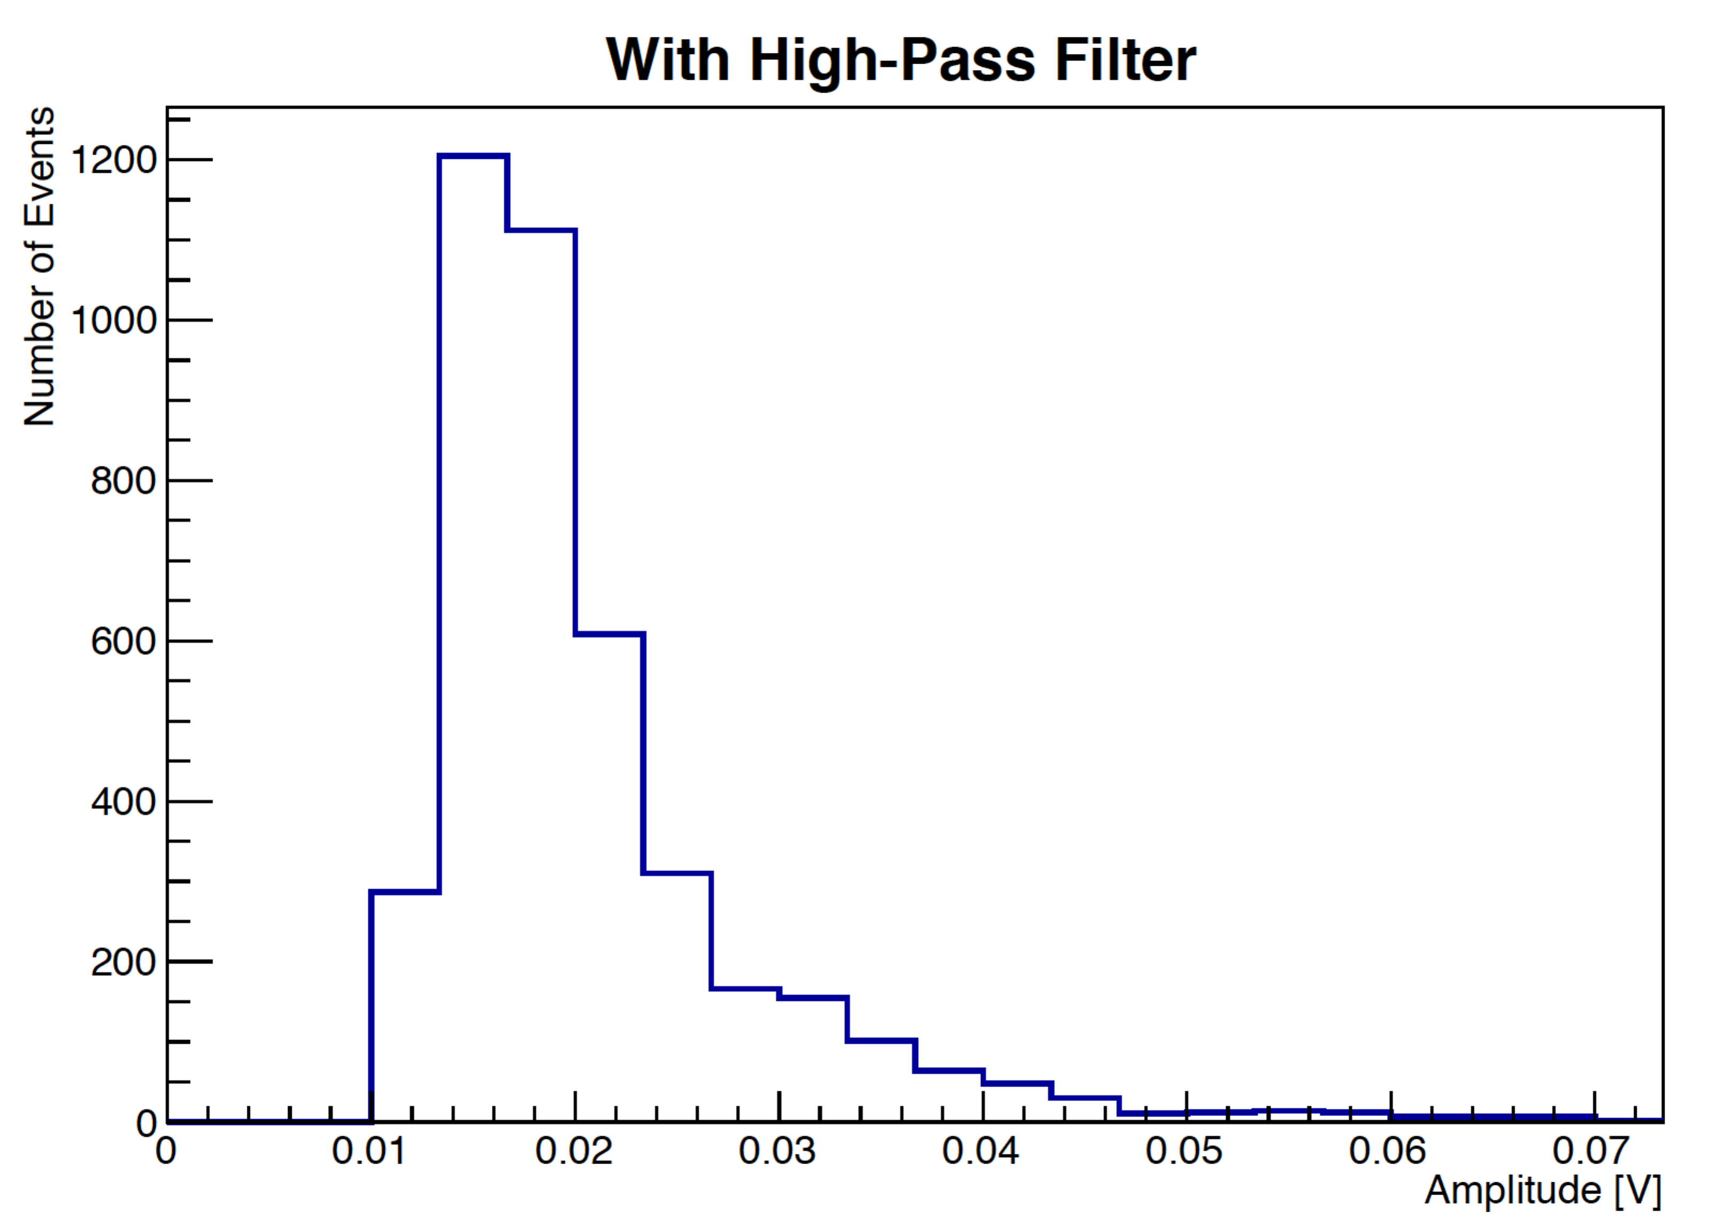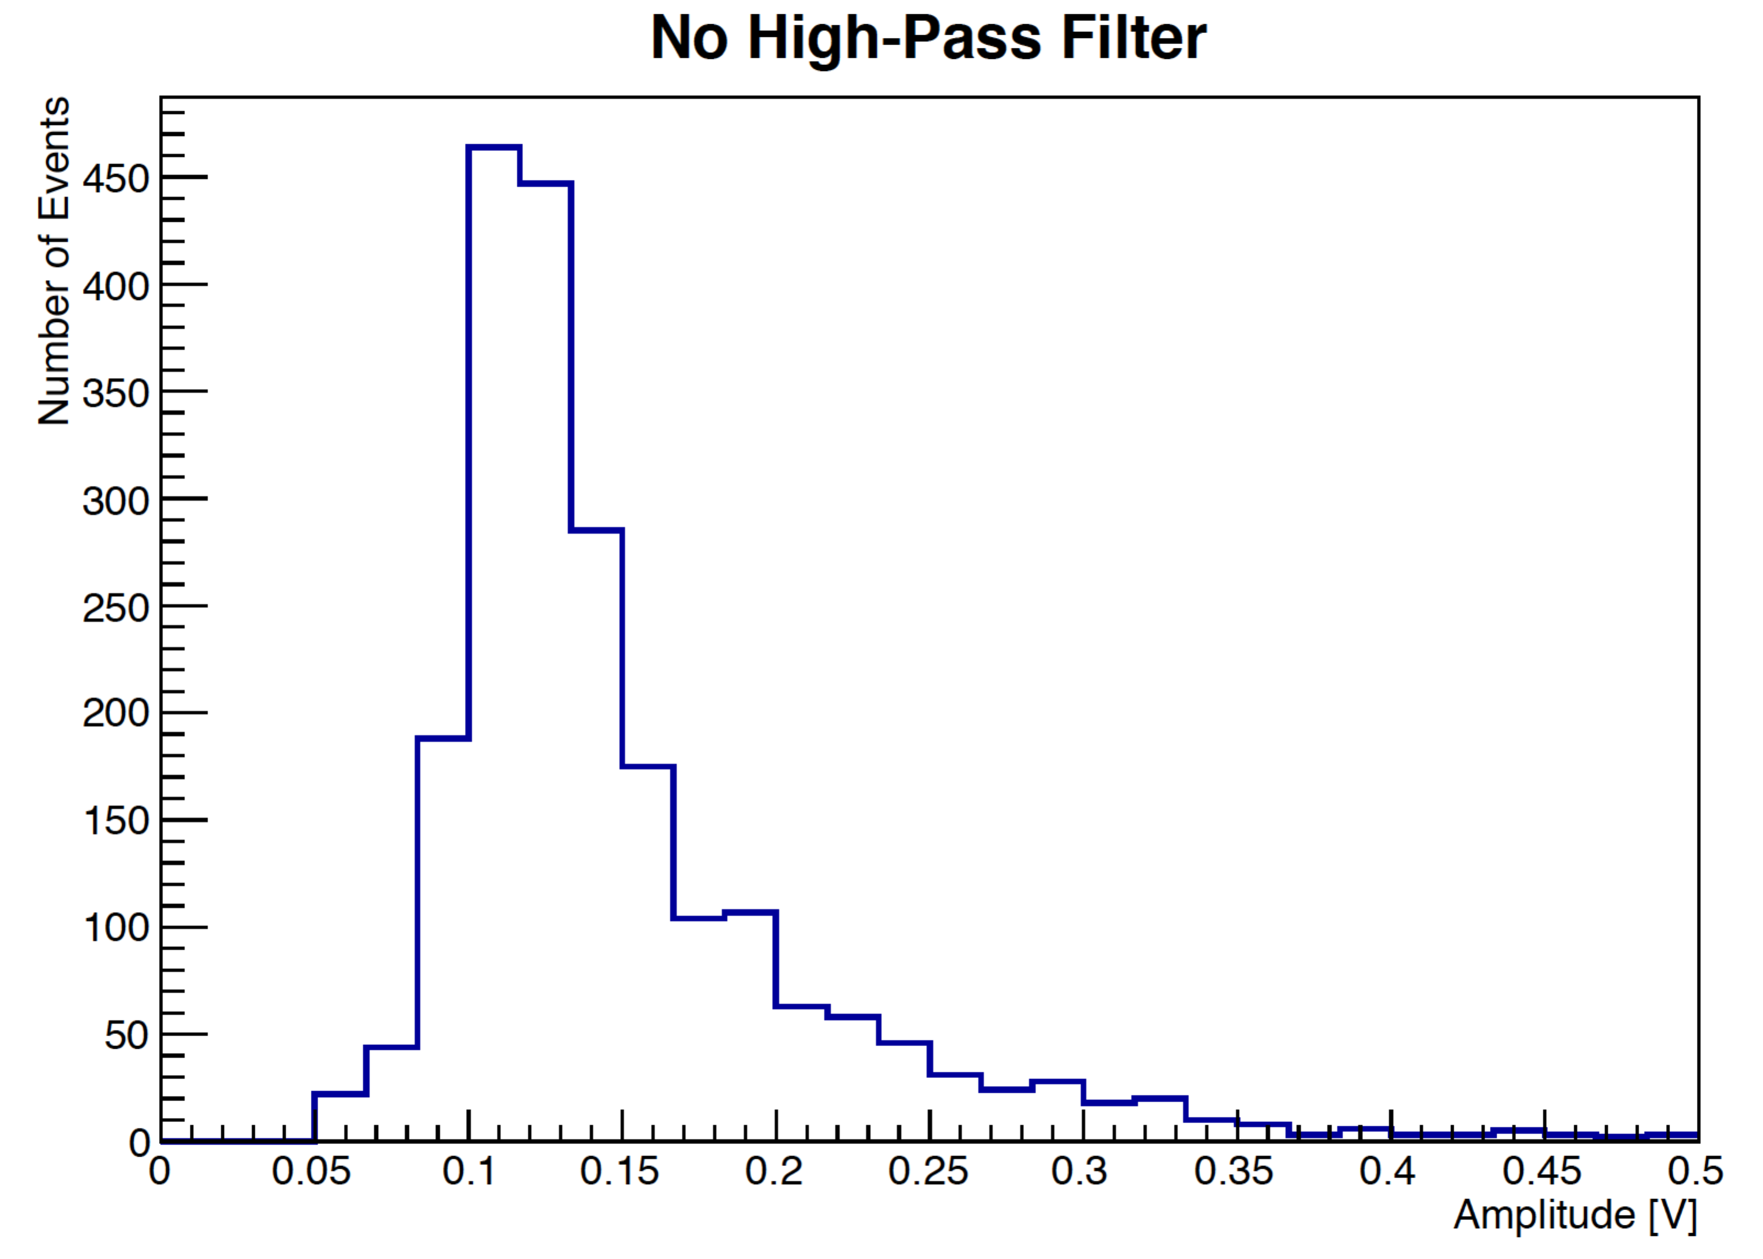
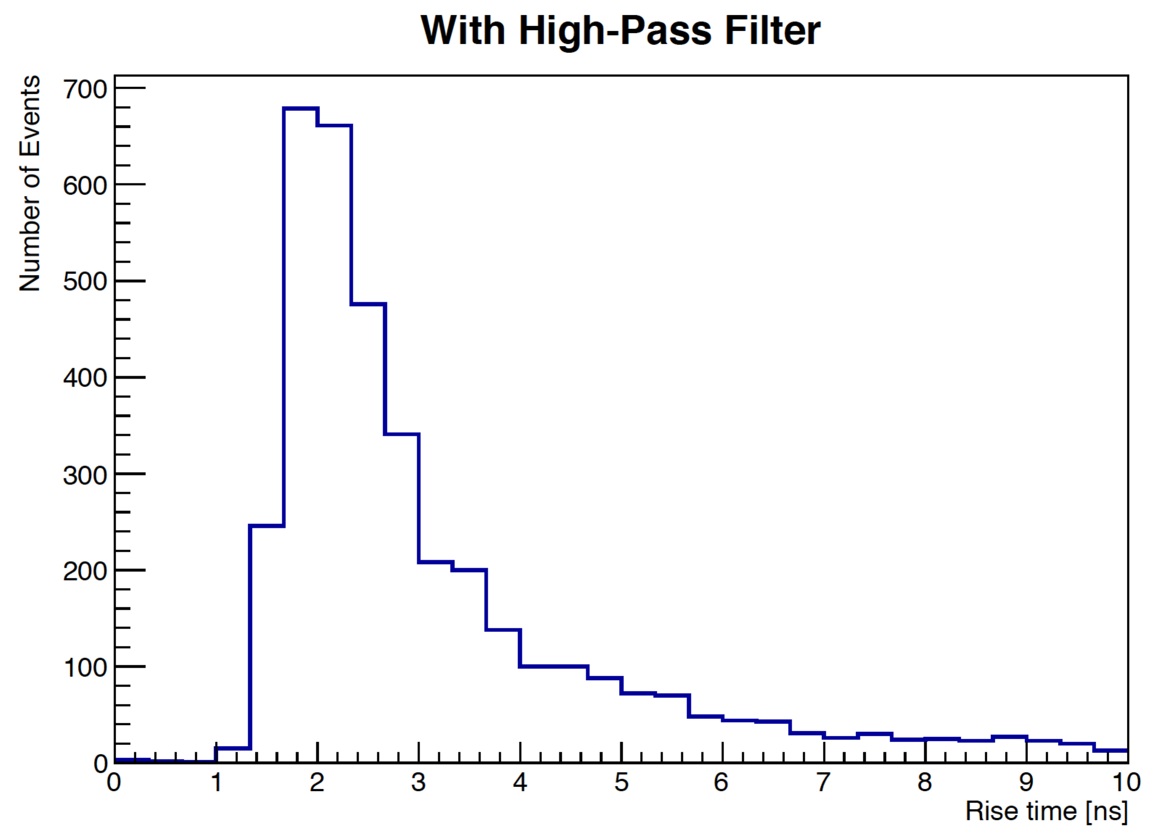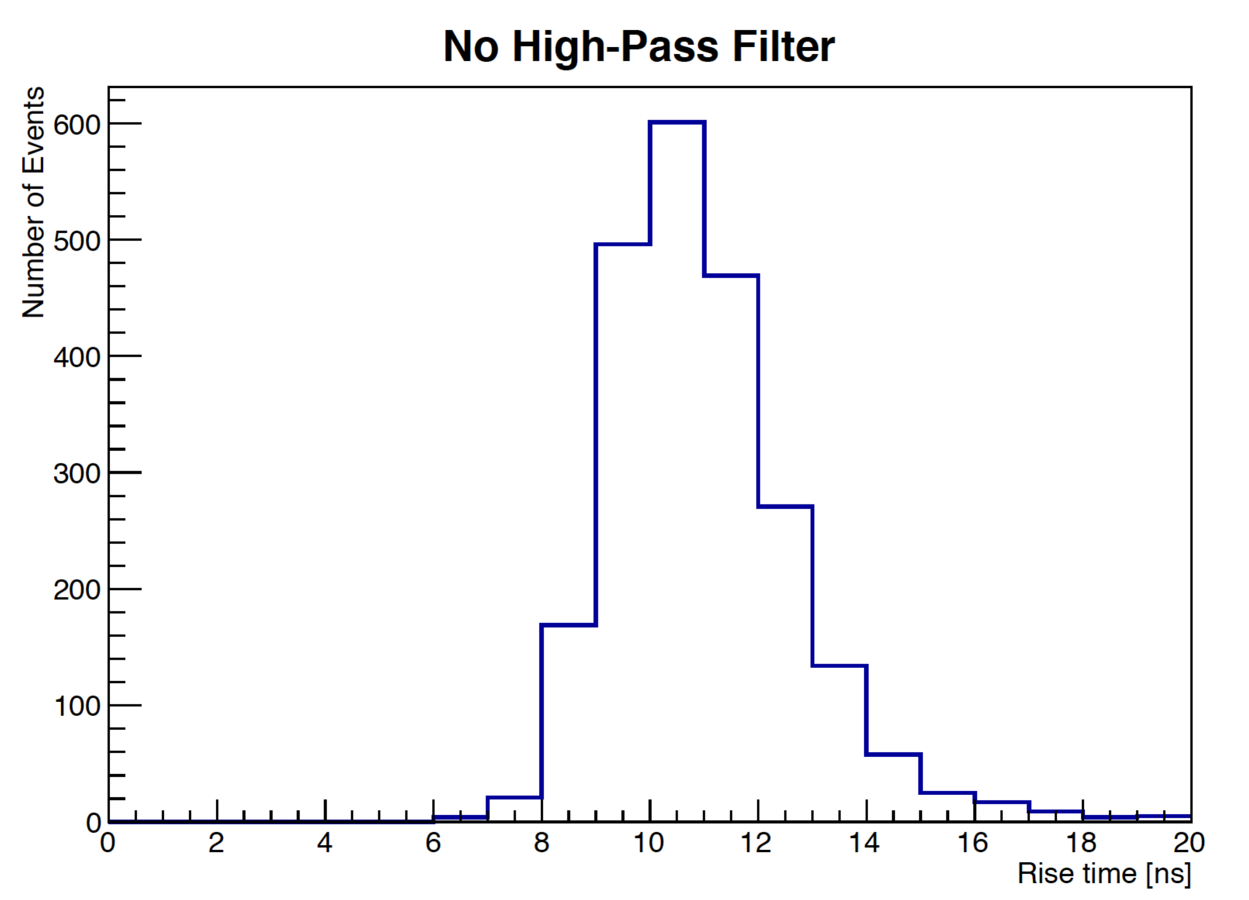

Issue 2:
OK, with sufficient prodding, the relevant details are finally coming out. I think more of the blue text needs to accompany the proffered green text, to make this situation clear to the reader.
We have added the following paragraph to explain this feature more explicitly:
The variation of signal amplitudes is due to variations in the operational gain
of the four SiPMs. As discussed in Section 3.2, each SiPM was operated as a bias voltage of 70 V. As the breakdown voltages for each SiPM varies slightly, the over-voltages also vary resulting in significant differences in gain. Furthermore, the SiPM-to-fiber coupling may not be perfectly identical, resulting in a small variation of light collection efficiency. The combination of these effects explains why the best time resolutions are achieved at different signal amplitudes in the four different channels.

Issue 3:
Again, these details are important. And I’m not convinced that the 5ns recharge time is the right number. It probably doesn’t matter in this case, but it should be given by the relevant RC, which should be much longer (depends upon actual pixel capacitance and quenching resistor details, but more like 100ns is typical for many of these devices).

We confirm that with a 100ns dead time per pixel, the resulting simulated rise time does not show a noticeable change.

I see the added Simulation plot (Fig 7), but Fig 6 looks to be the same, and doesn’t provide the measured risetime versus amplitude.

We have now added the risetime vs amplitude plot into the right side of Figure 6.

