Dear Editor,
We would like to thank the referees for reviewing our updated paper and producing second reports.
We have considered all comments, and we have applied several changes to the original version of the paper to address the issues raised. Detailed responses to all the comments can be found below. For ease of review, the original question is written in black font, the author response is written in blue font, and any modification to the paper draft is written in bolded green font.
We are at your disposal for any further clarifications and/or additional information.
Sincerely,
Si, Adi, Zhicai, Cristian, Maria

Reviewer #1:

15: "will result in very large amounts of simultaneous particle collisions (pileup) exceeding several
hundreds per bunch crossing."
is exaggerated and poorly written. Rewrite without exaggeration (200 is not several hundreds). p-p interactions, not particle collisions.
We have rewritten the sentence according to the reviewer’s suggestion:
With current accelerator and particle detector capabilities, such a high instantaneous luminosity will result in up to 200 simultaneous interactions (pileup) per bunch crossing.

16: "Therefore, the crucial ability to identify the origin of the particles produced at the different interaction points will be severely degraded"
This does not logically follow and is controversial. Higher pileup does not logically imply a reduced ability to measure verteces. In fact the new detectors will have higher vertex resolution than today. If you want to claim that track vertex reconstruction will have worse vertex performance at HL-LHC than today, you need to back that claim up with a reference that reaches that conclusion. Otherwise, the best you can do is say something like "The ability to associate the origin of particles with different interaction points is crucial to the physics program, and precision timing would provide a new tool for doing that, independently from track reconstruction"
We have rewritten the sentence according to the reviewer’s suggestion:
The ability to associate the origin of particles with different interaction points
is crucial to the physics program, and precision timing would provide a new tool for achieving it, independently from track reconstruction.

50: are widely used → are increasingly used
Done

59: spurious "i" at end of paragraph
Removed

62 and throughout the paper: replace "degrees Celsius" with oC
Done

74 delete: "at Caltech"
Done

115: remove redundant "as shown in Fig 1"
Done

136: the CERN beam line used and its composition have already been described before. The beam is not pure electrons and this sentence contradicts the previous, more detailed description.
We have added additional text in the detailed description near the beginning of the section:
Beam measurements were performed at the H4 beam-line of the CERN North-Area test-beam facility, which provides secondary beams of energies ranging between $20$~GeV and $400$~GeV. Electrons can be provided from tertiary beams up to $250$~GeV with acceptable efficiency. The beams are composed of a mixture of electrons and pions. The electron fraction in the beam is typically larger than $75\%$ and close to $100\%$ for beam energy above $100$~GeV.
And we have modified the later sentence to say:
We measure the timing performance of the calorimeter cell with high energy beams in a range between 20 GeV and 200 GeV. Selection cuts on the signal amplitude in the Shashlik cell
suppresses the pion contamination in the beam.

156-159 is redundant with the introduction
We have removed these sentences

161-165 is redundant with the introduction
We have modified the text as follows to reduce redundancy:
We present measurements of the timing performance for a
LYSO-based sampling calorimeter read out by wavelength-shifting light fibers connected to SiPMs and discuss the impact of
the intrinsic timing performance of SiPMs on the calorimeter timing measurement studied using light signals injected by a picosecond laser.

174: "but the amplitude at which this performance is achieved varies." Why? This needs to be explained. The simple model in which amplitude is proportional to the number of pixels fired suggests an amplitude ratio of 2.25 between 15um and 10um pixels (consistent with data) but an amplitude ratio of 2.8 between 25um and 15um pixels (too small by a factor of ~2 compared to data). How much of the SiPM does the fiber illuminate?

The fiber has a diameter of 1mm, so the SiPMs are not fully illuminated. Furthermore, the SiPMs were operated at the same bias voltage value, and because there is variance on the breakdown voltage of each SiPM, the operating gain of each SiPM was different. Due to limited beam time, we were not able to tune the bias voltages of each SiPM to the same gain in each channel. This is the main reason why the amplitudes of the four channels differ. We have added the following sentence to section 3.2 to discuss this aspect explicitly:

All four SiPMs were operated at a bias voltage of $70$~V, and due to the variance of breakdown voltages of the different SiPMs the operational gain was different for each channel.

181 and 194 missing period after reference
Fixed.

181: "The rise time of these signals are driven by the time constants of the wavelength shifter as demonstrated in reference"
This is not consistent with Fig. 6. There is a very clear difference between the 25um pixel 3mm SIPM's and all others in this figure. That can have nothing to do with scintillator rise time. Please explain where the difference comes from.

Indeed, the previous description was confusing to read as we were mixing up descriptions of the previous experiment from reference [4] and the results of the new measurement. We have rewritten this paragraph in order to improve the clarity:
In our previous study [4] that used MCPs as photodetectors, the rise time was measured to be about 3.0 ns and did not have any dependence on the signal amplitude. The very fast rise time of less than 150 ps of the MCP and its signal amplitude linearity implied that the rise time was dominated by the time constant of the wavelength shifter. In contrast, for the data presented here using SiPMs as photodetectors, we observe that the rise time varies between 1.4 ns and 6 ns. We attribute this effect to the fact that there are so many scintillation photons reaching the SiPM that the signal is in the non-linear saturation regime of the SiPM. As a result the signal appears to reach its maximum faster. This effect is reproduced by a simple simulation where we take a scintillation light pulse with a rise time of 3 ns impinging upon a 1x1 mm2 SiPM with 10 μm pixel size and simulate a dead time of 5 ns for each pixel. The resulting rise time as a function of light input is shown in Figure 7, and shows a decreasing rise time as the amount of light increases.

The 3x3mm SiPM with 25micron pixel size behaves differently because the capacitance for the high pass filter was different from the other channels. This resulted in a signal with larger amplitude but slower rise time, and explains why the trend of this channel is significantly different from the other channels. We have added this sentence in the text to explain this fact:
The capacitance of the high-pass filter for the 3x3 mm² SiPM with 25μm pixel size is significantly larger than the capacitance for the other three SiPMs, resulting in signals with larger amplitude but also larger rise time.

Fig. 6: How was figure 6 made? The data were simply divided in bins of rise time and the time resolution measured for each bin? Please add explanation.
Each data point shows the mean rise time for a dataset with given beam energy. We have added the following to the text:
Each data point corresponds
to a measurement of mean risetime for datasets taken using different beam energy.

188: "Additionally, we find that the rise time decreases with increasing amplitude"
How? Which figure shows this? What is the functional form of the rise time decrease with amplitude and does it then predict Fig. 5, since we know from fig. 6 that resolution is linear with rise time?

The paragraph has been rewritten (see above) and we no longer say this sentence. Nevertheless, this feature can be seen by looking at Fig. 5 and Fig.6 together and correlating together the different points as they correspond to the same datasets taken at different beam energy. To be explicit, a plot of the risetime vs amplitude is shown below for the reviewer, along with the simulation result. We see that the functional form of this dependence is roughly reproduced by the simulation.

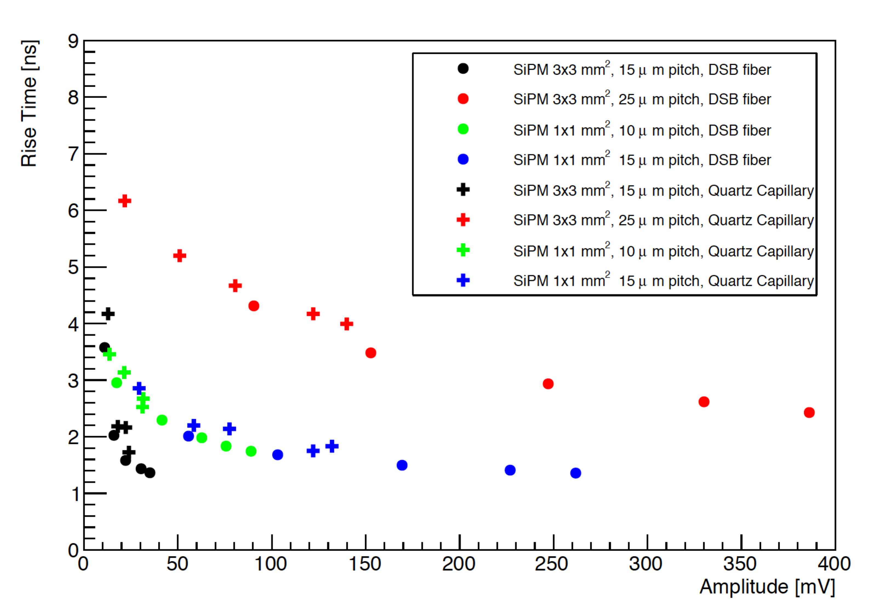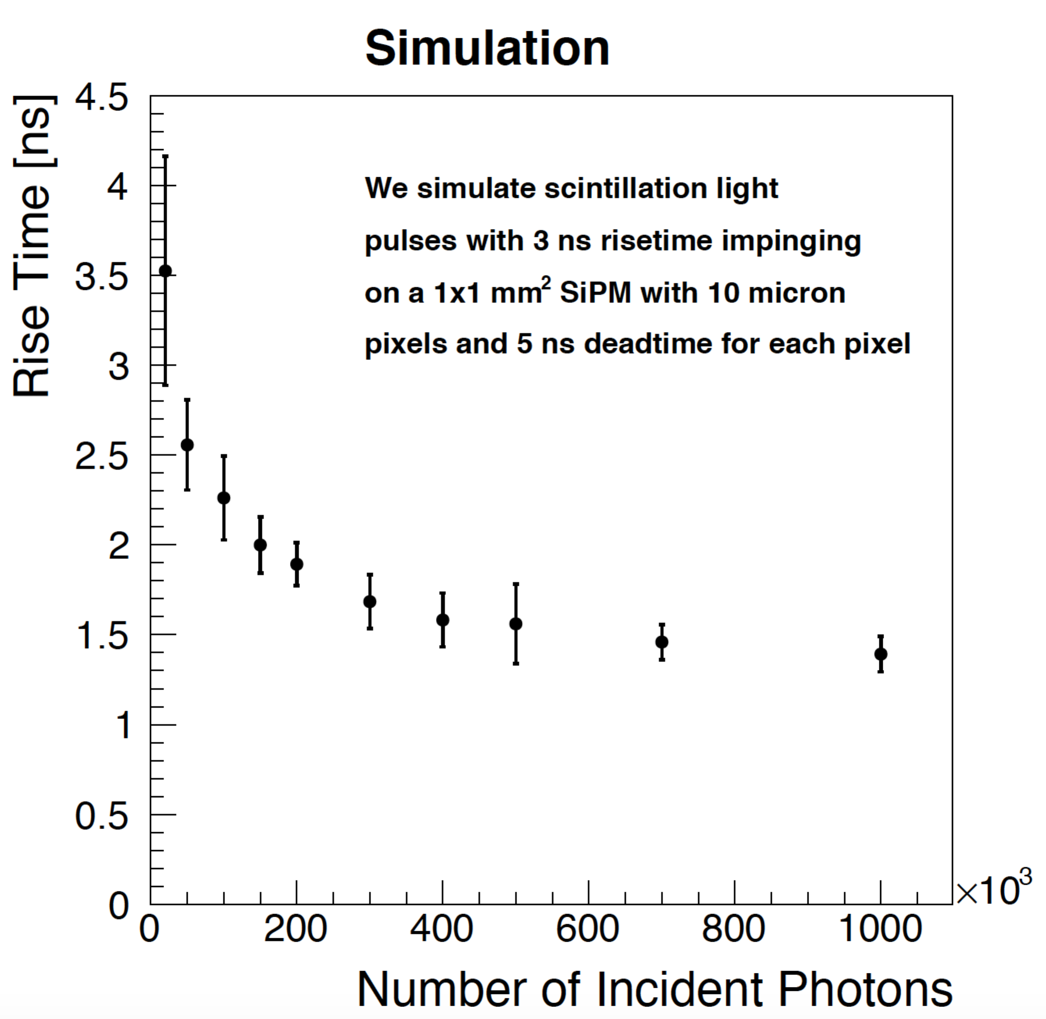

As a general rule of thumb, the time resolution is roughly proportional to rise time / (signal/noise). Based on the measurements of rise time and time resolution from Fig 5, we see that the time resolution is independently (at least partially) impacted by the decrease in risetime and the increase in amplitude. For example, for the black points in Fig.5 we see an increase in amplitude by a factor of 3, while the time resolution decreases by a factor of 5. The remaining effect is attributed to the additional effect of a decreasing rise time.

201: this sentence should go in parentheses and not be a new paragraph. Also remove "We should add".
Fixed

215: Why were these 2 specific devices chosen?
We have added the following to the text:
These two devices capture the impact due to differences
in the pixel pitch size and the total area.

216: The waveforms shown look very similar- same width, same amplitude. Yet fig. 6 shows that for same amplitude these devices have quite different time resolution. Why is that?

The waveforms shown here are taken from a setup where a fast laser pulse is directly shining onto the sensitive surface of the SiPM, while in Fig. 6 the signal comes from scintillation light from ionization in LYSO. The pulse shapes for these two situations are very different because in the case of ionization in LYSO, the resulting final pulse is the convolution of the scintillation light pulse with the electrical response pulse of the SiPM. In the case of the laser setup, the laser light pulse is so fast that it has no impact on the final pulse shape and all we see is the electrical pulse from the SiPM.

Fig. 9 caption does not say which part number is which subfigure.
We have modified the caption to say:
Digitized waveforms of the signals from the PiLas laser
in the S12571-015P (left) and S12572-25C (right) SiPMs.

218: "signal size" so far has referred to SiPM output. However, here it refers to light input. Perhaps it would be better to use different terms for signal output and light input.
The text has been changed from “signal size” to “input light intensity”

Fig. 10: which SiPM? It would be good to have the spectrum for a dark SiPM to be able to see the dark count and after-pulse pe peaks. From the right side figure it is clear that there are 0, 1, and 2 pe peaks from dark counts. In the left hand figure the light is too low to distinguish the dark count contribution.
The caption has been changed to:
The distribution of integrated charge from the S12571-015P SiPM sensor for data taken with …
With Fig 10, we intended to demonstrate our ability to control the input light intensity for the time resolution measurements. For the dark counts and after-pulsing properties of this type of SiPM, one can refer to reference JINST 10 (2015) no.10, P10031 where a larger area version of the S12571 MPPC was used.

226: "As the number of photons impinging on the SiPM can be clearly distinguished based on the amplitude or charge collected".
No, the number of photoelectrons can be clearly seen; the number of impinging photons cannot. A calibration should be done to get the response vs number of photons.
We intended to say photoelectrons rather than incident photons. We have changed the sentence as follows:
As the number of photoelectrons detected can be clearly distinguished
based on the amplitude or charge collected, we can study the dependence of the time resolution on the number of photoelectrons

228: The functional fit of Fig. 10 should be explained in the text, not the caption, and the actual function used given. The single photon, not single phtotoelectron, signal amplitude should be given.
We have moved the following sentence from the caption into the main text:
The data points are fitted to a functional form that includes a 1/N term to model the electronic noise, and a 1/\sqrt{N} stochastic term.
As we are comparing the number of photoelectrons from this plot with the number of photoelectrons in the plot for the calorimeter data in Fig 5, using the measured amplitude for a single photoelectron, it is better to continue to use the number of photoelectrons.

Sections 5 and 6: there is some overlap and redundancy between these 2 short sections. Why not combine them into a single conclusion section. Should add a statement about which one of the SiPM's tested is more suitable and/or what are the trade-offs between the devices.

We have combined the two sections into a single section called “Discussion and Summary” as you suggested. We have also added the following sentence concerning the choice of SiPMs:
As the time resolution performance is driven primarily by the
signal-to-noise ratio, SiPMs with larger gain, larger quantum efficiency, and higher light collection efficiency are preferred. Of those we tested, the SiPMs with larger pixel sizes achieved better time resolution as their gain are larger and they have better light collection efficiency due to reduced amount of insensitive area in between pixels.

Reviewer #2:

Generally most of the issues raised have been addressed, modulo specific comments below.

Specific comments:

1) the English is still rough in places, and there are typographical errors. Three examples:

a) Abstract
i) few 10 ps --> few 10's of ps.
Done

ii) initial rise of the scintillator --> initial risetime of the scintillator
Done

iii) silicon photomultipliers as sensors --> silicon photomultipliers as photosensors
Done

b) lines 20 and 23, the double dashes are very odd and not standard symbolical representation of a range span between the two numbers bracketed
This was a latex syntax mistake. We have fixed it now.

c) line 59 there is an orphan 'i' to end the line(?)
This ‘i’ has been removed.

d) The capitalization of acronyms and pseudo-acronyms is all over the place. For instance mostly SiPM, but SIPM in at least one place, and the Biblio has lyso versus LYSO (standard) in the text.
The capitalization issues in the bibliography has been corrected. We checked that we use “SiPM” consistently throughout the text now.

2) While CMS calorimeter is referred to, it seems more appropriate to reference (page 2, beginning of Section 2) the ground-breaking work of CALICE in using SiPMs for PFA calorimetry.
We have added a reference to the CALICE paper on the AHCAL with SiPM readout.

3) Previously raised points (those unmentioned have been adequately resolved):

R5) I still strongly object to characterizing this high-pass filter as a "clipping" circuit. It is not, as that term has 2 technical definitions in English:
1) a clip line, where the signal is physically shorted, such that the reflected signal cancels itself, creating a potentially very short signal (sub-ns or even shorter, depending upon the length of the clip line)
2) a diode/semiconductor circuit that limits the pulse, clipping its amplitude.

It is a high pass circuit, just leave it at that. And I would point out that it only works as a well defined HP circuit for a low value (low compared with R2) of resistance to the right of X1 and not shown in this schematic.

The text has been changed as follows:
The high-pass filter is used to decrease the rise-time of signal
pulses by removing low-frequency components of the signal pulse. As a consequence, the resulting signal pulse will be smaller in amplitude and will have a faster rise-time.

R8) The explanation given is too vague and does not adequately address the objection raised. Please argue quantitatively. As stated this reviewer is not persuaded.
The amplitudes for the different SiPMs (different colors) presented in Fig 5 differ primarily because the SiPMs were operated at different gain. The bias voltage for all SiPMs were set to the same value of 70V. However, the breakdown voltage for the different SiPMs are different, and therefore they were operated at different levels of overvoltage. That results in the different amplitudes that are observed. Due to limited beam time, we were not able to tune the bias voltages of each SiPM to have the same gain in each channel. This is the main reason why the amplitudes of the four channels differ. We have added the following sentence to section 3.2 to discuss this aspect explicitly:

All four SiPMs were operated at a bias voltage of $70$~V, and due to the variance of breakdown voltages of the different SiPMs the operational gain was different for each channel.

R9) Similarly, what specifically has been done to "reproduce this observation with a simplified simulation of the SiPM saturation effect." Please use numbers and measurement details.

We have simulated a scenario where scintillation light impinges on SiPM pixels whose normal electrical response would be a pulse with risetime of 3ns. We then assume a deadtime of 5ns for each individual SiPM pixel, such that if a photon hit that pixel, it would be unresponsive for the next 5ns. A full pulse is modeled by superimposing N number of such incident photons on the SiPM. We observed from the simulation that as N is increased beyond the total number of pixels in the SiPM, the apparent risetime of the resulting pulse decreases following a shape similar to what we observe in the data.

We have added plots of the risetime vs amplitude and the simulation study in the new version of the paper. Figures 6 and 7, respectively.

