Dear Editor,
We would like to thank the referees for reviewing this paper and producing the reports.
We have considered all comments, and we have applied several changes to the original version of the paper to address the issues raised. Detailed responses to all the comments can be found below.
We are at your disposal for any further clarifications and/or additional information.
Sincerely,
Si, Adi, Zhicai, Cristian, Maria

Referee 1

Line 31 - sensitive should be sensitivity

A: Fixed according to reviewer’s suggestion.

Line 47-48 "..Cadmium-Telluride has been studied since many decays, particularly in the the .." instead .."Cadmium-Telluride has been studied for many decays, particular in the .."

A: Fixed according to reviewer’s suggestion.

Figure 1 caption, second sentence "The baseplate is is …"

A: Fixed. The duplicate “is” word has been removed.

Lines 81-86 - stick with a single tense instead of changing tense from sentence to sentence

A: We have changed the tense of the following sentence so that the same tense is used throughout the paragraph:
The signals from the CdTe sensor are amplified using a Hamamatsu C5594 amplifier with a bandwidth of 1.5 GHz and providing a voltage gain of 36 dB.

Line 176 - energies below 50 GeV; I think this should be energies above 50 GeV

A: Here we are pointing out that for data points from 2 GeV to 50 GeV, the time resolution improves as the energy increases. For data points above 100 GeV, the time resolution no longer improves. We have modified the sentence to make that point more clear:
For beam energies between 2 GeV and 50 GeV, the time resolution improves with increasing signal size as expected based on the increasing signal-to-noise ratio.

Finally, figures 12a and 13a & 13b are 2-d color coded maps which may be confusing in B&W

A: We understand the concern of the reviewer, however it is difficult to convey the information in the 3rd dimension without using colors.

Referee 2

Abstract: However, their sensitivity to photons, which comprise a large fraction of the electromagnetic shower, is limited. A large fraction of the energy in an electromagnetic shower is carried by photons. SECOND SENTENCE IS REPETITIVE.

A: The second sentence has been removed following the reviewer’s suggestion.

L28-30: Authors cite a significant gain due to being sensitive to X-ray part of the EM shower. How much energy of a typical EM shower in a collider experiment is carried by X-rays? What is the improvement expected from being sensitive to X-ray part of the spectrum? Knowledge of the photon spectrum is critical in deciding whether this technology is expected to bring significant improvements to the calorimeters, or will be of marginal gain?

A: In Fig ?? of Reference [], we observe that for shower particles with energy above 1.5 MeV, there are roughly 7 times more photons than electrons. On the other hand, the amount of energy lost through ionization of charged particles traversing the sensor material and the energy lost by photons are not the same, and may depend on details of the interations with the specific material. Therefore without a detailed simulation study, it is difficult to provide a rough quantitative estimate of the impact of the photons on the total signal size. We intend to follow up with detailed simulation studies as well as follow up testbeam studies to provide a more clear quantitative answer to this important question (see a more detailed discussion on the future plans to a question below). However, we do know that the signal size is larger due to larger ionization yield ( factor of 5/3 over silicon sensors ) and the capability to use significantly thicker sensors ( 1cm vs 300 micron for conventional silicon sensors), and these aspects already improve signal to noise and time resolution over silicon based calorimeters.

L20-37: what is known about the radiation tolerance of CdTe sensors? Please cite any measurements if there are knowns ones in the literature. Naturally, this question is of paramount importance to any future collider detector development.

A:
Polycrystalline sensors have been tested for application in LHC, see reference [20]
E. Rossa et al., “Fast Polycrystalline-CdTe Detector for LHC Luminosity Measurements" CERN-SL-2002-002 BI, 2002.
Monocrystalline sensors have not been tested up to high doses. We intend to do this. The radiation hardness will crucially depend on the purity of the crystals, as it is known from scintillating crystals.

L31: sensitivity.

A: Fixed according to reviewer’s suggestion.

L47: haVe been studied.

A: Fixed according to reviewer’s suggestion.

L57: Give a quantitative measure of the "abundance of photons in EM showers".

A: We have modified the following text to clarify this aspect:
Photons secondaries are abundant in electromagnetic showers.
Reference [XX] shows that for shower secondaries with energy over $1$~MeV, there are $6$ to $7$ times more photons than electrons. The fractional shower energy carried by photons will further depend on the location in the shower and the exact material distribution in the vicinity of the sensor. We envision more detailed studies to investigate this further.

Reference to be added :
[XX] J. Beringer et al. (Particle Data Group), Phys. Rev. D86, 010001 (2012).

Fig 1 caption: "The baseplate is is biased" extra IS.

A: Fixed.

L73-78: why were two different beam lines used? Clarify which experimental programs were carried out at each beam lines, since in the following it becomes confusing at places.

A: The two beamlines provide beams with different ranges of energies. We have modified to text to clarify why the two different beamlines are used.:

We performed the measurements at the T9 beamline of the CERN East-Area testbeam facility and the H2 beamline of the CERN North-Area testbeam facility. The T9 beamline provides secondary beams of energies ranging between 0.5 GeV and 10 GeV based on the primary proton beam source from the Proton Synchrotron (PS), while the H2 beamline provides secondary beams of energies ranging between 20 GeV and 400 GeV based on the primary proton beam source from the Super Proton Synchrotron (SPS).

L84: what is the distance of the CdTe from the front face of the copper box? I.e. what is the total distance of the face of the CdTe detector from the back of the absorber?

A: It is about 3mm from the front face. We have added this to the text.
The sensor was placed in a box made of 0.3 mm thick copper sheets and located about 3 mm away from the front face of the copper box.

L96-98: Clarify how you use the LYSO crystal to discriminate electrons from pions, what is the efficiency of this method, and how you measured this efficiency.

A: The electrons will produce electromagnetic shower secondaries which will produce scintillation photons in LYSO, while pions do not. We have added the following text to clarify this issue to the reader:

The LYSO cube is about 1.7 cm thick, corresponding to about 1.5 radiation length. It is placed behind the reference counter, CdTe sensor and the additional absorber of about 2 radiation lengths. In the energy range between 2 and 7 GeV the LYSO is placed close to the shower max while the pions will interact very little. The signal size in the LYSO allows a reliable identification of electrons. A cross check with a Cherenkov counter is shown below (top right plot). In addition the signal in the CdTe sensor of residual pions in the sample is very small.

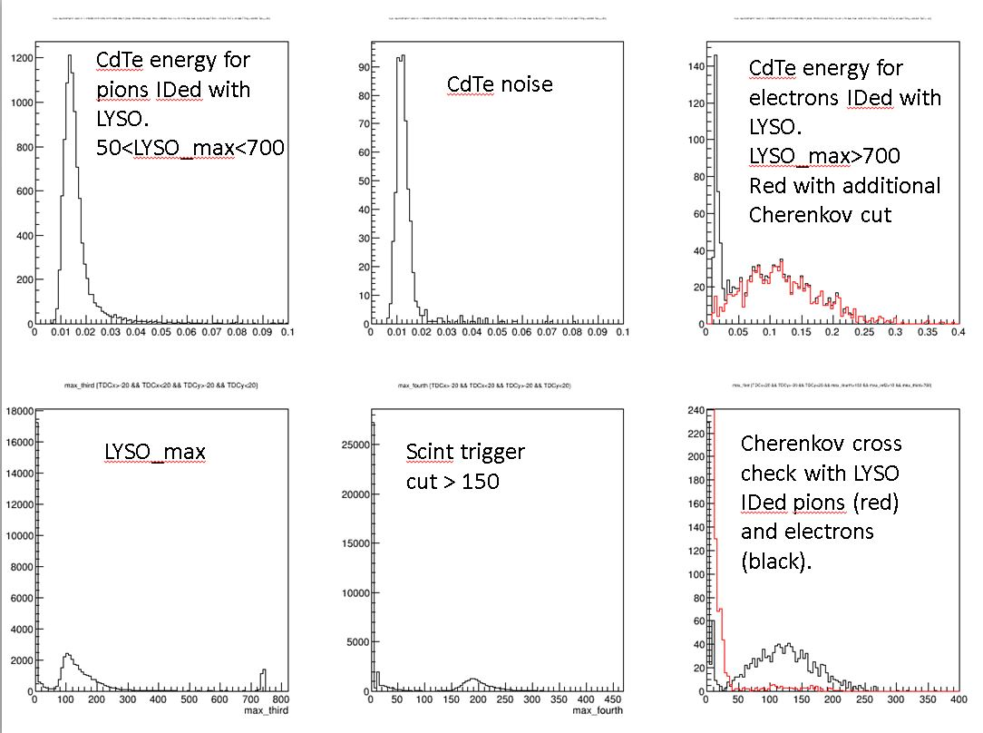

L103-107, and Figure 5: clarify which absorber (lead or tungsten) were used here? Are these plots consistent with the expected Moliere radius of your setup? Is there any simulations to compare with the measurements?

A: We have added clarification in the text that tungsten absorber is used here. This profile is the result of a convolution of the shower profile (moliere radius) with the sensitive area of the CdTe sensor. The moliere radius for tungsten is 0.93cm, and the sensor is 1 cm by 1cm, so we believe the plot is consistent with those parameters. We certainly intend to follow up with detailed simulation studies, but we have not completed it yet and therefore leave it to future work. The following text has been modified in the draft:
In Figure 5, we show the average amplitude measured in the
CdTe sensor after 6 radiation lengths of tungsten absorber
as a function of the horizontal and vertical positions as measured by the wire chamber.

L117: "ns time windown" extra N. "n CdTe is know" —> knowN

A: Fixed according to reviewer’s suggestion.

L118: Figure 4 of the cited reference shows examples pulse shapes from a similar CdTe detector, and pulses shapes are much shorter than those in your Figure 6. Given that fast signals are desired for future colliders, do you understand this long tail? Is the fraction of signal collected in the tail dependent on the impinging electrons energy?

A: The cited reference studies pulse shapes using the transient current technique (TCT) with alpha particles from an Americium 241. These alpha particles have a short range in the sensor material and the full signal is generated very close to one electrode. Therefore they are able to isolate the pulse shape from the electrons alone (shown in their Fig 4), while suppressing the signal component from holes. In our case the signal is generated all along the trajectory of the secondary shower particles as it traverses the sensor material, and therefore we observe both the electron component as well as the hole component. The fraction of signal carried by the longer hole component does not appear to depend the energy of the incident electron. Therefore, the energy measurement can likely be extracted from the electron component of the pulse shape. However, we do intend to follow up with more detailed future studies addressing this specific question. We have modified the text as follows in order to clarify this issue for the reader:

The relative size of the two signal components are observed to be independent of the energy of the incident electron, and therefore its energy may be determined from the fast component alone Si: check if the pulse shape really is the same for all energies

L131-148: again, unclear why you used two beam lines of electron beams. Clarify what the differences are, and what advantages each of them beam lines brings.

A: We have added the explanation at the beginning of Section 3 – see answer to above question. The reason is because the beamlines provide different ranges of beam energies.

Figure 7: Second sentence of the caption has many grammatical errors and typos, making it incomprehensible.

A: We have fixed this caption text as follows:
For the right plot, electrons are required to be within a 3~$\times$~3~mm area centered on the sensor. The accuracy of the wire chamber position measurement for the left plot was insufficient to make such a requirement.

L150: Was a MIP calibration performed, can you measure a MIP signal? What is the expected signal-to-noise ratio for MIP signals?

A: We attempted to do a MIP calibration but were not successful at the end because the noise level was a bit too high. The signal to noise ratio for a MIP signal was calculated to be approximately 1:1 and unfortunately we were not successful at isolating the MIP signal. This is something that we would like to achieve on future work, either by reducing the noise level or by using thicker sensors.

Figure 8: at least on my PDF version there is no red line in these figures.

A: We have removed the text in the caption referring to the red line.

L150-169: this is one of the most important sections of this study, but I was puzzled that authors do not mention anything regarding the expected improvement of the response due to the sensitivity to photons. Is there any statement you can make here whether or not the device is shown to bring in sensitivity to the X-ray components of the EM showers, and if yes, how much is it? Can it be estimated what fraction of the signal in Figure 7 is due to MIPs in the shower, and therefore deduce the amount of the X-ray components? Or simulation comparisons?

A: The present study did not produce sufficiently clear quantitative evidence of the impact of the photons on the signal size, and therefore we did not make an explicit conclusion on that aspect. This is indeed a very important aspect and we intend to produce clear quantitative evidence in follow up studies. Several improvements are envisioned for the follow up study including: 1) reduction of noise in order to perform a MIP calibration for the CdTe sensor, 2) simultaneous sampling of the EM shower by a layer of silicon placed immediately adjacent to the CdTe sensor to obtain an event-by-event comparison of the signal size, and 3) detailed simulation studies. Any of these approaches could produce quantitatively clear evidence of sensitivity to shower photons.

Nevertheless, we believe that the present results – even absent the quantitative evidence of the impact of shower photons – do already demonstrate larger signal size compared to conventional silicon based sensors ( due to larger ionization energy and the possibility for thicker sensors ) and produces results with excellent time resolution.

Fig 13: Is the inversion of the direction of the DeltaT around 4mm on the left plot understood? One would expect that this difference would keep increasing the farther the beam moves. Similar for the right plot.

A: We do not yet understand this inversion behavior. At the location of the inversion, the beam moves past the one edge of the sensor. However at the other end of the sensor, we do not observe the same behavior. Understanding the exact mechanism for this feature will require more detailed follow up study.

I would also recommend the introduction paragraph be rewritten for clarity to a broader community. The text currently seems to be written for LHC readers. I didn't find a description of acronym LHC and in the first few sentences, the words pileup, bunch crossing, interaction point, beam bunch profile are used as a justification for interest in this research.

A: Adi tries to re-write the intro.

