L96-98: Clarify how you use the LYSO crystal to discriminate electrons from pions, what is the efficiency of this method, and how you measured this efficiency.

A: The electrons will produce electromagnetic shower secondaries which will produce scintillation photons in LYSO, while pions do not. We have added the following text to clarify this issue to the reader:

The LYSO cube is about 1.7 cm thick, corresponding to about 1.5 radiation length. It is placed behind the reference counter, CdTe sensor and the additional absorber of about 2 radiation lengths. In the energy range between 2 and 7 GeV the LYSO is placed close to the shower max while the pions will interact very little. The signal size in the LYSO allows a reliable identification of electrons. A cross check with a Cherenkov counter is shown below (top right plot). In addition the signal in the CdTe sensor of residual pions in the sample is very small.

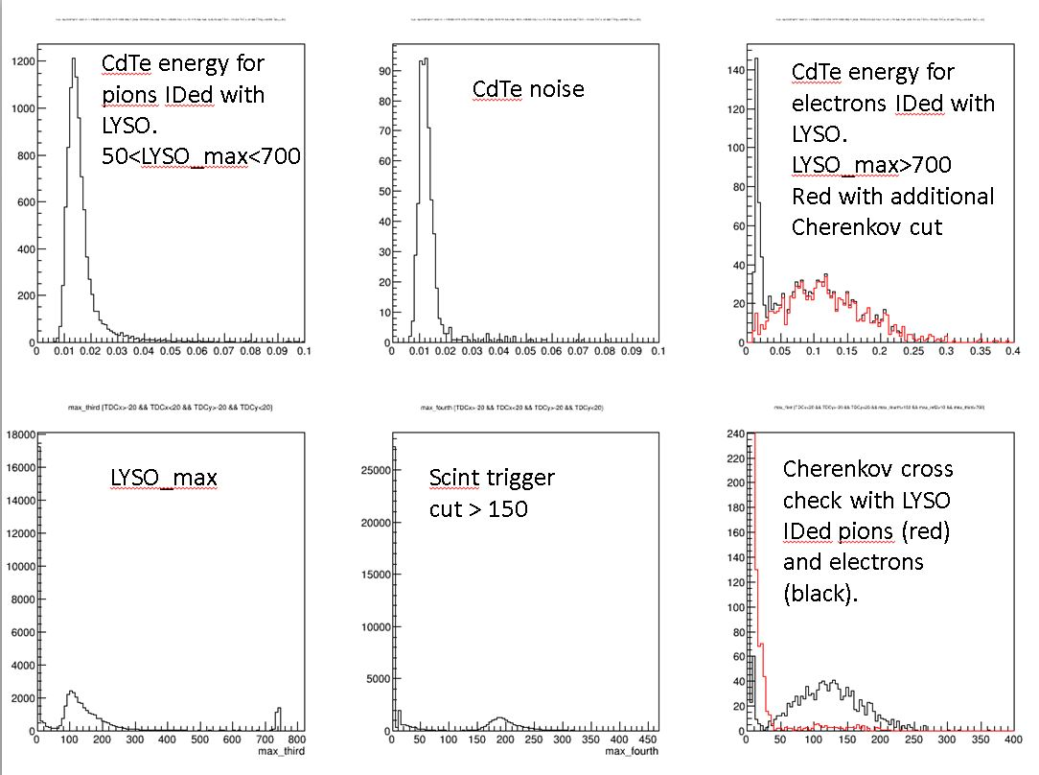

Si: I believe the bottom right plot measures the efficiency of the LYSO ID method. If we make a cut near 50 on the x-axis (which would eliminate most of the pions in red), then the efficiency looks to be close ot 95% - if I ignore the cases where there so no signal at all. My guess is that those events (maybe they geometrically missed the sensor and LYSO entirely) also make no signal in the CdTe sensor and are therefore cut out entirely.

