# Testing & Evidence – Step1

## Junit

### RecommendationsTest

*/*  
 * CS251 Programming  
 * Year 2, term 3  
 *  
 * Coursework Project 2020/21  
 * by nfb19202 - Calum Doughty  
 *  
 */*import *org.junit.jupiter.api.Test*;  
  
import static *org.junit.jupiter.api.Assertions*.*;  
  
class *RecommendationsTest* {  
 *Recommendations* reco = new Recommendations();  
 *Ride* ride = new Ride();  
 */*  
 name = "Testing";  
 typeOfHeight = 1; ">"  
 anotherTypeOfHeight = 0;  
 heightMax = 3;  
 heightMin = 2;  
 wheelchair = true;  
 groupMax = 4;  
 groupMin = 2;  
 theme = 1;  
 adrenaline = true;  
 horror = true;  
 kids = true;  
 water = true;  
 */  
  
 @Test* void suitabilityTest() {  
 }  
  
 *//check that this method changes String values to boolean  
 @Test* void changeToBooleanTest(){  
  
 boolean holder = reco.changeToBoolean("Y");  
 *assertTrue*(holder);  
  
 holder = reco.changeToBoolean("N");  
 *assertFalse*(holder);  
 }  
  
 *//check to see if the group check functionality works  
 @Test* void groupCheckTest(){  
  
 boolean holder = reco.*GroupCheck*(ride, 4);  
 *assertTrue*(holder);  
  
 holder = reco.*GroupCheck*(ride, 7);  
 *assertFalse*(holder);  
 }  
  
 *//check to see if the height check functionality works  
 @Test* void heightCheckTest(){  
  
 boolean holder = reco.*HeightCheck*(2.7, ride);  
 *assertTrue*(holder);  
  
 holder = reco.*HeightCheck*(1.7, ride);  
 *assertFalse*(holder);  
 }  
  
}

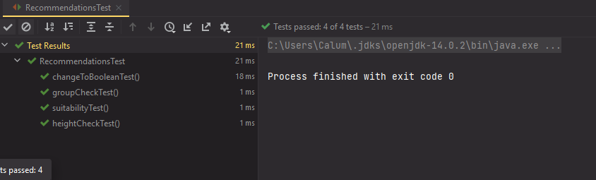

### VisitorTest

*/*  
 * CS251 Programming  
 * Year 2, term 3  
 *  
 * Coursework Project 2020/21  
 * by nfb19202 - Calum Doughty  
 *  
 */*import *org.junit.jupiter.api.Test*;  
  
import static *org.junit.jupiter.api.Assertions*.*;  
  
class *VisitorsTest* {  
  
 *@Test* void visitorCreateTest(){  
 *//Visitors(double height, boolean child, boolean heightPass, Boolean wheelchairQ, Boolean kidsQ, Boolean waterQ, Boolean horrorQ, Boolean adrenalineQ)  
 Visitors* visitor = new Visitors(1.3, true, false, true, true, true, true, true);  
  
 *assertEquals*(visitor.getHeight(), 1.3);  
 *assertTrue*(visitor.isChild());  
 visitor.setChild(false);  
 *assertFalse*(visitor.isChild());  
 }  
  
}

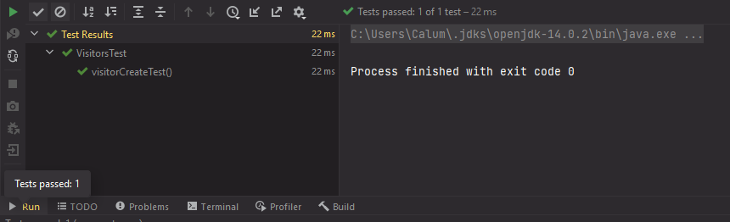

### RideTest

*/*  
 * CS251 Programming  
 * Year 2, term 3  
 *  
 * Coursework Project 2020/21  
 * by nfb19202 - Calum Doughty  
 *  
 */*import *org.junit.jupiter.api.Test*;  
  
import static *org.junit.jupiter.api.Assertions*.*;  
  
class *RideTest* {  
  
 *@Test* void rideDefaultTest(){  
 *//Ride(String name, int typeOfHeight, int anotherTypeOfHeight, double heightMax, double heightMin, boolean wheelchair, int groupMax, int groupMin, int theme, boolean adrenaline, boolean horror, boolean kids, boolean water)  
 Ride* ride = new Ride();  
  
 *assertEquals*(ride.getName(), "Testing");  
 *assertNotEquals*(ride.getTheme(), 2); *//actual = 1* }  
  
 *@Test* void rideCreateTest(){  
 *//Ride(String name, int typeOfHeight, int anotherTypeOfHeight, double heightMax, double heightMin, boolean wheelchair, int groupMax, int groupMin, int theme, boolean adrenaline, boolean horror, boolean kids, boolean water)  
 Ride* ride = new Ride("Tester", 1, 0, 0, 0, true, 0, 0, 1, false, true, false, true);  
  
 *assertEquals*(ride.getHeightMin(), 0);  
  
 }  
}

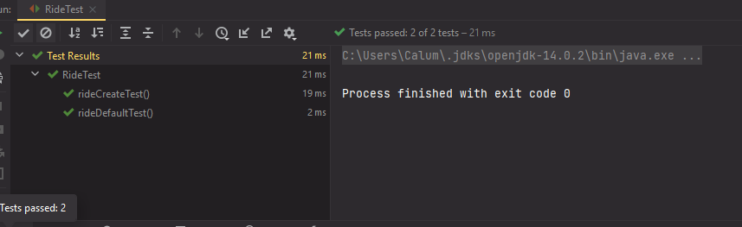

## Data outputs

false menu input

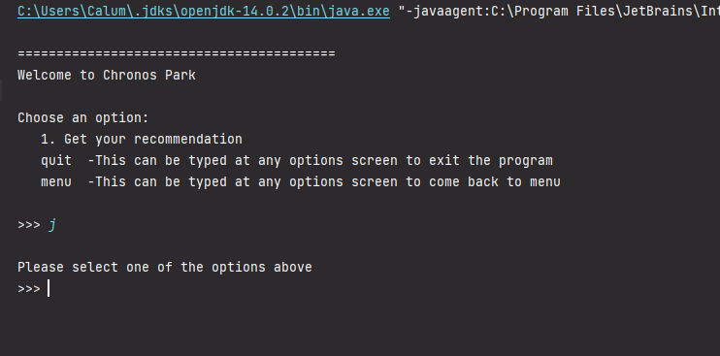

correct menu input

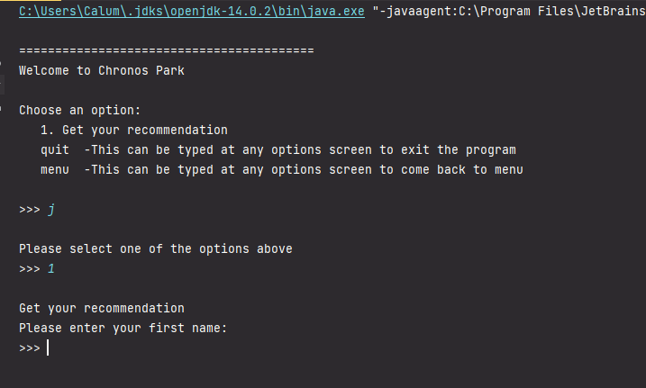

menu input

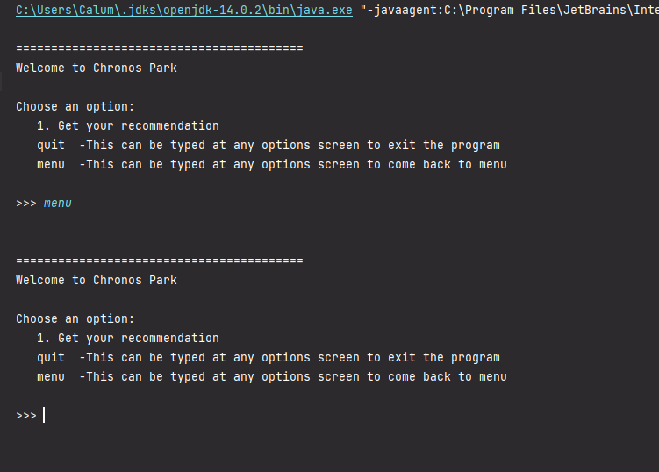

quit input

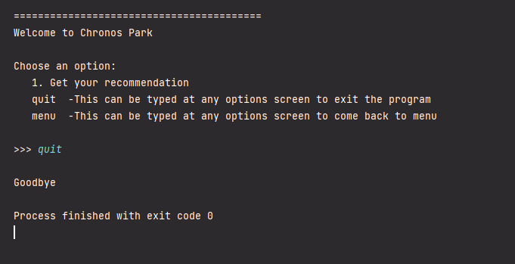

false email selection

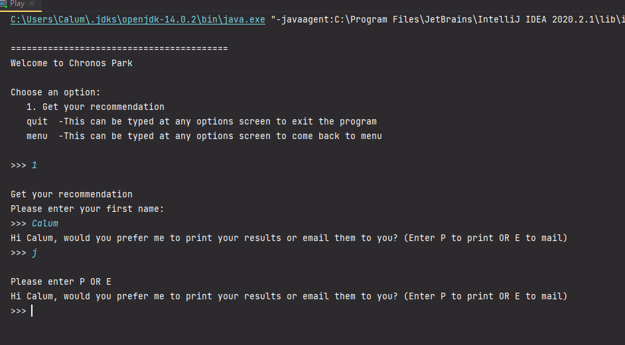

correct print selection

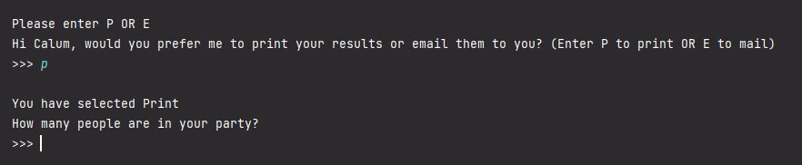

correct email selection

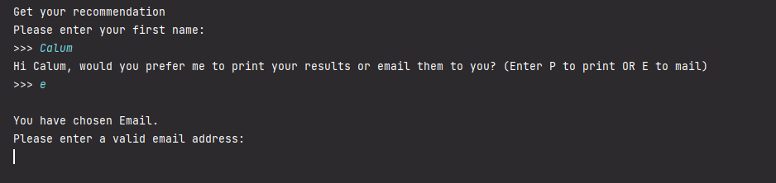

incorrect email input

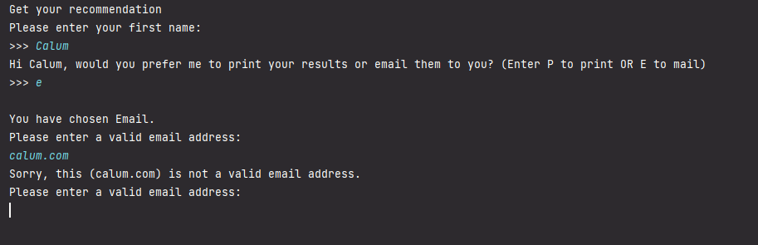

correct email input

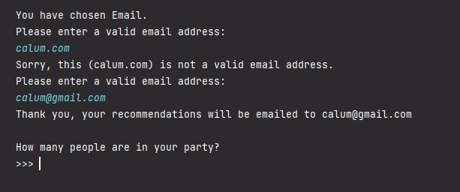

false party No input

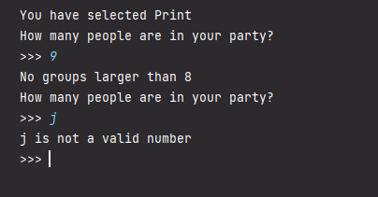

out of bounds party No input

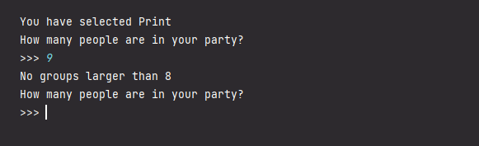

other out of bounds party No input

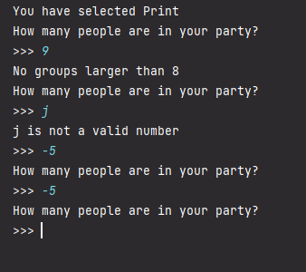

correct party No input

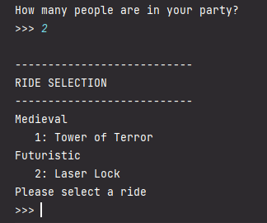

false input ride selection

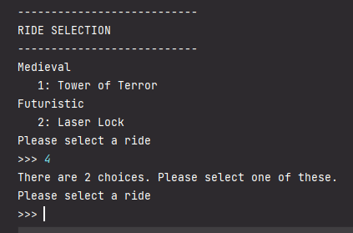

character input ride selection

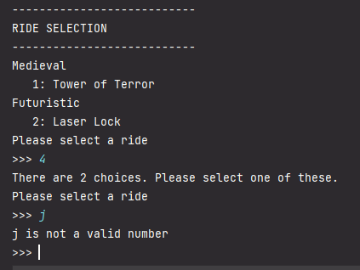

correct input ride selection

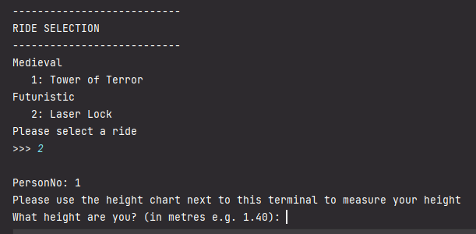

false input height

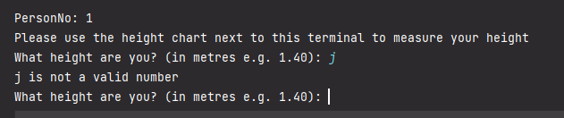

out of bounds height check

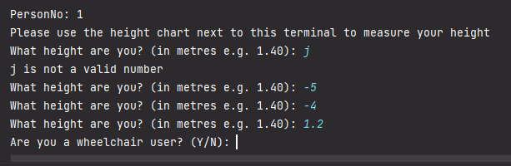

tall person double check

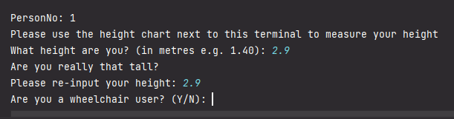

wheelchairQ false input

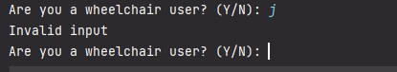

wheelchairQ correct input

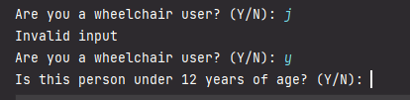

^^^ This type of error handling is identical for all following preference questions ^^^

correct input preference questions

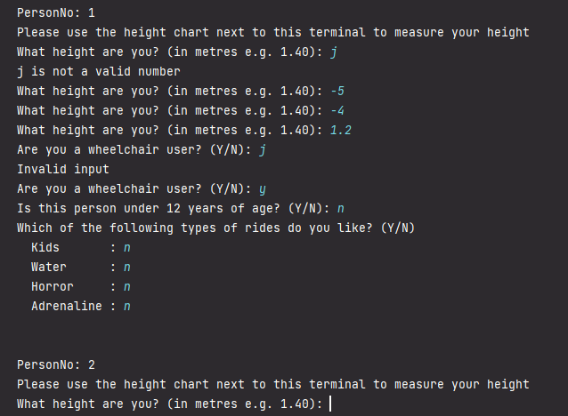



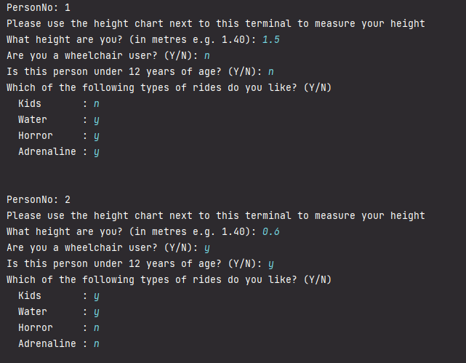

We can see here that this is correct output for input choices

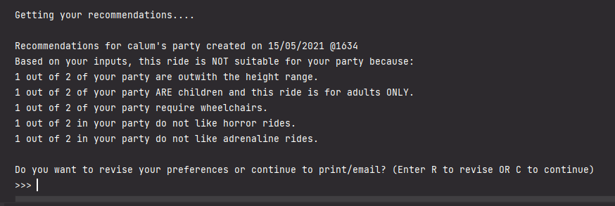

select revision

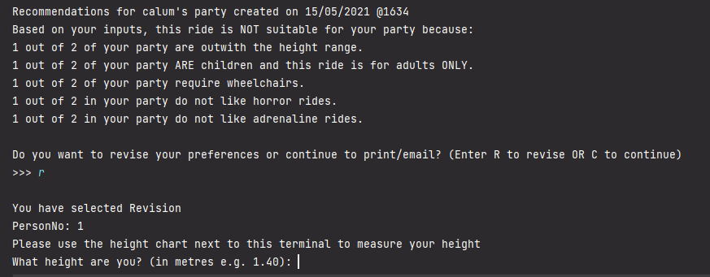

correct output for given input

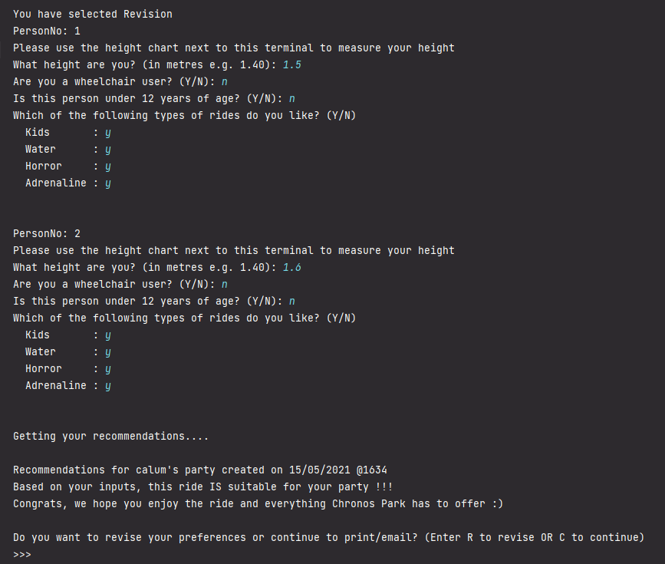

c to continue print

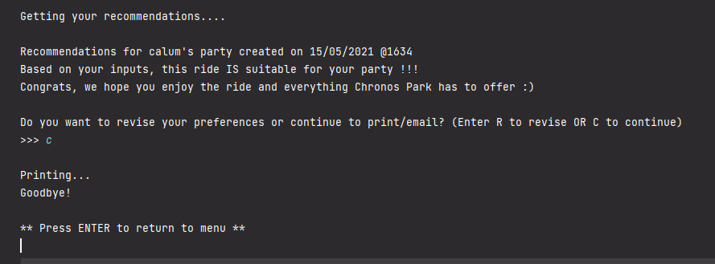

c to continue mail

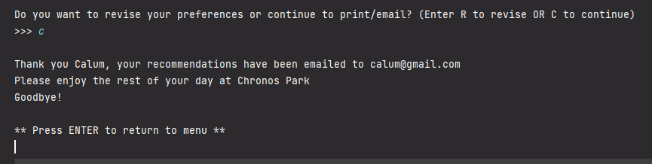

press Enter

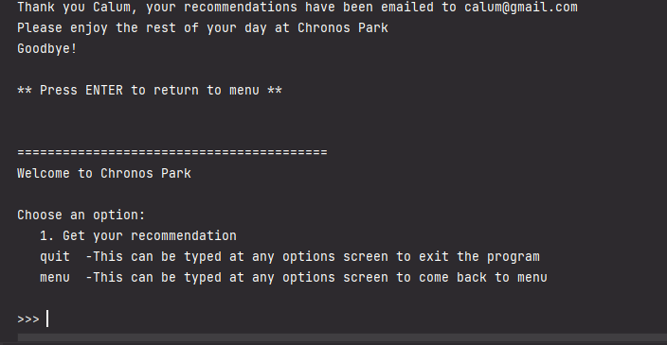

group out with bounds early bounce back

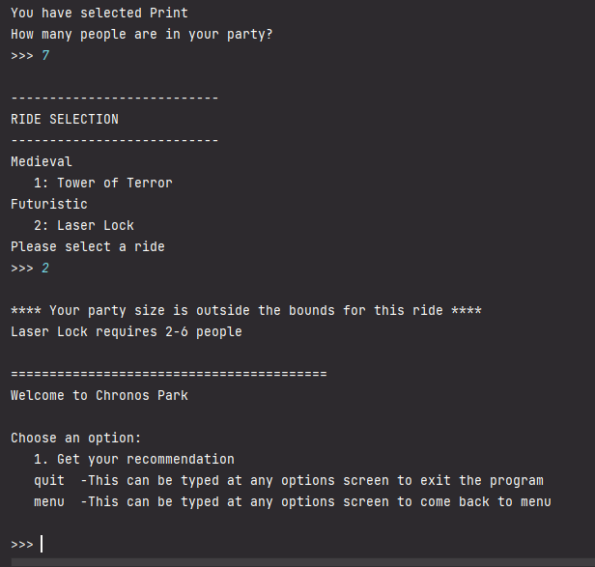

# Testing & Evidence – Step2

## Data outputs

menu

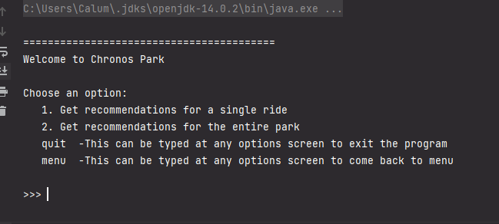

ride selection for OPTION 1 revised

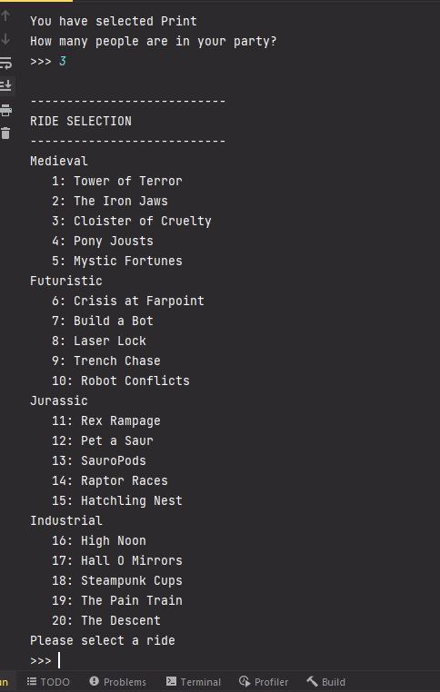

OPTION 2 selection

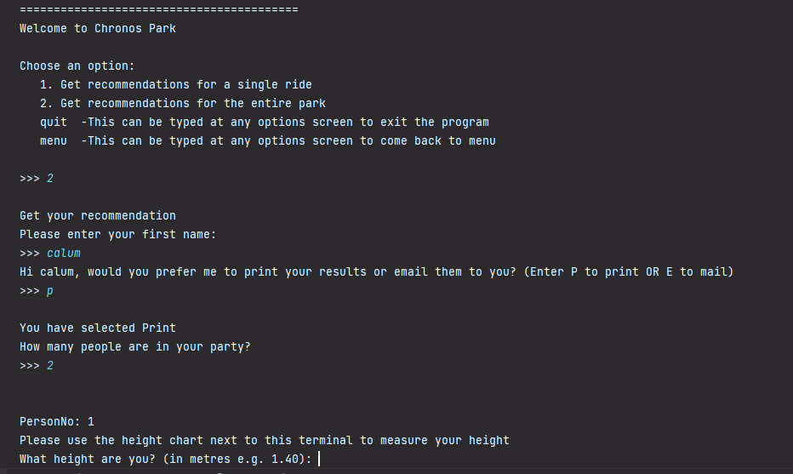

if rides aren’t compatible

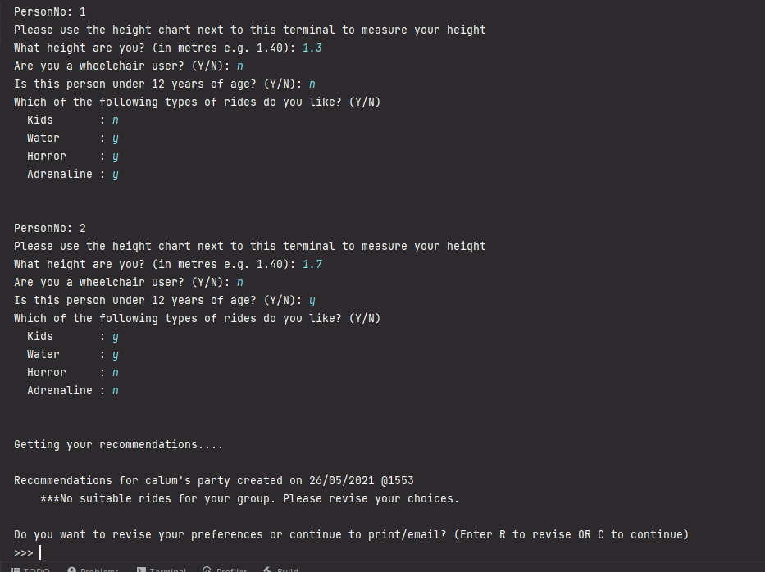

if rides are compatible

