Collaborative Virtual Environs
COMP10043

Final Document

Calum Sterritt – B00265229
Chloe Ruiz – B00253857
Cameron McIntosh – B00240452

Video Link:
https://www.youtube.com/watch?v=IJzQFFtxen8&feature=youtu.be

This Document specifies the final approach towards the creation of a virtual collaborative game development company. With the use of a previous created design document, this document compares the initial approach and the final approach in the following details.

- Introduction
This document compares the initial design document of the ideas and research about a games development/design company. With the use of research, we kept many of the features the same, but also changed up a lot of the main factors to make them work better with the system.

- Game Development Company
When researching into the department and roles of a game development company, many different areas came up, such as the size of the company that would be using this collaborative tool. We decided that a small AA studio (Indie) would suit best as it can consist from as low as 3-4 team members, in the roles of Business / Manager, Game Designer / Production, Technical / Engineering, and Art. Many of these roles can be completed by a single person, this meant that our virtual collaborative company would not need to be massive, letting us cut down the building time and focus on the functionality that would need to be implemented.

- Collaborative Tool
In our final design, we chose that the collaborative tool we would use is Sim-On-A-Stick. This collaborative tool, also new to our use, allowed us to show the creativity and functionality that would be wanted in a development company. Sim-On-A-Stick in an online collaborative tool, where users can be working with others on projects. These tools are clearly usable by all participants, from the creation of buildings, floors, walls, roofs. To the addition of computers, working surfaces, boards to pin messages, screens to show slideshows and more. There were some restrains that came with the use of this collaborative tool, So far, we have not found many restraints with this tool, except for it being non-Apple compatible, which only affected on of our team members, who had a proper computer at their home. So, we would still be able to collaborate through this tool. If any restrictions do appear during more use of the tool I will be fully stated in our final documentation.

- Building Plan
After the initial research into what roles and departments were needed, we created floor plans for each area. The initial idea was to create 4 separate buildings, one for each department, with 3 buildings all connected to a centralized hub which would hold the amphitheatre. These initial plans are shown below:
  - Developer / Design Studio
The developer and design studio will have the following areas, Development Area, Art Area, Computers, Sketching Tables, Meeting Room.
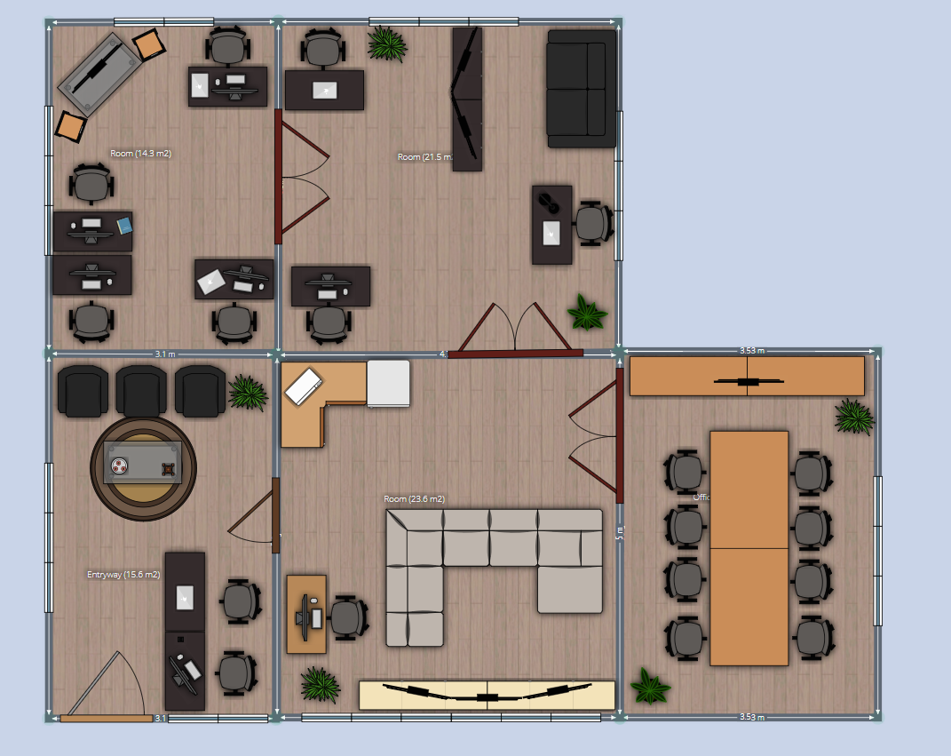
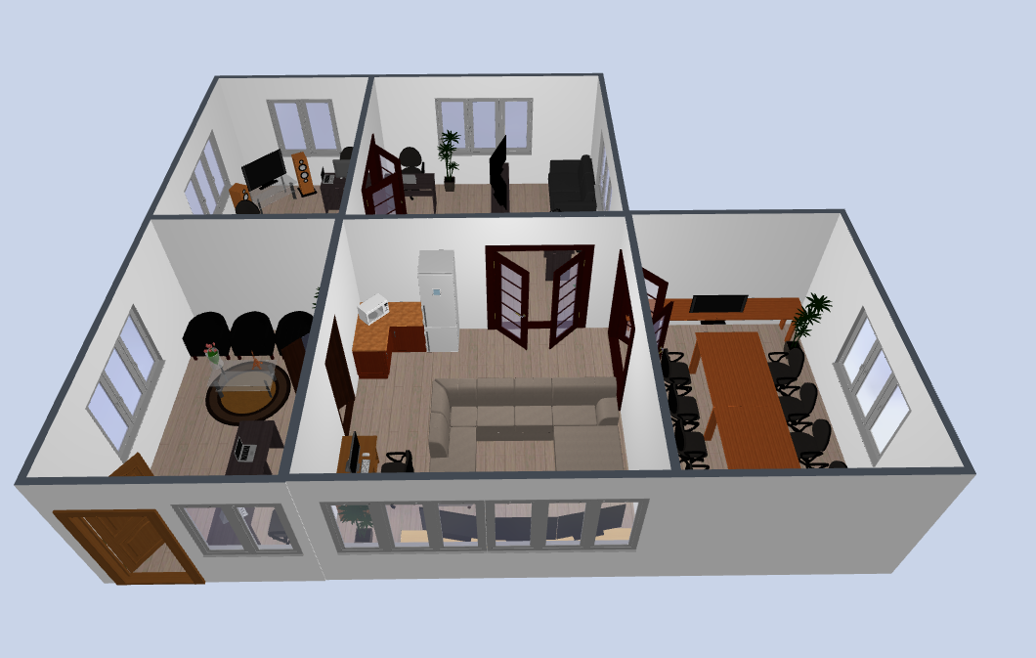
  - Offices
The offices are for the head of the company, this will include offices for each head of different team and a manager’s area.
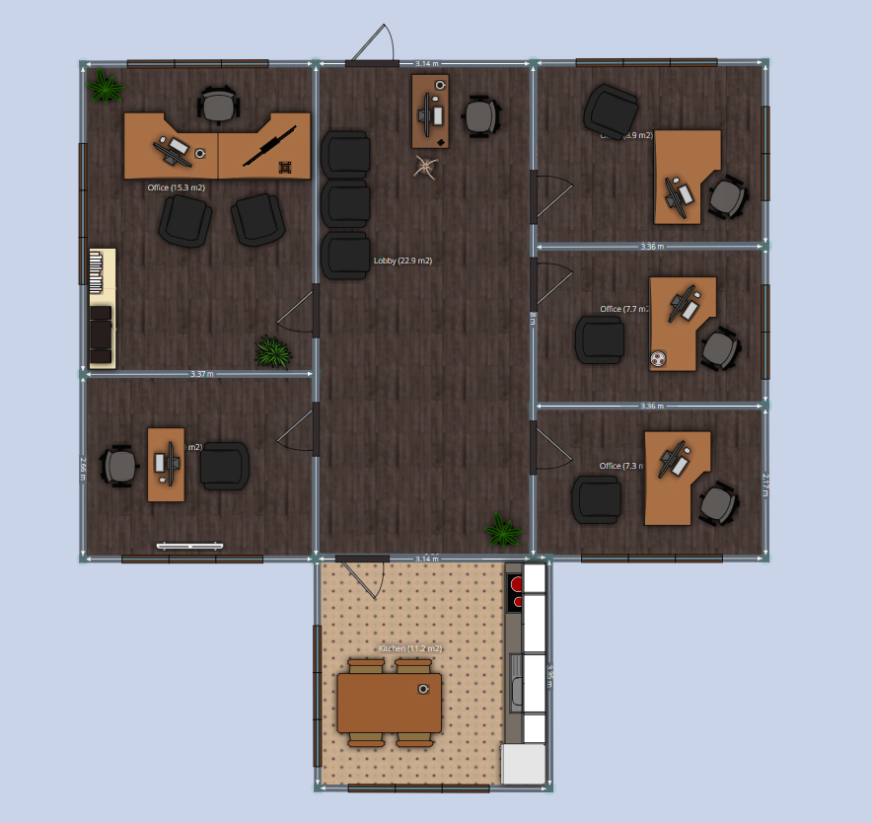
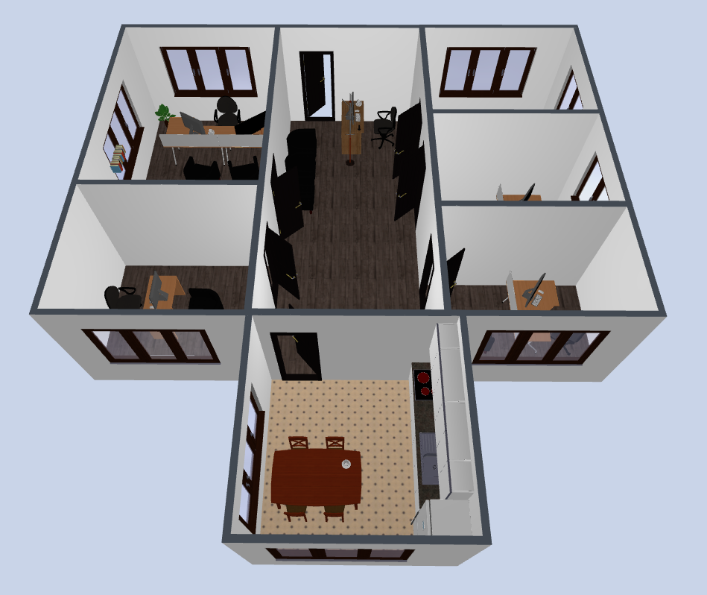
  - Story Board / Research / Server Room
The Story board, research and server room will have the following, a whiteboard and story board for pinning images and messages, servers for the full company, and research area.
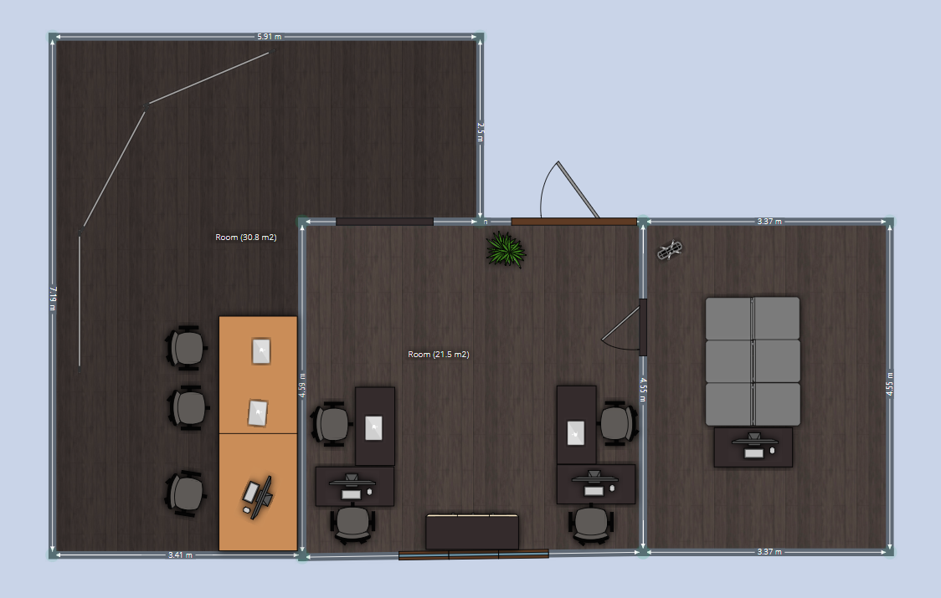
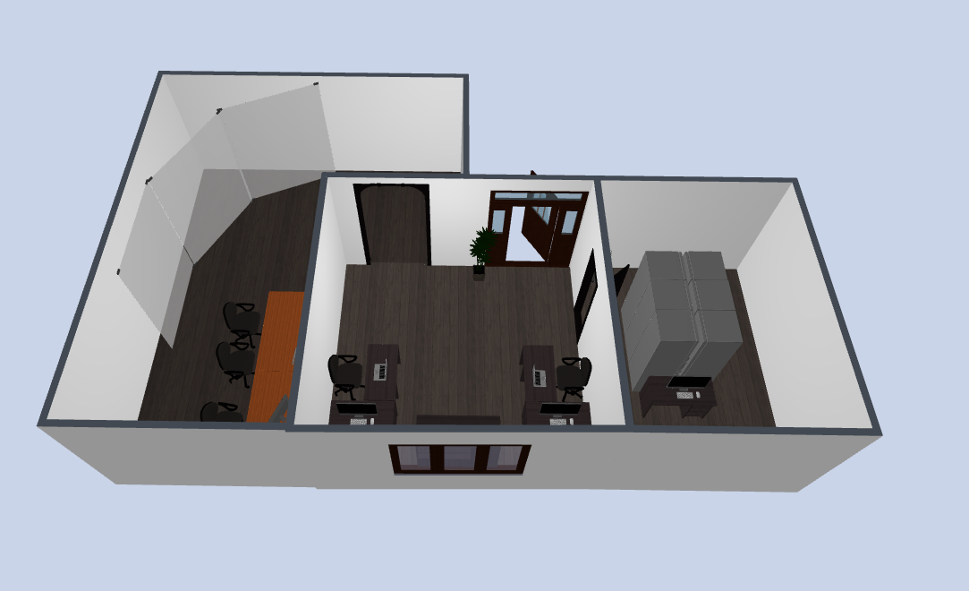

  - Hub
The Hub is the main section that will link all the groups together, this is where they will go to, to have full team meetings, presentations and also hold conferences and marketing events for when they are releasing a game.
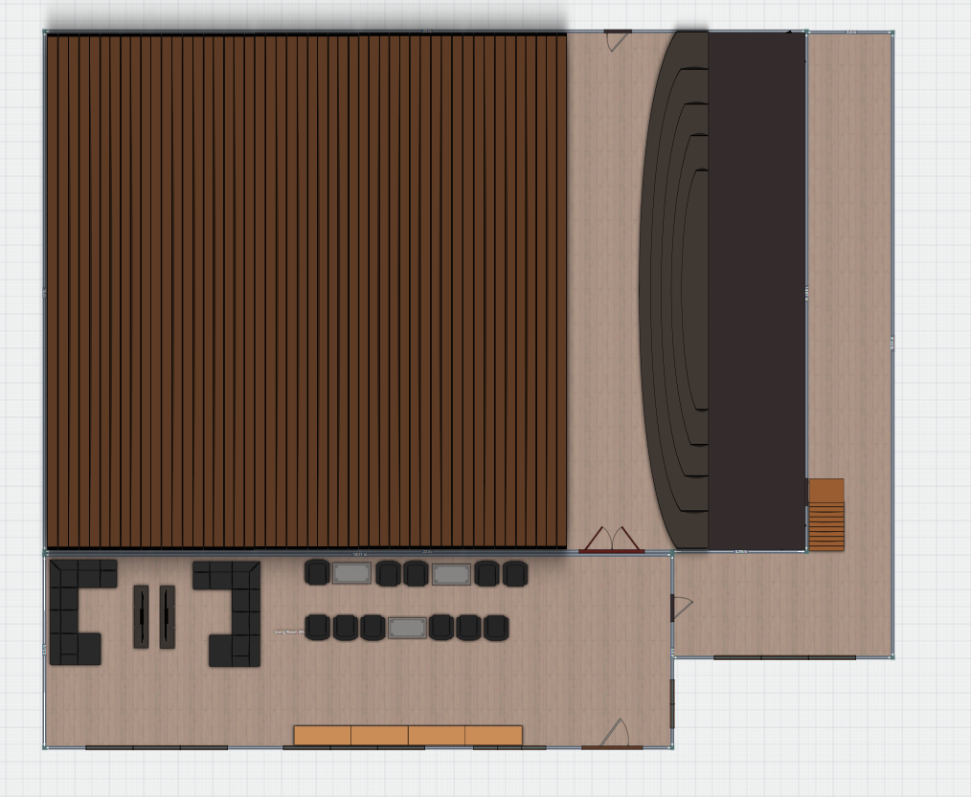
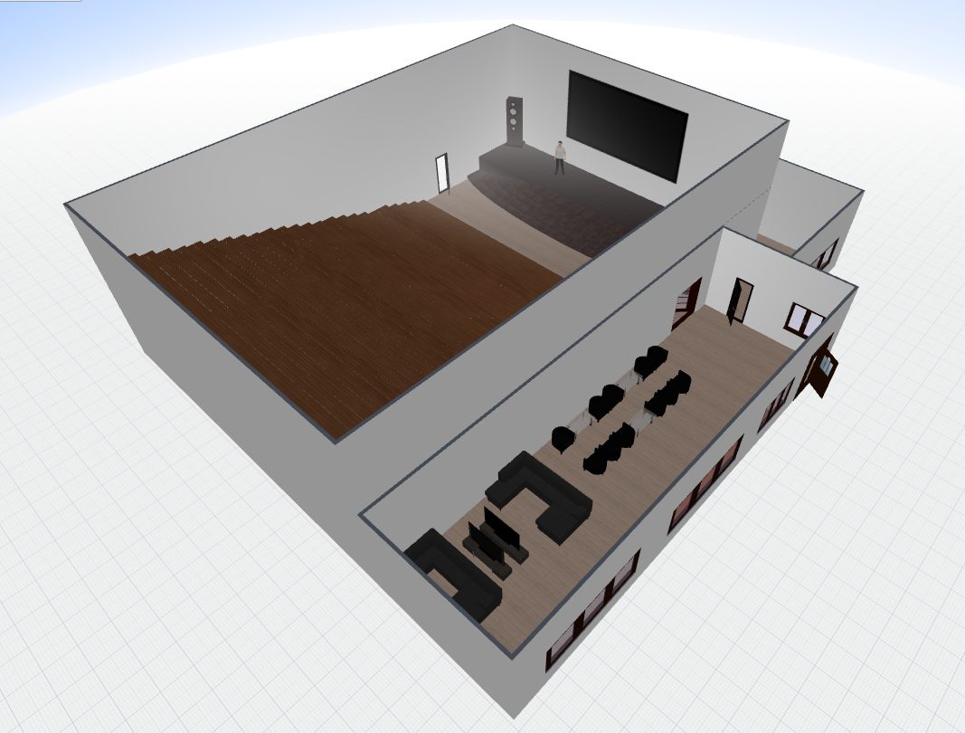
- Final Building
When starting the building phase, we found that the traditional 4 walls and a ceiling would only work if the building was very large with all the equipment being in the centre, due to the camera being very sensitive and phasing through the walls. Due to this we decided to change up the full building, this one full building would hold each or the rooms and the amphitheatre. The following is screen shots from our final creation.
  - Building
We decided that why not make a space ship to hold your company in. This holds all the rooms that we found to be the most use full for a small games development company. The second image is the inside, showing the separate rooms around a centralized stair case to the amphitheatre. There is also a link towards a collaborative tool that we used in the development of this building to share messages, and voice chat. Next to that is a small suggestion box which once interacted with allows that user to place a suggestion about what they would like, or need done.
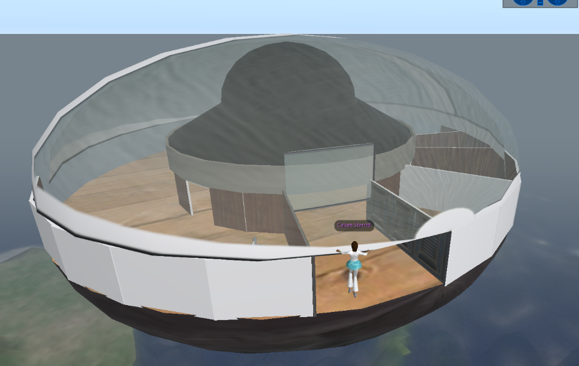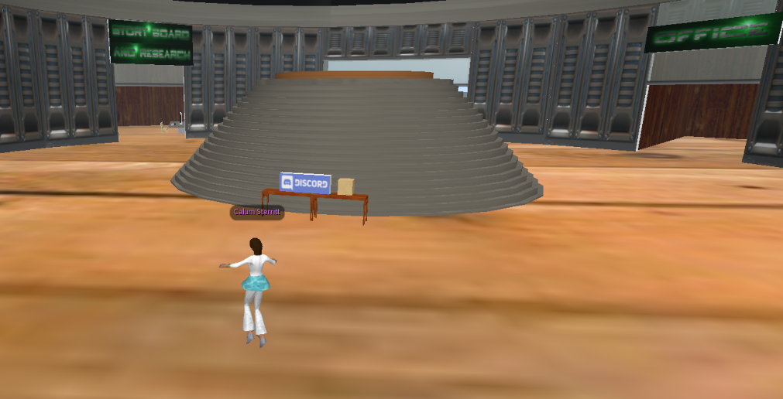

  - Developer Room
The developer room consists of multiple tables with computer systems on them. Each of these tables focuses on a separate are of development, with example the end table has speakers to show of the sound development feature, here the user can click on the computer to take them to a browser that loads Audacity, where that can work on anything sound/music related towards there game. The next table in is the main development ones. These computers once interacted with will take the user to the specified engine that they are developing on, in the video it is show that we have both Unity and Unreal, depending on the company this would be changed to meet their preferences. Due to this being an online collaborative tool, we would have liked it so that the users could work on the computers in the world, but due to restrictions with the Sim, it is currently not possible, but if it were to become available, the use of that feature would work well with the sound and game development features. There is also a broken tv in this room picture as well, this was placed so that the user can screen share from their computer, such as tutorials.
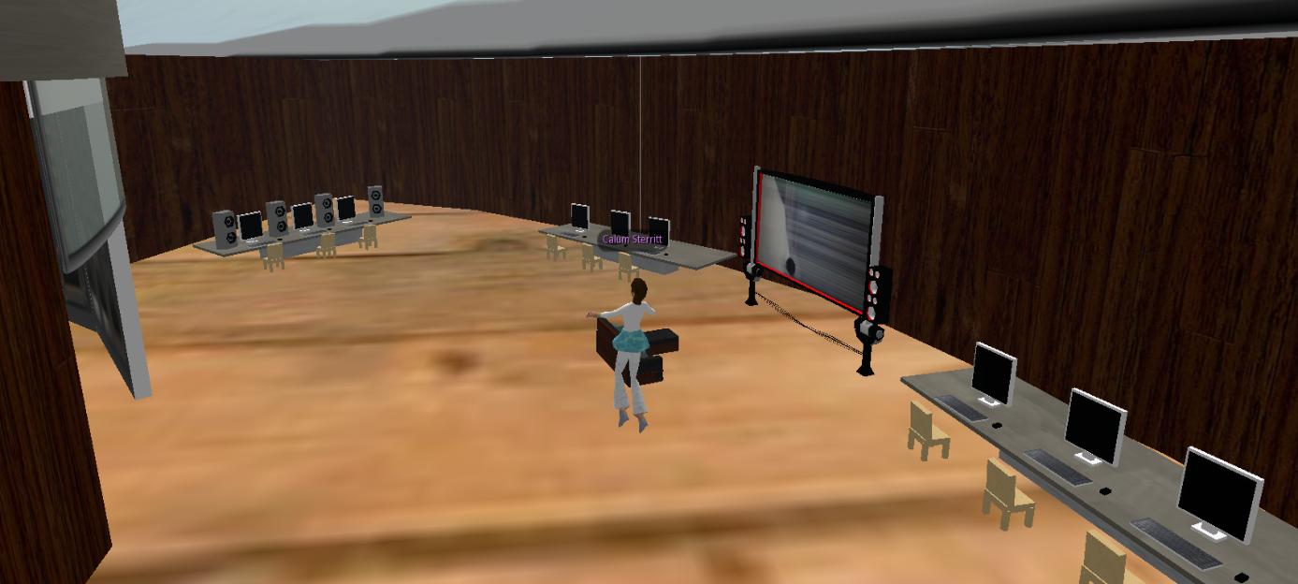

  - Story Board / Research
This rom was created in the initial though of this team being able to research specific items that could be required. The use of the computers in this room once interacted with will give the user the ability to load google, a search engine, and dropbox, where they can share materials between other users.
The story boards in this rooms work by loading images onto them, this is use full in this room to show other users their development on drawing or the storyboard. This feature works easily with loading the images into the sim and placing them on the board.
We would have liked the feature of adding notes to these boards so that the user could quickly let another user that may not be online, that once they are back can read it and do what is need done. Although this is currently not a feature in this sim, but if it were it would give good advantages towards that users may be in different time zones and not all on at the same time.
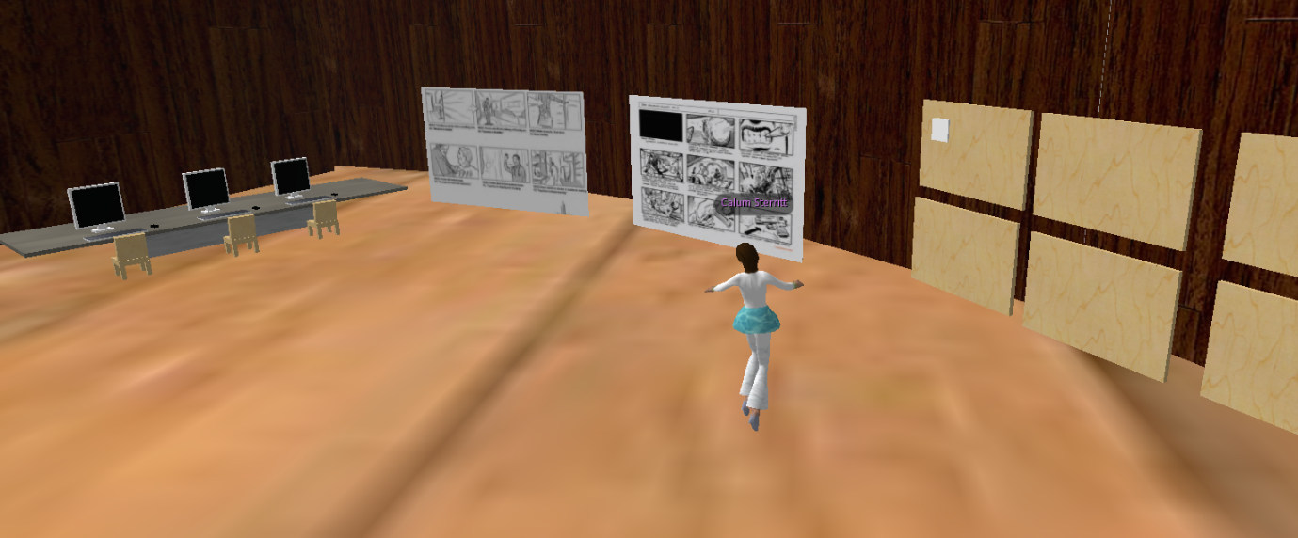

  - Office
The office is not so much an essential room, but it was created to add the feature of having meetings and small presentations. The computer in this room links the users to dropbox, where they can open any files that may be need for meetings. The room also has a presentation board, here the user can load up a presentation that will automatically run through slide by slide, or once clicked will move onto the next one.
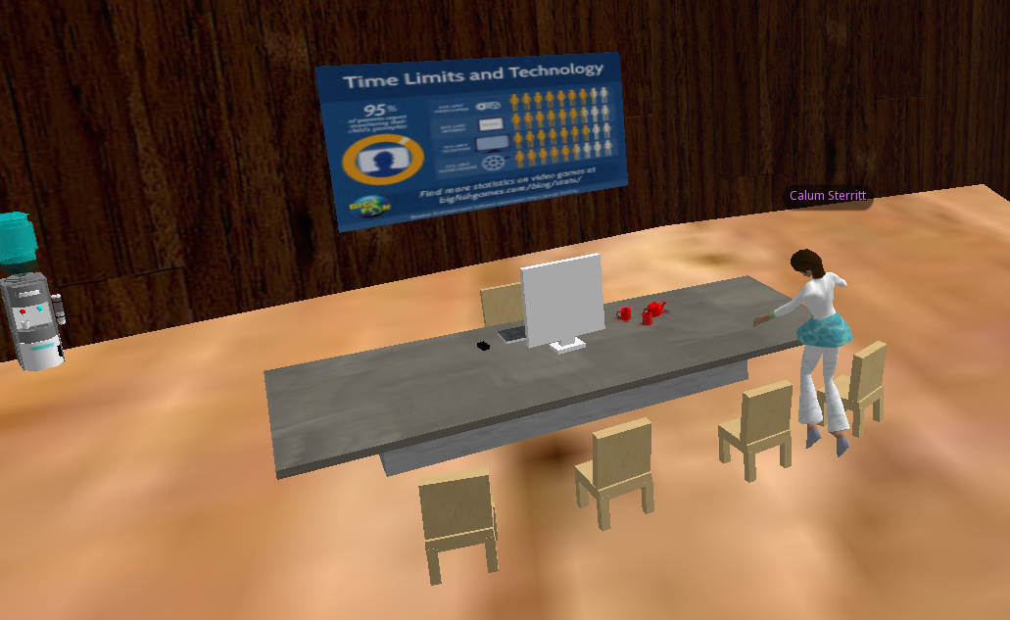
  - Amphitheatre
The amphitheatre is the centralized area in the space ship, here like the office the users can have a large presentation. This is for larger events, where the user can upload a presentation on to the screen. This screen would have been improved with the use of adding videos onto the screen, although this feature does not exist, it would improve the user experience for collaborating online.
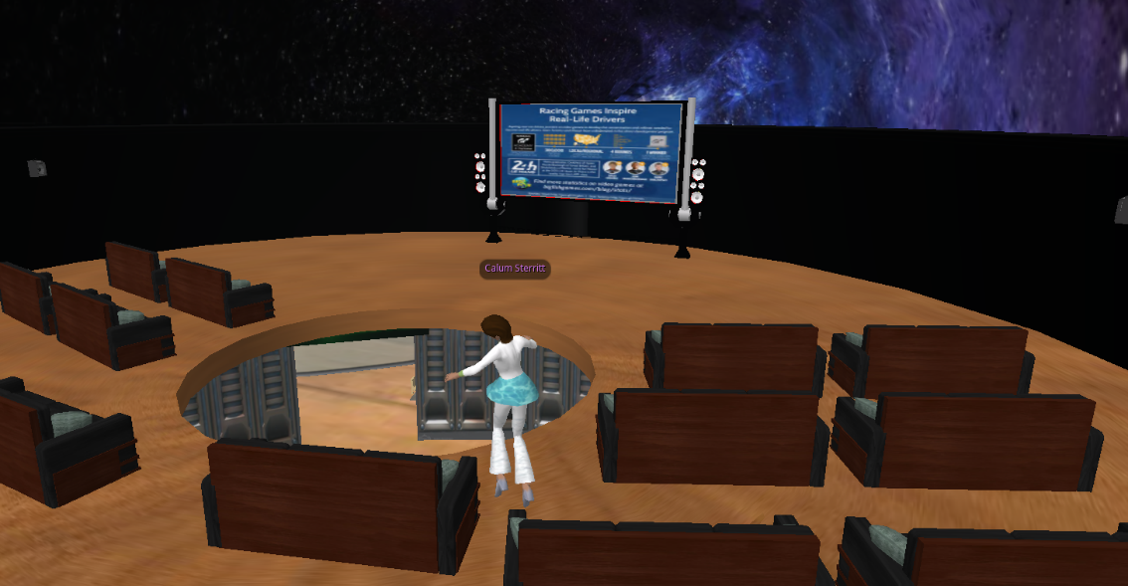
- Collaborative Work
The creation of this game development company inside of a collaborative tool was completed mainly with the use of collaborating tools. The main tool used was Discord, an online or downloadable app, mainly used by gaming communities and groups. It allows for sending of messages, files and group chats. As we can share files, it gives us an extra backup in case something happens to the original files.


