Group Members:

Tseliso Tsenoli 202201035

Makhetha Thapeli 202201147

Seeiso Moremoholo 202201945

Motlalehi Mafohla 202201257

Kananelo Semahla 202202287

Lerato Ramaoto 202201055

Kamohelo Matsumunyane 202201297

**Introduction**

A binary adder is a digital circuit that implements the arithmetic sum of two binary numbers supported with any length is known as binary adder. It is generated using full-adder circuits connected in sequence. The output carries from one full-adder linked to the input carry of the next full-adder.

Software Used

* Logisim

**Verification of our process**

First we derived the logic diagram of the 2-bit binary adder, then formulated a truth table of the adder from the logic diagram. Into the bargain, using the logisim software tool, we simulated the outputs from the logic diagram to check if they correspond with the ones on the truth table for different inputs. They matched.

The derived truth table:

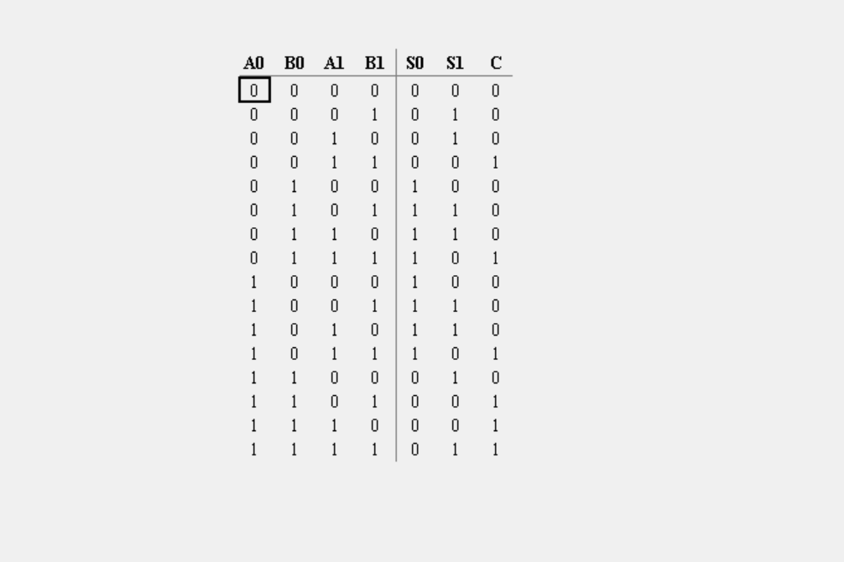

Simulation:

The bright green light indicates logic 1.

The dark green light indicates logic 0.

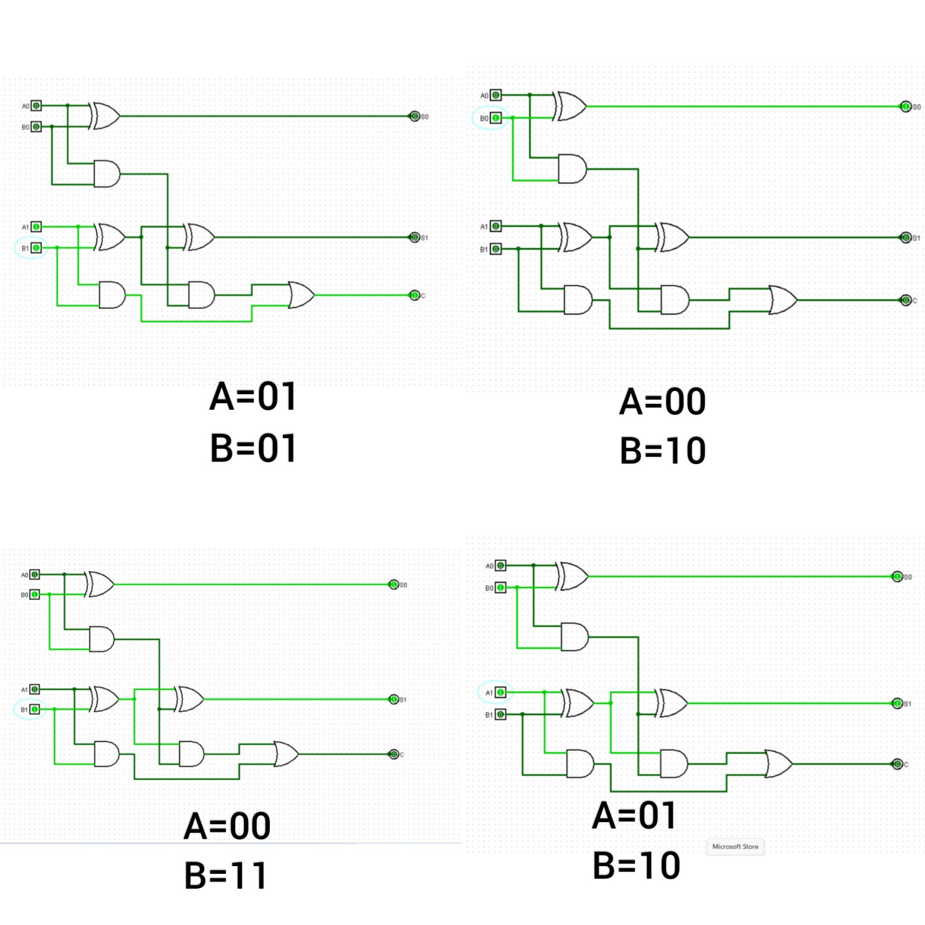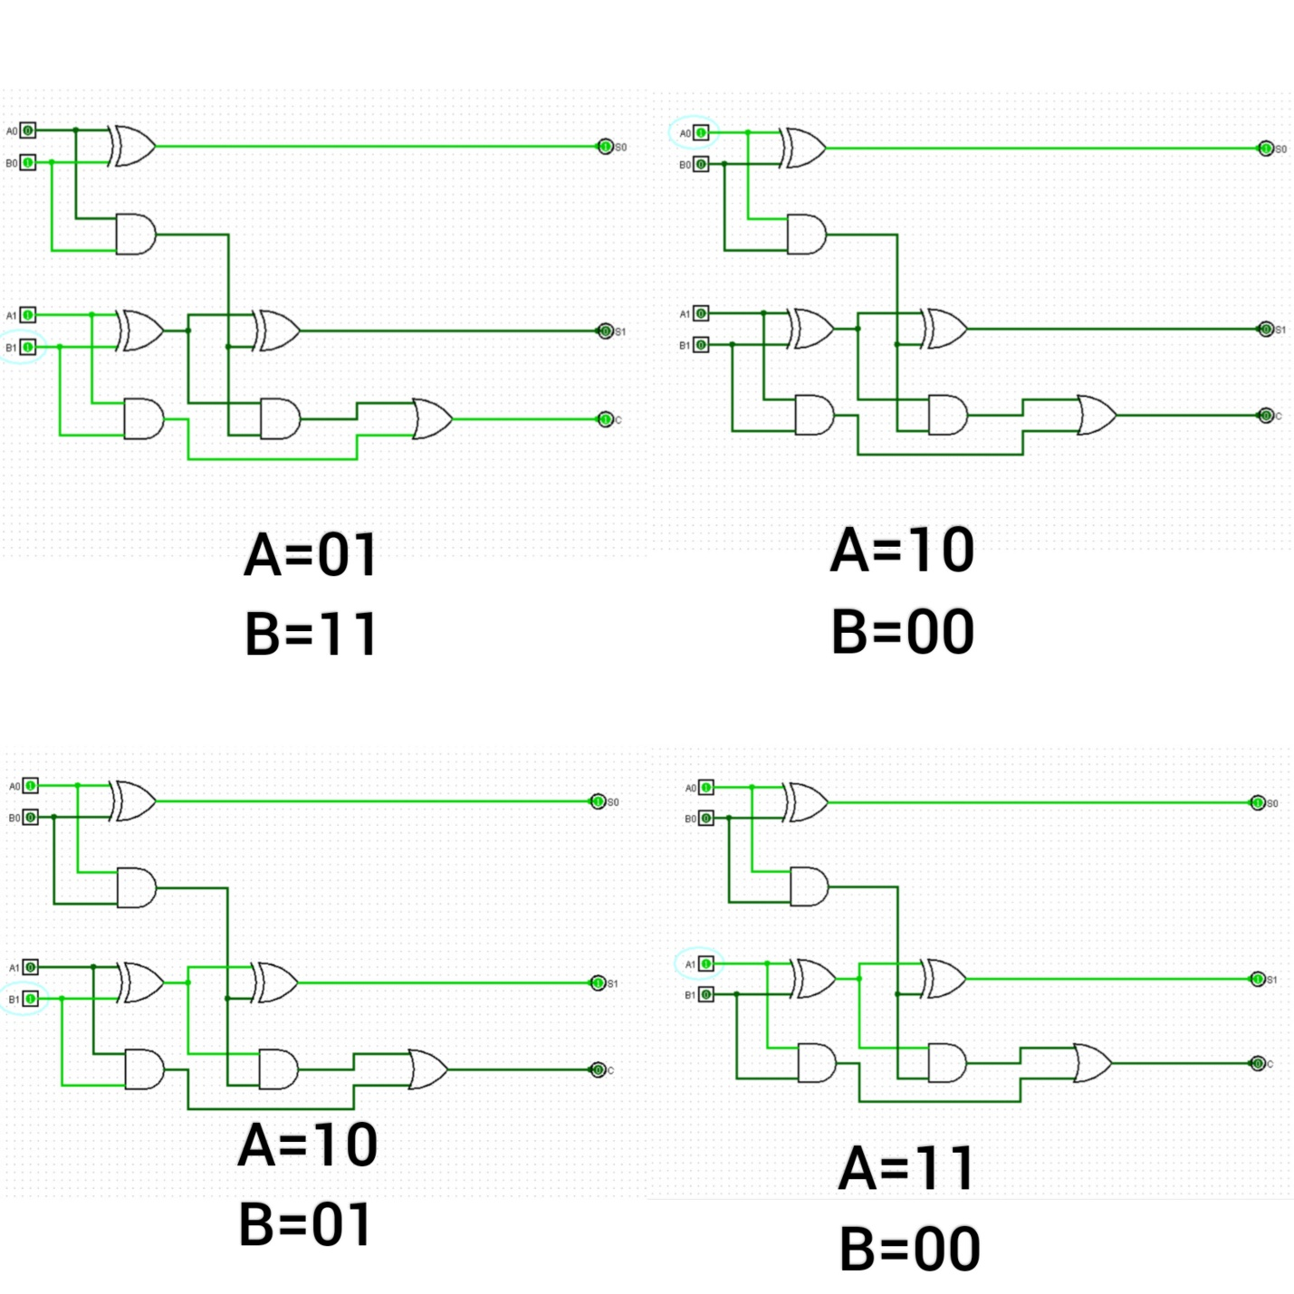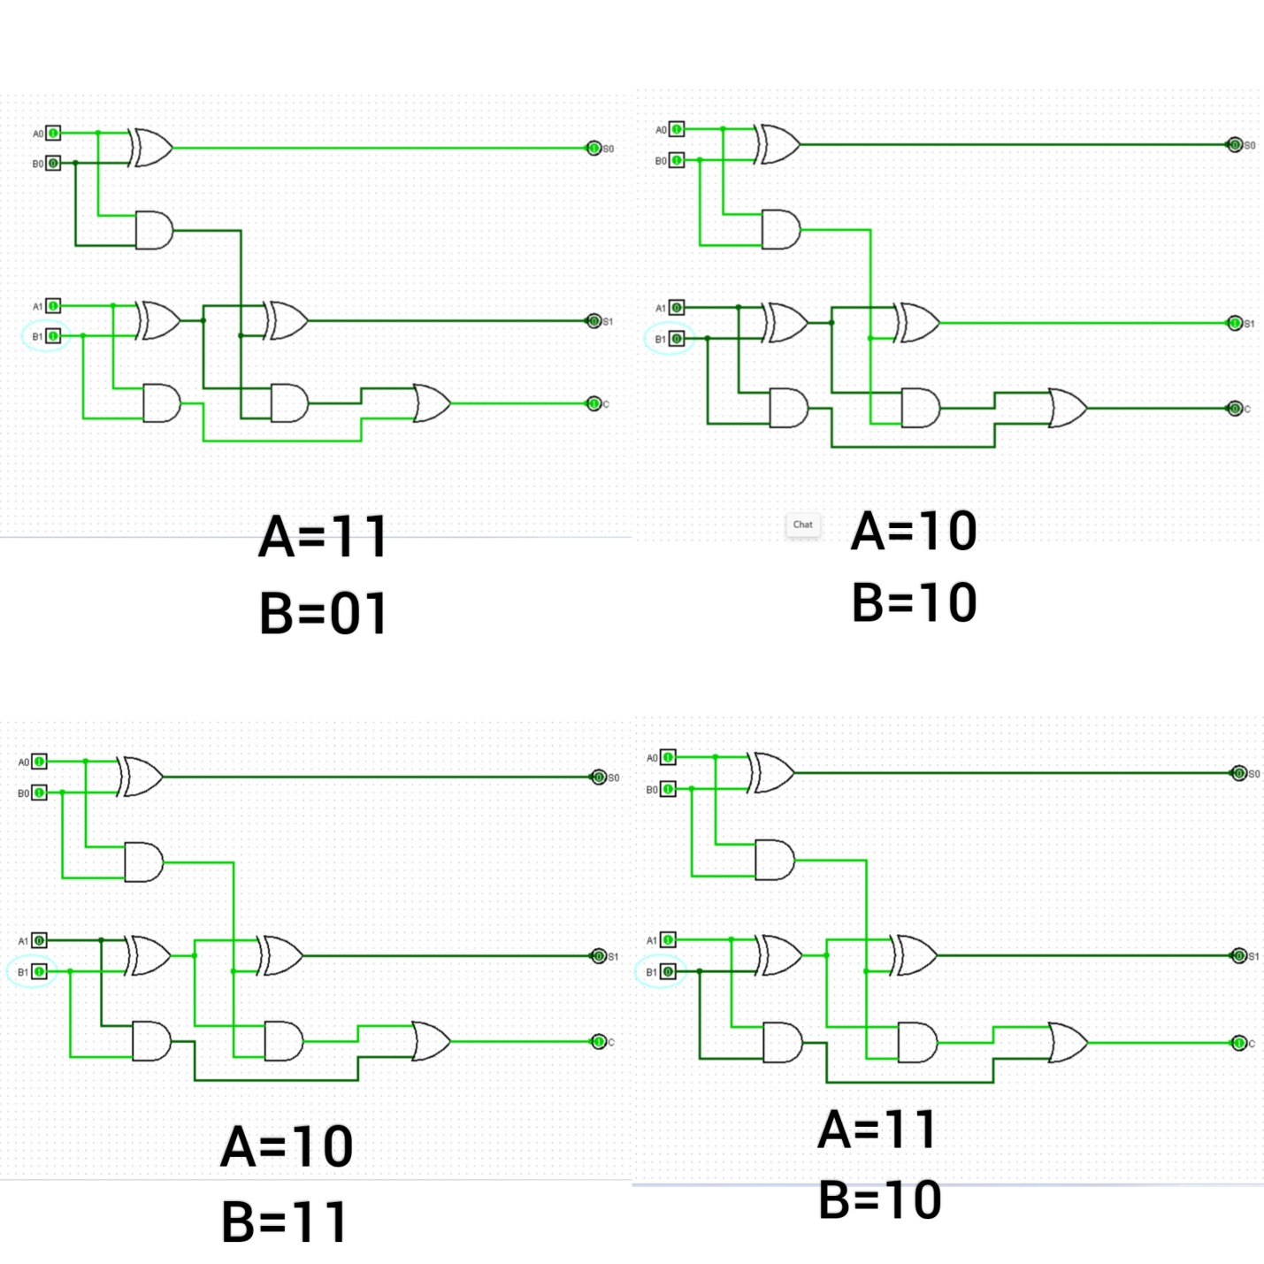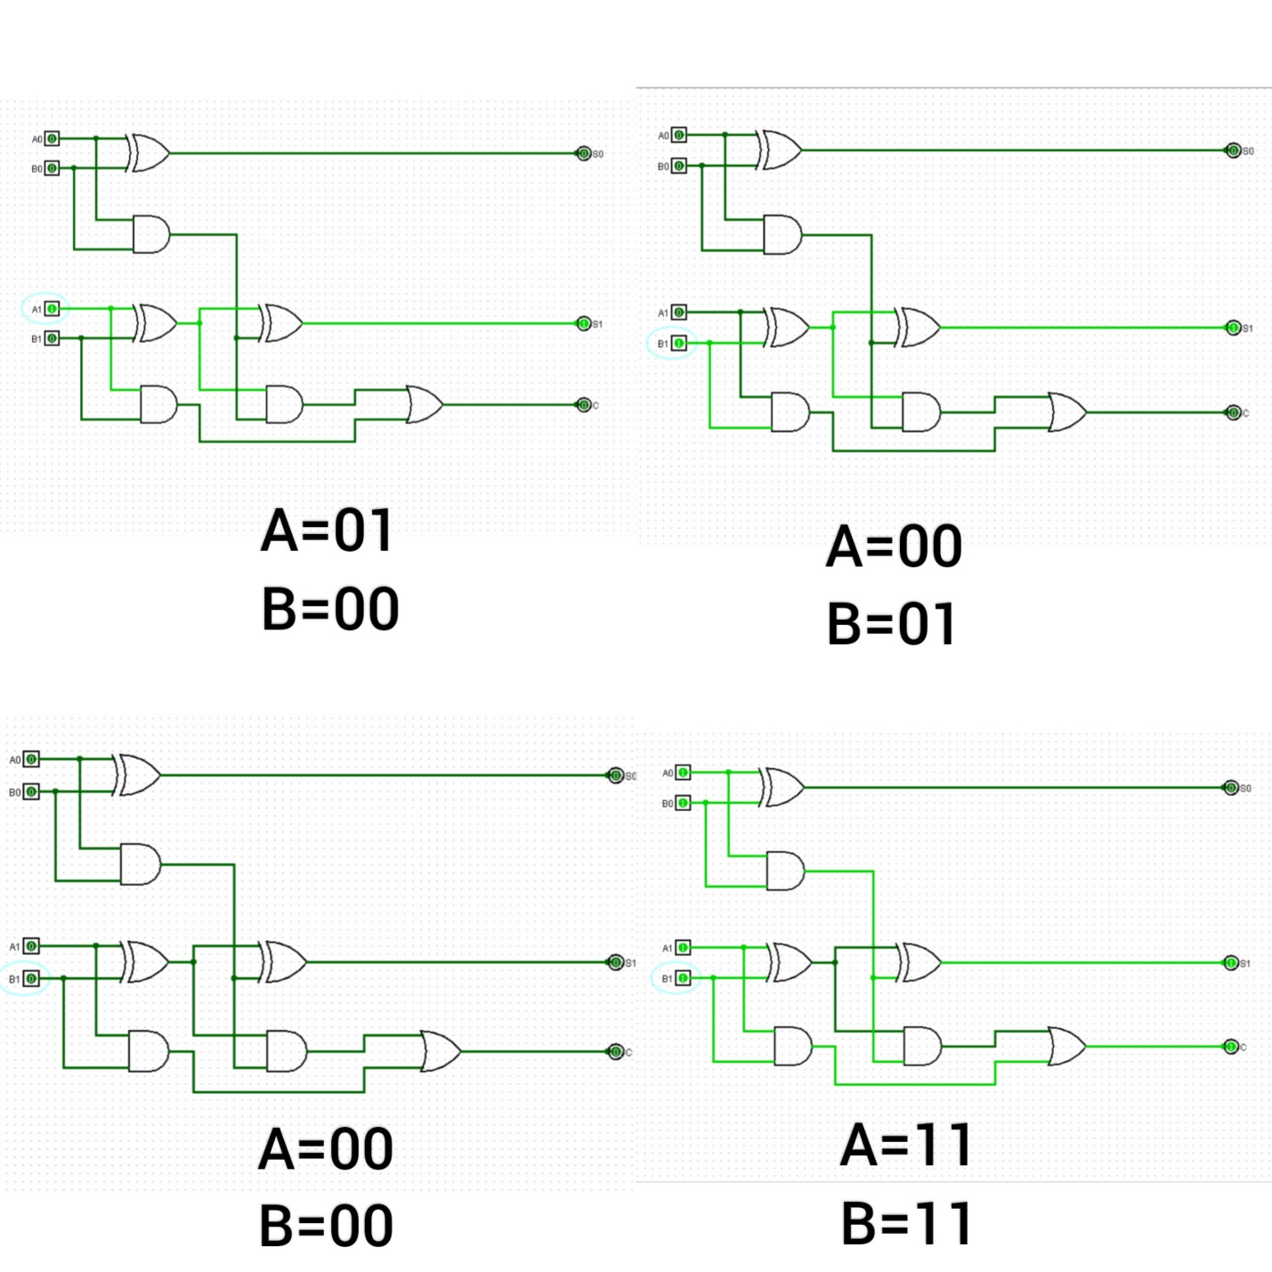

**Discussion**

During the simulation, we were not familiar with the software tool. However, with the help of YouTube tutorial (<https://youtu.be/cMz7wyY_PxE?si=KYIZEmlQTCAVsi-H> ) ,we were able to figure out how it works.

**Conclusion**

All in all, the binary adder was accurate as the values of the truth table of the adder matched with the one generated by the logic diagram. Here is the link to a YouTube as to prove that the adder was successful: <https://youtu.be/crE5M0530ak?si=k4qCyuqzxeoRIBU>