DS18B20 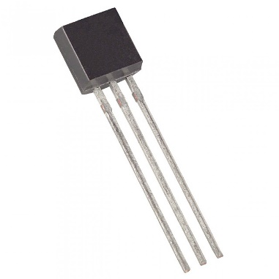

Temperature sensor with 1-wire protocol

Use case: Lock-system with 64-BIT lasered ROM code

With the DS18B20 library u can read the 64-BIT lasered ROM code of a given chip

**Working OLED to show if key is correct The DS18B20 temperature sensor**

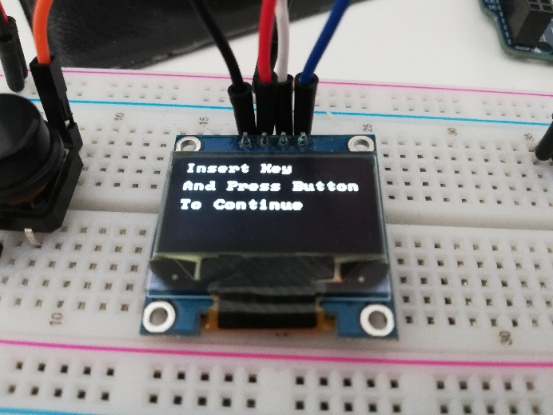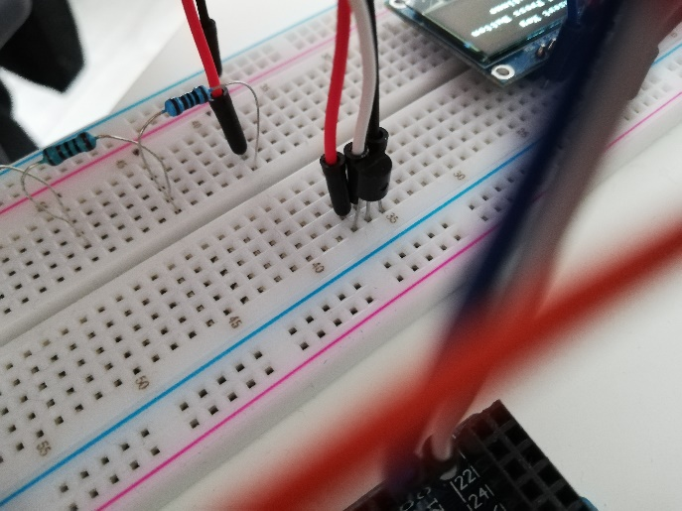

With the DS18B20 Library u can use your DS18B20 as a key for a lock-system.

Made by: Calvin Carter

Github page: <https://github.com/Calvin-Carter/IPASS>