Calvin Truong

BMI Calculator Project

9/12/2018

Output Results:

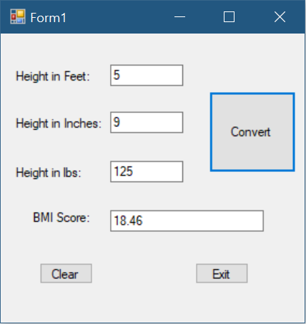

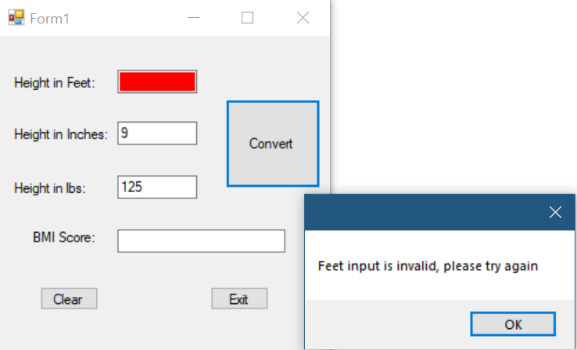

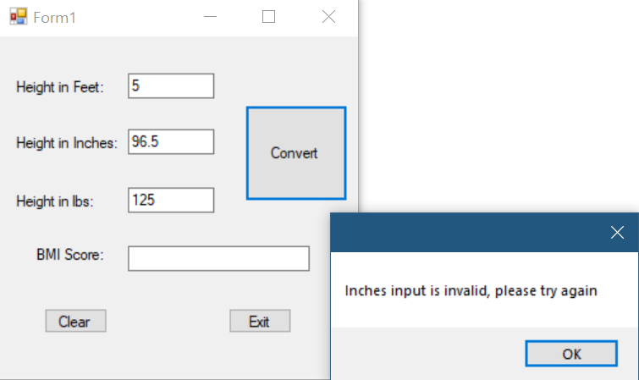

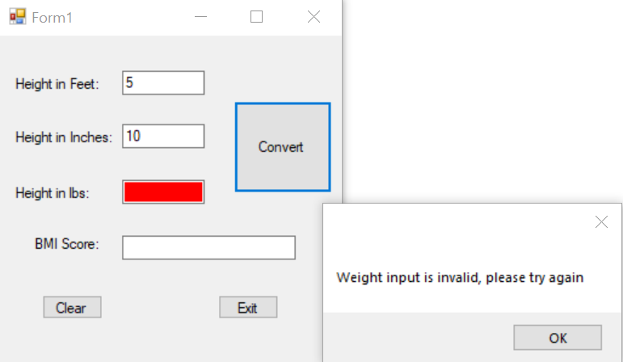

using System;

using System.Collections.Generic;

using System.ComponentModel;

using System.Data;

using System.Drawing;

using System.Linq;

using System.Text;

using System.Threading.Tasks;

using System.Windows.Forms;

namespace BMI_Calculator_Project

{

public partial class Form1 : Form

{

public Form1()

{

InitializeComponent();

}

private void btnCompute_Click(object sender, EventArgs e)

{

//Feet

int feet;

string feetInput = txtFeet.Text;

bool correctFeet = Int32.TryParse(feetInput, out feet);

if (correctFeet && (Convert.ToInt32(feetInput) > 0))

{

txtFeet.BackColor = SystemColors.Window;

}

else

{

MessageBox.Show("Feet input is invalid, please try again");

txtFeet.Clear();

txtFeet.Focus();

txtFeet.BackColor = System.Drawing.Color.Red;

txtBMI.Clear();

}

//Inches

int inches;

string inchesInput = txtInches.Text;

bool correctInches = Int32.TryParse(inchesInput, out inches);

if (correctInches && (Convert.ToInt32(inchesInput) > 0))

{

txtInches.BackColor = SystemColors.Window;

}

else

{

MessageBox.Show("Inches input is invalid, please try again");

txtInches.Clear();

txtInches.Focus();

txtInches.BackColor = System.Drawing.Color.Red;

txtBMI.Clear();

}

//Weight

double lbs;

string lbsInput = txtLbs.Text;

bool correctLbs = Double.TryParse(lbsInput, out lbs);

if (correctLbs && (Convert.ToDouble(lbsInput) > 0))

{

txtLbs.BackColor = SystemColors.Window;

}

else

{

MessageBox.Show("Weight input is invalid, please try again");

txtLbs.Clear();

txtLbs.Focus();

txtLbs.BackColor = System.Drawing.Color.Red;

txtBMI.Clear();

}

if (correctFeet && correctInches && correctLbs && feet > 0 && inches > 0 && lbs > 0)

{

int height = ((12 * feet) + inches);

double heightDouble = Convert.ToDouble(height);

double BMI = (lbs / (heightDouble * heightDouble)) * 703;

txtBMI.Text = Math.Round(BMI, 2).ToString();

}

}

}

}