Project 1

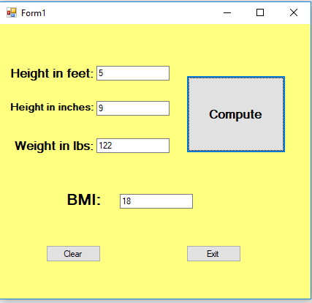

using System;

using System.Collections.Generic;

using System.ComponentModel;

using System.Data;

using System.Drawing;

using System.Linq;

using System.Text;

using System.Threading.Tasks;

using System.Windows.Forms;

namespace CalvinTProj1_BMI

{

public partial class Form1 : Form

{

public Form1()

{

InitializeComponent();

}

private void btnCompute_Click(object sender, EventArgs e)

{

double feet = Convert.ToDouble(txtFeet.Text);

double feetInches = feet * 12;

double inches = Convert.ToDouble(txtInches.Text);

double newInches = feetInches + inches;

double meter = newInches / 39.3701;

double lbs = Convert.ToDouble(txtLbs.Text);

double kilogram = lbs * 0.453592;

double BMI = kilogram / (meter * meter);

txtBMI.Text = Math.Round(BMI, 1).ToString();

}

private void btnClear_Click(object sender, EventArgs e)

{

txtBMI.Text = "";

txtFeet.Text = "";

txtInches.Text = "";

txtLbs.Text = "";

}

private void btnExit_Click(object sender, EventArgs e)

{

Close();

}

}

}