Calvin Truong

Grading System

9/12/18

**Output Results:**

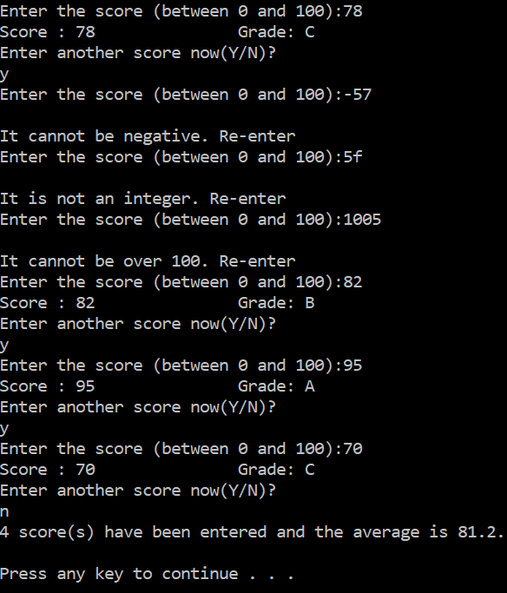

using System;

using System.Collections.Generic;

using System.Linq;

using System.Text;

using System.Threading.Tasks;

namespace Grading_System

{

class Program

{

static void Main(string[] args)

{

string score = "", letter = "A", yn = "";

int grade = -1, i = 1;

double avg = 0;

const int size = 5;

bool valid = true;

for (i = 1; i <= size; i++)

{

do

{

Console.Write("Enter the score (between 0 and 100):");

score = Console.ReadLine();

valid = Int32.TryParse(score, out grade);

if (!valid)

Console.WriteLine("\nIt is not an integer. Re-enter");

else if (grade > 100)

Console.WriteLine("\nIt cannot be over 100. Re-enter");

else if (grade < 0)

Console.WriteLine("\nIt cannot be negative. Re-enter");

else

{

switch (grade / 10)

{

case 10:

case 9:

letter = "A";

break;

case 8:

letter = "B";

break;

case 7:

letter = "C";

break;

case 6:

letter = "D";

break;

default:

letter = "F";

break;

}

}

} while (!valid || grade > 100 || grade < 0);

avg += grade;

Console.WriteLine("Score : {0}\t\t Grade: {1}", grade, letter);

Console.WriteLine("Enter another score now(Y/N)?");

yn = Console.ReadLine();

if (yn == "y" || yn == "Y")

continue;

else

break;

}

Console.WriteLine("{0} score(s) have been entered and the average is {1}.", i, Math.Round(avg / i, 1));

Console.Read();

}

}

}