-- exercise 1. Use WHERE

-- List all female employees who joined at 01/01/1990 or at 01/01/2000

-- exercise 2

-- Show the name of all employees who have an equal first and lastname

-- exercise 3. Use **BETWEEN** OR **IN**

-- Show employees numbers 10001,10002,10003 and 10004, select columns first_name, last_name, gender, hire_date.

-- exercise 4

-- Select the names of all departments whose names have ‘a’ character on any position or ‘e’ on the second place.

-- exercise 5. Use date_format, timestampdiff

-- Show employees who satisfy the following description: He(!) was 45 when hired, born in October and was hired on Sunday

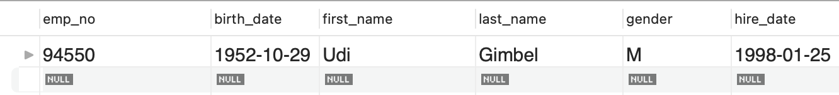

-- exercise 6. Use Agg with where

-- Show the maximum annual salary in the company after 01/06/1995

-- exercise 7. Use DISTINCT/Group by and having

-- In the dept_emp table, show the quantity of employees by department (dept_no). To_date must be greater than current_date. Show departmentswith more than 13,000 employees. Sort by quantity of employees.

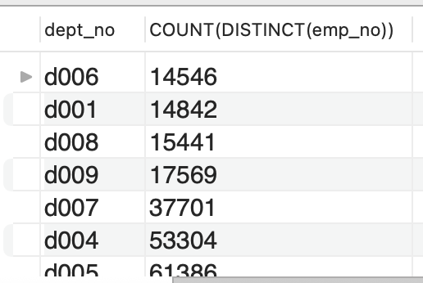

-- exercise 8

-- Show the minimum and maximum salaries by employee

